AP NEWS: Atom-smasher Won't Bring Armageddon

LHC CERN( interview with Staff)

RAP Simple overview of Project and Concern - Light

Official Site for CERN Project

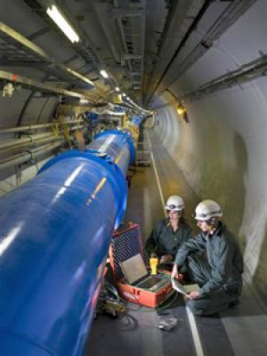

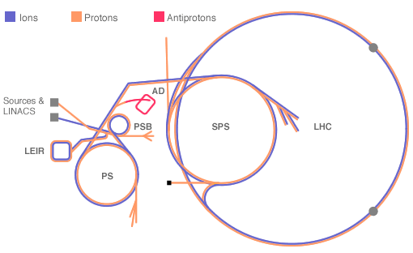
The CERN accelerator complex

Top of Form

Bottom of Form

