This chart shows some of the common materials used for Anodes and Cathodes with their corresponding electrode potential
ELECTRODE REACTION | ELECTRODE POTENTIAL
ANODES (-) | OXIDATION
Zn => ZnO | 1.2 volts
Cd => Cd(OH)2 | 0.8 volts
Pb => PbSO4 | 0.4 volts
CATHODES (+) | REDUCTION
HgO => Hg | 0.1 volts
AgO => Ag | 0.3 volts
MnO2 => Mn(OH)2 | 0.4 volts
NiOOH => Ni(OH)2 | 0.5 volts
PbO2 => PbSO4 | 1.7 volts
Lead Storage Battery 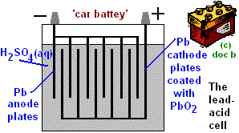
Cathode: REDUCTION
Pb⁽⁺⁴⁾O₂ (s) + 2e⁻ + 4 H+ (aq ) + SO₄²⁻ (aq ) --> Pb⁽⁺²⁾SO₄ (s) + 2 H₂O (l ) E⁰ = 1.685
Anode: OXIDATION
Pb⁽⁰⁾ (s) + SO₄²⁻ (aq ) --> Pb⁽⁺²⁾SO₄ (s) + 2e E⁰ =0.356
(1.685)-(0.356) = 2.04 V
6 cells x 2.04 V/cell = 12.25 V

Graphic illustration of Lead Storage Battery

The chemical reactions in a Alkaline NiCd battery

Cd_{(s)}|Cd(OH)_{2(s)}|KOH_{(aq)}|Ni(OH)_{3(s)}|Ni(OH)_{2(s)}|Ni_{(s)}
Anode discharging reaction
(i) Cd_{(s)} + 2OH⁻_{(aq)} ==> Cd(OH)_{2(s)} + 2e⁻ 0.81Volts
Cathode discharging reaction
(ii) 2NiOOH + 2H₂O + 2e⁻ → 2Ni(OH)₂ + 2OH⁻ 0.44 Volts

NiOOH + NiOOH + 2e + H2O + H2O -> Ni(OH)2 + Ni(OH)2 + OH- + OH-
The two reactions can be better visualized with the following picture:

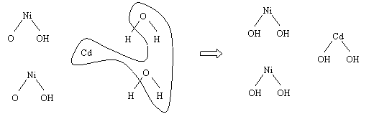
Nickel(III) Oxyhydroxide

Overall cell reaction (iii) Cd_{(s)} + 2NiOOH _{3(s)} ==> Cd(OH)_{2(s)} + 2Ni(OH) 1.25 Volts

• 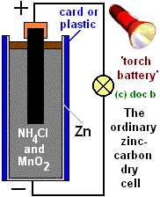Dry cell zinc-carbon battery, 1.5V falling to 0.8V as reaction products build up.
A rod of carbon cathode (+) is set into a paste of zinc and ammonium chloride (weakly acid electrolyte) and fine particles of manganese(IV) oxide and carbon contained in a zinc anode (-) 'compartment'. Although called a 'dry' cell, the paste must contain water, which is thickened with e.g. starch.
Zn_{(s)}|ZnCl_{2(aq)},NH₄Cl_{(aq)}|MnO(OH)_{(s)}|MnO_{2(s)}|C_{graphite}

anode discharging reaction Zn(0)=>Zn(+2)
Zn_{(s)} + 4NH_{3(aq)} ==> [Zn(NH₃₎₄]²⁺_{(aq)} + 2e⁻
cathode discharging reaction Mn(+4)=>Mn(+3)
MnO_{2(s)} + NH₄⁺_{(aq)} + e⁻ ==> MnO(OH)_{(s)} + NH_{3(aq)}
overall working cell reaction
Zn_{(s)}+ 4NH_{3(aq)}+ 2MnO_{2(s)}+ 2NH₄⁺_{(aq)} ==>[Zn(NH₃₎₄]²⁺_{(aq)}+ 2MnO(OH)_{(s)}+ 2NH_{3(aq)}

Standard Half Cell Potentials for batteries (Excellent Resource)

EXCELLENT BATTERY REVIEW

