

Dear Student:
In this course you will be using MasteringChemistry, an online tutorial and homework system designed to help you succeed (with proven results). Here’s how to get started!

1. Register for MasteringChemistry
These instructions are accurate at time of printing. Your experience may vary slightly.

Go to www.masteringchemistry.com and click New Students under Register.
- To register using the Student Access Code located inside the MasteringChemistry Student Access Kit, click Yes, I have an access code. –OR--
- Purchase access online: Click No, I need to purchase access online now and follow the on-screen instructions to purchase access using a credit card or other method. (The purchase path includes registration, but the process differs from the steps here.)

License Agreement and Privacy Policy
- Click I Accept to indicate that you have read and agree to both the license agreement and privacy policy.

Do you have a Pearson Education account?
- Yes - Enter your established Login Name and Password, even if your access to another Pearson Education website has expired. If you provide this, you may be asked to create a more secure password later.
- No - You will be asked to specify a Login Name and Password, and then to confirm your password by retyping it.
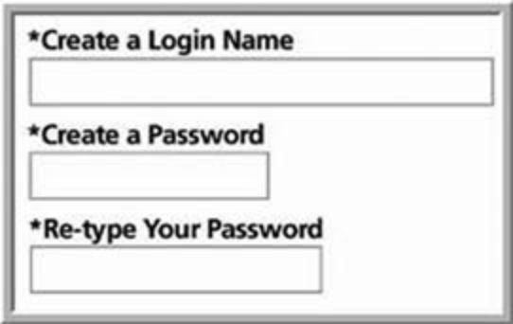
- Not Sure - Enter the email address associated with your Pearson Education student account and click Search.

Access Code
- Type your six–part student access code, one part in each box. Don’t type the dashes. Once you register for this site, you will not need this access code any longer.
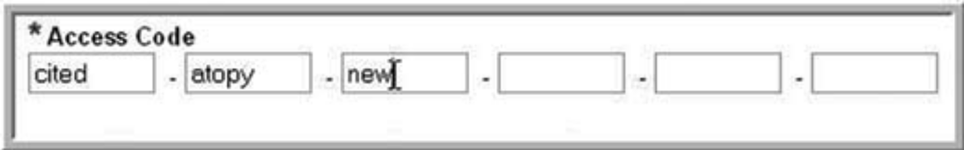

Personal Information and Security Information
- Enter your first and last name, as well as a valid email address that you check regularly. Your registration confirmation will be sent to the email address you provide.
- Enter the requested information to help identify your school location.
- Select a security question and enter the answer. This question is used in the event that you contact us and your identity must be confirmed.

Click Next (only once!) to submit your registration for processing, which takes just a few moments.

Confirmation & Summary
A confirmation page informs you of the site(s) you have access to and that you will be receiving a confirmation email. The confirmation email contains your login name and password for your reference. Your subscription to MasteringChemistry is good for 24 months from the time you first register.

2. Log in to MasteringChemistry
Log in to MasteringChemistry as follows:
- If you are continuing from the Confirmation & Summary page (from last step in previous section): Click Log In Now.
- If you have left the Confirmation & Summary page, you can log in later: Go to www.masteringchemistry.com, enter your login name and password, and then click Log In.

3. Enroll in your instructor’s MasteringChemistry course (instructors provide Course ID)
If your instructor informs you that you will be using MasteringChemistry for assignments, you need to log in to MasteringChemistry and enter your instructor specified Course ID and Student ID (only needed if your instructor gives you a student ID—you do, however, need the Course ID). Doing so enrolls you in your instructor’s MasteringChemistry course so that you can view class assignments. (If you don't have the Course ID information yet: You can enroll later by logging in and clicking Join Course.)

Join Course
- Enter the Student ID according to instructions from your instructor. You can safely ignore this field now if you haven’t been given information about a Student ID.
- Enter your instructor–provided Course ID. The Course ID field is not case-sensitive, so you can enter either lowercase or uppercase characters. Make sure you type in the exact Course ID the professor gave you so that you enroll in the correct online course. If you get an error message, please confirm with your instructor that he or she has enabled student enrollment for this course.
- Click Save and OK to view your MasteringChemistry course home page, welcoming you to the online course. The next time you log in, you will go directly to your home page for the course.
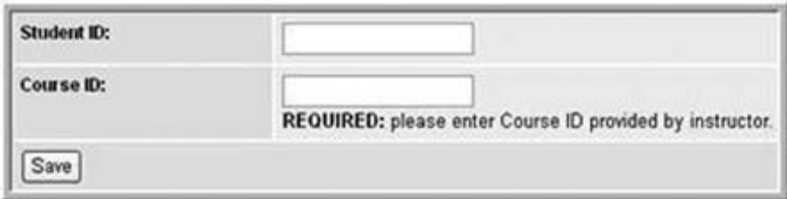
- To view your instructor’s assignments: Click Assignment List on the left.
- To view self-study resources: Click Study Area on the left.

4. Some products in MasteringChemistry contain a Study Area (do not need to provide Course ID)
Upon logging in for the first time, select the title and edition that matches your textbook. Then, click Go to Study Area. Click Study Area on the left to access resources available for your textbook.

5. Go to www.masteringchemistry.com for information on…
- System Requirements
- Support (NEED HELP? Live Chat, email and phone support are found at the MasteringChemistry home page)

