4) Osmotic Pressure
The treatment of osmotic pressure is not identical to the treatments of boiling point elevation and freezing point depression we have just given. A cartoon of an osmotic pressure apparatus is shown below. A U-tube has a "semipermeable membrane inserted in the center of the cross piece as shown. (A semipermeable membrane will allow solvent to flow through it, but not solute.) The left arm of the U-tube is filled with pure solvent and the right arm contains solution. The chemical potential of the solvent is higher in the pure solvent than in the solution so that solvent will flow through the semipermeable membrane from the pure solvent side into the solution side unless it is restrained. (Another way to look at this is that the solution "would like to become more dilute" and it will do so if it can. Given the chance, material will flow from a region of higher chemical potential to a region of lower chemical potential.) To prevent the solvent from flowing we apply an external pressure, Π , to the right side. The pressure, Π , which exactly stops the flow is called the osmotic pressure.
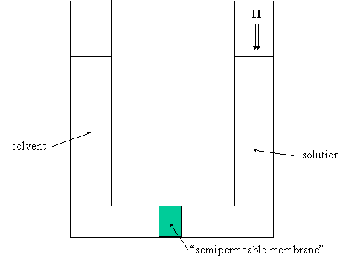
In this experiment temperature is held constant. We will bring the solvent on the solution side into equilibrium with the pure solvent by the exertion of an external pressure on the solution. As we add solute we lower the chemical potential of the solvent in the solution so we must increase the pressure on the solution to bring the chemical potential back up. That is, as we make the solution we need to increase the external pressure to keep μ_{1l} constant. Recall that
(40)
The question we ask is: if we increase the concentration of solute by an amount dX₂, how much does the external pressure have to change to keep the solution in equilibrium with the pure solvent? The derivative we want is,
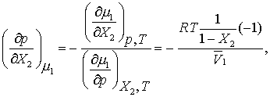 (41)
where we have used the fact that
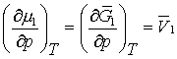 . (42)
Then Equation 41 simplifies to,
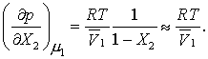 (43)
Prepare to integrate this equation,
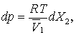 (44)
which integrates to (calling the applied external pressure, or the osmotic pressure, Π),
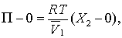 (45)
or, when the solution is dilute,
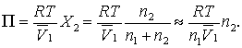 (46)
But so,
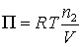. (47)
This looks exactly like the ideal gas equation of state, except the pressure is the osmotic pressure, Π, and the system is a solution, not a gas.
This derivation of osmotic pressure assumed the solution is ideal. For ionic solutions, which are not ideal, you can get an approximate osmotic pressure by taking account of the dissociation of the compound into ions in solution. If the compound gives c ions per compound unit ("molecule") the osmotic pressure for dilute ionic solutions can be written,
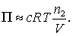 (48)
For more accurate work you can write an expansion similar to the virial expansion,
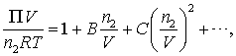 (49)

Taken from http://www.chem.arizona.edu/~salzmanr/480a/480ants/colprop/colprop.html

