PRACTICE EXAM

1) Phosponyl chloride, POCl₂ decomposes according to the equation,
POCl₂==> PO₂(g) + Cl₂(g)

At high temperature this he decomposition is second order with a rate constant of 3.2 x 10⁻² M⁻¹sec⁻¹ at 520 ºC.
If the original concentration is found to be 2.5 millimolar; how long will it take for 40%/30% of the sample to decompose? (10pts) Hint: Decompose means how much is lost?
0.5 8333 5375 37.6 734.2 none

-(1/0.0025)+1/(0.6*0.0025)= | 266.6667
=266.667/0.032= | 8333.3

2) The solvent for an organic reaction is prepared by mixing equal volumes of acetone (C₃H₆O) with ethyl acetate (C₄H₈O₂). This mixture is stored at 25.0 C. The vapor pressure and the densities for the two pure components at 25.0 C are given in the following table. What is the vapor pressure of the stored mixture? (10pts)

Compound | Vapor pressure | Density
Compound | torr | g/ml
Acetone | 230.0 | 0.791
Ethyl acetate | 95.4 | 0.900

162.7 153.1 180.6 172.3 15.31 none

Acetone : 0.791/68.04= 0.013628moles Xa = 0.5715
EA: 0.900/88.105 = 0.010215 moles XEA = 0.4284

0.5715*230.0+ 0.4284*95.4 = 172.3

3) In humans, the caffeine 1ST order half life varies from 3.5 to 10 hours - depending on your metabolism. .
If you're an average adult, half the caffeine has gone from your system after 5-6 hours (ASSUME 5.5 hours).
But if a woman who is pregnant or using oral contraceptives her caffeine half life doubles to about 12 hours.
Smokers also have a very short caffeine half life (3.5 hours), so they can also clear the caffeine out of their bodies rapidly. This might explain why smokers tend to drink more coffee than non-smokers (10pts)
Hint: Determine k then use…

After 24 hours what is the average percentage of caffeine still found in an average adult

4.9% 20.6% 12.6% 18.2% none

k= ln2/T1/2 = 0.126 A(24)= 1*exp(-0.126*24) = 0.0488

After 24 hours what is the average percentage of caffeine still found in an average adult smoker

15.9% 19.8% 0.9% 28.6% none

k= -/198 A(24) = exp(-0.198*24) = 0.00864
4) Four beakers are placed in an open container. , and.
Beaker A is filled with 100 mL of pure water 0
Beaker B is filled with 100 ml of 1.0 molal calcium chloride 3.0
Beaker C is filled with 100 mL of 2.1 molal potassium nitrite 4.2
Beaker D is filled with 100 mL of 3.3 molal sucrose (non-electrolyte) 3.3

The container is left for several days and then examined to the discovery that the four beakers no longer contain equal volumes. What would you predict to be the relationship of the volumes in beakers A, B, C and D? (10pts)
Write Order with inequality symbols between: C>D>B>A

5) Consider the reaction: NO₂ -> 2 NO + O₂
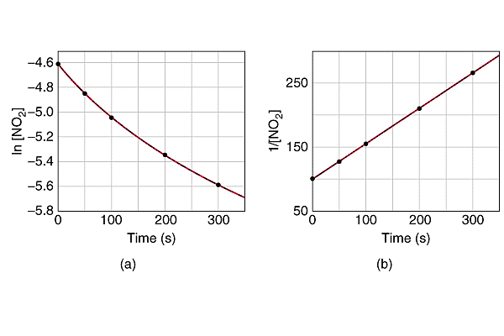
What is the Rate Law AND what is the Time Dependence of [NO₂](t) (5 pts)

Slope = 0.57 and 1/NO₂(0) = 100 thus NO₂(0) =0.01 1/[NO₂ ] = 1/0.01 + 0.57*t

What would be the Concentration (M) of NO₂ at 800/500 seconds? (5 pts)
Hint first derive needed relationship and utilize at appropriate time.
0.00180 2.60 0.0035 5.96 0.00259 none

1/[NO₂ ] = 100+0.57*800=556 [NO₂ ] =0.00180

1/[NO₂ ] = 100+0.57*500=385 [NO₂ ] =0.00259

E.C. Assuming there was ONLY reactants at beginning and no back reaction; what would be the concentration of NO at 500 sec? (E.C. 5pts) (No guesses must see work!)
0.02 771.4 0.0052 0.0148 0.0052 none
From last problem: [NO₂ ] =0.00259 and from general rate equation NO₂(0) =0.01

thus we lost x= 0.010-0.00259=0.00741 and gained 2x of NO = 0.0148
6) Henry’s law tells us that the solubility of a gas increases with the pressure of that gas above it. Assuming that air is simply N₂ ::O₂ (80%/20% by Volume) at one atmosphere. What would need to be the partial pressure of O₂ in a compressed air tank so as to maintain the SAME ABSORPTION of O₂ in the blood (water) at 363 ft below sea level ( assume 33ft = 1atm) ? (10pts)

363/33= 11atm of water + 1 atm =12 atm

=0.2/12 =0.0167 atm of O₂

7) A 0.550 M solution of NaHCO₃ (molar mass=84.0) has a density of 1.032 g/mL .
Calculate the molality of the solution. (10pts)
0.580 0.558 0.533 0.51 none

In 1L of solution 0.550moles thus 46.2grrams of sodium bicarbonate
1L would have a mass of 1032 gram which is both solvent and solute
Solvent is 1032-46.2 = 985.8 grams or 0.986 kg

0.550/0.986 = 0.5578

8) A solution of 0.28% by weight Potassium Carbonate (molar mass=138) has a density of the solution is
1.09 g/mL, calculate the Molarity of the solution. (10pts)
0.205 0.0187 2.59 0.0221 none

0.28grams of K2CO3 = 0.002029 moles
100-0.28 =99.72 grams of water
100 grams of solution/density = 91.743 ml or 0.09174 L

0.002029/0.09174 =0.0221 M or 22.1 mM

9) Five plots, labeled A) - E) are shown below. What can be obtained from each of these plots? (10pts)

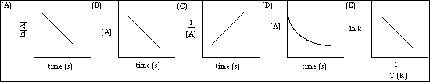

 |  |  |  | PLOT LABEL
 |  |  |  | A,B,C,D,E
The slope of the line tangent to the curve at t = 0 is the initial rate of the reaction. |  |  |  | D
The activation energy can be obtained from the product of the slope of the line and R. |  |  |  | E
The rate constant for a zero order reaction can be obtained from the slope of the line. |  |  |  | B
The rate constant for a second order reaction can be obtained from the slope of the line. |  |  |  | C
The rate constant for a first order reaction can be obtained from the slope of the line. |  |  |  | A
10) Given the following data for the upper atmospheric reaction of
NH + H₂ -> 2 NH₂ + H

NH | H₂ | Rate at 300K | Rate at 400K
0.0125 | 0.235 | 1.43E-16 | 9.62E-15
0.0250 | 0.470 | 5.71E-16 | 3.85E-14
0.0250 | 0.940 | 1.14E-15 | 7.70E-14
0.0125 | 0.470 | 2.86E-16 | 1.92E-14

What is the Rate Law of this reaction (including k’s)? (5pts )

Rate = k[NH][H₂]
k₃₀₀ = | 4.868E-14
k₄₀₀ = | 3.275E-12

What is the Activation Energy (E_{act}) for this reaction? (5pts)
Hint: Determine the Rate Constants FIRST for each temperature; k₃₀₀ = 4.9x10⁻¹⁴ what is k₄₀₀?

9.2 kJ 42.0 J 12.2 J 42kJ none

Ea = -R*ln(k₂/k₁)/( 1/T₂-1/T₁) = 42000 J/mole =42kJ/mole

E.C. What would be Initial Rate @ 350K for initial Concentrations of [NH]=0.05 M and [H₂]=0.94 M
Hint: First determine the Rate Constant at 350K (5pts) (No guesses, must see work!)

1.54E-13 2.53E-14 3.17E-15 7.81E-14 none
k₂(350)= k₁*exp[ -E_{a}/R( 1/T₂-1/T₁) ] = |  | 5.40E-13

Rate = 5.40E-13*0.05*0.94 = 2.538E-14

11) Which of the following forms of concentration would NOT be influenced by Temperature? (5pts)
- Molality b) Molarity
- Mole Fraction d) Parts Per Billion
e) Volume Percent f) Weight Percent

AND WHY? (5pts)

Volume which is related to the distance between molecules is influenced by the heat/temperature. The above are not influenced since they ONLY relate to ratios of mass!

