O-Phthalic Acid

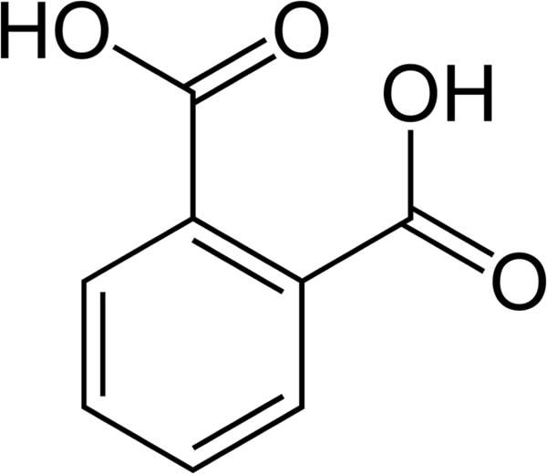
KHP (Potassium Hydrogen Phthalate)
is the first potassium salt of Phthalic Acid

o-Phthalic acid T(K)= 25, pKa(1) = 2.80 pKa(2)= 5.51.

