Pressure is the force acting on an object per unit area:

Gravity exerts a force on the earth’s atmosphere F= m*g
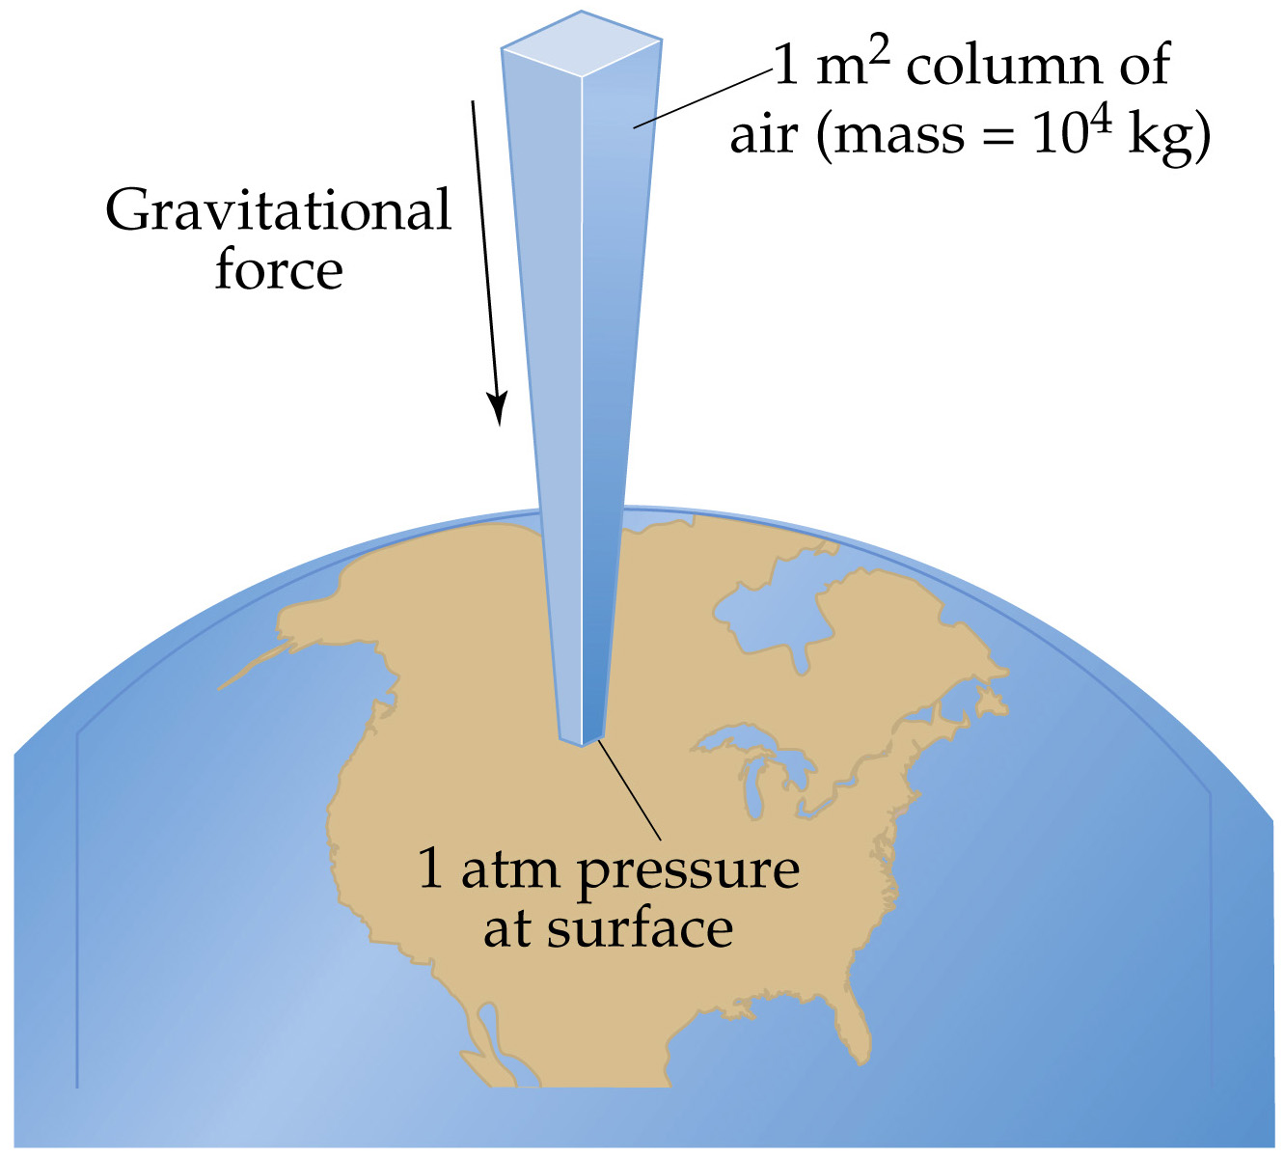
A column of air 1 m2 in cross section
exerts a Force:
F= 10⁴ kg*9.8m/s²≈ 10⁵ N.
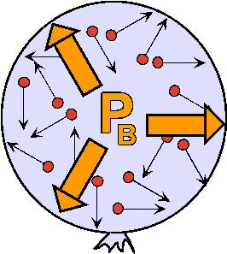
(10,340kg*9.8066m/s² = 1.0132 x 10⁵ N)

The Pressure of a 1 m2 column of air
is close to 10⁵ N/m² = 10⁵Pa =100 kPa.
(10,340kg*9.8066m/s² = 1.0132 x 10⁵ N)
P=F/A= 1.0132 x 10⁵ N/1m² = 1.0132 x 10⁵ Pa
But 1 bar = 10⁵ Pa thus P= 1.0132 bar

SI Units (mks; m, kg,sec)

F(Newtons) N m*kg/s²
P(Pascal) N/m² kg/m *s²
E(Joules) N m kg m²/sec²

Cgs Units (cm, g, sec)

F(Newtons) 10⁵ dyne cm*g/s²
P(Pascal) 10 poise g/cm *s²
E(Joules) 10⁷ erg g cm²/sec²

