Proper uses of lab equipment and equations

Learn the proper use of balance, buret, and other lab equipment. To make it clear at this point, your entire experiments (i.e. your grade) will be determined by how well you use the lab equipment. Some background information can be found on pages 29-46; 843-844 in your textbook.

Balances: The cardinal sin of quantitative lab is using your hands in weighing. Never, I repeat never and again never use your hands to transfer weighing bottles. Your hands contain grease and it will affect your weight. Use a strip of paper and the procedure shown by your TA. Weigh a weighing bottle together with a cap and separately. Compare their weights. Your results should be within 0.2 mg (0.0002 g). When weighing samples, weigh it on the analytical balance if it needs to be weighed to 0.1 mg, otherwise you may use the regular balance.

Glassware: Clean all glassware initially with soap and water at the beginning of the semester. After that, water should only be needed. After cleaning with regular water, rinse the glassware with small portions of distilled (DI) water. It is not necessary, and in fact wasteful to fill your glassware with DI water, 18 MΩ water, or your standard solutions just to rinse it. By using less to coat and rinse the glassware, you should not run out of standard solution and your TA will have more time to answer questions instead of always filling the DI water and 18 MΩ water containers. It is seldom necessary to dry the interior surface of glassware before use and may contaminate your sample. Just rinse with a small portion of the solution you will be placing into that vesicle before placing all of it into the vesicle.

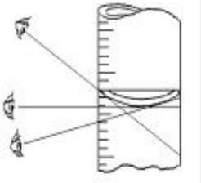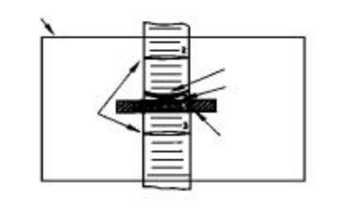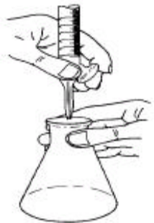
Figure 1: Effect of parallax Figure 2: Reading card in position Figure 3: Correct position
on reading buret. For titration

Buret :
Clean the buret using soap and brush. Rinse with DI water. If the buret is clean, no droplets will cling to the interior wall of the column. After cleaning the buret, no attempt should be made to dry the buret. The buret is simply rinsed several times with DI water and small portions of the standard solution. Use less than 10 mL when using the 50 mL buret for rinsing. Using more wastes chemicals and results in running out of solutions for the experiment. Learn to fill the buret without a funnel. Only use a beaker, while trying to minimize air bubbles forming. When taking readings on the buret, all air bubbles should be gone.

The surface of the liquid in the buret is concave up and is referred to as the meniscus. The bottom of the shaded portion of the meniscus is selected for reading. Parallax error can be fairly serious, but easily avoided. See Figure 1, in which the error produced by reading the meniscus from above and below is indicated but not greatly exaggerated. The markings on burets go all the way around the tube at one mL intervals and three-fourths around at 0.5 mL marks. There is really no excuse for making a parallax error. To take the initial reading, an index card or a white card may be placed behind the buret (Figure 2). Align the darkened line on the card with the bottom of the meniscus to make it easier to read the buret to the nearest 0.01 mL. When titrating, it is easiest to manipulate the stopcock from behind with the left hand, assuming you’re right-handed, then use the right hand to swirl the receiving flask while titrating (Figure 3).

Volumetric Flask
Volumetric flasks are calibrated to contain a particular volume when the bottom of the meniscus is adjusted to the center of the line on the neck of the flask (Fgure 4).

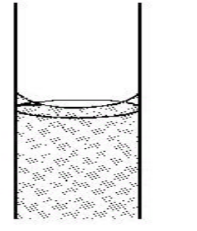

Figure 4: Where the
meniscus should be
on volumetric flask
and pipet.

Make sure you have the sample dissolved into solution before adding your liquid to the line. When the meniscus is approaching the line, use a Pasteur pipet to fill the flask to the line.

Do not go over the line, otherwise you will not know the correct concentration of the solution and should remake the solution.

Pipet:

Pipets are used for delivering known volumes of liquids.

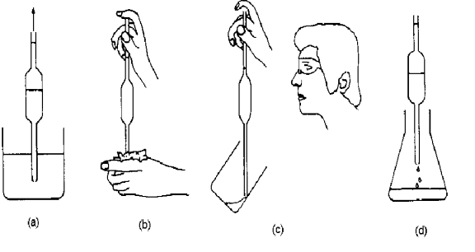

Figure 5: Correct procedure for using a pipet.

Use your bulb to draw up your solution after washing with water and rinsing with that liquid to a little over the calibration line (figure 5a). Remove the bulb and place your forefinger over the top to stop flow (Figure 5b). By moving/rocking your finger, you will be able to dispense liquid until it reaches the calibration mark (figure 5c). Then dispense the sample into your Erlenmeyer flask or beaker (figure 5d). Do not blow the last little bit out of the pipet. It is calibrated to contain a small amount in it while delivering the desired amount. When flow ceases, gently rest the tip against the side of the receiving container to receive the last little drop.
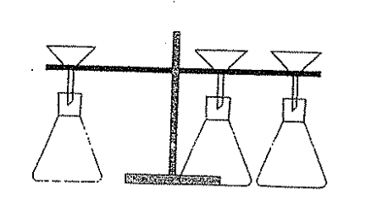

Figure 6: Filter apparatus setup

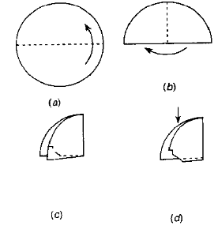
Figure 7: Folding filter paper

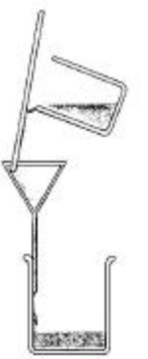
Figure 8: Filtering sample

Crucibles

Place crucible on a clay triangle attached to a ring stand (Figure 9). Place the lid on the crucible so that there is a small room for air to escape and also the lid does not become stuck on while the contents are oxidized. Heat the bottom of the crucible red hot for 15 minutes and place on wire gauze for 2 minutes before placing in desiccator. Let it cool to room temperature. When weighing crucible, if the weight is changing on the balance, it is not cool yet.

Filtering

Set up the filter apparatus as in Figure 6.

Take the filter paper (with these labs it is Whatman #42 ashless paper) and fold it in half, then in half again (Figure 7 a-c). Then tear off a corner to better seat the paper filter in the funnel (Figure 7d). You may elect not to tear a corner off. Open the side that was not torn and place it in the funnel. Then wet the filter paper with the DI water.

When filtering the precipitate, use a glass stirring rod to help pour sample into the filter paper (Figure 8). Rinse the stirring rod into the filter before setting it down so that all of the precipitate is transferred into the filter. Make sure not to let the solution level drop too far down the funnel/filter paper, if it does, you will lose sample through the paper when you pour more to filter.

Figure 9: Crucible on ring stand

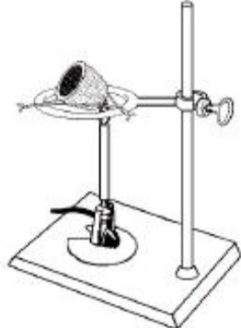

Ashing:

Flatten the filter paper cone (Figure 10a) and then fold in the two edges and then the top carefully in order not to loose sample (figure 10 b & c). The bottom of the filter paper cone is folded and then the paper is placed into the crucible (figure 10d). The crucible is then placed as illustrated (Figure 9). The tilted position allows for the ready access of air. A clean crucible cover should be located nearby, ready for use if necessary. Heating is then commenced with a small burner flame. The temperature is gradually increased as moisture is evolved and the paper begins to char. The smoke that is given off serves as a guide with respect to the intensity of heating that can be safely tolerated. Normally, smoke will appear in thin wisps. An increase in its volume indicates that the paper is about to flash. Heat should be discontinued if this condition is observed. If, despite precautions, a flame does appear, it should be immediately snuffed out with the crucible cover while removing the flame. Finally, when no further smoking can be detected, the residual carbon is removed by gradually increasing the flame. Strong heating, as necessary, can then be undertaken.

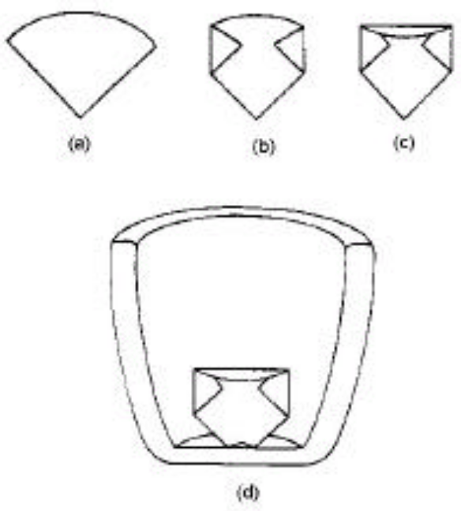

Figure 10: Fold and place filter
paper in crucible for ashing

ppt Equation:

To get the precision of the results, use the ppt equation to determine if the results are acceptable.

ppt = 1000* standard deviation/ mean = sd/ <x> where sd = √{ ∑(x_{i} - <x>)² / (n - 1)}

where n is the number of trials

Appropriate Amount Equation:

(Appropriate amount is the amount needed to do a titration that will not exceed the volume of your buret (in your case most likely 50 mL). Use the unknown wt. percentages given to you to calculate the appropriate amount. Then the weight is adjusted to get the volume of your standard solution used to between 35-45 mL. M_{ss} is molarity of standard solution and V_{ss} is the Volume of standard solution in liters.

Appropriate Amount (g)

= (MW of Unknown) x (Stoichiometric Ratio) x M_{standard} x V_{standard} x 100%
(Largest Weight % Possible)

Stoichiometric Ratio = Coefficient of unknown/Coefficient of Standard

Example for Experiment 1: (106) (1mole of Na₂CO₃/2moles Acid) (0.1M) ( 0.04L) X 100
50

Subsequent Adjusted Amount (g) = Actual Weight of First Sample x 40 mL
Volume in mL of Standard Solution

