KEY QUIZ NAME ___________________________

- Selecting from the choices offered, what is the most likely identity of "X" in the reaction
4Ga + 3X₂ ---> 2Ga₂X₃?

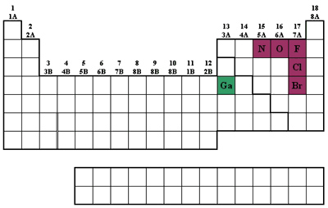
O₂ F₂ Br₂ Cl₂ N₂

2 Which of the following is a metalloid?
Ca S C I Te

3 In which list are all of the elements in the same group?
K, Ca, Sr B, Ga, Tl Ba, La, Hf N, O, F Ce, Pr, Nd

4 Electronegative character ________ from left to right across a period and ________ down a group of the periodic table.
increases, decreases increases, increases decreases, decreases

5 Which of the following metals would be least safe to drop into water?
Iron Lithium Potassium Aluminum Magnesium

6 Consulting Table suggest the missing properties of Francium?

TABLE: Properties of Alkali Metals
Name | Melting Point (°C) | Boiling Point  (°C) | Density (g/cm3) | 1st Ionization Energy | % Abundance on Earth | Atomic Radius Aº | Ionic (M+) Radius (Aº)
Lithium | 181 | 1342 | 0.53 | 520.2 | 0.0020 | 1.52 | 0.68
Sodium | 98 | 883 | 0.97 | 495.8 | 2.36 | 1.86 | 1.02
Potassium | 63 | 760 | 0.86 | 418.8 | 2.09 | 2.27 | 1.38
Rubidium | 39 | 686 | 1.53 | 403.0 | 0.009 0 | 2.48 | 1.47
Cesium | 28 | 669 | 1.87 | 375.7 | 0.000 10 | 2.65 | 1.67
Francium | 26 | 660 | 2.0 | 360 | Trace | 2.8 | 1.8—
7. Which element has the greatest nonmetallic character?
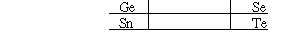
Sn Ge Te Se

8 Which of the following is the least reactive?
Sr Ba Mg Ca Na

9. Which of these elements has the highest first-ionization energy?
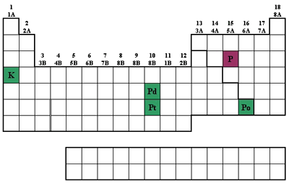
palladium platinum polonium potassium phosphorus

10 In which choice below are the elements ranked in order of increasing first-ionization energy?
Ar, Cl, S, Si, Al Al, S, Si, Cl, Ar
Al, Si, S, Cl, Ar Cl, S, Al, Ar, Si

11 Which of the following has the most negative electron affinity?
Na I Se Ar Cl

12 Arrange the following atoms in order of increasing atomic radius: N, K, As, Fr
N < As < K < Fr Fr < K < As < N
As < K < N < Fr N < K < As < Fr

13 In which atom do we find the largest occupied 3d orbital?
Ga Ca Al As Mg

14 Which of the following sets of elements is arranged in the correct order of decreasing ionization energy (highest energy first, etc.)?
K, Na, Li Rb, K, Ca As, S, F Cl, Br, I Sb, Te, I

15 Which of the following is the largest atom?
Mg Ca Al Sr B Rb

16 Which of the following sets of elements is in the incorrect order of increasing atomic radius (smallest one first, etc.)?
Se, As, Sb Cl, S, O Cl, Br, I P, Si, Al S, As, Sn

17 Which of these elements has the highest second-ionization energy?
Polonium Palladium Platinum Phosphorus Potassium

- Show the electronic configuration of Fe⁰ , Fe(II) and Fe(III) and why is Ferric more stable?

[Ar] 3d⁶ 4s² [Ar] 3d⁶ 4s⁰ [Ar] 3d⁵ 4s⁰ Ferric (Fe⁺³) has a half filled d-shell which is energetically favorable

19-20) Which fourth shell transition metal has

a) the most possible oxidation states Mn
b) has only ONE possible PLUS TWO oxidation state and what is the electronic config Zn
c) has a PLUS ONE OXIDATION state but the PLUS TWO is more stable Cu
d) has only ONE possible PLUS THREE oxidation state and what is the electronic config Sc
 | Sc | Ti | V | Cr | Mn | Fe | Co | Ni | Cu | Zn
OXIDATION  STATE | [Ar] 3d¹ 4s² | [Ar] 3d² 4s² | [Ar] 3d³ 4s² | [Ar] 3d⁵ 4s¹ | [Ar] 3d⁵ 4s² | [Ar] 3d⁶ 4s² | [Ar] 3d⁷ 4s² | [Ar] 3d⁸ 4s² | [Ar] 3d¹⁰ 4s¹ | [Ar] 3d¹⁰ 4s²
1 |  |  |  |  |  |  |  |  | d¹⁰
2 |  |  | 4s⁰d³ |  | 4s⁰d⁵ | 4s⁰d⁶ | 4s⁰d⁷ | 4s⁰d⁸ | 4s⁰d⁹ | d¹⁰
3 | 4s⁰d⁰ |  |  | 4s⁰d³ |  | 4s⁰d⁵ | 4s⁰d⁶
4 |  | 4s⁰d⁰ |  |  | 4s⁰d³
5 |  |  | 4s⁰d⁰
6 |  |  |  | 4s⁰d⁰
7 |  |  |  |  | 4s⁰d⁰

