KEY GROUP QUIZ 1

1) What are the TWO major chemical driving forces in nature?
Enthalpy (ΔH) and Entropy (ΔS)

2) What equation defines whether a reaction CAN or CAN NOT take place. What is required of this equation? ΔG =ΔH-TΔS ΔG must be negative for the reaction tend in THAT direction

3) Define the THREE major components which define the Enthalpy of Dissolution for a salt. Also define the typical SIGNS for each these processes?
ΔHsolution = Δ_{Hsolute-solute} + Δ_{Hsolvent-solvent} + ΔH_{solute-solvent} First two relate to breaking intermolecular forces and are positive while the third is negative. These tend to roughly cancel each other out with typically an overall slightly positive resultant ➔ endothermic

4) If the NET Enthalpy as defined above is POSITIVE, the reaction is said to be
Endothermic ; that is the reaction absorbs heat to/from the environment.

5) If the NET Enthalpy is positive then why might a sold/salt still dissolve?
Entropy will overwhelm enthalpy thus resulting in a negative ΔG

6) Using Henry’s Law:
K Gases dissolved in water at 298K
Oxygen (O₂) | 769.2 L•atm/mol
Carbon dioxide (CO₂) | 29.4 L•atm/mol
Nitrogen (N2) | 163.9 L•atm/mol
hydrogen (H₂) | 1282.1 L•atm/mol

Assume that the molar ratio of N₂ to O₂ is 79/21; what is the partial pressure of both gases at 5.1 atm and what would be the solution pressures of each gas
p_{N2} = 5.1*0.79 = 4.03 atm using p=kc c = 4.03/163.9 c c = 0.0246M
p_{O2} = 5.1*0.21 = 1.07 atm using p=kc c= 1.07/769.2 c c = 0.00319M

7) In a laboratory experiment, students synthesized a new compound and found that when 15.0 grams of the compound were dissolved to make 320.0 mL of a chloroform solution, the osmotic pressure generated was 4.20 atm at 298 K. The compound was also found to be nonvolatile and a non-electrolyte.
What is the molecular weight they determined for this compound?
8) The solvent for an organic reaction is prepared by mixing 30.0 ml of acetone (C₃H₆O) with 40.0 ml of ethyl acetate (C₄H₈O₂). This mixture is stored at 28.0 C. The vapor pressure and the densities for the two pure components at 28.0 C are given in the following table. What is the vapor pressure of the stored mixture?
Compound | Vapor pressure  () | Density  ()
Acetone | 230.0 | 0.791
Ethyl acetate | 95.38 | 0.900

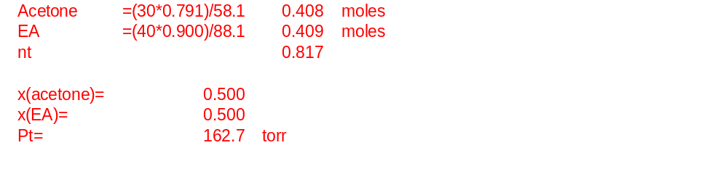

9) An aqueous solution is 6.00% by mass ethanol, CH₃CH₂OH, and has a density of 0.988 g/mL.
The Molality and Molarity of Ethanol in the solution is

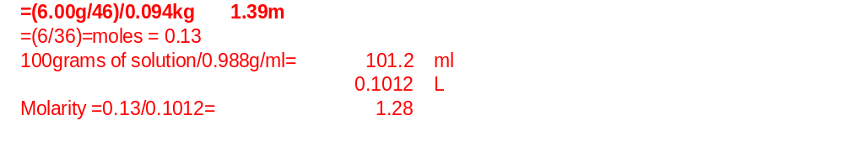
10) The diagram below shows the total vapor pressure at 25C for a mixture of diethyl ether (b.p. 34.6°C) and ethyl alcohol (b.p. 78.3°C), as calculated from the vapor pressure curves of the individual substances?
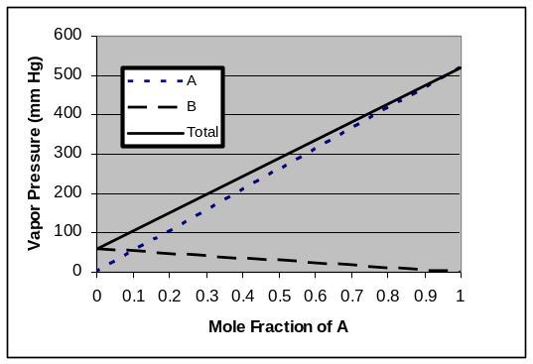
What are the vapor pressures for ethyl alcohol and diethyl ether at 25 C?
What is the vapor pressure of ethyl alcohol at 78.3ºC
Why does the vapor pressure of the B line go down

