QUIZ 3
Name: Print ______________________ Sign_______________________________

- Describe in DETAIL the Oxidation/Reduction Reaction in which Iron is oxidized into Rust. Show the balanced reaction and show what is being oxidized and what is being reduced. Further show the movement of electrons.
4 Fe + 3 O₂ –^{12e}---> 2 Fe₂O₃
4{ Feº ➔ Fe⁺³ + 3e } Oxidation with Fe being the reducing agent
3{ O₂ + 4e ➔ 2 O⁻² } Reduction with O2 being the oxidizing agent
SOLUBILITY TABLE:
s=Soluble ss= Slightly Soluble i=Insoluble d= decompose n= not found

 | NO₃- | acetate |  | Cl⁻ | Br | I |  | SO₄ | S⁼ | CO₃ | PO₄ | OH⁻ |  | CrO₄
NH₄ | s | s |  | s | s | s |  | s | s | s | s | s |  | s
Na | s | s |  | s | s | s |  | s | s | s | s | s |  | s
K | s | s |  | s | s | s |  | s | s | s | s | s |  | s
Ba | s | s |  | s | s | s |  | i | d | i | i | s |  | i
Ca | s | s |  | s | s | s |  | ss | d | i | i | ss |  | s
Mg | s | s |  | s | s | s |  | s | d | i | i | i |  | s
Sr |  |  |  |  |  |  |  | i
Al | s | ss |  | s | s | s |  | s | d | n | i | i |  | n
Pb | s | s |  | ss | ss | ss |  | i | i | i | i | i |  | i
Cu | s | s |  | s | s | n |  | s | i | i | i | i |  | i
Fe(II) | s | s |  | s | s | s |  | s | i | i | i | i |  | n
Fe(III) | s | s |  | s | s | n |  | ss | d | n | i | i |  | i
Hg(I) | s | ss |  | i | i | i |  | ss | i | i | i | n |  | ss
Hg(II) | s | s |  | s | ss | i |  | d | i | i | i | i |  | ss
Ag | s | ss |  | i | i | i |  | ss | i | i | i | n |  | ss
Zn | s | s |  | s | s | s |  | s | i | i | i | i |  | s

2) Which of the following Reactions will occur, and then balance:
a) Sodium Phosphate and Lead Nitrate
2 Na₃PO₄ + 3 Pb(NO₃) ₂ ➔ Pb₃ (PO₄) ₂ + 6 NaNO_{3 (Aq)}

b) Potassium Carbonate and Silver Acetate
K₂CO₃ + 2AgAc ➔ Ag₂CO₃ +2 KAc _{(Aq)} ( But AgAc is slightly soluble so reaction will be hindered)

c) Magnesium Sulfate and Sodium Chromate
MgSO4+ NaCrO₄ ( No reaction since both MgCrO4_{(aq)} + NaSO_{4(aq)} are soluble
d) Barium Carbonate and Ammonium Chloride
BaCO₃ (INSOLUBLE) plus possible products are soluble - No Reaction

e) Soluble Sodium Carbonate is mixed with Nitric Acid
Na₂CO₃ + 2HNO₃ ➔ 2NaNO3 + H₂O + CO₂(g)

3) How could one separate a solution that contained Al, Ag and Ba?

Add Chloride to precipitate AgCl, leaving Al and Ba in solution, then precipitate Al as Al(OH)3 leaving Ba in solution. Ba could be then precipitated with Sulfate if you wish.

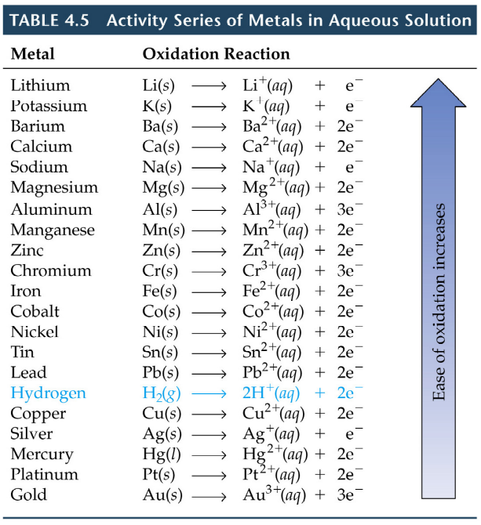

3) A sample contains metallic Zinc, Tin and Copper. Which metals will react with Acid

Zn and Sn will react with acid but NOT Copper

4) You are given Ca, Al and Ni as well as solutions containing the chlorides of each of these metals. Show ALL THREE of the possible BALANCED reactions and the total ionic reactions.

3Ca + 2Al⁺³ ==6e➔ 3 Ca⁺² + 2Al

Ca + Ni⁺² ==2e➔ Ca⁺² + Ni

2Al + 3Ni⁺² =6e= 2Al⁺³ +3Ni

- What are the oxidation numbers for the elements in the following molecules:
P₂O₅ SO₂ KMnO₄ N₂O NO₂

P=+5 S=+4 K=+1; Mn=+7 N=+1 N=+4

