Discussion Quiz 2B NAME _______________________________
GRADE____
- The Henry constant for hydrogen cyanide is 1.35 x 10⁻² mol/(V*atm). At what partial pressure (in torr) would the blood pressure of this gas equal a fatal level of 1 micro-molar? (Assume blood is solely water) Thus what would happen

1.35E-2 *P= 1.0E-6 = 7.41E-5 atm or 0.0119 torr

- 10 grams of sodium chloride are added to 90 grams of water. What is the percent weight of salt? The density of solid salt is 1.25 g/cc and the final density of the above solution is found to be 1.0726. What is the volume of the solution before and after mixing the components? What is the molality and molarity of the solution?
10 grams of Salt(58.44) |  | 1.25 g/cc | 8.00 | ml | 98.0 ml total before mixing
100 grams of solution |  |  | 93.23 | ml
90 grams of water
Molality = | 0.171 | moles/ | 0.09 | kg/water= | 1.901
Molarity= | 0.171 | moles/ | 0.093 | L | 1.835

3). Calculate the SOLUBILITY of N₂ (~80%) and O₂ (~20%) in the blood at sea level and then at 130 ft given that K_{f} for oxygen and nitrogen gases have value of 1.30 x10⁻³ and 6.10 x10⁻³ mole/(L*atm) respectively.

Depth (feet) sea/fresh water |  | Atm. |  | PSI |  | Density
33/34 |  | 2 |  | 29.4 |  | 2x
66/68 |  | 3 |  | 44.1 |  | 3x
99/102 |  | 4 |  | 58.8 |  | 4x
132/136 |  | 5 |  | 73.5 |  | 5x
 | (Mole/L/)atm |  | P=1 atm |  | P=5 atm
 | K_{f}
O₂ | 1.30E-03 |  | 2.60E-04 M |  | 1.30E-03M
N₂ | 6.10E-03 |  | 4.76E-03M |  | 2.38E-02M
- In a laboratory experiment, students synthesized a new compound and found that when 15.0 grams of the compound were dissolved to make 320.0 mL of a chloroform solution, the osmotic pressure generated was 4.20 atm at 298 K. The compound was also found to be nonvolatile and a non-electrolyte.
What is the molecular weight they determined for this compound?

5) The diagram below shows the total vapor pressure at 25C for a mixture of diethyl ether (b.p. 34.6°C) and ethyl alcohol (b.p. 78.3°C), as calculated from the vapor pressure curves of the individual substances?

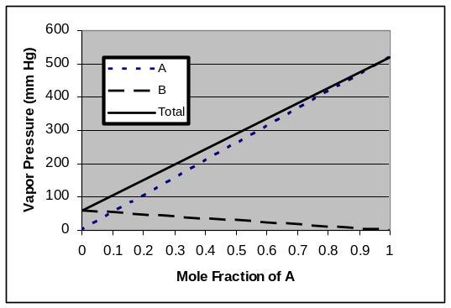

What are the vapor pressures for ethyl alcohol and diethyl ether at 25 C?

What is the vapor pressure of ethyl alcohol at 78.3ºC

Why does the vapor pressure of the B line go down

