1) The action of bacteria on protein produces, among other things, a compound called Cadaverine. As you might surmise from its name, it’s not pleasant smelling. It’s composition is 58.77% C; 13.81% H and 27.42% N? What is its Empirical Formula? If the molar mass (molecular weight) of the compound were approximately 102 what would be the Molecular Formula?

Element | Percent | Moles/100g | Ratios | Integer Ratios
C | 58.77 | 4.893 | 2.500 | 5 | 60.055
H | 13.81 | 13.702 | 6.999 | 14 | 14.1106
N | 27.42 | 1.958 | 1.000 | 2 | 28.014
 | 100 |  |  |  | 102.1796
 | Empirical Formula |  | C₅H₁₄N₂
 | EF(MW)= | 102.18 thus this is also molecular weight
2) Consider the COMBUSTION of Octane (C₈H₁₈) [A component of Gasoline] in an EXCESS of oxygen gas: (MW=114.228)
- Write the Balanced Equation for this reaction.

2C₈H₁₈ + 25 O₂ → 16 CO₂ + 18H₂O

- In the combustion of 57.1 g of Octane how many GRAMS of water and carbon dioxide would be generated.
MW= | 114.22
moles = | 0.50 | Octane
 | 0.050 moles of Octane | * [16 moles CO2] | = | 4.0 | moles of CO2
 |  | 2 moles of Octane
 | 0.050 moles of Octane | * [18 moles H2O] | = | 4.5 | moles of H2O
 |  | 2 moles of Octane

- The ΔH_{rxn} for this reaction is 2633 kcal. How much heat would be generated in kJ.

-2633 kcal | 4.1868kJ |  | -11023.8 | kJ
 | 1 kcal
-11,023 kJ | 0.50 moles of Octane |  | = | -2755.8 | kJ
 | 2 moles of Octane

- How many killojoules would are generated per mole of Octane (kJ/mole)

-11,023 kJ | 1.0 moles of Octane |  | = | -5511.9
 | 2 moles of Octane

- If the density of Octane is 0.702 g/ml, how much energy(heat) in kJ/ml will be released? (extra credit)
-5511.9 kJ/moles of Octane | 1 mole of Octane | 0.702 grams of Octane | = | -33.87 |  | kJ/ml
 | *114.228 grams of Octane | *1.0 ml of Octane

- Consider the COMBUSTION of C₂H₅OH (Ethanol); a so-called cost efficient additive to gasoline. (MW=46.06)
  - Write the Balance Equation for this reaction.

C₂H₅OH + 3 O₂ → 2 CO₂ + 3 H₂O

  - If 13.82 grams of ethanol and 14.4 grams of oxygen gas are mixed. How much Ethanol will react?
 | MW | moles
O2 | 32 | 0.450
C₂H₅OH | 46.07 | 0.300
 |  | 0.300 moles of Ethanol x | 3 moles of O2 | 0.900 | moles requires |  | Not enough O2 == LIMITING
 |  |  | 1 mole of Ethanol |  |  |  | ALL O2 will be used up
 |  | 0.450 moles of O2 | 1 moles of Ethanol used |  | = | 0.15 | moles Ethanol used
 |  |  | 3 moles of O2 |  |  | 0.15 | moles Ethanol left

  - How many grams of CO₂ would be generated.
0.450 moles of O2 | 2 moles of CO2 generated |  | = |  | 0.30 | moles
 | 3 moles of O2
0.30 moles CO2 * | 44.011 g/mole= |  |  |  | 13.203 | grams of CO2

  - The ΔH_{rxn} for this reaction is 30.54 kJ/g for ethanol. How much heat is generated?

0.15 moles of Ethanol * | 46.07 g/mole * | 30.54 kJ/g for Ethanol | -211.05 | kJ

  - If the density of ethanol is 0.79 g/ml. How much energy is for Ethanol in kJ/ml? How does this compare with Octane and what does it infer?

30.54 kJ/g for Ethanol | 0.79 gram of Ethanol/ml |  |  |  | = | -24.13 | kJ/ml
 | Octane ====> |  |  |  |  | -33.87 | kJ/ml
Ethanol about 50% less effective than Octane

4 ) One gives you a 1M solution of Ammonium Sulfate. How would you prepare a 1L solution of 0.15 M solution? (15 points) What could be the concentration of the solution with regard to both Ammonium and Sulfate? (5 points)
1M x V = 1L X 0.15M
V= | 0.15 | Liters
Thus one introduces 150 ml of 1.0 M (NH₄)₂SO₄ into 1L volumetric and then fill to line ( 1L total solution)
[NH₄⁺] = | 0.30 M
[SO₄⁻²] = | 0.15 M
********** THIS PROBLEM WAS WRONG ON THE QUIZ ********
5) If 72.9 milligrams of HCl was dissolved in 100 ml of water. (20 points total) (MW=36.46) (20 points)
a) What would be the Molarity of the solution
b) What would be the pH of the solution
Now if 50 ml of a 0.02M solution of KOH where added to this solution:
c) Show the reaction for this process
d) What would be the final pH of this solution?

moles of HCl= g/MW | 0.002 | moles
Molarity {HCl }=moles/liters= [HCl] = [H+] = [H3O+] | 0.020 | M
pH = -log([H3O+]) | 1.70
HCl + KOH ==> H2O + KCl
0.05L * 0.02 M KOH = | 0.001 | moles of KOH which will neutral same amount of Acid
Remaining Acid = 0.002- 0.001= | 0.001 | moles of acid
Molarity HCl = 0.000/0.2 | 0.005
pH= -log[H3O+} = -log( 0.018) = | 2.30

NOTE: If the base or acid is dibasic or a di-protonic source you need to multiple the moles of acid by the number of this number: ie 0.1M H₂SO₄ = 0.2M [H₃O⁺] and 0.4moles of Ba(OH)₂= 0.8moles of OH⁻

6) Why is the pH of a NEUTRAL SOLUTION of water equal to 7? Show the mathematical relationship associated with the dissociation/equilibration of water. Define what pH, pOH, Kw and their interrelationships are. (10 points)

H₂O <==> H⁺ + OH⁻ or
2H₂O <==> H₃O⁺ + OH⁻
There is always an equilibrium between molecular water and hydronium/hydroxide formation
K_{w} = [ H₃O⁺][OH⁻] = which is equal to 1.0 x 10⁻¹⁴ at 25 C
(K_{w} )= [ H₃O⁺][OH⁻] =1.0 x 10⁻¹⁴
take - log of both sides giving
pK_{w} = pH + pOH =14
where pH = -log([H₃O⁺])
pOH = -log([OH-])
pK_{w} = -log(K_{w})

- Discuss the four(4) major categories of Reactions and what DRIVING forces are in play in such reactions. (10 points)

There are THREE subcategories of mechanisms by which ions can be removed from solution and thus drive a metathesis reaction? The driving force for metathesis reactions is the removal of ions from solution
1. Certain ions can associate to form an insoluble precipitate (as with the formation of AgCl(s))
2. Certain ions can chemically combine to form a neutral molecular compound (resulting in either a non-electrolyte, or a weak electrolyte).
  - Acid/base neutralization reactions that produce water from H⁺ and OH⁻ ions are an example of this.
  - Being a non-electrolyte (or weak electrolyte) the formation of the molecular compound from the constituent ions is essentially an irreversible process

A+ + Y- ➔ AY
IONS MOLECULE
3. Certain ions can chemically combine to form a gas, and the gas physically escapes from the solution
Forth Category of Reactions is OXIDATION REDUCTION REACTIONS: A reaction that involves transfer of electrons from one substance to another. Redox reactions always involve a change in oxidation number for at least two elements in the reactants

8) An Unknown Compound has the following Properties: (20 points)

C_{p}(Solid) | 1.51 J Gram⁻¹ K⁻¹
C_{p} (Liquid) | 5.09 J Gram⁻¹ K⁻¹
C_{p} (Vapor) | 2.43 J Gram⁻¹ K⁻¹
ΔH(Fusion) | 11.65 kJ Moles⁻¹ K⁻¹
ΔH(Vaporization) | 212.42 kJ Moles⁻¹ K⁻¹
Molar Mass | 35.23
Melting Point | 35.0 ºC
Boiling Point | 185.2º C

a) How much Heat would be required to raise the Material from 25 º C to 100º C
b) How much additional energy would be required to raise the temperature to 200º C

Assume ONE GRAM of Material or better determine per gram
25ºC below MP thus it is a solid
100ºC below boiling pt but above MP
Solid from 25-35.0 C | C_{p}(solid)*m*ΔT | 15.10 | J/g
Solid ==Liquid | ΔH(fusion)* (mole/grams) | 330.68 | J/g
Liquid from 35-- 100 | C_{p}(liquid)*m*ΔT | 330.85 | J/g
TOTAL (a) |  | 676.63 | J/g
Liquid 100 -- 185.2 C | C_{p}(liquid)*m*ΔT | 433.668 | J/g
Liquid == Vapor | ΔH(vap)* (mole/grams) | 6029.52 | J/g
Vapor from 185.2 to 200 | C_{p}(vapor)*m*ΔT | 35.964 | J/g
Total (b) |  | 6499.152 | J/g

9) Discuss the Definition of Enthalpy as it Relates to Internal Energy. Show this BOTH graphically and mathematically. Define the Gibbs Free Energy and discuss the TWO primary chemical driving forces in nature. ( 20 points)

H= E+pV
Where H is the Enthalpy
E is the Internal Energy which is the sum of kinetic and potential energies of molecules

P is the pressure and V is the volume
W= work is defined as – pΔV

Internal Energy can be distributed as Q(Heat) + W(Work)

ΔE = Q + W

When Constant P then ΔH = ΔE+pΔV= Q+W + pDV = Q + -pΔV + pΔV = Q
Thus ΔH= Qp

When Constant V: there can be no work so ΔH= ΔE

Now there are two driving forces the first is ENERGY associated with ΔH (Enthalpy)
and the second is DISORDER associated with ΔS(Entropy)

A Negative ΔH corresponds to energy being released in the reaction ➔ EXOTHERMIC
A Positive ΔH corresponds to energy being absorbed in the reaction ➔ ENDOTHERMIC

A Positive ΔS corresponds to an increase in Disorder (Generally Favorable)
A Negative ΔS corresponds to an increase in Order (Not generally favorable)

These two driving forces combine to determine a state function ΔG (Gibbs Free Energy)

ΔG = ΔH –TΔS where T is temperature in K

If ΔG is NEGATIVE the reaction is called SPONTANEOUS and goes in the direction defined
If ΔG is POSITIVE the reaction is NON-SPONTANEOUS and does not go forward in fact if it could it would actually prefer to go in the opposite direction
If ΔG is ZERO the reaction is defined as being at EQUILIBRIUM

10) 1.50 grams of Glucose C₆H₁₂O₆ is burned in constant high pressure calorimeter. The experiment rises the temperature of the system from 21.35ºC to 28.10 ºC. The calorimeter contains 600 grams of water which has a specific heat capacity of 4.184 J/(g *K) and the bomb has an overall heat capacity of 942 J/K. What is the ΔH_{rxn} for Glucose? (10 points)

ΔH_{rxn} = [C_{p}(H₂O) x m(H₂O) + C_{p}(Bomb) ] * ΔT
ΔH_{rxn} = [4.184* 600+ 942] * 6.75K | 23303.7 | J | per 1.5 grams of Glucose
 | 15535.8 | J/g | Glucose
 | MW= 6*12.011+12*1.0067+6*15.999
 | 180.14
 | 2798.6 | kJ/moles Glucose

11) Using this Table (20 points)

Standard Molar Enthalpies of Formation
ΔH_{f}º ( CO₂) | -393.51 kJ/mole
ΔH_{f}º ( H₂O) | -285.83 kJ/mole
ΔH_{f}º (C₄H₉OH) | -104.7 kJ/mole
a) Write down the balanced reaction for the combustion of Butanol (C₄H₉OH).

C₄H₉OH + 6 O₂ → 4 CO₂ + 5 H₂O

b) Draw an Energy Level Diagram to illustrate the ΔH_{rxn} for this reaction illustrating their relative energies to each other and to their elemental sources. (Shown for Propane NOT Butanol))

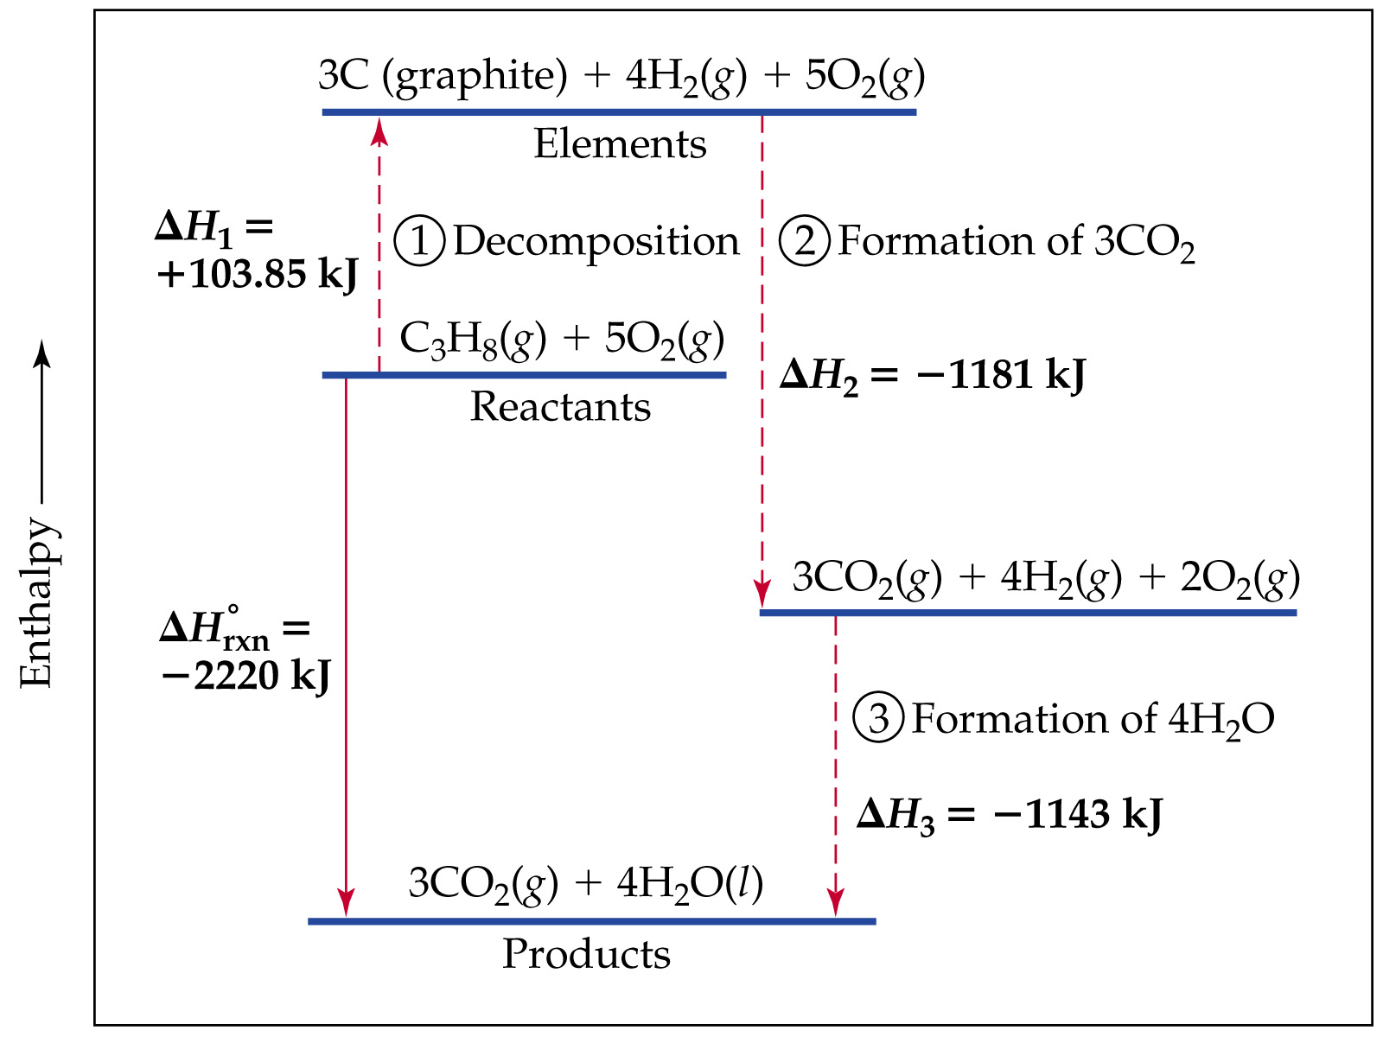

- Use Hess Law to show the elemental reactions associated with this net reaction.

C₄H₉OH ➔ 4C_{(s)} + 5H₂ +1/2 O₂ ΔH_{f} (C₄H₉OH) = +104.7 kJ
4C + 4O₂ ➔ 4CO₂ ΔH_{f} (CO₂) = 4*(-393.51)= -1574.0 kJ
5 H₂(g) + 5/2 O₂ ➔ 5 H₂O ΔH_{f} (H₂O) = 5*(-285.83) = -1429.2 kJ
___________________________________________________________________________
C₃H₈ + 6O₂ ➔ 4CO₂ + 5H₂O ΔH= - 2898.5 kJ

- Calculate ΔH_{rxn} directly from the standard molar enthalpies for the reactants and products.

ΔHº_{rxn} = 5*(-285.83 kJ)+4*(-393.51kJ) - [(-104.7kJ) – 6(0)] = -2898.5 kJ
