Quiz 3 (Chem 101)
NAME: Print__________________________ Sign_________________________

Select THREE(3) of the following 5 problems

Describe the THREE (3) types of Metathesis Reactions and give on example of each category. Further why do these reactions actually take place?

A+B➔ GAS + D

A+B ➔ Precipitate +D

A+ B ➔ Non-Electroylte +D

HCl + NaOH == H₂O + NaCl

In each case one of the products is removed from the reaction system thus pulling the reaction to the Right(Product) this resulting in a real reaction

Describe in DETAIL the Oxidation/Reduction Reaction in which Iron is oxidized into Rust. Show the balanced reaction and show what is being oxidized and what is being reduced. Further show the movement of electrons.
4 Fe + 3 O₂ –^{12e}---> 2 Fe₂O₃
4{ Feº ➔ Fe⁺³ + 3e }
3{ O₂ + 4e ➔ 2 O⁻² }
You are given a 3.000 M Solution of Sodium Sulfite and asked to make up a 0.1M Solution in Sodium. Show how you would accomplish this

3.0M Na₂SO₃ = 6.0M [Na⁺]
M_{i}V_{i} =M_{f}V_{f}

2*3.0 x V = 0.1 x 1.0 Liter
V=0.0166L = 16.7 ml

How many grams of Silver Nitrate would you need to generate 3L of a 2.5M solution in Silver Ion.

2.5 = (#g/169.89) / 3L ➔ #g = 2.5*3L*169.89 = 1,274.2 g AgNO₃

How many mls of 0.25M H₂SO4 solution would you need to neutralize 15ml of a 0.4M Solution of NaOH?

H₂SO₄ + 2NaOH == 2H₂O + Na₂SO₄

0.4M*0.015L = 0.006 moles of NaOH

0.006 moles of NaOH (1mole H₂SO₄/ 2 moles of NaOH) = 0.003moles of H₂SO₄

0.003moles of H₂SO₄ = 0.25M x V

V= 0.012 L ➔ 12ml

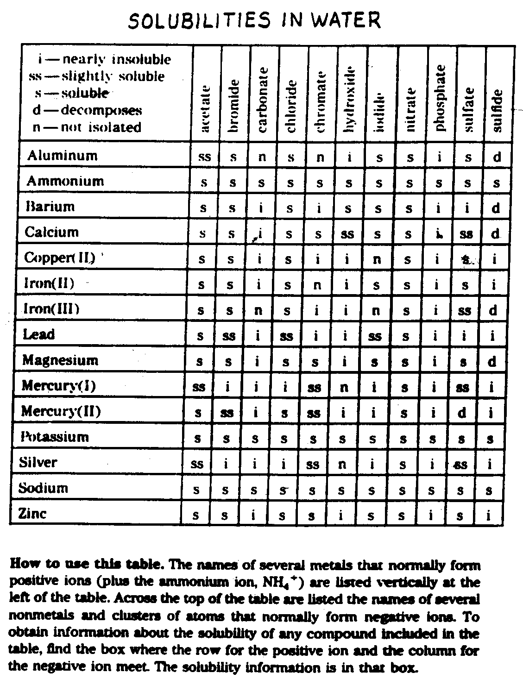

Given this Table of Relative Solubilities, Discuss how one could separate and/or identify a solution suspected to have Cu⁺², Ba⁺² and Ag⁺? (More than one way)

1) Add Br and Precipitate Ag
2) Add OH and precipitate Cu
3) Ba remains in solution

