KEY QUIZ 3 NAME _____________________________
July 11,2007

- 0.4moles of AlCl₃ (133.3)are dissolved (and dissociates) WITH 800 ml of water
resulting in density of 1.12 g/ml(40 pt)

- If the vapor pressure of pure water at 55 C is 67.2 torr what is the vapor pressure of the above AlCl₃ solution?
n_{a} | 44.44444444 | moles H2O
n_{b} | 0.4 | moles of AlCl3
 | i= | 4
X_{a}=na/(na+i*nb)= |  | 0.965251
P_{a}=X_{a}P_{a}⁰ | =0.9653*67.2= | 64.9 | torr

- What is the molality and Molarity(tricky) of the solution?
molality= #moles AlCl3/#kg H2O
molality= 0.4/0.8= |  | 0.5 m
Total grams = AlCl₃+ H₂O= 0.4*133.3 + 800= |  |  |  | 853.32 | g
Density= 1.12 g/ml so divide mass by density to get volume
Volume Solution = |  | 761.9 | ml
 |  | 0.762 | L
MOLARITY = moles/Vol= |  | 0.4/0.762 | 0.525 | M

- What would be the Osmotic Pressure of this solution at 75 C?

Π = i MRT = 4* 0.525*0.0821*(273+75)= 60.0 atm

- What would be the effect (quantitatively) on the freezing point of water K_{f}=1.86

ΔT = i K_{f} m = 4* 1.86*0.5= 3.72 thus T_{new} = -3.72 ºC

2) If a salt’s solubility decreases with increasing temperature, what does that tell us about the thermodynamics (free energy etc) of the system? (10 pts)

Normally the main driving force of dissolution of solids into solution is S; normally increasing the temperature would drive the reaction to greater solubility
ΔG =ΔH-TΔS

unless the reaction is already driven by it being also exothermic then increasing the temperature pushes the reaction back.
Then Salt + Water ⬅ Solution + HEAT
3) Kinetics Review (50pts)

- Write the dissociative reaction of N₂O₅ into NO₂ and O₂; if this reaction is found to be first order.

2N₂O₅ == 4 NO₂ +O₂

- Write the Rate Law for the Reaction

Rate = Δ[N₂O₅ ] / Δt = d[N₂O₅ ] / d t = - k [N₂O₅ ]

- What would be the Equation to describe the Concentration of N₂O₅ with time

[N₂O₅ ](t) = [N₂O₅ ](t=0) * exp( - kt)

- Draw a graph showing how the raw data would look and also how could the raw data be REPLOTTED (transformed) to extract the rate constant.

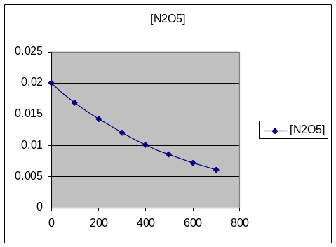

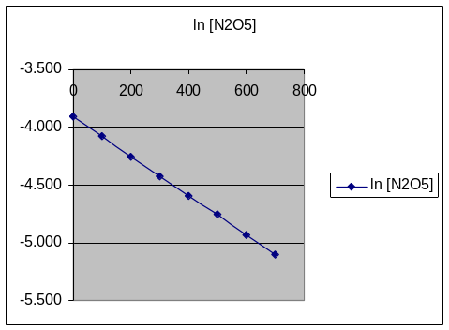

- Why does the order of the reaction have nothing to do with the stoichometric coefficients for the Net Equation.

The stoichometric coefficients relate to the NET reaction; the total and overall process. However the rate of the reaction is determined by the slowest fundamental/primary/elemental reaction called the Rate determining Step.

