Quiz 6: KEY Name ____________________________________

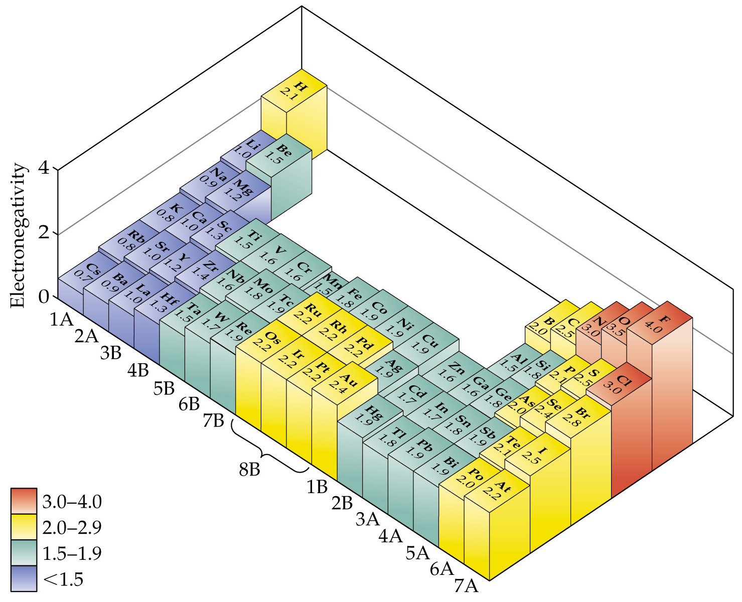

Using the Table Above.

1) Define the type and polarity of the following BONDS: CH, SrI, NO, CN, OH, and CuF

CH 0.4
SrI 1.5 ( polar nearly ionic)
NO 0.5 (slightly polar)
CN 0.5 (slightly polar)
OH 1.4 (polar)
CuF 2.1 (ionic)

2)Compare the atomic radius of the neutral elements and their electronegativity

Electronegativity increases as the atomic radius becomes smaller. It is greatest in Upper Right (smallest radius) and least in the Lower Left(radius is largest)
3)Draw the Lewis Dot Structures for the following Molecules

CO₂ N₂

(4nbe)O::C::O(4nbe) :N:::N:

NO₃⁻ SO₄⁼

3 Resonant Structure
2 single NO bonds with 6 nb on O e plus 4 single SO bonds with 6 nb electrons on each O
One double bond(4e) and 4nb e on O

4)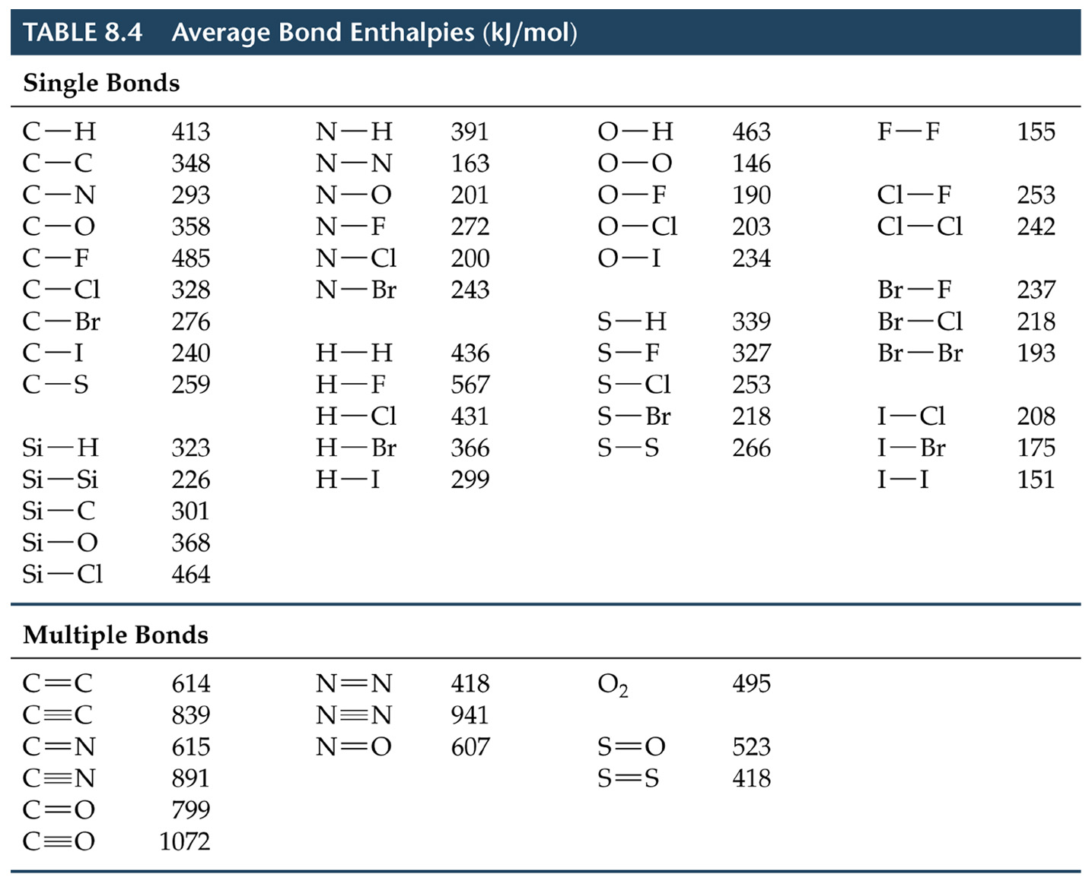
Using the Above Bond Enthalpies. What is the Enthalpy for the following Reactions

CH₃- CH=CH₂ + Br₂ ➔ CH₃-CHBr-CH₂Br

614+193-2(2*276+348)= 93 kJ./mol

C₃H₈+ 5 O₂ ➔ 3CO₂ +4 H₂O (need to balance)

8*413+2*348+5*495-(6*799+8*463)= -2023 kJ/mol

