KEY Quiz 7
NAME _______________________________ Sign _____________________________

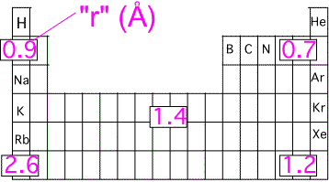
1). Using your insight into trends in atomic size, place the following atomic radii in empty boxes for the four corners of the table and the center of the Transition metals: 0.7, 0.9 1.2, 1.4 and 2.6 A

2) Using the Period Table below. Draw ARROWS defining the trends across and down the Periodic Table for
- Electro negativity(Increasing from Lower Left towards Upper Right)
- Ionization Potential(Increasing from Lower Left towards Upper Right)
- Metallic Character
- Electron Affinity(Increasing from Lower Left towards Upper Right)

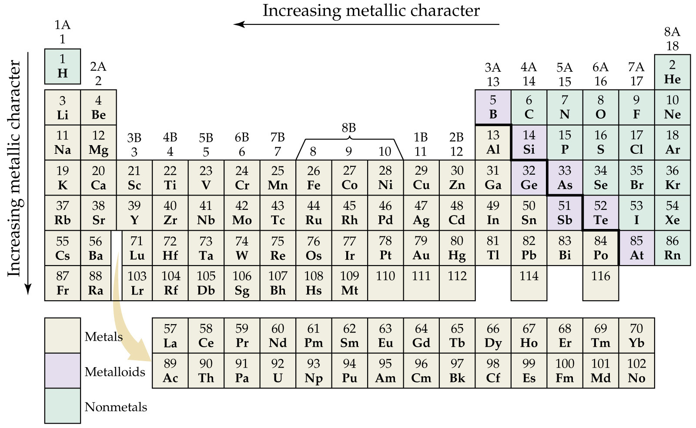

3) The VISIBLE Emission Lines for the Alkali Metals are found to be:
Li line: 2p → 2s transition (Crimson)
Na line (589 nm): 3p → 3s transition (Yellow)
K line: 4p → 4s transition (Blue)

Discuss why you might expect this shift in color (wavelength) among these metals.

There is a blue shift( greater energy) due to increasing distance between orbitals (occupied and unoccupied) as a result of the increasing size and diminishing attraction of the orbitals to the nucleus.

4).All of the Alkali Metals react with cold water while all the alkaline earth metals with the exception of Be will react with steam, hot water or RT water. Discuss the order of tendency for these two groups towards water.

As the atoms become increasing larger (moving down the table) the oxidation reactivity of the metal increases due to the weaker attraction of the outer electron(s) to the atom.

