Raoult’s Law:

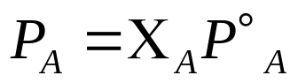

P_{A} is the vapor pressure with solute,
P_{A}° is the vapor pressure without solute, and Χ_{A} is the mole fraction of A, then

Lowering Vapor Pressure

