Rate law of slow step=Rate law of reaction
When determine the rate of a step, simply make the exponent of the reactant's concentration in the rate law the same as the coefficient of the reactant in the step.
1) Find the slow step of the following reaction mechanism
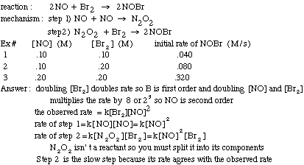

Practice Kinetic Quantitative Problem:
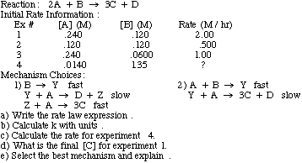
Kinetic quantitative solution.
Practice Kinetic Qualitative Problems:
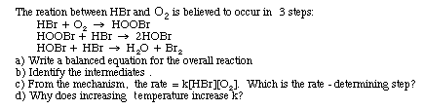
Kinetic qualitative solution.

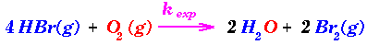overall rxn. with rate constant k_{exp}.
Experimental Rate Law - determined by the isolation method: R = Rate = k_{exp}[HBr][O_2]. This is first order with respect to HBr(g), first order w/r to O_2(g) and second order overall.
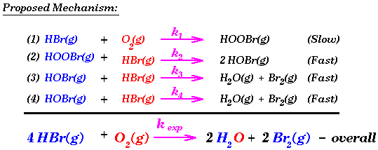
The rate constants, k_1, k_2, k_3, and k_4 above, are termed elementary rate constants, since they are rate constants for elementary reactions. Note that the sum of the E.R.'s must add up (in an algebraic manner) to the overall reaction. In the above mechanism, they do. Species that are generated during the course of the elementary reactions (not externally introduced), but do not appear in the overall reaction are termed intermediates. HOOBr(g) and HOBr(g) classify as intermediates in the above mechanism. What do the terms "Fast" and "Slow" appended after the elementary reactions mean? We'll see in a moment.
The elementary rate constants are often indirectly determined - of course our hope is to be able to derive the value of these elementary rate constants from "first principles". This is often very difficult to do and can only be done so in an empirical or semi-empirical manner - even for the simplest of reactions! At least, we would like to be able to express the observed rate constant for the overall reaction, k_{exp}, as a function of the elementary rate constants (k_1, k_2, k_3, k_4) above. This leads us to the next requirement of a good or "plausible" mechanism. The mechanism must be able to generate the experimentally determined rate law. In order to see how it relates to the observed rate (R) of the overall reaction. We will denote the rate of an elementary reaction by r and the observed (initial) rate of the overall reaction by R. Remember, since an elementary reaction (E.R.) denotes the molecular event, i.e. the molecular collisions taking place; the stoichiometric coefficients are telling more than just the relative proportions that must react to form products.
Consider the elementary reaction (1) above:

A catalyst is a substance added to a reaction which comes out of the reaction unchanged. As mentioned earlier, catalysts help lower the activation energy as shown in the following graph. They do this by changing the reaction mechanism.
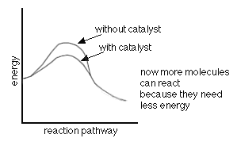
The following is an example of how this can be done.
