Classification by Physical Properties
.
Fingerprint Types
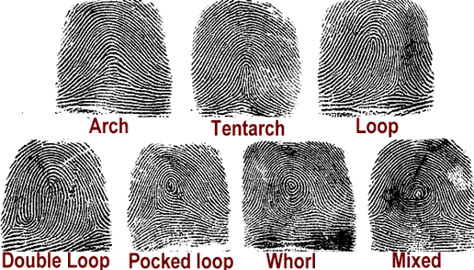
Figure 2: These are the different types of fingerprint patters

Minutiae-Based Matching
The second form of optimizing classification is kind of a step in the opposite direction from ordinary signal processing. Whereas all the previous methods dealt with find the correlation between two photos, this type of classification is a minutiae-based approach . This classification separates fingerprints into different types, as seen below

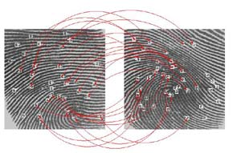
Figure 4: When using a minutiae-based approach, individual properties of the fingerprint are matched, instead of using the correlation of values

