Solvent-Solute Interactions

Introduction
. At the risk of oversimplifying, we will divide solutes into 3 groups:
- Ionic
- Polar covalent
- Non-polar covalent
We will use the adage "like dissolves like" as our guide to understanding the forces that enable a solute to dissolve in a solvent. Remember that this adage is really a variation on the statement of Coulomb's Law that says "opposite charges attract". The force of attraction depends upon the nature of the solvent and the nature of the solute. We will look at four types of interactions:
- Charge-Dipole
- Dipole-Dipole
- Dipole-Induced dipole
- Induced Dipole-Induced Dipole
It is important here to distinguish between intermolecular interactions and the intramolecular interactions that we call covalent bonding. The strengths of covalent sigma bonds range from a low of about 50 kcal/mol to a high of around 125 kcal/mol. The interactive forces described below range from 2-10 kcal/mol. Because they are so much less than typical covalent bonding forces, these interactions are sometimes called secondary bonding interactions.

Charge-Dipole Interactions

Ions Surrounded by Polar Molecules
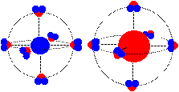

Dipole-Dipole Interactions

Dipole-Dipole Interactions
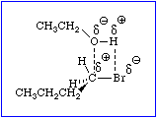
When one of the bonds involved in a dipole-dipole interaction is an O-H bond, the interaction is given the special, but common, designation hydrogen bonding.
.

Dipole-Induced Dipole Interactions

Polar Molecule Inducing a Dipole In a Non-Polar Molecule
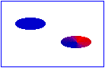

Induced Dipole-Induced Dipole Interactions

Very Weak Induced (London Dispersive Forces)

Between Non-Polar Molecules

