Spectrophotometric Determination of Iron

Use a buret to add 10, 7.5, 6, 5, 2.5, 0 (blank) mL of standard iron solution to five respective 25 ml volumetric flasks. Record the EXACT buret readings to two places past the decimal (i.e. 10.00, 7.50, etc.) This is important for calculating accurate iron standards’ concentrations!

Then add the following (use graduated cylinder to measure volume) IN THE ORDER SHOWN:

2.5 mL hydroxylamine hydrochloride (reducing agent – MUST add first)
2.5 mL sodium acetate solution (slightly basic)
2.5 mL orthophenanthroline (Complexing agent)

Dilute each flask to volume with MilliQ water. Parafilm, mix, and let stand for at least 5 minutes.

Obtain an unknown sample from the TA in a 25mL volumetric flask. Add hydroxylamine hydrochloride, sodium acetate, and orthophenanthroline solutions as done previously. Then dilute the solution to volume with MilliQ water. Parafilm, mix, and let stand for 5 minutes.

Follow the procedure below to adjust the Genesys 20 Spectrophotometer and determine the absorbance of each standard solution and the unknown.

- Turn the power switch on. This switch is located on the lower left in the back of the instrument. It is a black toggle button. Allow five minutes for the instrument to warm up.

- Push the up or down toggle arrow button that is labeled as nm (nanometers) to select the proper wavelength for maximum absorbance. The wavelength maximum (λ_{max}) for this experiment is 510nm. Note that the color of the Iron(II) phenanthroline complex is orange/red. Remember that the color (wavelength) absorbed is complementary to the color we see with the human eye. So because we see an orange/red solution, the energy being absorbed by the solution is actually in the Blue/green region, 440-570nm. That is why we
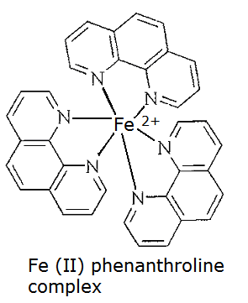
set the spectrophotometer to 510nm.

- Violet: 400 - 420 nm
- Indigo: 420 - 440 nm
- Blue: 440 - 490 nm
- Green: 490 - 570 nm
- Yellow: 570 - 585 nm
- Orange: 585 - 620 nm
- Red: 620 - 780 nm
Wavelength range by color Structure of orange/red complex
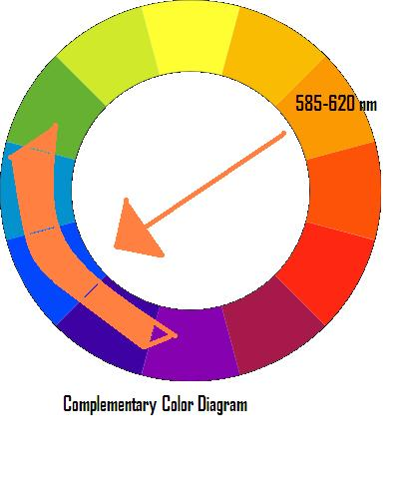
INCLUDEPICTURE "http://www.cem.msu.edu/~reusch/VirtualText/Spectrpy/Images/wave.gif" \* MERGEFORMATINET INCLUDEPICTURE "http://www.cem.msu.edu/~reusch/VirtualText/Spectrpy/Images/wave.gif" \* MERGEFORMATINET INCLUDEPICTURE "http://www.cem.msu.edu/~reusch/VirtualText/Spectrpy/Images/wave.gif" \* MERGEFORMATINET 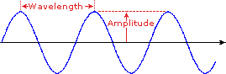
INCLUDEPICTURE "http://www.cem.msu.edu/~reusch/VirtualText/Spectrpy/Images/vispect2.gif" \* MERGEFORMATINET INCLUDEPICTURE "http://www.cem.msu.edu/~reusch/VirtualText/Spectrpy/Images/vispect2.gif" \* MERGEFORMATINET INCLUDEPICTURE "http://www.cem.msu.edu/~reusch/VirtualText/Spectrpy/Images/vispect2.gif" \* MERGEFORMATINET 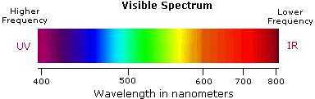
Diagram showing the wavelengths in the visible range Color wheel

- Fill a cuvette ¾ full with the blank solution and cap it. Wipe cuvette dry with Kimwipe making sure there are no fingerprints or marks on the clear sides. Place the cuvette filled with the blank solution into the cell compartment. *Position the cuvette such that the instrument beam of light is passing through the flat (not ribbed) sides of the cuvette! Close the cell compartment cover. Press the 0 ABS 100 % T button. The readout should say 0.000A. Remove the cuvette and discard the blank solution. You will not have to Blank the instrument again.

- Next, using the same cuvette, fill with the LEAST concentrated standard solution (this solution will be the lightest in color), and pour this “rinse” solution from the cuvette into a waste beaker. Then, refill cuvette ¾ full with a fresh aliquot of the same standard solution. Cap the cuvette (dry with Kimwipe if necessary) and place it into the cell compartment, closing the cover. Record the absorbance.
- Continue this procedure (step 4) with the remaining standard solutions, always reading absorbances from the least to most concentrated standard. Also, always fill the cuvette with standard and then dispose of the “rinse” solution into a waste beaker before filling with the same standard that will be read on the spectrophotometer. Record all absorbance values as they are not stored in the instrument.

- Lastly, fill the cuvette with the unknown iron solution, and record the absorbance. If the unknown absorbance does not fall within the range of the standards of known concentration, a dilution of the unknown will need to be completed. The standards should all have absorbances less than 1.00. To dilute the unknown, measure out 1 mL of unknown solution using either a glass pipet or a micropipette. Dispense this amount into the cuvette. Then measure out 1 mL of MilliQ water and add this amount to the cuvette. Since you are measuring 1 part of unknown in a total of 2 parts (1 part unknown and 1 part MilliQ water), this dilution process is called a 1:2 dilution. How would you make a 1:3 dilution of the unknown?

Added Notes:

- Plot the Fe concentration (x axis) vs. absorbance points (y axis) on the computer, using excel software. Use a least squares fit or linear regression line to “draw the best straight line” through the points. DO NOT estimate this line with a straight edge.

- After obtaining the line for the standards (y = mx + b), use the unknown absorbance (y value) to substitute into the linear equation in order to mathematically determine the concentration of the Fe unknown in Molarity (x value). The slope of the line (m) is the molar absorptivity of the
- Iron (II) phenanthroline complex. Also determine standard deviations (s_{b} and s_{m})

- Remember: If a 1:2 dilution was made on the unknown, the concentration determined from the standard curve is based on the diluted unknown. To determine the real UNDILUTED unknown concentration, the value obtained mathematically from the calibration curve line should be multiplied by 2 (for a 1:2 dilution), or 3 for a 1:3 dilution, etc.
Tips for Obtaining Good Calibration Standard Curves and Unknown Absorbance:

- Make sure that the cuvette is clean before using.

- Always put a cap on the cuvette and close the cell compartment to prevent stray light from entering the solution, which will skew the results.

- Always handle the cuvette by the ribbed sides only.

- Wipe off the clear sides of the cuvette with a kimwipe to wipe off any oils from fingerprints.

- Always place the cuvette with into the holder with the ribbed sides toward the left and right, and use the SAME cuvette for all absorbance readings.

- Always place the cuvette in the holder with the arrow facing toward you.

- Always rinse out the cuvette to a waste beaker with the solution that will be tested before taking an absorbance reading.

- Always test a blank solution first before standards or unknowns.

- Always test the solutions from LEAST to MOST concentrated.

- When finished, remove the cuvette and rinse out several times with MilliQ water and turn over to dry.

- NEVER dry a cuvette with a paper towel, as towel fibers can get stuck onto the sides. ALWAYS leave the cuvette turned over to drain.

- Remember to set the wavelength to the proper setting for the experiment being performed.

