Spectrophotometric Determination of Iron

Use a buret to add 10, 7.5, 5, 0 (blank) mL of standard iron solution to four respective 25 ml volumetric flasks. To two additional 25 mL volumetric flasks, add a volume between 10 and 7.5 mL to one and between 7.5 and 5 mL to the second. Read the buret to 2 decimal places to know the exact amount of iron added. Then add the following in the order show:

2.5 mL hydroxylamine hydrochloride (reducing agent – MUST add first)
2.5 mL sodium acetate solution (slightly basic)
2.5 mL orthophenanthroline (Complexing agent)

Dilute each flask to volume with MilliQ water. Mix and let stand for at least 5 minutes.

Obtain and unknown sample and prepare it using 15 mL of the unknown in a 25 mL volumetric flask. Add the hydroxylamine hydrochloride, sodium acetate solution, and orthophenanthroline solutions as done previously. Finally dilute the solution to 25 mL total volume with MilliQ water.

The wavelength chosen for this analysis is based on the fact that colors absorb opposite them in the color wheel. The color of the prepared samples is orange-ish, it is likely that the wavelength of maximum absorbance (λ_{max}) is in the region of blue wavelengths. It is found that λ_{max} for this particular complex is found at 510 nm.

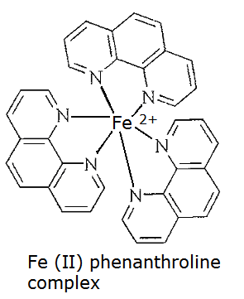
- Violet: 400 - 420 nm
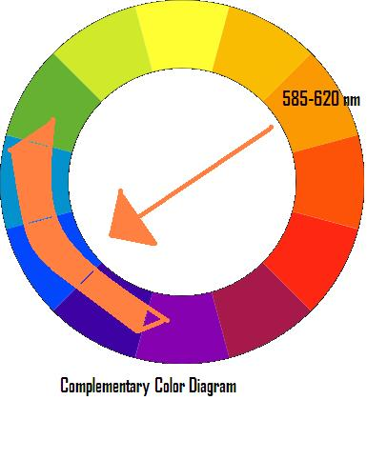
- Indigo: 420 - 440 nm
- Blue: 440 - 490 nm
- Green: 490 - 570 nm
- Yellow: 570 - 585 nm
- Orange: 585 - 620 nm
- Red: 620 - 780 nm

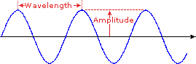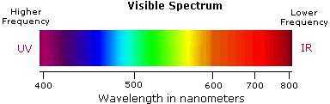

Follow the procedure below to determine the wavelength of maximum absorbance and analyze the samples.

- Set the spectrophotometer to analyze using a wavelength of 510 nm. Fill a cuvette half full with the blank solution, wipe it off with a kimwipe, and place it in the cell compartment. Set the absorbance to zero. Remove the cuvette and discard of the solution.
- Next, using the same cuvette, fill it with the LEAST concentrated standard solution (this solution will be the lightest orange color), and rinse the cuvette into a waste beaker. Then refill with this same standard solution and place the cuvette into the cell compartment, and close the cover. Record the absorbance.

- Continue to analyze the remaining standards and the unknown using this same procedure. Remember to always analyze standards from lowest to highest concentration. Also, always fill the cuvette with standard and then rinse the solution into a waste beaker before filling with standard that will be read on the spectrophotometer.

- If your unknown absorbance is outside of the calibration curve, it must be diluted. Dilute the sample as desired in a 25 mL volumetric flask. For example, if you think the unknown needs to be diluted by a factor of 25, accurately measure out 1 mL of unknown, add the remaining reagents in the appropriate order, and dilute the solution to 25 mL total volume. This is a 25x dilution or a 1:25 dilution (1 part sample to 25 total parts). Record the new absorbance and calculate the concentration. Remember to consider the dilution in your calculations.

Added Notes:
- If desired, you can periodically check and adjust the 0 absorbance with the blank solution.
- Plot the Fe concentration (x axis) vs. absorbance points (y axis) on the computer, using Excel software. Use a least squares fit or linear regression line to “draw the best straight line” through the points. DO NOT estimate this line with a straight edge.
- After obtaining the line for the standards (y = mx + b), use the unknown absorbance (y value) to substitute into the linear equation in order to mathematically determine the concentration of the Fe unknown in Molarity (x value). The slope of the line (m) is the molar absorptivity of the Iron (II) phenanthroline complex. If desired, you can also determine standard deviations (s_{b} and s_{m})

Tips for Obtaining Good Calibration Standard Curves and Unknown Absorbances:

- Make sure that the cuvette is clean before using.
- Always close the cell compartment to prevent stray light from entering the solution, which will skew the results.
- Always handle the cuvette by the ribbed sides only.
- Wipe off the clear sides of the cuvette with a kimwipe to wipe off any oils from fingerprints.
- Always place the cuvette with into the holder with the ribbed sides toward the left and right, and use the SAME cuvette for all absorbance readings.
- Always place the cuvette in the holder with the arrow facing toward you.
- Always rinse out the cuvette to a waste beaker with the solution that will be tested before taking an absorbance reading.
- Always test a blank solution first before standards or unknowns.
- Always test the solutions from LEAST to MOST concentrated.
- When finished, remove the cuvette and rinse out several times with MilliQ water and turn over to dry.
- NEVER dry a cuvette with a paper towel, as towel fibers can get stuck onto the sides. ALWAYS leave the cuvette turned over to drain.
- Remember to set the wavelength to the proper setting for the experiment being performed.

