Van Der Waals Forces / London Dispersive 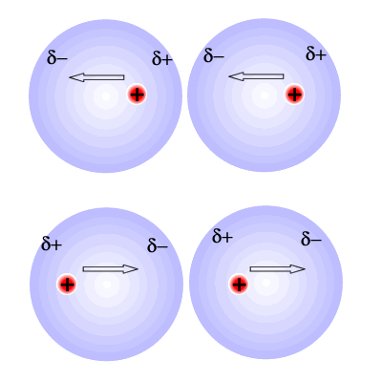

- Van Der waals forces
- London Dispersions
- Animation London Dispersion (shockwave required to play animation)
Dipole-Dipole Interactions
(None Uniformity of Electronegativity)
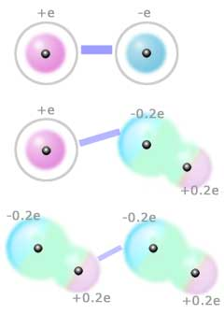
- Dipole-Dipole Force ICl example
- Animation Dipole-Dipole Interaction (shockwave required to play animation)

Hydrogen Bonding (O-H N-H F-H) 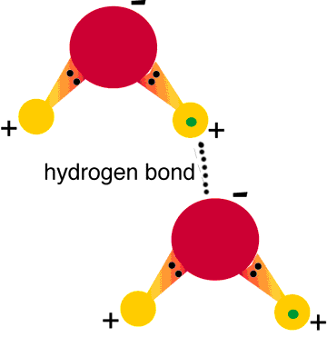
- Hydrogen Bonding
- Animation Hydrogen Bonding (shockwave required to play animation)

Ionic Bonding
(Largely electrostatic attraction between Ions)

