If the pH of a solution of NaF is adjusted;. Using the fact that pK_{a}(HF) = 3.17;
at what pH is 25% of the total fluoride in the form of F-?
2.69 3.65 3.29 3.77 3.17 none

200 ml of 0.5 M Acetic Acid(pK_{a}=4.75) is mixed with 300ml of 0.45 M Potassium Acetate, what is the final pH, and is this a good buffer?

4.62/YES 4.75/YES 4.88/YES 4.80/YES 4.88/NO none

180ml of 0.481 M reolic acid (pK_{a} = 3.35) ; 200 ml of 0.340 M sodium reolate (salt of reolic acid) and 150 ml of 0.5M potassium hydroxide are mixed together , what is the pH of the resulting solution? (Assume that the volume are additive)

moles of initial base 0.075
moles of initial nitrite 0.068
moles of initial acid 0.08658
moles of final acid 0.01158
moles of final nitrite 0.075 + 0.068 = 0.143

pH=pKa-log(acid/conj base)
4.16 4.44 2.25 9.56 3.25 none

2) What are the pH’s of the following solutions?

 | 0.2M Nitrous Acid | 0.2M HCl | 0.5M NH3(aq) | 0.5M NaOH
 | pk_{a} = 3.32 |  | pK_{b}= 4.75
Solution 1 | 0 ml | 30 ml | 10 ml | 0 ml | 1.6
Solution 2 | 0 ml | 30 ml | 0 ml | 10 ml | 1.6
Solution 3 | 40ml | 0 ml | 0 ml | 0 ml | 2.01
Solution 4 | 50 ml | 0 ml | 0 ml | 10 ml | 3.32
Solution 5 | 0 ml | 20 ml | 10 ml | 0 ml | 5.05
Solution 6 | 0 ml | 50 ml | 0 ml | 20 ml | 7.00
Solution 7 | 50 ml | 0 ml | 0 ml | 20 ml | 8.24
Solution 8 | 0 ml | 15 ml | 10 ml | 0 ml | 9.07
Solution 9 | 0 ml | 0 ml | 20 ml | 0 ml | 11.47
Solution 10 | 50 ml | 0 ml | 0 ml | 40 ml | 13.05

What are the pH’s of each of the above ten solutions, choose from below:

1.6 2.01 3.32 4.34 5.05 7.00 8.24 9.07 10.21 11.47 12.32 13.05
3) Which of the following aqueous solutions are good buffer systems AND WHY!!?
0.56 M potassium acetate + 0.26 M formic acid | NO two differing weak acids
0.24 M nitric acid + 0.22 M sodium nitrate | NO(strong acid)
0.21 M ammonia + 0.14 M perchloric acid | YES
0.23 M sulfuric acid + 0.91 M ammonia | YES(Half of the base will be converted to conjugate acid
0.47 M hydrofluoric acid +0.04 M potassium fluoride | NO(could be BUT KF too small
1.15 M hydrocyanic acid + 1.39 M sodium cyanide | YES

4) The activation energy for the gas phase decomposition of dinitrogen pentoxide is 51.5kJ.
N₂O₅ 2 NO₂ + 1/2 O₂
The rate constant at 400 K is 4.5 x 10⁻³ sec⁻¹. What is the Rate Constant at 300 K.

2.58x10⁻⁰⁵ 7.85x10⁻⁰¹ 4.48x10⁻⁰³ 1.03x10⁻²¹ 2.02x10⁻⁴ none

5) Consider the reaction: NO₂ -> 2 NO + O₂
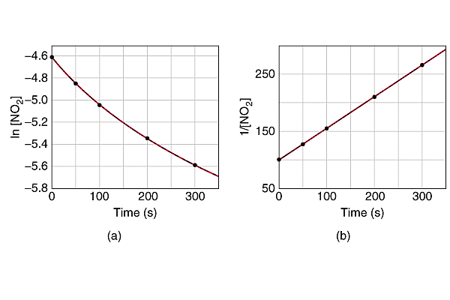
What is the Rate Law AND what is the Time Dependence of [NO₂](t) (5 pts)

1/[NO₂ ] = 1/0.01 + 0.57*t

What would be the Concentration (M) of NO₂ at 500/800 seconds? (5 pts)
Hint first derive needed relationship and utilize at appropriate time.
0.00180 2.60 0.0035 5.96 0.00259 none

1/[NO₂ ] = 100+0.57*500=385 [NO₂ ] =0.00259

1/[NO₂ ] = 100+0.57*800=556 [NO₂ ] =0.00180

E.C. Assuming there was ONLY reactants at beginning and no back reaction; what would be the concentration of NO at 500 sec? (E.C. 5pts) (No guesses must see work!)
0.02 771.4 0.0052 0.0148 0.0052 none

[NO₂ ] =0.00259 thus we lost x= 0.010-0.00259=0.00741 and gained 2x of NO = 0.0148
6) Henry’s law tells us that the solubility of a gas increases with the pressure of that gas above it. Assuming that air is simply N₂ ::O₂ (80%/20% by Volume) at one atmosphere. What would need to be the partial pressure of O₂ in a compressed air tank so as to maintain the SAME ABSORPTION of O₂ in the blood (water) at 363 ft below sea level ( assume 33ft = 1atm) ? (10pts)

363/33= 11atm of water + 1 atm =12 atm

=0.2/12 =0.0167 atm of O₂

7) A 0.550 M solution of NaHCO₃ (molar mass=84.0) has a density of 1.032 g/mL .
Calculate the molality of the solution. (10pts)
0.580 0.558 0.533 0.51 none

0.55 moles of NaHCO3 |  | 46.20 |  | grams of NaHCO3
Assume 1 Liter of SOLUTION would contain 0.55 moles
1L x 1032g/L= | 1032 TOTAL grams made of water and NaHCO3
 | =1032-46.2 |  |  | 985.8 | grams of water
 |  |  |  | 0.9858 | kg of solvent
molality = | 0.55 moles of NaHCO3/0.9858kg solvent= |  |  |  |  |  |  | 0.558

8) A solution of 0.28% by weight Potassium Carbonate (molar mass=138) has a density of the solution is
1.09 g/mL, calculate the Molarity of the solution. (10pts)
0.205 0.0187 2.59 0.0223 none

Assume 100 grams of solution
=0.28/138= | 0.002029 | moles of K₂CO₃
100grams of solution * (1ml/1.09 grams of solution) = |  |  |  |  |  | 91.74 | ml
 |  |  |  |  |  | 0.0917 | L
Molarity = | 0.002029moles/0.0917L = |  |  |  | 0.0222 | M

