GDC – TERRAFORM

GCP CONFIGURATION
. Activate free trial
. Create a new project
. Create a new service account and generate keys
. Install google sdk

https://itslinuxfoss.com/install-google-cloud-sdk-ubuntu-22-04/

export GOOGLE_APPLICATION_CREDENTIALS=./Downloads/winged-vigil-379810-791a8ed1f63c.json

./google-cloud-sdk/bin/gcloud auth application-default login

. Instaling Terraform

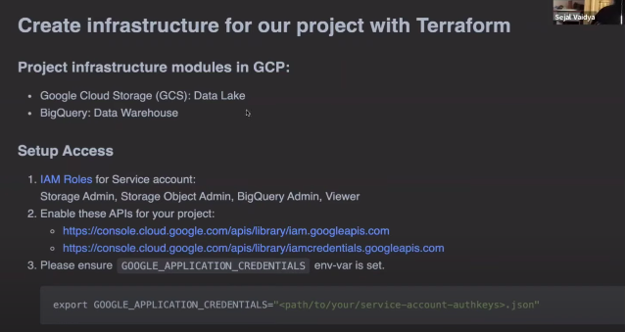
Setup Access – add new profile roles:
big query admin
storage admin
storage object admin

Enable apis:
https://console.cloud.google.com/apis/library/iam.googleapis.com?project=subtle-photon-342714

# TERRAFORM

3 main files - .terraform_version / main.tf / variables.tf

main.tf
1 – terraform souce
.define version
. backend:
. required providers – optional, create resources basead in standard configurations
. providers
. resources – google storage and data lake
there a pre-defined configuration into terraform website

.main.tf – it’s like a library that will be import to python to be use

Notes – explain in details every part of terraform
https://github.com/ziritrion/dataeng-zoomcamp/blob/main/notes/1_intro.md#terraform-and-google-cloud-platform

In the variables.tf we will store variables that may change depending on your needs and location. The ones to note are:
- region may vary depending on your geographical location; change it according to your needs.
- BQ_DATASET has the name of the table for BigQuery. You may leave it as it is or change it t fit your needs.
- project is the Project ID of your project in GCP. SInce the ID is unique, it is good practice to have Terraform as for it every time in case the same code is applied on different projects.

Terraform comands
These commands needs to be done in the terraforms folder where contains the main.tf and variables.tf files.
. terraform init
. terraform plan – need to put the google project id
. terraform apply

============================================
GCP VM configuration

. create a ssh key from google compute engine
terminal -
go to ssh directory
$ cd .ssh/
$ ssh-keygen -t rsa -f ~/.ssh/gcp -C conradobio -b 2048
#senha mv – gcp
. Go to metadata / ssh and add the ssh into it.
$ cat gcp.pub
Copy and past in metadata ssh

. Go to Compute Engine and create a VM.
. After creating the VM copy the external url.

Back to the terminal
$ ssh -i ~/ssh/gcp conradobio@34.70.80.141

. Configuration the VM
Check the google cloud version
$ gcloud –version

. Now lets install programns and configure
Instaling Anaconda
$ wget https://repo.anaconda.com/archive/Anaconda3-2022.10-Linux-x86_64.sh
$ bash Anaconda3-2022.10-Linux-x86_64.sh
And install

Lets return to our machine to configure other things.
$ cd .ssh/
$ touch config
$ code config #will open the vs code
config file – WITH PROBLEM
Host dtc-zoom
HostName 34.70.80.141
User conradobio
IdentityFile ~/.ssh/gcp

. Instaling docker
$sudo apt-get update
$sudo apt-get install docker.io

* Acessing ssh into VS Code
In VS Code install the remote ssh extension

. Acessing docker without using sudo
$ sudo groupadd docker
$ sudo gpasswd -a $USER docker
$ sudo service docker restart
$ restart the vm

. Instaling docker compose
$ mkdir bin
$ cd bin/
$ wget https://github.com/docker/compose/releases/download/v2.16.0/docker-compose-linux-x86_64 -O docker-compose
$ chmod +x docker-compose #changing permissions

# modifing the path to run docker
$ nano .bashrc
at the end of the scrip
export PATH=”${HOME}/bin:${PATH}”
ctrl O, enter, ctrl x
$ source .bashrc – to conclude the changes

----------------------------------------------------
git clone data-eng-zoomcamp
run jupyter notebook
follow the same steps in the class 2_docker_sql

. Download Terraform
. Configurate GCP on VM
Lets tranfer files via sftp
$ mkdir .gc
$ put Downloads/winged-vigil-379810-791a8ed1f63c.json to home/conrado/.gc/ny_rides.json

- authentication GCP
$ export GOOGLE_APPLICATION_CREDENTIALS=~/.gc/ny-rides.json
$ gcloud auth activate-service-account --key-file $GOOGLE_APPLICATION_CREDENTIALS

