WEEK_2 – Data Lake

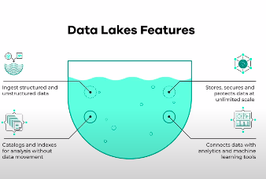

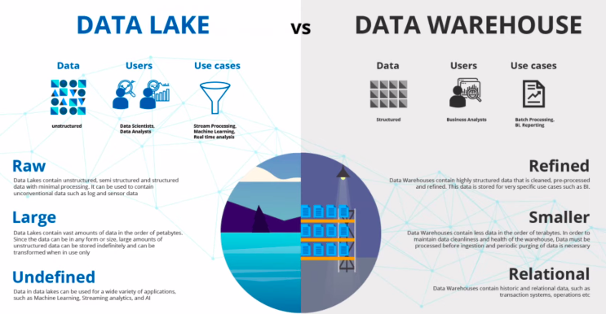

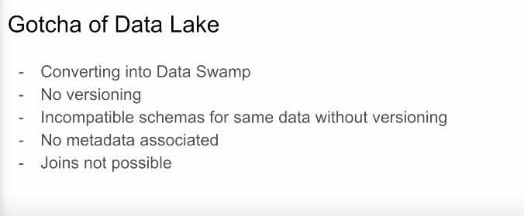
WORKFLOW ORCHESTRATION

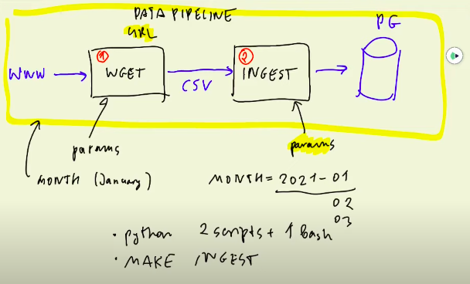
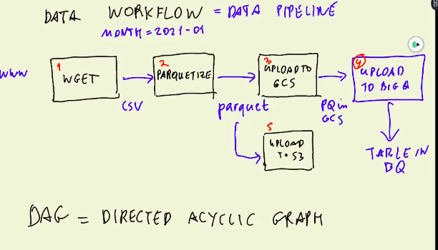

AIRFLOW

https://github.com/ziritrion/dataeng-zoomcamp/blob/main/notes/2_data_ingestion.md

* Creating first dag

. https://crontab.guru/#0_0_1_*_*

--------------------------------
# Acessing airflow worker container to check if the files is there
$ docker exec -it {container-image-numer} bash
$ ls
$ ls -lh #see the size of the files
$ wc -l outup.csv #see the number of rows of the file

. Summary of the class
https://github.com/ziritrion/dataeng-zoomcamp/blob/main/notes/2_data_ingestion.md

