What the Featurette Code is Doing

Here is some code. Could you please tell me what it is doing.

'<div class="container marketing">

<!-- START THE FEATURETTES -->

<hr class="featurette-divider">

<div class="row featurette">

<div class="col-md-7">

<h2 class="featurette-heading fw-normal lh-1">First featurette heading. <span class="text-body-secondary">It’ll blow your mind.</span></h2>

<p class="lead">Some great placeholder content for the first featurette here. Imagine some exciting prose here.</p>

</div>

<div class="col-md-5">

<svg class="bd-placeholder-img bd-placeholder-img-lg featurette-image img-fluid mx-auto" width="500" height="500" xmlns="http://www.w3.org/2000/svg" role="img" aria-label="Placeholder: 500x500" preserveAspectRatio="xMidYMid slice" focusable="false"><title>Placeholder</title><rect width="100%" height="100%" fill="var(--bs-secondary-bg)"/><text x="50%" y="50%" fill="var(--bs-secondary-color)" dy=".3em">500x500</text></svg>

</div>

</div>

<hr class="featurette-divider">

<div class="row featurette">

<div class="col-md-7 order-md-2">

<h2 class="featurette-heading fw-normal lh-1">Oh yeah, it’s that good. <span class="text-body-secondary">See for yourself.</span></h2>

<p class="lead">Another featurette? Of course. More placeholder content here to give you an idea of how this layout would work with some actual real-world content in place.</p>

</div>

<div class="col-md-5 order-md-1">

<svg class="bd-placeholder-img bd-placeholder-img-lg featurette-image img-fluid mx-auto" width="500" height="500" xmlns="http://www.w3.org/2000/svg" role="img" aria-label="Placeholder: 500x500" preserveAspectRatio="xMidYMid slice" focusable="false"><title>Placeholder</title><rect width="100%" height="100%" fill="var(--bs-secondary-bg)"/><text x="50%" y="50%" fill="var(--bs-secondary-color)" dy=".3em">500x500</text></svg>

</div>

</div>

<hr class="featurette-divider">

<div class="row featurette">

<div class="col-md-7">

<h2 class="featurette-heading fw-normal lh-1">And lastly, this one. <span class="text-body-secondary">Checkmate.</span></h2>

<p class="lead">And yes, this is the last block of representative placeholder content. Again, not really intended to be actually read, simply here to give you a better view of what this would look like with some actual content. Your content.</p>

</div>

<div class="col-md-5">

<svg class="bd-placeholder-img bd-placeholder-img-lg featurette-image img-fluid mx-auto" width="500" height="500" xmlns="http://www.w3.org/2000/svg" role="img" aria-label="Placeholder: 500x500" preserveAspectRatio="xMidYMid slice" focusable="false"><title>Placeholder</title><rect width="100%" height="100%" fill="var(--bs-secondary-bg)"/><text x="50%" y="50%" fill="var(--bs-secondary-color)" dy=".3em">500x500</text></svg>

</div>

</div>

<hr class="featurette-divider">

<!-- /END THE FEATURETTES -->

</div> <!-- /.container or the class container marketing -->'.

ChatGPT

The provided code appears to be a section of HTML markup within a web page. This code is likely part of a web page's content, and it appears to be defining a series of "featurettes" within a container with the class "container marketing." Each featurette seems to consist of a two-column layout, with textual content on the left and an image (or possibly a placeholder) on the right. Let's break down the code:

<div class="container marketing">: This is the starting <div> element with the class "container marketing," which is often used in Bootstrap to create a container that helps structure and format the content.

<hr class="featurette-divider">: This is an <hr> element with the class "featurette-divider," which is a horizontal rule used to separate sections, likely indicating the separation between different featurettes.

<div class="row featurette">: This is a <div> element with the class "row featurette," indicating the beginning of a featurette. Each featurette appears to be structured as a row with two columns.

Within each featurette:

<div class="col-md-7">: This <div> element with the class "col-md-7" represents the left column of the featurette, typically taking up 7 out of 12 columns on medium-sized screens and larger (Bootstrap grid system).

<h2 class="featurette-heading fw-normal lh-1">: This is a heading element with the class "featurette-heading." It seems to represent the main heading or title of the featurette. The classes "fw-normal" and "lh-1" may control font weight and line height.

From looking in the Bootstrap notes, I found:

Breaking Renamed .font-weight-\* utilities as .fw-\* for brevity and consistency.

So fw does refer to font weight. Here are some notes from Bootstrap.

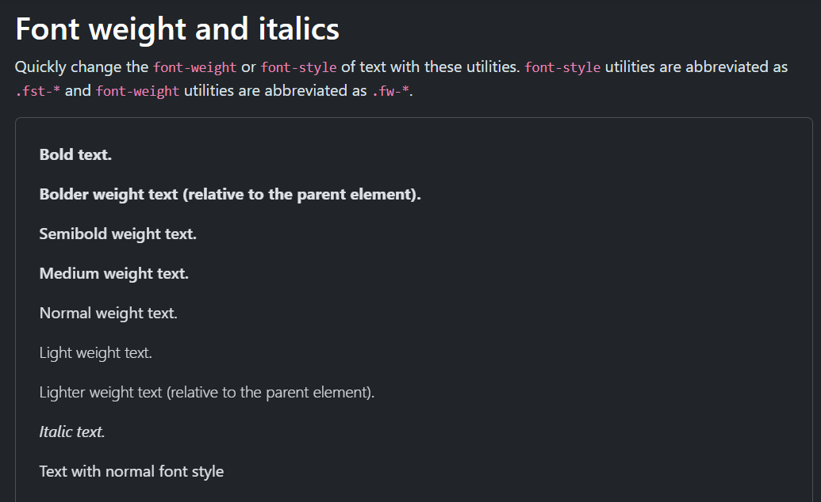

And I also found:

Added new line-height utilities: .lh-1, .lh-sm, .lh-base and .lh-lg. See here.

So this does refer to line height. Here is some notes from Bootstrap.

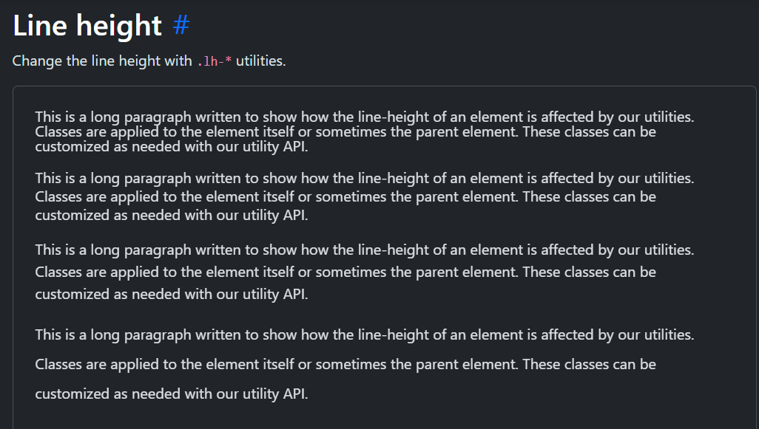

Could you explain what this code is doing please.

'<span class="text-body-secondary">It’ll blow your mind.</span>'.

ChatGPT

The provided code <span class="text-body-secondary">It’ll blow your mind.</span> is defining a <span> element with the class "text-body-secondary" and containing the text "It’ll blow your mind."

Here's an explanation of what this code is doing:

<span> element: <span> is an HTML inline element used to apply styles or markup to a specific portion of text within a larger block of text. It doesn't introduce a line break and is typically used for applying CSS styles, JavaScript interactions, or semantic meaning to specific text within a paragraph or other text-containing element.

class="text-body-secondary": This is an HTML class attribute assigned to the <span> element. The class "text-body-secondary" is likely a custom CSS class defined in the CSS stylesheet of the web page or provided by a CSS framework like Bootstrap. The purpose of this class is to apply specific styling to the text enclosed within this <span> element. The exact styling will depend on the CSS rules associated with this class.

It is a new value that has replaced the old one. I think it just has a slightly different colour to the normal text.

There is still no way I can just go to this value and see exactly what it does.



It’ll blow your mind.: This is the text content enclosed within the <span> element. It is the text that will be affected by the CSS styles defined in the "text-body-secondary" class.

The specific styling applied by the "text-body-secondary" class, such as text color, font size, font weight, or any other visual properties, would need to be defined in the CSS stylesheet associated with the web page. Without seeing the CSS rules for this class, it's challenging to provide details on the exact appearance of the text.

In summary, the provided code defines a <span> element with a custom class, and the purpose of this code is to apply specific styling to the text "It’ll blow your mind." The actual styling would be determined by the CSS rules associated with the "text-body-secondary" class.

Where can i find the actual referral to 'text-body-secondary'.

ChatGPT

The actual definition and styling for the CSS class text-body-secondary would be found in the CSS stylesheet associated with the web page or project where this class is used. To locate the definition for text-body-secondary, follow these steps:

Check the HTML Document: Start by looking in the HTML document (usually in the <head> section) for any <link> elements that reference external CSS files. These links specify the location of the CSS stylesheet(s) used on the page.

For example:

html

<link rel="stylesheet" href="styles.css">

Open the CSS File: Once you identify the CSS file(s) linked in the HTML, open the corresponding CSS file in a text editor or code editor of your choice.

Search for text-body-secondary: In the CSS file, use the search function (usually Ctrl+F or Command+F) to search for the class name text-body-secondary.

For example, in your CSS file, you might find something like this:

css

.text-body-secondary {

color: #333; /\* Some color code \*/

font-size: 16px; /\* Some font size \*/

/\* Other styling properties \*/

}

This CSS rule defines the styling for the text-body-secondary class, including color and font size. You can adjust these styles as needed in your CSS to achieve the desired appearance for text with this class.

If you have access to the project's codebase, you should be able to find the text-body-secondary class definition in one of the CSS files. If you are working with a website where you don't have direct access to the CSS files, you can use browser developer tools to inspect the element and view its computed styles. This can help you identify the CSS rules being applied to the element, including the styles associated with the text-body-secondary class.

What do you mean by 'view its computed styles'.

ChatGPT

In web development, "computed styles" refer to the final set of CSS styles that are actually applied to an HTML element after considering all the applicable styles from various sources, including the element's own inline styles, styles from linked or embedded stylesheets, and inherited styles from parent elements. Computed styles represent the exact visual appearance of an element as it is rendered in the web browser.

To "view computed styles" means to inspect and see the precise CSS properties and values that are affecting an HTML element's appearance in the browser. You can do this using the browser's built-in developer tools, which provide a convenient way to examine and debug web page elements.

Here's how you can view computed styles in commonly used web browsers like Google Chrome:

Right-click and Inspect: Right-click on the HTML element you want to inspect (in this case, an element with the text-body-secondary class) and select "Inspect" from the context menu. This opens the browser's developer tools.

Select the Element: In the developer tools, your selected element will be highlighted in the HTML panel.

Computed Styles Tab: In the developer tools, locate the "Computed" or "Computed Styles" tab. This tab displays a list of all the CSS properties and values that are applied to the selected element. The styles are computed based on the CSS rules that apply to the element, including styles inherited from parent elements.

Inspect Specific Properties: You can expand the computed styles for a property by clicking on it. This will show you the source(s) of that specific style (e.g., which CSS rule or inline style applied it) and any CSS values that may be overridden by more specific rules.

By viewing computed styles, you can see exactly how CSS is affecting an element's appearance, making it easier to understand and debug styling issues. This is particularly useful for identifying the source and values of styles applied to elements with specific classes like text-body-secondary.

<p class="lead">: This is a paragraph element with the class "lead." It is used to display a lead or introductory text for the featurette.

<div class="col-md-5">: This <div> element with the class "col-md-5" represents the right column of the featurette, typically taking up 5 out of 12 columns on medium-sized screens and larger.

<svg>: This is an SVG (Scalable Vector Graphics) element that appears to be used as a placeholder for an image. It may have a text label inside it.

<hr class="featurette-divider">: Another horizontal rule indicating the separation between featurettes.

This pattern repeats for multiple featurettes, each consisting of a left column with text and a right column with an image placeholder.

Finally, there's a closing comment indicating the end of the featurettes: <!-- /END THE FEATURETTES -->.

Overall, this code represents a section of a web page with multiple featurettes, each featuring a title, some descriptive text, and an image or placeholder image. The classes used in this code suggest that it is designed using the Bootstrap framework for responsive web design.

What are the codes for controlling 'Font Size' in BootStrap.

ChatGPT

In Bootstrap, you can control font sizes using a combination of utility classes, predefined text classes, and custom CSS. Here are some of the main ways to control font sizes:

Utility Classes:

Bootstrap provides utility classes for controlling font size, which you can apply directly to HTML elements:

.fs-1 to .fs-6: These classes set font size from extra small (smallest) to extra large (largest). For example, .fs-1 sets the font size to the largest, while .fs-6 sets it to the smallest.

.text-[size]: Replace [size] with Bootstrap's predefined text size classes like .text-small, .text-normal, .text-large, etc.

Example:

html

<p class="fs-4">This is a larger font size.</p>

<p class="text-small">This is a smaller font size.</p>

Typography Classes:

Bootstrap includes typography classes for controlling font sizes within specific elements like headings and paragraphs:

.h1, .h2, .h3, .h4, .h5, .h6: These classes are used for headings and come with predefined font sizes. .h1 is the largest, and .h6 is the smallest.

.lead: This class is often used for larger text, like introductory paragraphs.

Example:

html

<h1 class="h1">Heading 1</h1>

<p class="lead">This is a lead paragraph with a larger font size.</p>

Custom CSS:

If you need more control over font sizes, you can define your custom CSS rules. You can target specific elements or create your own CSS classes.

Example:

html

<style>

.custom-font {

font-size: 18px; /\* Adjust the size as needed \*/

}

</style>

<p class="custom-font">This has a custom font size.</p>

Remember that Bootstrap's utility classes and predefined styles offer a quick and consistent way to control font sizes. You can combine these classes and add your custom CSS rules to fine-tune the typography of your Bootstrap-based website.

Here is some code.

'<hr class="featurette-divider">

<div class="row featurette">

<div class="col-md-7">

<h2 class="featurette-heading fw-normal lh-1">First featurette heading. <span class="text-body-secondary">It’ll blow your mind.</span></h2>

<p class="lead">Some great placeholder content for the first featurette here. Imagine some exciting prose here.</p>

</div>

<div class="col-md-5">

<svg class="bd-placeholder-img bd-placeholder-img-lg featurette-image img-fluid mx-auto" width="500" height="500" xmlns="http://www.w3.org/2000/svg" role="img" aria-label="Placeholder: 500x500" preserveAspectRatio="xMidYMid slice" focusable="false"><title>Placeholder</title><rect width="100%" height="100%" fill="var(--bs-secondary-bg)"/><text x="50%" y="50%" fill="var(--bs-secondary-color)" dy=".3em">500x500</text></svg>

</div>

</div>'.

Could you please tell me what the class="lead" does in Bootstrap.

ChatGPT

In Bootstrap, the class="lead" is used to style a paragraph (usually a <p> element) to make it stand out and appear more prominent compared to regular text. It increases the font size and adds some additional line-height, making the text visually distinct. It's often used for introductory or important content to draw attention.

Here's what the class="lead" does in Bootstrap:

Larger Font Size: It increases the font size of the text inside the element to make it larger and more noticeable.

Increased Line Height: It adds extra line-height to the text, increasing the spacing between lines. This improves the readability and provides a sense of separation from surrounding content.

The lead class is typically used for introductory paragraphs or sections of content that you want to emphasize. It's not meant for all paragraphs but rather for specific pieces of content that you want to highlight within your page. Here's an example of how you might use it:

html

<p class="lead">This is an important introductory paragraph that should grab the reader's attention.</p>

By applying the lead class to the paragraph, you make it visually distinct from other paragraphs on the page, drawing the reader's focus to the content you consider important.

This is for putting a picture into the featurette.

How do i go about putting a picture into it instead of the image they have.

ChatGPT

To replace the placeholder image in your Bootstrap featurette with an actual picture, you'll need to modify the <svg> element and replace it with an <img> element. Here's how you can do it:

First, you'll need to have an image file ready to use. Let's assume you have an image file named "your-image.jpg" that you want to use.

Replace the <svg> element with an <img> element inside your featurette:

html

<div class="container marketing">

<hr class="featurette-divider">

<div class="row featurette">

<div class="col-md-7">

<h2 class="featurette-heading fw-normal lh-1">The Story</h2>

<h5 class="featurette-heading fw-normal lh-1 fs-1">An account of a scientifically historic event for Mankind, and an absolute gamechanger for World Wide Warfare.</h5>

<p style="margin-top: 3rem;" class="lead"> It was named 'The Manhattan Project' because there was something about it starting out there. It originally had a budget of $6000, but after the possibilities and repercussions were realized, it became virtually limitless. It was estimated to cost 2 billion dollars in the mid-1940s, which converts to about 70 billion dollars in today's money.</p>

</div>

<div class="col-md-5">

<!-- Replace this with your image -->

<img src="your-image.jpg" class="bd-placeholder-img bd-placeholder-img-lg featurette-image img-fluid mx-auto" width="500" height="500" alt="Your Image Description">

</div>

</div>

</div>

Replace "your-image.jpg" with the actual path to your image file, and you can also add an alt attribute to provide a description of the image for accessibility purposes.

This code will insert your image into the featurette in place of the placeholder SVG. Make sure to adjust the src, alt, and other attributes as needed to fit your specific image and styling requirements.

In this featurette, am i able to place some text describing the picture.

ChatGPT

Yes, you can certainly place text to describe the picture in your featurette. To do this, you can add a <figcaption> element inside a <figure> element around your <img> element. Here's how you can modify your featurette to include a caption for the picture:

html

<div class="container marketing">

<hr class="featurette-divider">

<div class="row featurette">

<div class="col-md-7">

<h2 class="featurette-heading fw-normal lh-1">The Story</h2>

<h5 class="featurette-heading fw-normal lh-1 fs-1">An account of a scientifically historic event for Mankind, and an absolute gamechanger for World Wide Warfare.</h5>

<p style="margin-top: 3rem;" class="lead"> It was named 'The Manhattan Project' because there was something about it starting out there. It originally had a budget of $6000, but after the possibilities and repercussions were realized, it became virtually limitless. It was estimated to cost 2 billion dollars in the mid-1940s, which converts to about 70 billion dollars in today's money.</p>

</div>

<div class="col-md-5">

<!-- Replace this with your image -->

<figure>

<img src="your-image.jpg" class="bd-placeholder-img bd-placeholder-img-lg featurette-image img-fluid mx-auto" width="500" height="500" alt="Your Image Description">

<figcaption>Your image caption goes here.</figcaption>

</figure>

</div>

</div>

</div>

In the code above, the <figure> element contains both the <img> element and the <figcaption> element. Replace "your-image.jpg" with the actual path to your image file, and replace "Your image caption goes here." with the text you want to use as the description for the picture.

This will provide a structured way to associate a caption with the image in your featurette, making it more informative and accessible to users.