Central U.P. Fire Risk Assessment

Study Area

The Central U.P. is our area of interest. The counties included in this assessment are: Marquette, Dickinson, Delta, Menominee, Alger, Schoolcraft, Luce (partial), Mackinac (partial), Iron (partial), Baraga (Partial). An assessment was done for the entire state of Michigan and then clipped.

Data

We used U.S. Forest Service’s LANDFIRE data for this assessment. LANDFIRE is a nationwide remote-sensed vegetation dataset. This is a “raster” dataset, where one cell, or pixel, is equal to some square plot of the landscape, think like an intricate tile mosaic. The cell size is 30m x 30m. For our purposes, we used the Fuel Vegetation Type (FVT) dataset, although there are many different types of data available. This dataset reports what type of vegetation is present on the landscape, and assigns fuel transition type prefix, which provides a guide to what type of vegetation distribution is there (barren, tree, developed, etc.). We downloaded FVT data into ArcGIS and cut it to our study area.

“Crosswalk”

Once FVT data was mapped and clipped to our study area, we opened the .csv/spreadsheet file associated with the area and examined all the vegetation types. We created a new “Hazard” column and assigned a hazard level value to each FVT (Figure 1). The level of hazard was based mostly on the likelihood of ignition and “spotting” (sending an ember flying to ignite another portion of land), based on knowledge of the vegetation present (Table 1). Types that were known to be very flammable and likely to spark embers (e.g. spruces, pines) were awarded the highest hazard rating, while vegetation types that are known to have very low fire potential (e.g. wetlands, barren) were given the lowest hazard rating.

Once this “crosswalk” was completed (each vegetation type has a hazard value), we mapped the FVT raster dataset on to our area of interest once again, only displaying the “hazard value” of each vegetation type.

Focal statistics

Taking the hazard value map, we proceeded to run the ArcGIS spatial analyst tool “focal statistics” to prudce the exposure risk map. Focal statistics is a mathematical function where one raster cell adds up all the surrounding cells of a certain radius to come up with a new value. For our assessment we used a focal statistic radius of 16 cells (797cells~500m). Every cell’s hazard value in that 16m radius was added up to give the center cell a new value, which led to creation of a new raster layer.

The highest possible cell value in this new layer is 797000 (797 cells at 100 hazard rating). To make all of the values a more presentable value, we divided every cell by 797 to get new values ranging from 0-100.

Final Product

So, what does the final product tell us? Each cell is a metric of the likelihood and risk of fire and fire spread between its surrounding cells. It shows us how high the fire risk of one patch of the landscape is, based on the type of vegetation present in that patch, and the vegetation type of its neighboring pieces of land.

Figures and Tables

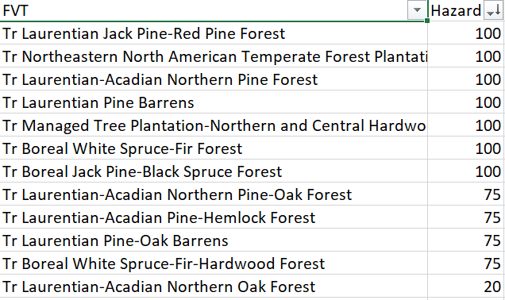

**Figure 1:** Example of hazard level column created for assigning to FVT.

|  |  |  |
| --- | --- | --- |
| Veg Type | Hazard Level | Hazard Class |
| Evergreen Forest | 100 | Very High |
| Deciduous Forest | 6 | Low |
| Mixed Forest | 75 | High |
| Mixed Forest | 50 | Mod/High |
| Woodland | 100 | Very High |
| Low Shrub | 6 | Low |
| Tall Shrub | 6 | Low |
| Agriculture | 0 | Very Low |
| Open Shrub | 20 | Low/Mod |
| Herbaceous | 6 | Low |
| Sparsely Vegetated | 0 | Very Low |
| Grassland | 6 | Low |
| Wetland | 0 | Low/Mod |
| Shallows/Littoral | 0 | Very Low |
| Barren | 0 | Very Low |
| Water | 0 | Very Low |

**Table 1:** Hazard level and class for each vegetation type, used as reference during crosswalk.