Camera Base

Version 1.7

User Guide

Mathias Tobler

September 2015

Table of contents
1 Introduction 3
2 License 4
3 Overview 5
3.1 Data Management 5
3.2 Analysis and outputs 5
4 Installation 6
4.1 System requirements 6
4.2 Installation 6
4.3 Settings 8
4.4 Update to a new version of the database 9
4.5 Known Problems 9
5 Entering Data 10
5.1 Overview 10
5.2 Entering information for a survey 11
5.3 Entering data for each camera station 12
5.4 Entering images 13
5.5 Batch-processing images from digital cameras 15
5.6 Editing species names 19
6 Reports and Queries 20
6.1 Reports 20
6.2 Queries 21
6.3 Additional queries 23
6.4 Exporting data for analysis in other programs 24
7 Capture-Recapture Analysis 30
7.1 Identify individuals 30
7.2 Run the analysis in CAPTURE 31
7.3 Calculate the Mean Maximum Distance Moved (MMDM) 32
8 Version History 33
9 Links to software for data analysis 36
10 Acknowledgements 37

Introduction

Camera trap surveys produce hundreds if not thousands of photos during each survey. Managing all those photos and the corresponding information can be a difficult task. Camera Base is a tool that should help biologists manage the complete data for multiple camera trap surveys and provide tools for different types of data analysis. The tool was written and used to manage two surveys we carried out in Peru and has saved us a lot of time.
Camera Base is based on Microsoft Access and requires an installation of Access to run properly. All of the code was written in Visual Basic for Applications and can be accessed through the database. Feel free to make modifications to the database to meet your requirements. I am a biologist and not a computer programmer, so some of the code might be a little messy. Should you add a new module or make an improvement you think might be useful to other users, please let me know and I can include it in the official release. We tested the software with several different datasets and I hope I have eliminated most bugs. If you are having problems feel free to contact me. I am also interested in feedback that could help me improve the software.

License

This file is part of Camera Base (Copyright 2012 Mathias Tobler).
Camera Base is free software: you can redistribute it and/or modify it under the terms of the GNU General Public License as published by the Free Software Foundation, either version 3 of the License, or (at your option) any later version.
Camera Base is distributed in the hope that it will be useful, but WITHOUT ANY WARRANTY; without even the implied warranty of MERCHANTABILITY or FITNESS FOR A PARTICULAR PURPOSE. See the GNU General Public License for more details.
You should have received a copy of the GNU General Public License along with Camera Base. If not, see <http://www.gnu.org/licenses/>.

Overview

Data Management
- Manage multiple surveys in one database
- Manage all photos of all species
- Batch import data from digital cameras
- Link photos to the data for browsing within the database
- Identify individuals for capture-recapture analysis interactively
- Manage the exact days cameras were operating

Analysis and outputs
- Show a summary of number of photos and capture frequencies (N captures / 1000 camera days) for each species
- Show a photo report for each species
- Run capture-recapture analysis in CAPTURE directly out of Camera Base
- Calculate Mean Maximum Distance Moved (MMDM)
- Show activity pattern graphs
- Automatically assign to each photo if it was taken during the day, night or dusk or dawn based on sunrise and sunset calculated for the survey location for each specific date.
- Mark each photo as independent or dependent event based on a user defined minimum time interval.
- Export data to Mark, DENSITY, Presence, EstimateS and other statistical or GIS software

Installation

System requirements
Camera Base was tested with MS Office XP 2002, 2003 and 2010. It should work in future Office versions but might need some testing. It will probably not work properly in Office 2000 or earlier versions.
Hard drive space: The installation uses about 10 MB of space. The space required for your photos largely depends on the resolution but can be 100s of MB for a whole survey.
RAM: 512 MB is generally recommended if you are running Windows XP. However, the database should work fine with less RAM. The photo report requires a lot of memory and you might run into problems when creating a report with a large number of images.

Installation
Unzip the files to a new folder. You should see the following directories and files:

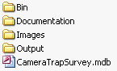

The folder Bin contains files needed for image processing. The folder Capture contains all the files necessary to run the program CAPTURE. The folder Images is where all the image files will be stored after they are imported to the database. Make sure there is enough room for the images on the drive you install the database. The folder Output will be used by the database and by CAPTURE to store input and output files for capture-recapture analysis.
Open the database CameraBase.mdb. You might get a message telling you that the file might contain harmful code. This is because much of the functionality of the Camera Base was written in Visual Basic for Applications (VBA). Tell Access to open the file. If you get an error message telling you that Access can not open the file for security reasons you need to change your security settings. Select Tools – Macro – Security… from the menu and set the security level to Medium.

Video player
By default Camera Base uses the Windows Media Player (WMP) to play video files. On some systems or with some files the WMP freezes frequently. As an alternative you can use the VLC Player (http://www.videolan.org/). Make sure you install the version with the Active X control and select VLC Player under settings.

Important fixes
There are several fixes included in the Fixes directory. Some of them change registry entries that make Access work better with Camera Base.

Registry fixes

- By default Access will show a dialog when loading an image. This makes browsing images slow and can result in Access cashing when quickly moving from one image to another. To avoid this problem double-click on the ImageRegistryFix.reg file in the Fixes directory and let Windows add the information to the registry.
- For certain processing commands Access will produce an error when the number of records is large. The MaxLocksPerFileFix.reg fix will increase the maximum value in the registry. Activate it by double-clicking on the file.

Reconyx Hperfire problem
Some Reconyx Hyperfire cameras don't store the date and time in the standard EXIF format. Instead they store that information in the Maker Notes. Fortunately there is an easy way to copy the DateTime information from the MakerNote to the actual EXIF DateTime field using Phil Harvey's ExifTool (http://www.sno.phy.queensu.ca/~phil/exiftool/). The EXIFTool is included in the Fixes folder. The EXIFTool can also batch extract EXIF data.

Here the command that will process all images in all subdirectories of a given directory (replace DIR with the path of the directory containing all image directories)
exiftool "-DateTimeOriginal>DateTimeOriginal" -r -overwrite_original -ext .JPG DIR

Easy steps to apply this fix to all of your images:

- Copy the exiftool.exe and FixHyerfire.bat files into the directory where your images are (they can be in subdirectories). So if your images are in C:\Images\Camera1, C:\Images\Camera2 etc. copy it to C:\Images.
- Run the FixHyperfire.bat by double-clicking on it. This will update all the images in the directory and all subdirectories.

Other possible problems
Before you can start using Camera Base you might need to activate some references in Visual Basic. This needs to be once on each computer running Camera Base. Open The Visual Basic editor form the menu Tools.. Macro.. Visual Basic Editor. In the Visual Basic editor choose Tools… References and make sure the following references are selected:
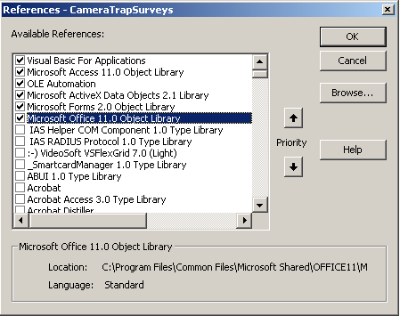
- Visual Basic For Applications
- Microsoft Access 1x.0 Object Library
- OLE Automation
- Microsoft ActiveX Data Objects 2.1 Library
- Microsoft Forms 2.0 Object Library
- Microsoft Office 1x.0 Object Library
The version number can vary depending on the version of Office you have installed.

Settings
Before you can start working with the database you need to make sure all the settings are right. In the main menu that is shown when you open the database click on Settings. In the dialog that opens make sure that all the paths point to the correct directories.
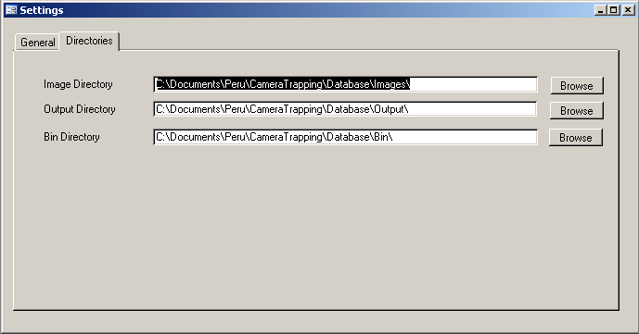

Update to a new version of the database
Unfortunately in Access the data and program code are stored in a single file. So in order to update to a newer program version you will have to transfer your old data to the new version. This can be done in the following steps:

- Download the new version from the web.
- Export the data using the Export XML command.
- Open the new, empty database and import your data using the Import XML command. If there is already existing data in your database you will most likely get an error message.
- If you have custom queries, reports or forms you can import them using the Get External Data… Import… command in Access.
- After importing all the data repair your database with Tools… Database Utilities… Compact and Repair Database… This will prevent possible problems with the indices of various tables.

Known Problems
There are a few known bugs that are related to limitations of Access.

- Moving rapidly from one image to another can cause Access to crash or show an error message. This can be fixed by applying the registry fixe included with Camera Base. To apply the fix just open the file ImageRegistryFix.reg . For more information see this link http://www.ammara.com/access_image_faq/access_loading_image_dialog.html
- Creating an image report can take a long time or even freeze your computer. Again this is related to the limitations of Access for image handling. Creating reports with hundreds of images uses a lot of memory. Unless you have a large amount of free memory it is recommended to limit reports to species with up to 30-50 photos.

Please report additional problems with a description of the error message and what you were doing.

Entering Data

Overview
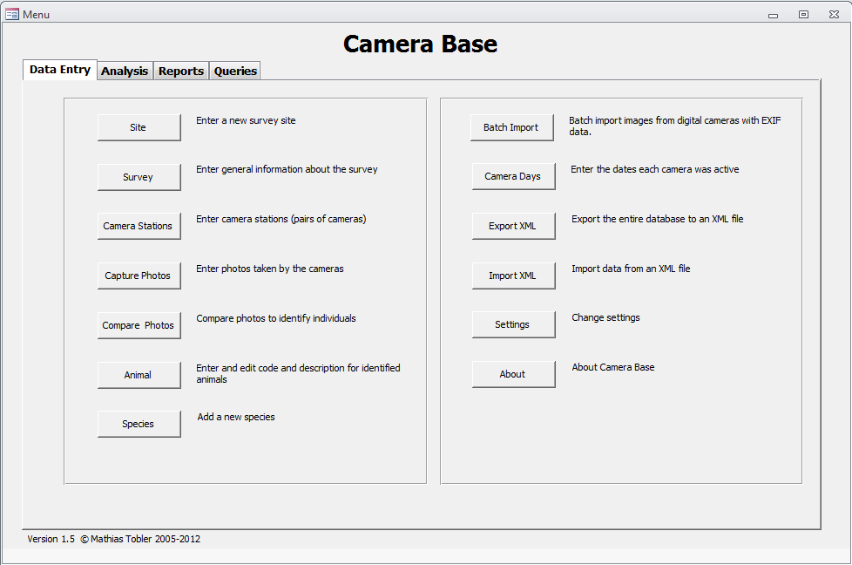

All the functions of Camera Base can be accessed through the main menu. There are different tabs for data entry, analysis, reports and queries.
The following order of entering data is recommended:
- Enter a Site name
- Enter the survey information
- Enter the information for each camera station
- Enter all the photographs
- Compare photographs to identify individuals
- Analyze your data

The following chapters describe each of these steps in details.

Entering information for a survey
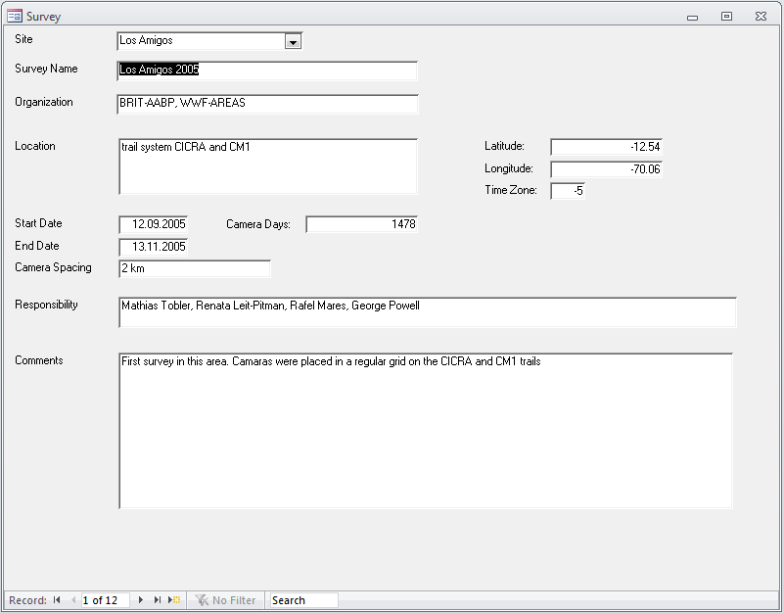
This dialog lets you enter general information on the survey.

Survey Name A reference name for the survey. This name will be used throughout the database to refer to the survey.
Project Name of the Organization conducting the survey.
Location A general description of the survey location.
Latitude Latitude in decimal degrees for the survey site. Sites south of the equator have a negative number. This value is needed to calculate sunrise and sunset for the activity patterns.
Longitude Longitude in decimal degrees for the survey site. Sites west have a negative number. This value is needed to calculate sunrise and sunset for the activity patterns.
Time Zone Time zone of the survey site with respect to GMT. This value is needed to calculate sunrise and sunset for the activity patterns.
Start Date The first day of the survey.
End Date The last day of the survey.
Camera Days The number of camera days as the sum of the days each camera was active. This number is used to calculate capture frequencies.
Camera Spacing Average distance between cameras.
Responsibility The people in charge of the survey.
Comments General Comments

Make sure you correctly enter the start and end date. These values will be used by many of the output queries and analysis to filter the data.

Entering data for each camera station
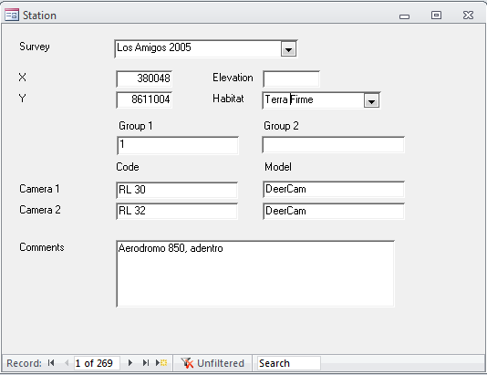

This dialog lets you enter data on each camera station. A station is defined as a location where one or two cameras are set up.

Survey The name of the survey this station belongs to.
X X coordinate of the station location in projected or geographic coordinates.
Y Y coordinate of the station location in projected or geographic coordinates.
Elevation Elevation above sea level.
Habitat Habitat type at the station location.
Group 1 A code or covariate for camera which allows you to organize cameras and later filter by group. This information is not required.
Group 2 A second code or covariate for camera which allows you to organize cameras and later filter by group. This information is not required.

Code Code for each camera.
Model Model of each camera.
Comments Comments for the station.

Entering images
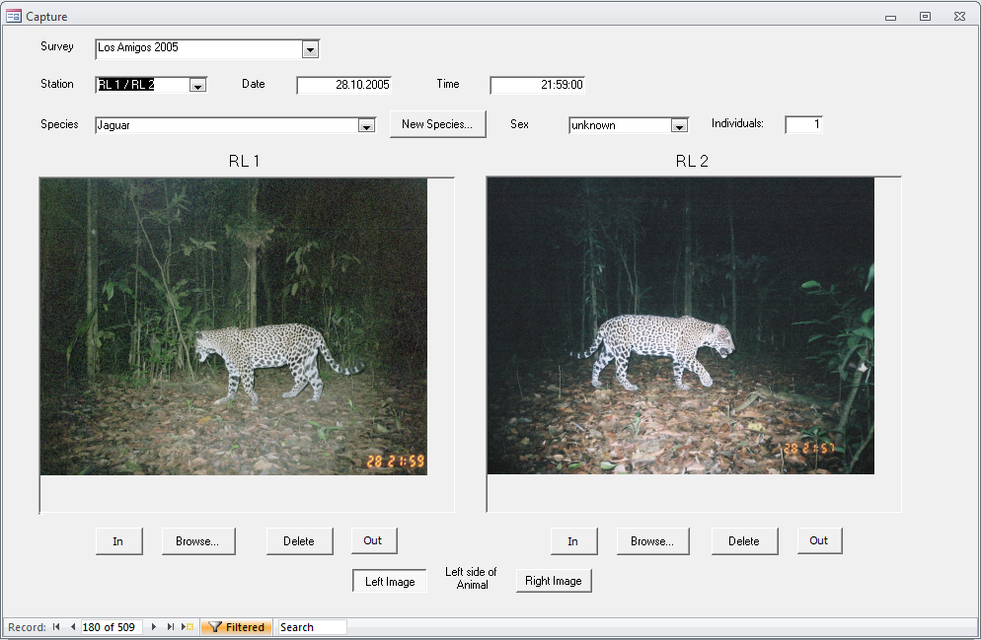

This dialog lets you enter all the photographs and the associated information. To move from one record to the next use the navigation bar at the bottom left.

Survey The name of the survey you want to enter photos for. You need to select a survey before you can enter photos.
Station The station you want to enter photos for. The drop-down list shows you all the stations you entered for the chosen survey. Stations are show with the code of the two cameras.
Date The date the photo was taken. This information is mandatory.
Time The time the photo was taken. This information is mandatory too.
Marked Use this field to mark images (e.g. especially good images, images that need further revision). You can then filter on that field.
Species The species shown on the photo. You can enter a new species using the New Species… button.
Sex The sex of the animal shown.
Individuals Number of individuals seen in the photo.
Left side of Select which image shows the left side of the animal. This information
Animal will be used in the identification module and to format the image
report.
Browse Browse for an image file
Delete Delete an image file. This will also delete the file from your image directory.
The program automatically makes a copy of the photos in the folder specified under Settings for storing images. The photo will automatically be renamed using the following convention: CameraName_Date_Time.jpg. A photo taken by camera Cam1 on the 15th of August 2005 at 15:34 will be named Cam1_20050815_1534.jpg. All photos from the same survey are stored in a subfolder. In order for the program to rename the file correctly it is required that you fill in the station name, date and time.

Important: Images entered with a time of "0:00" are not used in the activity pattern analysis. This allows you to enter images with a missing time stamp without affecting your activity analysis. Should you have an image that was taken exactly at midnight, enter it with a time "0:01".

Filter images

You can filter the images shown by different criteria. This is very useful if you want to see only images by a specific station or from a single species.
- To filter images click on the Filter by Form button:
- Select a station, species and/or sex from the drop-down lists
- If you want to filter by a specific date enter the date in the date field
- Apply the filter using the Apply Filter button
- To remove the filter click on the Remove Filter button

With the filter applied you can edit records but you can not add new records.

Batch-processing images from digital cameras
Most digital camera traps store the date and time when a picture was taken in the EXIF data of the image file. This information can be used to automatically organize images and match pairs of images from two cameras at a station. The Batch Image Import module allows you to quickly process a large number of images from digital cameras. You can move through the images with the arrow keys.

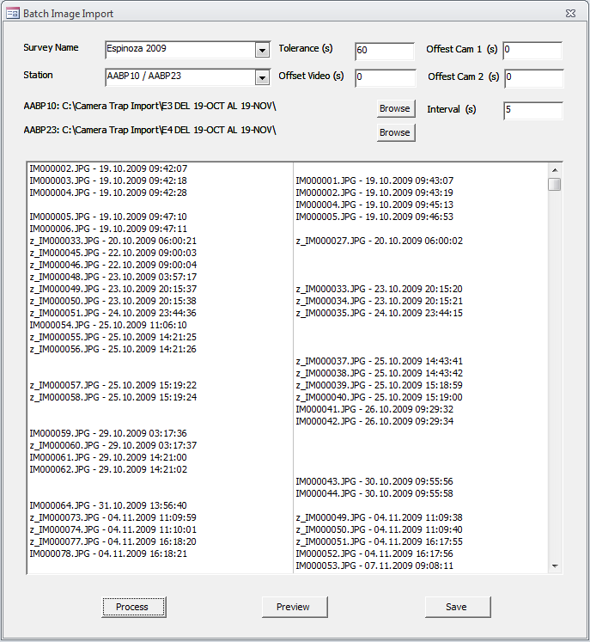

Survey The name of the survey you want to enter photos for. You need to select a survey before you can enter photos.
Station The station you want to enter photos for. The drop-down list shows you all the stations you entered for the chosen survey. Stations are show with the code of the two cameras.
Tolerance The maximum time difference between two images to still be considered a pair.
Offset Cam 1 This field can be used to correct the time of Camera 1. Often the camera clock is off by a few seconds or even minutes, making it impossible to match images between the two cameras. With this field you can correct the time for Camera 1. E.g. if you enter a value of -30, 30 seconds will be subtracted from the time of Camera 1.
Offset Cam 2 Same as Offset Cam 1 for Camera 2.
Offset Video Time difference between the true time and the file Date Modified time for all video files. The Date Modified time ready by camera base can differ from the true time the video was taken if the time zone has changed. The value has to be entered in seconds.
Interval (s) The maximum interval in seconds between two photos to be considered a series. E.g. If your camera takes 5 photos with a interval of 2 seconds for each trigger event, then set this value to 3 seconds.
Process Processes all the images in the selected folders and matches pairs.
Preview Shows the preview window that lets you specify the species and sex for each animal.
Save Imports all the images and saves the data to the database.

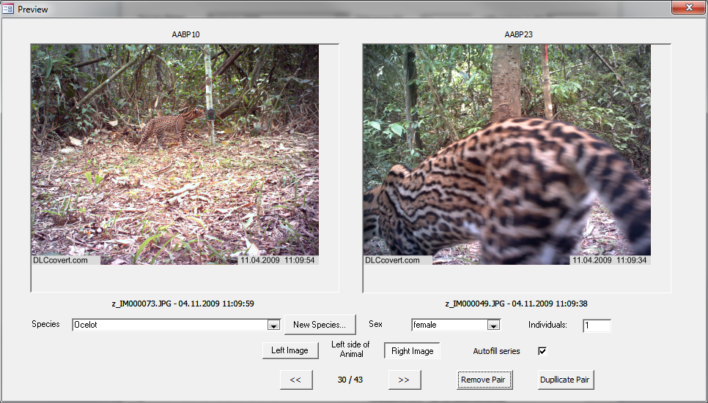

Species The species shown on the photo. You can enter a new species using the New Species… button.
Sex The sex of the animal shown.
Left side of Select which image shows the left side of the animal. This information
Animal will be used in the identification module and to format the image
report.
Autofill Series Many new camera models can take multiple photos every time they are triggered. For those photos the species and sex information will usually be the same for all. If this option is selected that information will automatically be filled in for images series.
Marked Use this field to mark images (e.g. especially good images, images that need further revision). You can then filter on that field.
Remove Pair Mark the current image pair for removal so it won’t be imported. The can be undone by clicking on the button again.
Duplicate Pair This will duplicate the image pair and import it twice. This can be useful to record multiple individuals or species that occur in one single picture. When entering information for the duplicated image pair make sure to temporarily disable Autofill series.

The steps of a typical batch import session:
- Select the survey and station you want to import images for
- Select the tolerance values (suggested values are between 30 and 120 seconds)
- If you know the time offsets of your cameras enter them now.
- Browse for the folder containing images from Camera 1.
- Browse for the folder containing images from Camera 2.
- Process the images.
- Make sure the times shown in the list match the time stamp in the image or video.
- Verify that matching pairs really show the same individual. If you have no matching pairs the clocks of your cameras might not have been synchronized well enough. Examine the data and use the Offset fields to correct the problem.
- If needed correct offset values and process the images again.
- Use the preview form to add species information to all images.
- Save the data to the database.

Opening a previous batch import session
Any batch session is continuously saved so that you won’t lose any data when you close batch processing without saving or if a batch session should crash. When you open Batch Processing the next time a window shows a list of unfinished batch sessions. You can Load a previous session, Delete a previous session or start a New session.

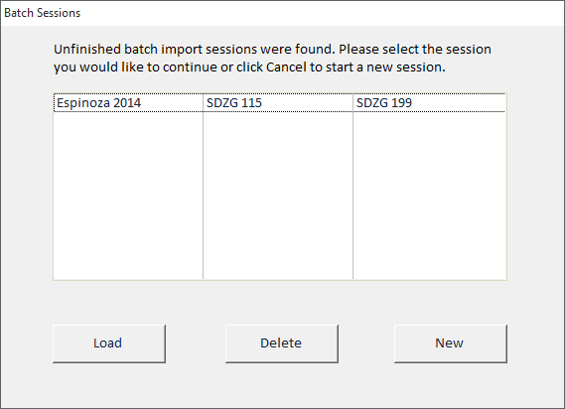

Batch-deleting images
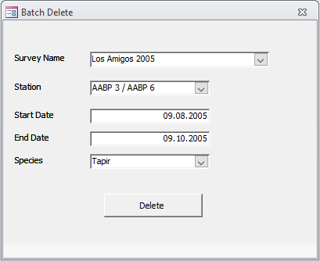
Sometimes images get imported wrongly and one needs to delete a whole series of records. Batch delete gives an option to delete records and the associated images based on several criteria.

- Select the survey.
- Select the station for which you would like to delete records.
- Select a Start Date and End Date. If no dates are selected all records for that station will be deleted
- Optionally select a species for which you want to delete records.

Enter camera days
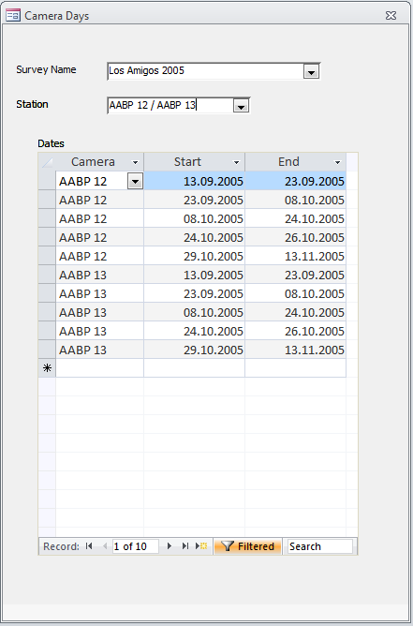
This module allows for the management of the dates when each individual camera was operating. Due to the time it takes to set and retrieve cameras, camera failure or empty batteries not all cameras are usually active for the whole duration of the survey. The exact dates when a camera was active can be entered into this form. Dates are entered in blocks often corresponding to the start and date of a roll of film or memory card. The end date of one record can be equal to the start date of the next one. Data does not need to be entered in chronological order.

To enter data select a survey and a station. Then select the camera from the drop-down menu and enter the start and end data for the period the camera was active. When done entering the information for a particular station select the next one.

This data can be summarized and exported and is also being used when exporting data for occupancy analysis (currently only in the RMark format) and for analysis in Density (see 6.4).

Editing species names
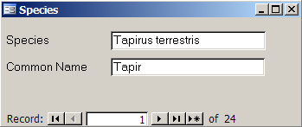

This dialog lets you enter species names and add new species to the database.

Reports and Queries

Reports
There are a number of predefined reports. You can create additional reports using the tools provided by Access.

Surveys
This report shows information on all the surveys present in the database.

Species
This report shows a summary of all the species recorded in a survey, the number of photos for each species and the number of stations where the species occurred and the capture frequency as photos/1000 camera days. All values are based on independent events. The time between two events for them to be independent is defined under Settings.

Captures
This report shows a list of photos taken for each species. For each photo it shows the date, time and station where the photo was taken. If individuals were identified, it reports the information by individual.

Animals
Shows the different individuals identified for each species.

Photos
This option creates a report of all the images for a chosen species in a chosen survey. For each image the station information, date and time are given. If individuals are identified images are grouped by individual. Access is limited in its capability of handling images. If there are many images for a species Access will use a lot of memory or the report might crash. Reports work well up to 50 images, depending on your system’s resources.

Activity 1
This report shows a summary for each species of how many photos were taken during the day, night or dusk and dawn. Values are calculated based on sunrise and sunset for each day based on the coordinates entered in the Survey form

Activity 2
This report shows you dynamic activity pattern graphs. You can select different species and different Surveys. You can modify different properties of the pivot chart.

Export Photos
This report lets you export photos for a particular species to a new folder. If individuals have been identified their name can be included as part of the file name.

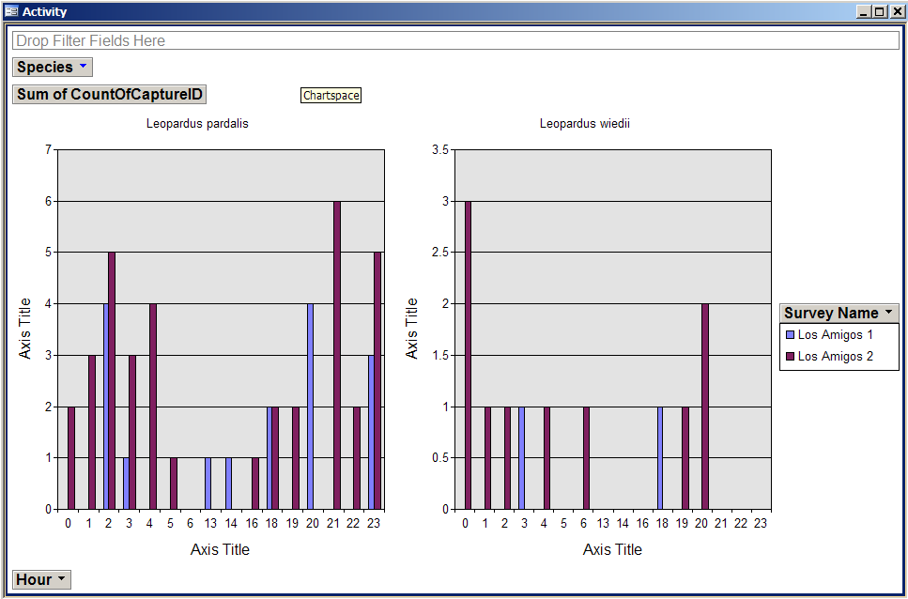

Queries
Export
This option opens all the data in a tabular format for exporting to Excel or a statistical package. To export the data select all records and copy then paste them over to Excel. If you would like to export the data in a different format or add additional fields, you can build your own query in Access. There are more predefined queries available in the query list of Access. Please do not delete any of those queries since some of them are needed to create the reports.

If you would like to export only a subset of the data (e.g. only one survey or only one species) you can easily create a filter.

- Click on the Filter by Form button:
- Select the desired options from the drop-down menus
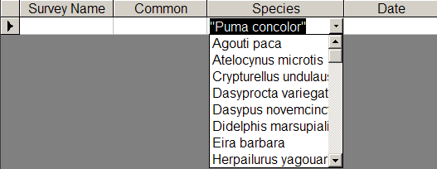
- Apply the filter using the Apply Filter button
To remove the filter click on the Remove Filter button

Species
Shows the species list with the number of images and capture frequency.

Habitat Use
This shows the number of photos in each habitat type for each species and survey.

Sex Ratio 1
Sex ratio based on identified individuals.

Sex Ratio 2
Sex ratio based on information provided when entering data in the Capture Photos form.

Activity
Shows activity patterns for all species organized by number of photos by hour.

Activity 2
This query shows a summary for each species of how many photos were taken during the day, night or dusk and dawn. Values are calculated based on sunrise and sunset for each day based on the coordinates entered in the Survey form.

Animals
Generates a summary of the number of captures for each identified individual for each survey.

Mapping
This query was made for mapping the number of photos of each species taken by each station. This data can easily be imported into GIS software to map the distribution of photos.

Additional queries
Additional queries can be found in Access’s query list. Some of these queries are needed for the reports so please don’t delete or make changes to them. You can build your own query using the tools provided by access.
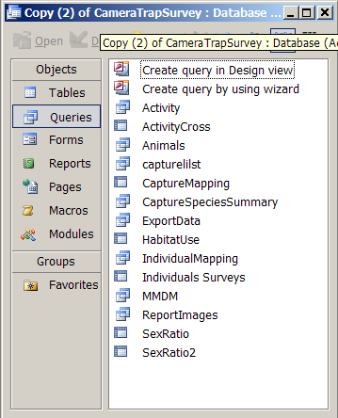

Useful additional queries are:

Individual Mapping: Returns a list of capture events with coordinates for each identified individual. You can use filter to reduce your list to a specific species or individual. This list can then be imported into a GIS for mapping.

Individuals Surveys: This query shows the number of photos taken for each individual for each survey. This is especially useful if you want to look at the occurrence of individuals in different surveys at the same place.

Exporting data for analysis in other programs
Camera Base has a variety of options for exporting the data in the correct format for analysis in a variety of software packages such as Mark, Presence and EstimateS. To export the data select the format from the Analysis tab.

Capture History Export

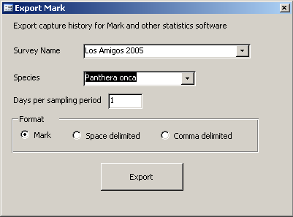

This option lets you export capture histories for analysis in MARK (http://warnercnr.colostate.edu/~gwhite/mark/mark.htm) and other software packages.

Survey Name The survey you want to export data for
Species The species you want to export data for
Days per sampling period The number of days that are treated as one sampling period. Multiple captures of the same individuals during one sampling period will be treated as one capture. Note that leftover days will not be considered. For example if your survey time was 62 days and you choose 6 days per sampling period you will get 10 sampling periods of 6 days and the last two day won't be used.
Format The export format; Mark, space delimited text file or comma delimited text file.

Export for DENSITY

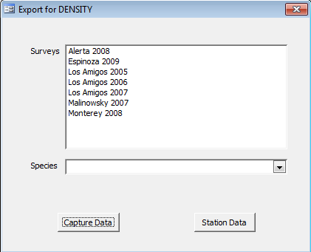

This option lets you export capture-recapture data to DENSITY. Data from multiple surveys can be combined and each survey will show as a session in Density.

Surveys The surveys you want to export data for. Multiple surveys can be selected.
Species The species you want to export data for
Capture Data Export the capture data to a text file in format TrapID.
Station Data Export the station data to a text file as Mutli Live.

Export for Occupancy Analysis

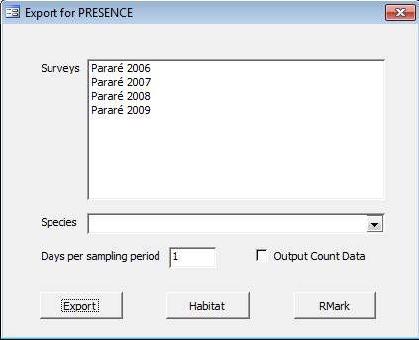

This option lets you export the data to PRESENCE (http://www.mbr-pwrc.usgs.gov/software/presence.html) for occupancy analysis. This can be done for all species and does not require individuals to be identified.

Surveys The surveys you want to export data for. Multiple surveys can be selected.
Species The species you want to export data for
Days per sampling period The number of days that are treated as one sampling period. Multiple captures of the same individuals during one sampling period will be treated as one capture. Note that leftover days will not be considered. For example if your survey time was 62 days and you choose 6 days per sampling period you will get 10 sampling periods of 6 days and the last two day won't be used.
Output Count Writes the number of events instead of 0 and 1 for each survey occasion.
Export Writes the detection history file for PRESENCE.
Habitat Writes a file with the habitat for each station that can be used as covariate.
RMark Writes a file that can be used to run occupancy models in RMark. The file contains the detection history as well as all covariates.

Export to EstimateS

This option lets you export your data for analysis in EstimateS (http://viceroy.eeb.uconn.edu/estimates). EstimateS lets you calculate rarefied species accumulation curves and a variety of diversity estimators. To import the data into EstimateS use the Format 4 (Sample, Species, Abundance triplets).

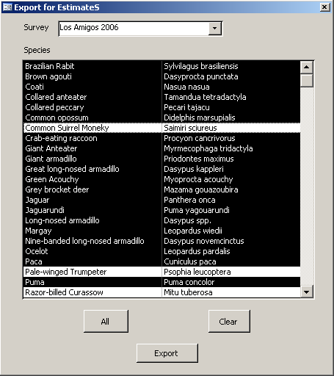

Survey The survey you want to export data for
Species The list of species you want to include. All selected (black) species will be included. You can exclude some species by clicking on them. You can also quickly select All species or Clear the selection.

Map

Shows a map with the distribution of photos of a species in the camera grid.

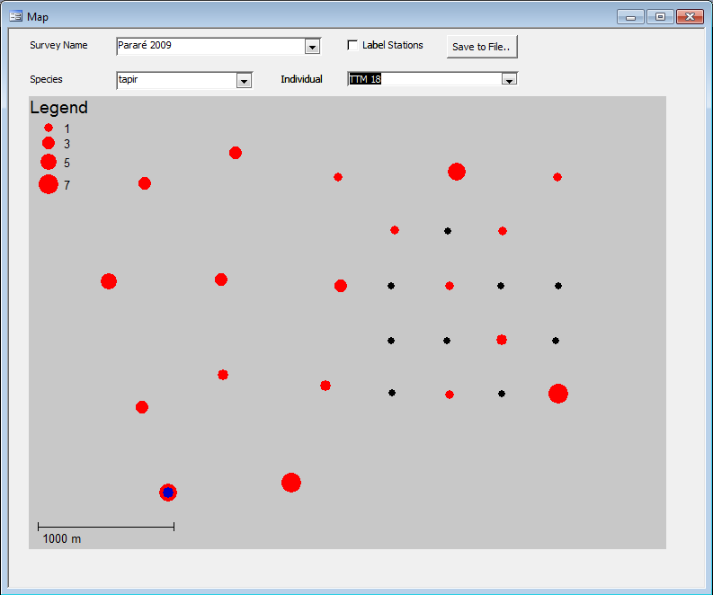

Survey The survey you want to show data for.
Species The species you want to show data for.
Individual The individual you want to show data for. Individual locations will be shown in blue.
Save to File Save the map to a Bitmap file.

Export Camera Days

Based on the camera day information entered (see 5.6) this report shows a summary of the start and end date as well as the exact number of cameras days for a survey. The information can also be exported as a data matrix for analysis outside of camera base. For the export data from several days can be pooled. In that case a camera or station is being considered active if at least one camera was running for one day. When the Station Summary box is checked that means that the exported data is being summarized by station instead of for each camera. A station is considered active when at least one of the two cameras was working.

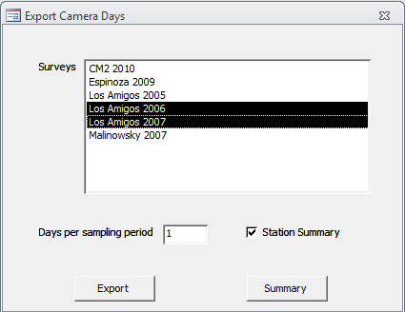

Capture-Recapture Analysis
Camera Base comes with a complete module for identifying individuals and running capture-recapture analysis.

Identify individuals

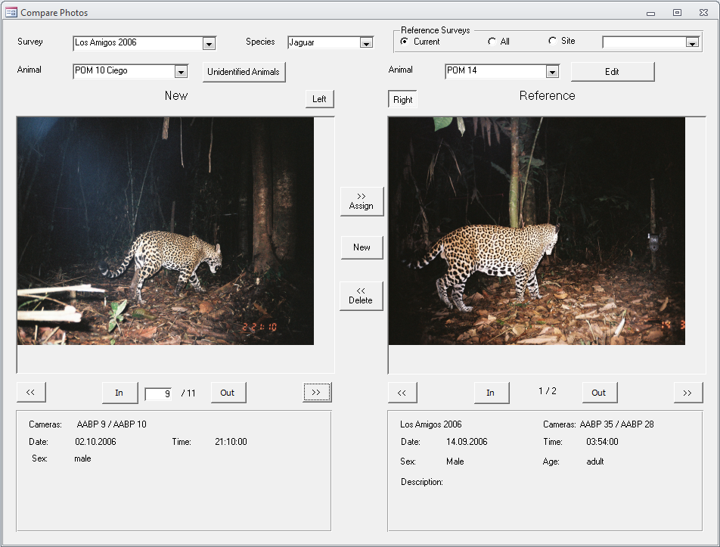

The window is divided into a left and a right side. The right side shows the reference image of individuals that have already been identified; the left side shows the photo to be identified. The number bellow the image shows you the current photo and the total number of photos for an individual (e.g. 3/5, showing photo 3 out of 5).

Survey The name of the survey you want to work on. This information has to be defined before you can start.
Species The species you want to work on. This is the second information you have to enter.
Reference Survey You can compare individuals to individuals from either the same survey only, from all surveys from the same site, or from all surveys in the database. The second option is especially useful if you conduct repeated surveys at the same site and would like to see which individuals were photographed in multiple surveys.
Animal This drop-down list lets you select an individual. On the left side you can either choose all unidentified individuals or an identified individual you want to check against others to verify your identification.
Left / Right Switches between the left and right side of the animal.
>> Assign Assign the left photo to the individuals selected on the rigth.
New Creates a new individual.
<< Delete Deletes the identification for a photo on the left side and marks it as unidentified.
<< and >> Move to the previous and next photo.
In / Out Zoom in and out of the photo.

Run the analysis in CAPTURE
Camera Base gives you the option to create an input file for CAPTURE or directly run an analysis in CAPTURE with the click of a few buttons.

Before you choose this option make sure the following information is present:

- The Start and end date for the survey are defined in the Survey dialog
- All individuals for the species of interest are identified
- The directories for the CAPTURE program and the Output directory are set correctly

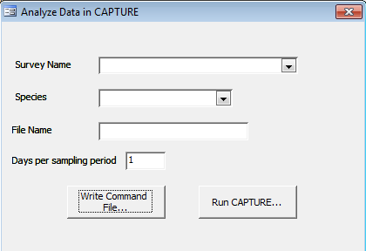

In the dialog select a survey, species and define a filename (without extension). Please limit the file name to 8 characters. CAPTURE is a DOS program and only handles filenames up to 8 characters.
You can either write an input file for CAPTURE which you can run later or you can directly run CAPTURE. If you choose the first option the input file will be written and will open in Notepad. If you choose the second option CAPTURE will open in a black window. Please wait until that window disappears until you click OK on the message box. After you click OK your output file will open in Notepad. All files (input and output) are stored in the Output directory you defined under Settings.

Calculate the Mean Maximum Distance Moved (MMDM)
You can calculate the MMDM for species where you have individuals identified. All individuals with photos form two or more stations will be considered. The results will be shown on the form and can be exported as a text file.

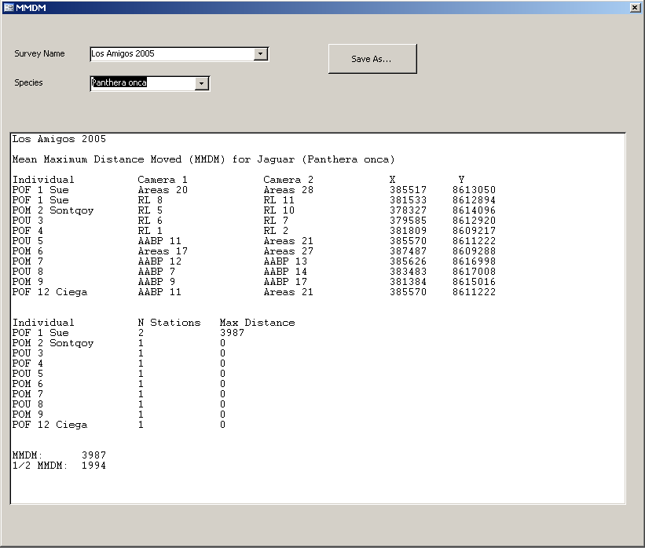

To create the MMDM report select a survey and a species and enter a filename (without extension). The file will be written to the output directory. Files with the same file name will be automatically overwritten.
In the first part the report lists for each individual all the stations where it had been photographed and gives the X and Y coordinates for each station. It then gives a summary for each individual listing the number of stations the animal has been photographed by and the maximum distance moved. At the end it lists the MMDM considering all individuals photographed by at least two stations.
Important: In order for the program to be able to calculate distances the coordinates for each station need to be in a projected coordinate system (e.g. UTM). Geographic coordinates (Lat/Long in decimal degrees) will return invalid results. The output units are in the units of the coordinate system (e.g. meters for UTM).

Version History

Version 1.7
- Completely re-wrote the batch import routine to save inport sessions at any time.
- Most windows now correctly scale on larger screens allowing to make the interface larger or smaller.
- Added support for the VLC video player as an alternative for the Windows Media Player. Make sure to install VLC with the Active X control option.
- There is a new Batch Delete function to delete series of images.
- Images can be easily marked (e.g. interesting images, images that need revision).
- Image export includes more options.
- Added more error checking
- Updated the independent event code to use the time since the last independent event instead of the time since the last picture.
- Removed dependency on comdlg32.ocx (finally!)
- Fixed several smaller data export bugs.

Version 1.6.1
- Added Group 2 to the header for RMark Occupancy export and fixed problem with covariates values
- Fixed an error with the duplicate image file name check
- Added image name to compare interface.
- Filter is now applied to EstimateS Export.
- Increased maximum size for directory settings to 255 characters from 100 characters
- Fixes problem with count export for occupancy models.
- Fixes problem with cameras not exporting for mapping if habitat was missing.
- Fixed an issue with importing large XML files.

Version 1.6
- Fixed an bug that prevented version 1.5.1 to run on older Office versions
- Added the ability to batch-import video files based on the Date Modified of the file.
- Changed the sort algorithm to a non-recursive algorithm that works with a much larger number of images.
- During batch import image pairs can now be marked for removal and this can be undone.
- During batch import images can be easily duplicated to account for multiple individuals/species.
- Camera Base now checks if the directories defined under Settings exist and gives a readable error message if they don’t exist.
- Tweaked the EXIF import routine to be more error resistant.
- Increased the number of characters for the Group 1 and Group 2 fields to 100.

Version 1.5.1
- Updated the code to work with the 64bit version of Office 2010.
- Fixed a bug that would cause an error when the number of individuals entered in the batch import was larger than 1.
- The export for occupancy analysis in PRESENCE now masks out days when cameras were not active if that information is available.

Version 1.5
- New form for entering camera day information to track when individual cameras were active.
- Camera day information is being used to mask out days when cameras were inactive in occupancy and DENSITY analysis.
- Added two new fields to the station table: “Elevation” and “Group 2”. “Group” was renamed to “Group 1”.
- Added an individual field to the capture table to enter the number of individuals in a photo.
- The image import routine now makes sure that each image name is unique. This resolves a problem where images where overwritten when the date and time were identical, a problem with recent rapid fire technologies.
- Fixed many bugs and added more error checking.

Version 1.4
- New batch import functionality for images from digital cameras
- Enhanced export function for occupancy analysis. Data from multiple surveys can now be combined and data can be exported to RMark.
- New export module for capture-recapture analysis in DENSITY
- New mapping functionality for easy visualization of the distribution of events
- Movie files can now be used together with images.

Version 1.3.5
- Fixed a bug that would show an error if only one camera was defined for a station
- Errors caused by missing images are now handled properly
- Seconds are now included in the file name
- A warning is now shown when an image file is missing.

Version 1.3
- Added a new table "Site" that lets you combine surveys from the same site
- MMDM now shows results in the window
- MMDM can use geographic or projected coordinates
- New option to export capture histories in different formats (e.g. Mark)
- New option to select the number of days that are treated as one survey event for capture-recapture analysis
- New option to export data for occupancy analysis in Presence
- New option to export data to EstimateS for species diversity analysis
- In the "Compare Photos" window you can now filter individuals by site
- Activity queries now ignore events with time "0:00", that time can therefore be used for photos with missing time
- Moved CAPTURE.exe to the Bin directory
- Moved the small images into the survey image folder
- Fixed various small bugs and usability issues

Version 1.2

- Updated the activity pattern pivot table so that all hours are shown even if there are no data for some hours.
- Added new field “Independent” to table Capture, type Yes/No
- Added new field “CameraDays” to table Survey, type Long Integer
- Added new field “TimeEvent” to table Settings, type Long Integer
- Added a macro that automatically marks a record as an independent or dependent event. The macro is run when the Capture Form is closed.
- Added filters to use only independent events to all queries.
- Added capture frequency to the species summary report.
- Added new field “Lat” to table Survey, type Number Single
- Added new field “Long” to table Survey, type Number Single
- Added new field “TimeZone” to table Survey, type Number Integer
- Added new field “DayNight” to table Capture, Type Text 15
- Added a macro that defines for each photo if it was taken during the day, night or at dusk or dawn. The macro is run when the Capture Form is closed.
- Made small changes to the capture history routine.
- Added XML export and import functions
- Made small changes on the Compare Photo form
- Added an option to rename the original image file after importing to the settings
- Updated the main menu
- Added automatic extraction of date and time from EXIF data for digital cameras

Version 1.1

- Improved support for multiple surveys throughout the database
- Added support to compare animals between multiple surveys to the animal identification module
- Added a module to calculate the Mean Maximum Distance Moved (MMDM)
- Added new queries
- Added activity pattern graphs
- Added automatic resizing to create small images for the reports
- Moved over to Access 2003
- Created this User Guide

Version 1

This was the first working version of the database. This version was written in Access 2000 and served as a test platform.

Links to software for data analysis

R – Software for statistical analysis and modeling with many specialized packages
http://www.r-project.org/

MARK – Capture-recapture and occupancy analyses
http://warnercnr.colostate.edu/~gwhite/mark/mark.htm

RMark – R interface to MARK
http://www.phidot.org/software/mark/rmark/

DENSITY – Spatially explicit capture-recapture analysis
http://www.otago.ac.nz/density/

CAPTURE – Closed-population capture-recapture analysis
http://www.mbr-pwrc.usgs.gov/software/capture.shtml

PRESENCE – Occupancy analysis
http://www.mbr-pwrc.usgs.gov/software/presence.html

EstimateS – Species accumulation curves and diversity estimation
http://viceroy.eeb.uconn.edu/estimates

Acknowledgements
Initial funding for this work came from the Gordon and Betty Moore Foundation through a grant to the Botanical Research Institute of Texas. Camera trap work that led to the creation of this database was carried out in collaboration with the WWF AREAS project. Future work was carried out with the Office National de la Chasse et de la Faune Sauvage in French Guiana and recently with additional funding form the Gordon and Betty Moore Foundation and the Blue Moon foundation. I would like to thank Samia Carrillo-Percastegui for continuous input and testing during the development of this database.

The code used to calculate sunset and sunrise was translated from a NOAA Javascript to VBA by Greg Pelletier (gpel461@ ecy.wa.gov). http://www.ecy.wa.gov/programs/eap/models.html
Parsing EXIF data is done with the EXIF Reader Class: http://sourceforge.net/projects/exifclass/
Image processing is done with the help of the software Irfan View 3.98, written by Irfan Skiljan. http://www.irfanview.com/

