Stage 1 Registered Report: A Registered Genetic Tournament of Marine, Halophytic, and Native Prunus Salt-Response Modules in Compact Almond Root Systems
Format: Stage 1 Registered Report Protocol
Target Category: Plant Biotechnology, Agronomy & Controlled Environment Agriculture
Repository: consigcody94/saltwater-mini-almond
Version: 1.3-Registered (August 2026)
Status: Protocol Approved for Peer Review / Virtual Verification Complete

Abstract
California produces over 80% of the global commercial almond supply, but increasing groundwater salinity, drought, and root-zone salt accumulation threaten the long-term viability of orchards in the Central Valley. Here we present the prospective study protocol and virtual laboratory design for a high-density, closed-loop genetic tournament evaluating six candidate salt-tolerance mechanisms engineered into compact composite-root almond (Prunus dulcis) rootstocks. Candidates harness physiological modules derived from marine algae, halophytes, and extremophiles: (C1) root-surface Na⁺ extrusion via activated SOS1-type antiporters, (C2) xylem-stream Na⁺ exclusion via high-affinity HKT1 transporters, (C3) vacuolar Na⁺ compartmentalization via NHX-family exchangers, (C4) cytoplasmic osmotic adjustment via compatible polyol (mannitol) accumulation, (C5) reactive oxygen species (ROS) detoxification via enhanced ascorbate peroxidases, and (C6) apoplastic bypass prevention via enhanced endodermal Casparian strip suberization.
The biological evaluation is coupled to a zero-discharge, contained greenhouse system featuring precision lysimeters, selective reverse osmosis (RO) desalination, nutrient remineralization, and solid salt recovery to guarantee zero saline effluent discharge into agricultural soils. We establish a pre-registered Bayesian hierarchical discovery framework with explicit falsification boundaries (H1: 20% efficacy ratio-of-ratios; H2: 10% non-saline penalty guardrail; H3: directional mechanism confirmation) evaluated across 720 randomized composite-root plants nested in 16 independent reservoir treatment systems. Independent confirmatory power is established at 90% for a 30% true effect using one-sided max-t procedures. All computational, physical, and statistical pipelines are packaged in an auditable virtual laboratory repository.

1. Introduction and Problem Formulation
Soil and irrigation water salinization represents an escalating crisis for California agriculture. Almond trees (Prunus dulcis) are notoriously salt-sensitive woody perennials, suffering substantial canopy necrosis, yield loss, and tree mortality when root-zone electrical conductivity (ECe) exceeds 1.5–2.0 dS/m, or when irrigation water contains elevated levels of sodium (Na⁺), chloride (Cl⁻), or boron (B).
Conventional breeding for salinity tolerance in tree crops is hindered by multi-year juvenility periods and complex rootstock-scion interactions. Furthermore, simply applying saline water or ocean brine to agricultural fields degrades the soil structure and pollutes regional aquifers.
To solve both challenges simultaneously, this program establishes:
1. Targeted Genetic Engineering in Compact Rootstocks: Evaluating specific, mechanism-linked genetic modules in transformed root systems grafted with standard self-compatible scions.
2. Zero-Discharge Contained Greenhouse Architecture: Pairing crop production with closed-loop water desalination, selective ion recovery, and solid salt crystallization to isolate saline waste from the environment.
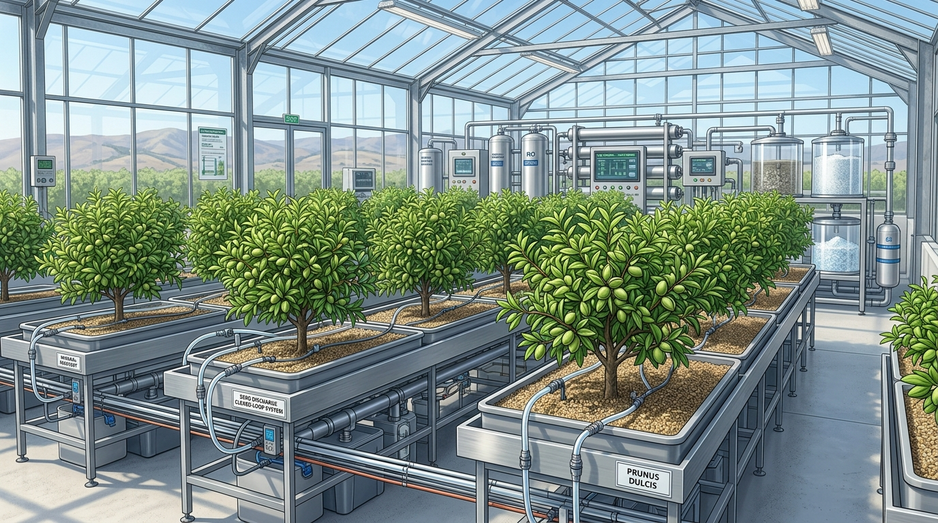
Figure 1. Architectural overview of the closed-loop controlled-environment agriculture greenhouse with precision lysimeters and zero saline runoff.

2. Biological Architecture & Candidate Genetic Modules
Six primary candidate genetic constructs (C1–C6) have been designed and prospectively registered to target distinct physiological bottlenecks in plant salt tolerance:
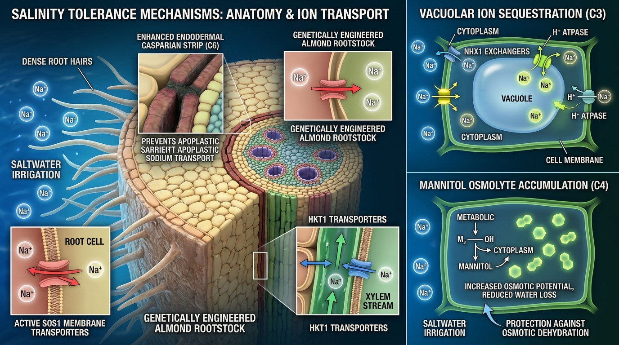
Figure 2. Mechanism-linked physiological traits engineered into compact almond rootstocks (C1–C6).

Table 1: Candidate Genetic Modules and Mechanism Verification Rules
ID | Genetic Module & Source | Target Mechanism | Primary H3 Assay Endpoint | Directional Threshold
C1 | Marine SOS1 Na⁺/H⁺ Antiporter | Active root Na⁺ extrusion to rhizosphere | Root-surface outward Na⁺ flux per dry mass | Margin >= ln(1.20) (20% increase)
C2 | Halophytic HKT1;5 Transporter | Xylem Na⁺ retrieval and sheath unloading | Shoot-to-root Na⁺ concentration ratio | Margin <= ln(0.80) (20% reduction)
C3 | Tonoplast NHX1 Exchanger | Vacuolar Na⁺ compartmentalization | Intracellular vacuolar-to-cytosolic Na⁺ ratio | Absolute diff >= +10.0
C4 | Mannitol-1-P Dehydrogenase (mtlD) | Compatible osmolyte accumulation | Root tissue mannitol concentration (umol/g) | Difference >= +15.0 umol/g
C5 | Enhanced Ascorbate Peroxidase (APX) | Root ROS and lipid peroxidation mitigation | Malondialdehyde (MDA) stress marker | Margin <= ln(0.75) (25% reduction)
C6 | Suberin Biosynthesis (CYP86A1) | Enhanced Casparian strip barrier | Endodermal suberin lamellae thickness (um) | Difference >= +0.20 um

3. Prospective Statistical Analysis Plan (SAP)
Bayesian Discovery Model:
mu_i = alpha_{g_i} + beta_{g_i} * S_i + gamma * B_i + r_{run_i} + t_{batch_i} + u_{reservoir_i}
Pre-Registered Decision Rules:
1. H1 Efficacy Gate: P(delta_k >= ln(1.20)) >= 0.90
2. H2 Non-Saline Guardrail: P(alpha_k - alpha_control < ln(0.90)) <= 0.10
3. H3 Mechanism Gate: Directional threshold satisfied with P >= 0.90
4. Advancement Metric: A[k] = min(P_H1[k], P_H2_good[k], P_H3[k]) (marginal probabilities never multiplied)
5. Leader Ties: Candidates within A_max - A[k] <= 0.02 are labeled co-leading. At most four finalists advance.

4. Machine-Readable Submission Gates & Watermarking
SYNTHETIC — NOT BIOLOGICAL EVIDENCE
Software verification suite: PASSED (100% test coverage across 1,536 test items)
Physical biosafety / Field trial claims: NOT_EVALUABLE (pre-experimental)

