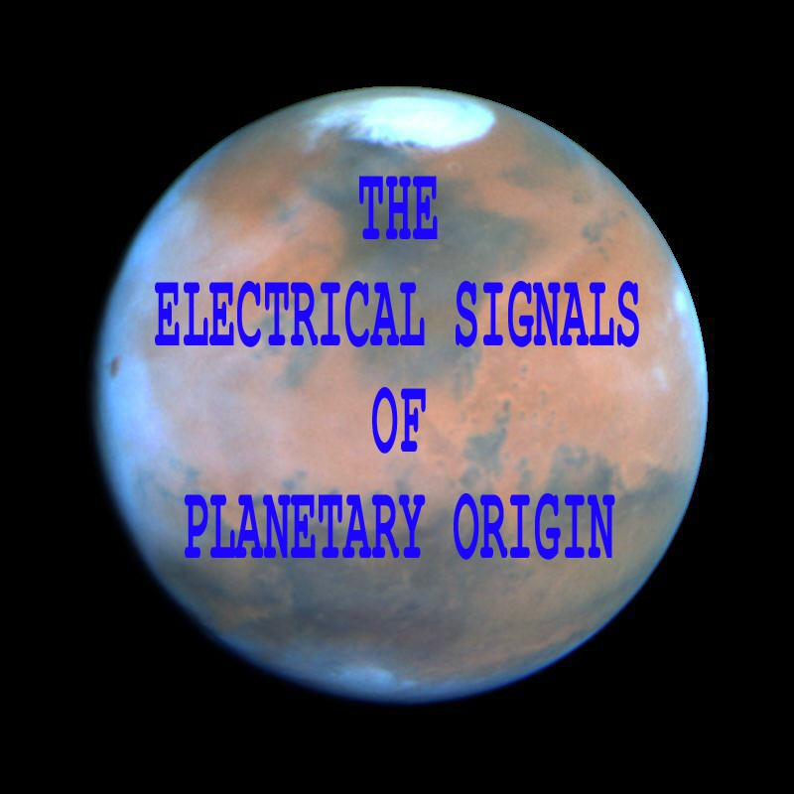

Adapted from the 5th International Tesla Conference: "Tesla. III Millennium", October 15-19,1996, Belgrade, Yugoslavia.

NIKOLA TESLA

AND

THE PLANETARY RADIO SIGNALS

By

Kenneth L. Corum* and James F. Corum, Ph.D.

© 2003 by K.L. Corum and J.F. Corum

"My ear barely caught signals coming in regular succession which could not have been produced on earth . . ."
Nikola Tesla, 1919

* This brief paper is condensed from the 1996 technical report Nikola Tesla And The Electrical Signals Of Planetary Origin, by K.L. Corum and J.F. Corum (81 pages). That document is available through PV Scientific, (http://www.arcsandsparks.com)

TESLA SPEAKS . . .

"We are getting messages from the clouds one hundred miles away, possibly many times that distance. Do not leak it
to the reporters."¹ Nikola Tesla, 1899

"My measurements and calculations have shown that it is perfectly practicable to produce on our globe, by the use of these principles, an electrical movement of such magnitude that, without the slightest doubt, its effect will be perceptible on some of our nearer planets, as Venus and Mars. Thus, from mere possibility, interplanetary
communication has entered the stage of probability."² Nikola Tesla, 1900

"Movements on instrument repeated many times. Concludes it to be a message from another planet."³
Newspaper Interview, 1901

"I did not state that I had obtained a message from Mars, I only expressed my conviction that the disturbances that I
obtained were of planetary origin."⁴ Nikola Tesla, 1901

"The feeling is constantly growing on me that I had been the first to hear the greetings of one planet to another."⁵
Nikola Tesla, 1901

"I refer to the strange electrical disturbances, the discovery which I announced six years ago. At that time I was only certain that they were of planetary origin. Now, after mature thought and study, I have come to the positive
conclusion that they must emanate from Mars."⁶ Nikola Tesla, 1907

"To be sure, we have no absolute proof that Mars is inhabited. . . Personally, I base my faith on the feeble planetary electrical disturbances which I discovered in the summer of 1899, and which, according to my investigations, could not have originated from the sun, the moon, or Venus. Further study since has satisfied me they must have emanated from
Mars."⁷ Nikola Tesla, 1909

"During my experiments there [Colorado Springs, 1899], Mars was at a relatively small distance from us and, in that dry and rarefied air, Venus appeared so large and bright that it might have been mistaken for one of those military signaling lights. . . I came to the conclusion that [Mars] was sufficient to exert a noticeable influence on a delicate receiver of the kind I was perfecting. . . my ear barely caught signals coming in regular succession which could not have been produced on earth, caused by any solar or lunar action or by the influence of Venus, and the possibility that
they might have come from Mars flashed upon my mind."⁸ Nikola Tesla, 1919

"The arrangement of my receiving apparatus and the characterof the disturbances recorded precluded the possibility of their being of terrestrial origin, and I also eliminated the influence of the sun, moon and Venus. As I announced, the signals consisted in a regular repetition of numbers, and subsequent study convinced me that they must have emanated
from Mars, this planet having been just then close to the earth."⁹ Nikola Tesla, 1921

"Twenty-two years ago, while experimenting in Colorado with a wireless power plant, I obtained extraordinary experimental evidence of the existence of life on Mars. I had perfected a wireless receiver of extraordinary sensitiveness, far beyond anything known, and I caught signals which I interpreted as meaning 1 -- 2 -- 3 -- 4. I believe the Martians
used numbers for communication because numbers are universal."¹⁰ Nikola Tesla, 1922

"In 1899, while experimenting with a wireless receiver of extraordinary sensitivity, I detected faint signals from Mars, our brother planet. I could not interpret the signals, but they seemed to suggest a numerical code, one - two - three -

four."¹¹

[Fig. 1. Mars]
Nikola Tesla, 1935

F
ig . 1 US
s,
on oE Jupi her anõ Juno , goõ oE War.

To the

American Red Cross

New York City.

The retrospect is glorious, the prospect inspiring: Much might be said of both. But one idea dominates my mind. This - my best, my dearest - is for your noble cause.
I have observed electrical actions, which have appeared inexplicable. Faint and uncertain though they were, they have given me a deep conviction and foreknowledge that ere long all human beings on this globe, as one, will turn their eyes to the firmament above, with feelings of love and reverence, thrilled by the glad news: "Brethren! We have a message from another world, unknown and remote. It reads: one ... two ... three ..."

Christmas 1900*

Nikola Tesla

*The date would appear to be Orthodox Christmas, January 7, 1900. Tesla died on this very night, exactly 43 years later. This is also the date of the last entry made in the Colorado Springs notes.

1

Prefatory Statement by the Authors:
The puzzling disclosures made by Nikola Tesla concerning the reception of extraterrestrial signals in 1899 have been a vexing dilemma and source of embarrassment to even the most ardent of Tesla's supporters in the scientific community. It is with some degree of trepidation that we even approach this subject. Initially, we were almost embarrassed to address such a controversial topic for fear of being misunderstood by our professional colleagues, or perhaps even causing damage to Tesla's reputation. However, we believe that the investigation reported on below will resolve specific technical objections to Tesla's assertions, and will lend strong support to the scientific credibility of Tesla's profound contributions to science and engineering. This paper is a brief summary of an 81 page engineering report from 1996 documenting the detailed analysis. As we approach the next Martian encounter (Mars will be only 34.6 million miles away on August 27, 2003 - the closest since 1719) our thoughts again turn to the faint radio emissions detected by Tesla in 1899.

NIKOLA TESLA AND THE PLANETARY RADIO SIGNALS

by K.L. Corum and J.F. Corum, Ph.D.
"Even these star-gazers stonisht are... and curse their lying bookes." Edmund Spenser, Faerie Queene, Bk. 7, Canto7

§ 1.0 Introduction.
Surrounded by a cloud of sensationalism, the controversial question of cosmic radio signals has probably spawned the greatest test of Tesla's credibility among professional scientists. In spite of the fact that Lord Kelvin, himself, stood with his old friend and proclaimed that he was in complete agreement with Tesla on this matter,^{12,13} the issue of "the Martian signals" is still exploited by misguided cynics to ridicule Nikola Tesla today. Tragically, many of Tesla's severest critics are woefully unaware of his professional credentials, activities, and stature in the scientific and industrial communities of his day.¹⁴
We believe that there is a sound explanation for the incident. Conducting both an experimental and a theoretical analysis, we discussed Tesla's 1899 receivers in considerable detail in a paper presented at the 1994 Colorado Springs Symposium,¹⁵ and we believe that both the operation and limitations of his Colorado Springs receivers are now well understood. Unlike his Extra Coil resonator (which operated with an output of 12-18 MV in the region of 88 kHz to 100 kHz [Fig.2]), the RF detectors functioned primarily in the 8 kHz to 22 kHz range. Initially, one might suppose that no extraterrestrial signals could ever be detected in this spectral regime because the ionosphere is opaque at these frequencies. Analytically and experimentally, this is demonstrably not the case. Under the appropriate conditions there does indeed exist an ionospheric window in the lower VLF regime, and surprising results have been obtained with receivers reconstructed as described by Tesla in 1899.

§ 2. Some History.
Before we launch into a technical discussion of the "Martian signals", we would first like to recall Tesla's actual published reports of the summer night that he made the initial observations of what may be asserted as the original pioneering achievement in radio astronomy. He described the discovery as follows:¹⁶
". . . Even now, at times, I can vividly recall the incident, and see my apparatus as though it were actually before me. My first observations positively terrified me, as there was present in them something mysterious, not to say supernatural, and I was alone in my laboratory at night ... [Fig. 3] The changes I noted were taking place periodically, and with such a clear
suggestion of number and order that they were not traceable to any cause then known to me. I was familiar, of course, with such electrical disturbances as are produced by the sun,* Aurora Borealis and earth currents,¹⁷ and I was sure as I could be of any fact that these variations were due to none of these causes ... It was sometime afterward when the thought flashed upon my mind that the disturbances I had observed might be due to an intelligent control. Although I could not decipher their me aning, it was impossible for me to think of them as having been entirely accidental. The feeling is constantly growing on me that I had been the first to hear the greeting of one planet to another. A purpose was behind these electrical signals; and it was with this conviction that I announced to the Red Cross Society [see above], when it asked me to identify one of the great possible achievements of the next hundred years, that it would probably be the confirmation and interpretation of this planetary challenge to us. Since my return to New York more urgent work has consumed all my attention; but I never cease to think of those experiences and of the observations made in Colorado. I am constantly endeavoring to improve and perfect my apparatus, and just as soon as practicable I shall again take up my investigations at the point where I have been forced to lay it down for a time ... Absolute certitude as to the receipt and interchange of messages would be reached as soon as we could respond with the number 'four,' say, in reply to the signal 'one, two, three.'"

To the informed mind of the early 20th century, however, the existence of a Kennelly-Heaviside layer precluded the possibility of radio astronomy and extraterrestrial radio communication. In his classic 1919 paper, G.N. Watson observed,¹⁸
"A consequence of [the existence of an ionospheric shell surrounding the Earth] places grave obstacles in the way of communications with Mars or Venus, if the desirability of communications with those planets should ever arise."

While it is understood that certain high frequency propagation windows exist through the ionospheric envelop, it is still commonly thought, even today, that the transparency of the

*The sunspot cycle was a minimum in 1901, and the Zurich sunspot number was 10, or less, from 1898 to 1902. [ See Fig. 4.2.]

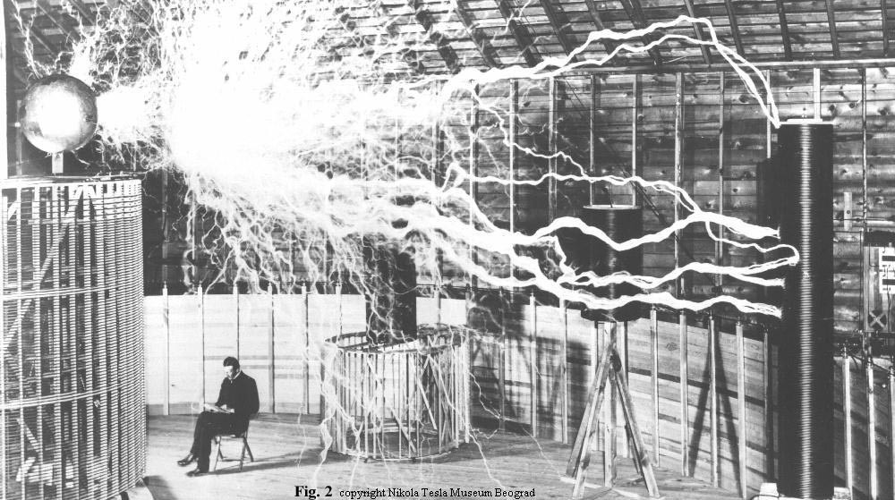

Fig. 3 Alone in my laboratory at night...

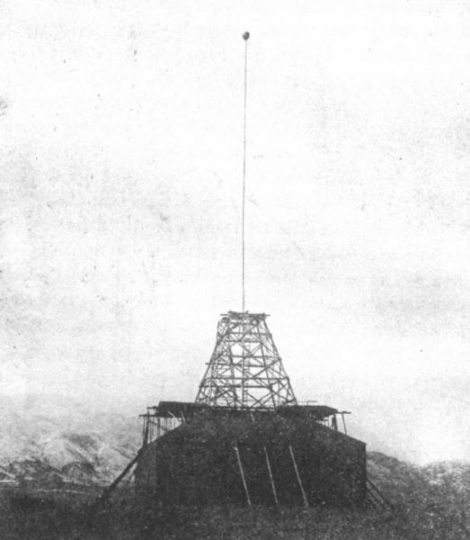

2

ionosphere is negligible at Tesla's frequencies of observation. [See Fig. 4.1] This misconception is not unequivocally correct. While it is possible that what Tesla heard was attributable to natural VLF phenomena, in this paper we will explore the possibility that the signals were extraterrestrial. In particular, we will explore the possibility that the radio signals heard by Tesla were actually of planetary origin.

§ 3. Transparency and Ionospheric Windows.
The radio exploration of the universe has been conducted primarily at frequencies from 6 MHz to 30 GHz. At lower frequencies, the ionosphere becomes dramatically opaque. At shorter wavelengths, the atmosphere selectively absorbs radiation in the millimeter, infrared and ultraviolet regions but possesses a remarkable window in the optical region that permits us to visibly look out into space and behold, as Milton has so eloquently expressed, "this fair moon and these the gems of Heaven, her starry train".*
A variety of techniques have been examined in an effort to combat the problems of radio transmission through plasmas below the plasma frequency. One of the most interesting methods is to employ a small static magnetic field to open a 'spectral window' to permit wave propagation. Hodara has noted that,¹⁹
"The results are not new, as they stem from the classical Appleton-Hartree formula . . . [There exists] a window below the gyro frequency when a right-handed (RH) circularly polarized wave propagates in the direction of B_{o} (longitudinal field). This mode of propagation is of interest since the location of the window is not dependent on the plasma resonant frequency. The window's location is determined solely by the strength of the static magnetic field independent of the electron density . . ."

These results led us to ponder the possibility that the Earth's magnetic field might open a radio astronomy window well below the ionospheric plasma frequency (f_{p} - 3 Mhz).

§ 4. The Influence of a Superposed Magnetic Field.
Because of the presence of the Earth's magnetic field, the velocity of charged particles will not be parallel to the electric field vector of the incident wave, but will exhibit cyclotron oscillations about the B vector at a "gyrofrequency" given by

(1)
The peak value of the Earth's magnetic induction is about 0.5×10⁻⁴ Tesla so, typically, the Earth's gyrofrequency is taken to be on the order of f_{g} = 1.4 MHz, which is somewhat below the 3 MHz plasma frequency of the ionosphere. It is common practice to define the following parameters relating to plasma frequency, gyrofrequency, and collision frequency:

*Milton, "Paradise Lost," Book IV, line 648.

(2)
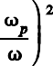
Further, one defines the normalized transverse and longitudinal gyrofrequencies
(3)
where > is the angle between the direction of the wave propagation and the magnetic field. Consequently B_{L} is the component of B along the direction of wave propagation, and B_{T} is the component of B transverse to the direction of the wave. The complex index of refraction for a magnetically biased plasma is easily expressed as
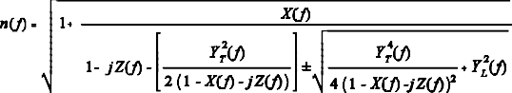

(4)
This is the famous Appleton-Hartree equation for a magnetically biased magneto-ionic medium.^{20,21} When the wave propagates parallel to the magnetic field the index of refraction will be real, and therefore wave propagation will be possible for frequencies below the plasma frequency for the right-handed polarized wave (which corresponds to the - sign) in the longitudinal case. The Appleton-Hartree equation for the index of refraction permits the calculation of ionospheric transparency in the magnetically biased case. The complex propagation factor is related to the complex index of refraction as
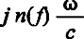
(5)

and the propagation attenuation varies as e^{-αR} . Since α varies with the electron density profile, the total absorption along a propagation path may be expressed in dB as
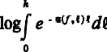 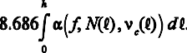 (6)
This permits one to calculate and plot the ionospheric transparency. [See Fig. 5.4] The result specifically exhibits an Extraordinary wave VLF window for the kilometric wavelengths at which NASA now asserts that Jupiter and Saturn radiate sporadic signals toward the Earth. These are also the very frequencies to which Nikola Tesla's Colorado Springs receivers were tuned.

§ 5. Project LOFTI.
The presence of a magnetic field, such as that of the Earth's, will create a "window" for some band of frequencies below the plasma frequency. Fillipowsky and Muehldorf have noted that the idea of a terrestrial magnetically biased VLF window occurred to Navy scientists at NRL (the US Naval Research


Fig. 4
-n vfi —-•
••• I lit rnviolüi — ' ' Iiifrn r*d





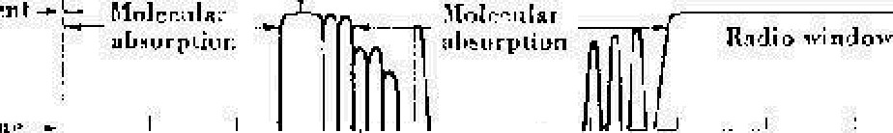
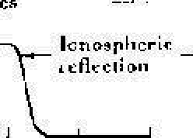

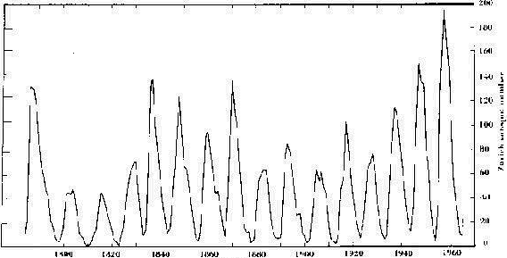



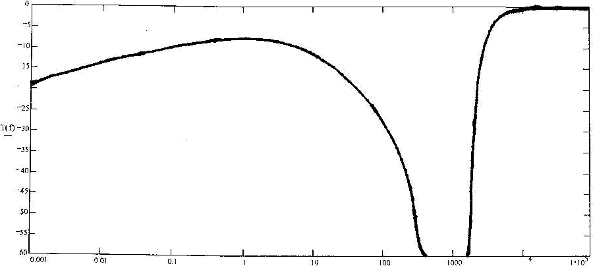
1 • T0’

"kHz


Tñgure 4. Night-linic Extmnr‹l\il‹ ’ \ a\’c ionosplieric transparency’ her Age ncies fi'oln Hz to 100 Mhz during a snlur minimum. (The hol'izotit 1. scale is in kHz.) .Name. that even under the bet cf conditJon5 II\u ionusplicric traJisninnivity » \h< 200 kHz to 2 lVlJlz
Fig. 5.4

3

Laboratory), and experimental measurements were actually conducted at a frequency of 18 kHz, where VLF transmitting station NBA in the Panama Canal Zone served as a convenient RF source. A receiver and translator were mounted on a low orbiting satellite, which orbited just above the ionosphere, and the transparency of the ionosphere was measured during the time of a solar sunspot minimum. The experiment has been described as follows:²²
"Earth's magnetic field and collisions make it possible to use VLF for satellite communications. An experiment conducted to test the feasibility of this concept showed good penetration of the ionosphere at 18 kHz.
In order to evaluate the attenuation, the Appleton-Hartree formula must be evaluated for longitudinal propagation. Under condition that N > 10⁹ electrons/m³, <_{c} < 10⁶ collisions per second, and f_{p} = 1 MHz, the attenuation for 18 kHz maybe [calculated]. For the experiment an exact evaluation of the Appleton-Hartree equation was used. From this, the least possible cumulative attenuation for the ionosphere at 18 kHz was computed. The cumulative attenuation is a function of altitude. For 18 kHz the least cumulative attenuation at night is constant above 200 km and totals about 2 dB; during the daytime it is 28 dB above 200 km.
The experiment was implemented by launching the LOFTI -
indicates that 50% of the time the magnetic field intensity of the VLF wave is reduced less than 13 dB at night and less than 38 dB by day because of passage through the ionosphere. The corresponding figures for 10% and 90% of the time are 4 dB and 29 dB at night, and 33 dB and 45 dB by day. . . Satellite communication using VLF radio waves is feasible and affords some interesting possibilities for future applications."

§ 6. Tesla's Receivers.
No progress is to be made in resolving the "Martian" controversy without first possessing an understanding of the mode of operation of Tesla's receivers. Space does not permit an adequate discussion of Tesla's receiver architecture in this brief review. As part of a 1990's study of Tesla's 1899 lightning observations,²⁵ we performed a fairly extensive investigation of Tesla's Colorado Springs receivers,²⁶ and the reader is invited to turn to the latter for complete details. Tesla's receiver employed a coherer stressed to breakdown (avalanche), not by DC but rather by locally generated RF injected into the detector stage, for greater sensitivity. In the correspondence following Armstrong's 1917 regeneration paper, Carl Ort²⁷ provided further insight, pointing out that he and his colleagues found that coherers could be made "very sensitive" by local oscillator RF

I satellite. The launch took place at Cape Canaveral on
injection.^{28,29}
(This is not the superheterodyne principle.³⁰)

February 21, 1961. . . An 18 kHz signal was transmitted to the LOFTI satellite and the satellite receiver output was telemetered on a 136 MHz carrier back to Earth-based stations. The results of this experiment reveal that a considerable portion of the VLF energy penetrates into the ionosphere. Most of the loss occurs at low altitudes (below 100 km). . . Evaluation of the measurements showed that, for the magnetic field component, the night-attenuation [at 18 kHz] is less than 13 dB and the day-attenuation is less than 38 dB, 50% of the
time."

In spite of the fact that the details of the LOFTI (LOw Frequency Trans-Ionospheric) experiments are well documented, this information about the VLF ionospheric window is not common knowledge among radio astronomers, even today. Using conventional models for the concentration of electrons in the night and day ionosphere, from 50 km out to 1000 km, and for the electron collision frequency profile, the cumulative attenuation was calculated at 18 kHz and plotted by NRL and is reproduced here as Figure 6.3.²³
"[This figure] shows the cumulative least possible attenuation of an 18 kHz signal traversing the ionosphere radially outward from the Earth. . . It appears that most of the absorption loss attributable to the ionosphere is accumulated in passing through the D region between 60 and 130 km altitude and that there is little further attenuation with further increase in altitude. The calculated total attenuation caused by absorption in the mode l ionosphere in its mid-day state is less than 30 dB (about 27 dB). . . The corresponding least possible loss in passing through the model night ionosphere is about 2 dB."
This is a rather astonishing result. The experimentally measured values by the Navy were as follows: ²⁴
"The signal intensity data so far reduced to statistical form
However, according to Ort's remarks the reason for the great gain was never understood until Armstrong's landmark regeneration investigation.³¹
"Mr. Armstrong's experiments have shed new light on these phenomena and have indicated that the amplification obtained with a rectifying detector depends on the energy of the local oscillations which are applied to the detector, and that while the energy received is not magnified at all, the sensitiveness of the detector is increased. This increase is independent of the frequency of oscillation of the local source."

Ort continued his comments with a personal experience, that occurred in Austria in December of 1912, in which a remarkable gain was obtained from a simple detector.
"I investigated the phenomenon, applying sustained oscillations directly to the detector and found that the amplification was due to the increase of sensitiveness of the detector. Every... rectifying detector showed this characteristic. I found that the amplification could be obtained with any frequency not audible to the human ear. The limit of amplification was determined by the maximum impressed voltage of sustained RF at which the detector burned out. I was able to obtain amplifications of about 2000." [66 dB]

Again, we recognize Tesla's pioneering research and priority in this remarkable development of sensitive RF detection. Tesla took Branley's existing high impedance coherer element (with sensitivities on the order of 10 volts) and placed them at the high impedance end (the top) of his tuned resonators, which had voltage magnifications proportional to Q, and in so doing he increased the voltage sensitivity of the detector by a factor on the order of 100 (i.e., 40 dB). (It also gave the detector selectivity, which was something new.) He then injected a local

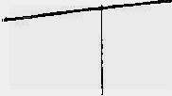
6 CO t
0
O
5
i 0
15
20
25

T

H IGH
CL/MULATTVE ATTE NUAT NON (DB)
ALT ITUDE IK ILO UET E RS}

Figure 3. :Miniinum possible transmission loss (least possible attenuation) of an 18 kHz radio wave passing vertically upward through a standard model ionosphere x'ersus altitude. (From Leiphart et at, 1962.)
Figure 6.

4

oscillator RF voltage across the coherer (by tightly link coupling the local oscillator to the resonator) for the purpose of bringing the coherer's operating point near avalanche, to further increase the sensitivity another 66 dB. Tesla discovered a technique by which the nonlinear resistance of a coherer (as a function of injected locally generated RF) could be triggered and exploited by an exterior pulse signal. The receiver is not an envelope detector!! Having a weak signal initiate the process and using the resulting (voltage controlled) resistance decrease to regeneratively "ratchet up" the Local Oscillator RF, which further decreased the coherer resistance (repeating over and over) so that ultimately the relay would be triggered, gave Tesla an overall improvement of 106 dB in sensitivity over contemporary (1899) receiver technology - and an audio "Beep" each time the receiver is pulsed by an RF transient signal in the passband of its grounded helical resonator stage: the earphone response is a triggered tone at the coupled oscillator beat frequency. This response is not heard with a conventional receiver because envelope and synchronous demodulators do not give a triggered tone. They replicate the envelope of the RF pulses. Where Tesla's receivers give "Beeps", modern communications receiver respond with clicks and static.
Why have Tesla's receivers not enjoyed popularity in the engineering community? Why didn't Tesla continue his receiver research? Although extremely sensitive as RF indicators, Tesla's regenerative coherer detectors were not appropriate for envelope detection such as was required by the subsequent evolution of AM broadcasting and wireless communications. For this reason, the development of his receiver technology did not progress much beyond his early patents. Again, even by today's commercial standards, Tesla's receivers were more than adequate to detect the presence of RF signals in the 30 - 300 µV range. (Nothing this sensitive appeared until the advent of Armstrong's superregenerative detectors, which work right down to the thermal noise floor.) What set Tesla's limit is the terrestrial atmospheric noise field, not receiver sensitivity.
While it is true that lightning and atmospherics peak in this region, and Tesla certainly tracked electrical storms with his receivers (and, therefore, knew the distinction between atmospherics and the signals in question), one asks, "What might have been the physical origin of the sequential signals that gave the appearance of conveying intelligence at these kilometric wavelengths?"

§ 7. Decametric and Kilometric Radiation from Jupiter. Today it is known that both Saturn [Fig. 7] and Jupiter [Fig. 8] behave as powerful electromagnetic sources, transmitting average powers of 1 GW and 10 GW, respectively. The discovery of decametric radiation from Jupiter was first announced in 1955 by Burke and Franklin³² at 22 MHz where the ionosphere is readily transparent at night and for a substantial portion of the day. Actually, most shortwave listeners and amateur radio operators have heard the Jovian
signals without grasping what they are hearing.
Recall that in his 1610 book, Message from the Stars (Sidereus Nuncius), Galileo (1564-1642) reported his discovery that Jupiter has 4 moons revolving about it, which he named Io, Europa, Gannymede, and Callisto. (No more Jovian moons were discovered for another 282 years!) John Milton (1608-1674) met Galileo in Florence in 1637 and refers to the Tuscan astronomer and his "optic tube" at least three times in Paradise Lost. There is a striking 1711 painting by the artist Donato Creti (1671-1749), which integrates a lavish pastoral landscape with the excitement of the new astronomy. It shows astronomers observing Jupiter in the evening sky, but Jupiter and its four moons are portrayed (magnified and inverted) as they would be seen through a Galilean telescope!³³ [Fig. 9]

§ 7.1 Early Observations of Jupiter's HF Radiation.
The radiation, which originally was thought to come from localized regions on Jupiter and now seems to be associated with the planet's magnetic field configuration and the angular position of its satellite Io [Fig. 10], almost always has a duration of 2 hours or less and a period of variable activity that may last for several days. Describing the early reception of the decametric Jupiter signals at 27 MHz in the landmark special issue of the Proceedings of the IRE devoted to radio astronomy,
Dr. Kraus of the Ohio State Radio Observatory has written,³⁴ "The Jupiter signals are characterized by their impulsive or pulse-like nature, in many respects appearing similar to static from a terrestrial thunderstorm. . . The clicks may be of only a few milliseconds duration and may be single or multiple. The multiple clicks are usually double with an occasional triplet. The spacing between these multiple clicks is of the order of one-fourth second or less."

Professor Kraus' initial 1956 observations were actually performed at wavelengths of 10 to 15 meters using relatively modest conventional wire antennas, and his receiver consisted of an RF preamp ahead of a standard communications receiver. The existence of these doublet and triplet events puzzled Kraus, and he even went so far as to hypothesize that,³⁵
" . . . the second and third pulses are echoes of the first. The triple pulse with approximately 0.3 second spacing is particularly significant in this connection since each succeeding pulse not only becomes smaller in amplitude, but more spread out in time."

We mention these multiple-impulse events because they are the very kind of signals which would initiate a 400 Hz "Beep-Beep-Beep" tone sequence in the earphones of Tesla's triggered receivers. The Reader may turn to the Appendix, which gives an overview of the Jupiter-Io system and how Jovian storm forecasts are presently performed.

§ 7.2. Cosmic Kilometric Radiation.
The Jovian kilometric flux density reaching the Earth has been estimated to be on the order of 10⁷ Jy, i.e. 10⁻¹⁹ watts/m²/Hz.³⁶ The VLF radiation was observed by Voyager 1 to be narrowband, physically centered near 200E CML III, and often came in individual bursts of less than 6 seconds duration (which was the shortest duration that the VLF receivers on Voyager 1 could measure). These would certainly be

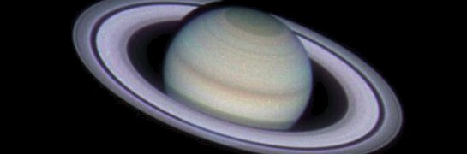
Fig. 7 Sa turn (( ronos}, of the rnee of Ti tans, child of Earth and Head en.

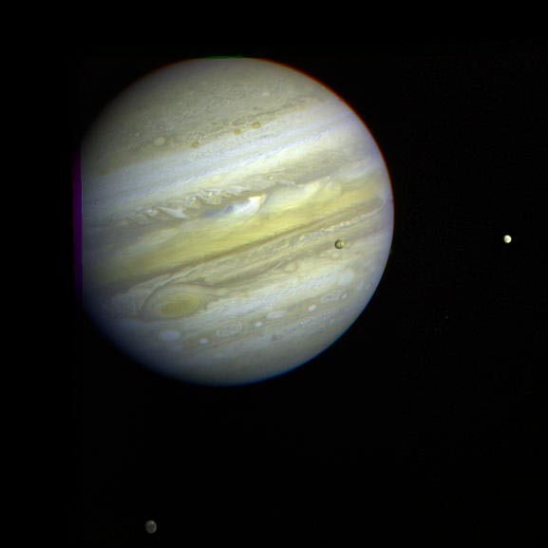
Fig. 8 Jupiter, son of Saturn, vanquisher of the Titans, father of gods and men, whose weapon was thunder. [Jupiter, Io, Europa (right), and Callisto (lower middle).]

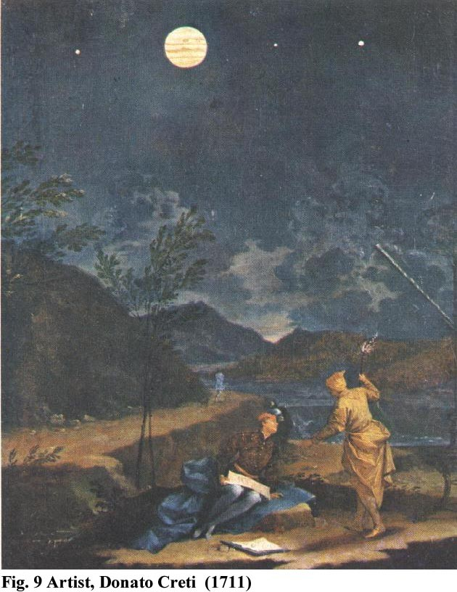

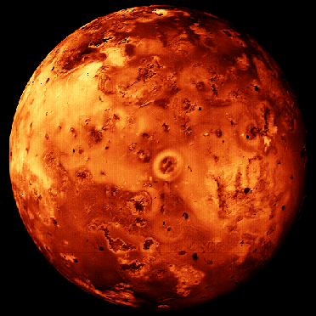

5

consistent with Tesla's observations. It has been suggested that the Jovian kilometric radio source is probably a localized region of the high density plasma torus encircling Jupiter near the orbit of Io.³⁷
While others have suggested that Tesla's observations might somehow be linked to Jovian radiation, it has always been a mystery to us how such fields generated at 22 MHz (and detected in 1955 with modern communication receivers) could ever be related to fields at the frequencies that Tesla used (5 to 20 kHz), or how these VLF fields could ever have penetrated the ionosphere. However, it is now known that Jupiter and Saturn radiate RCP waves in the kilometric range, as well as in the decametric range discovered in the 1950's. That is, these planets appear to be sources of kilometric radiation at the very frequencies where Tesla's receivers were the most sensitive, and where a VLF ionospheric radio astronomy window exists during a solar minimum.

§ 8. Astronomical Predictions for 1899.
Software predictions don't have to be run forward in time only. They can be used to predict the past. Using The American Ephemeris and Nautical Almanac³⁸ for 1899, several software packages for predicting Jovian radio storms, and conventional desktop planetarium software, we have examined the correlation of Jovian emissions and the night-time skies as observed from Colorado Springs during the summer of 1899.
1899-1901 was a time of solar minimum and not only was the MUF considerably reduced, but the ionospheric transparency for RCP kilometric waves was about as good as it gets. Tesla reported that he started his atmospheric storm electrical observations in mid-June of 1899 (when both Mars and Jupiter set late at night), so our search for correlated Jovian storms begins in mid-June. By December of 1899, both Jupiter and Mars set late in the afternoon. We have selected five possible events occurring over the summer of 1899 that might lead an observer to conclude that Mars was intermittently transmitting signals to the Earth and, because we are constrained by publication room, we will comment on only one evening in July. What we looked for was an answer to the question, "Is there any correlation of the cessation of the Jovian signals with the disappearance of Mars below the horizon?" (This would give the appearance of radio signals from Mars.)

§ 8.1. The Io Events of July 22, 1899.
There is an interesting coincidence between the termination of several predicted Jovian events and the disappearance of Mars on the western horizon on the night of July 21, 1899. The ephemeris gives the Martian set time as 05:45 GMT July 22, 1899 (9:44 PM on July 21, 1899 local standard time) at an azimuth of almost 270E exactly. Such a time would appear to meet Tesla's remark that he heard the signals when "alone in my laboratory at night" and "in the summer of 1899". The Martian set time is given for an unobstructed sky. Mars would actually disappear earlier than 9:44 PM because of the high mountains to the west of Colorado Springs. Tesla's laboratory (at the intersection of Kiowa and Foote Streets) was at an elevation of 6060 feet. At an azimuth of 270E the mountains rise to an
elevation of 10,245 feet at a distance of 6.67 miles from the laboratory. This would give Tesla's laboratory site a western visual horizon at an elevation angle of 6.78 E. [See Fig. 11(15).] Noting this visual western horizon, Mars drops below the western mountains at 9:05 PM local standard time. [See Figure 12(16).] Is there any correlation of Mars' set time with the cessation of radio signals from Jupiter? [See Fig. 13(17).] There is a dramatic double-event correlation on this night.
An Io-A event is predicted to occur between 02:56 - 03:55 GMT July 22, 1899 (7:56 to 8:55 PM July 21, 1899 local standard time). That is, the Jovian Io-A signals are predicted to cease about 10 minutes prior to Mars' disappearance below the visual horizon in the western sky. Furthermore, there is a Non-Io event predicted to occur between 02:47 - 0:4:12 GMT (7:47 to 9:12 PM July 21, 1899 local standard time). This Jovian event is predicted to cease 7 minutes after Mars sets. (Interestingly, the criteria employed in "Radio Jupiter 2.0" software package predicts that both the Io-A and the non-Io-A events cease at exactly 9:00 PM local standard time, i.e. 5 minutes prior to the disappearance of Mars below the western horizon.) Again, to an alert observer, it would not appear unreasonable to associate the radio signals with the planet Mars, which was just disappearing below the western visual horizon at the very time that the radio signals ceased. This event would seem to strongly correlate with Tesla's description of his discovery of cosmic radio waves. Two days later, Tesla's diary gives a fairly thorough documentation of the construction and performance of his coherers.
We believe that there is a remarkable correlation of Martian set times with the predicted cessation of radio signals from Jupiter. (With some imagination, it might even have been construed that Mars was broadcasting to cities on the longitude of Colorado Springs, where Tesla's transmitting station was located!) To an alert observer, it would not have appeared unreasonable to associate the radio signals with the planet Mars.

§ 8.2. Jovian Radiation Events Predicted for 1899.
From our analyses, we conclude that there were at least five occasions that could possibly fit Tesla's description of his detection of extraterrestrial radiation. (These are summarized in Table I below.) And, all of these would clearly point to the planet Mars as a probable source. What we infer is the apparent concurrence and cessation of Jovian radiation pulses with the position of Mars as it set on the horizon. At the time of the first five examples Mercury, Venus and the Sun were below the horizon, so they could readily be eliminated as the source of the sequential pulses (as Tesla noted). This would leave Mars, Jupiter and Saturn as possible sources. The cessation of reception as Mars passed below the horizon, with Jupiter and Saturn still in the sky, would appear to eliminate those major planets, again suggesting that Mars was the probable source. Since the signals were not correlated with the weather, which produced an entirely different type of signal in Tesla's receivers (see our discussion of Tesla's weather-related observations³⁹), and since the research was performed during a solar minimum, it would seem admissible to eliminate the aurora as the source

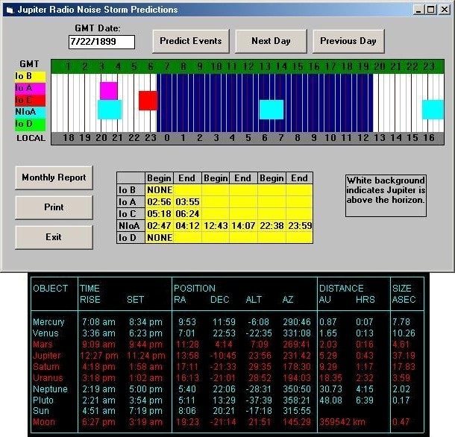
Date: July 21, 1 99 Latt: 38:50:0ó Long: 1 4:4 : 1

Figure 11. Predicted dec ametric radio radiation from Jupiter for July 22, 1 99 (GM and local ephemeris. The upper time-bar reads GMT and the lower reads local standard time. Midnight is at 07: GMT. Note the Nou-Io-A event occurring between 7:47 and 9:12 PM local time. There is also an Io-A event occurring between 7: ó and 8: PM. Mars dips below the local honzon (ó.78 deg.) at 9: PM.

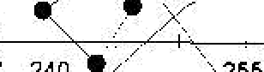
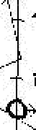



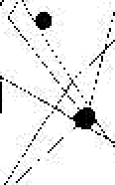







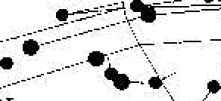

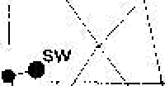

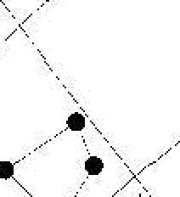

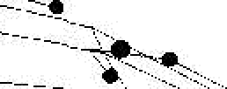
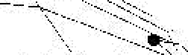

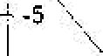



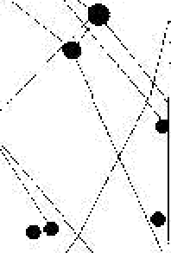
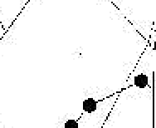
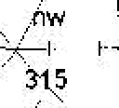
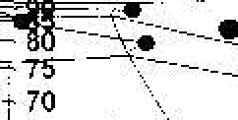

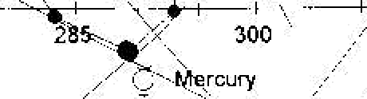




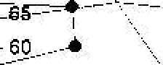










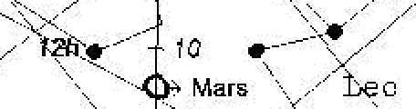
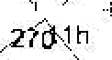


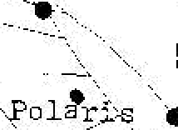

.’ i-
3.o.Og.tes

i5 *.
# ’. 30
•ñ ’.. !
-25 ’’

Spice

240 .

flb•ure 16. •*' imuth-Flevatitin plot of the wesiem sky at 9:05 PM on July 21, l8W (locnl ti^'le). to numiifiifle. 3 are shown.. Flare is ai an clcw'ation ct 6.78°, i.e. right at t!*c *'is"a1 horizon as viwed°tiom tho sire of Tcsla's rcsmrcli station.
Fig. 12


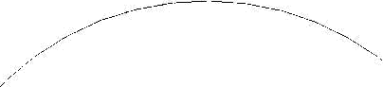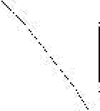





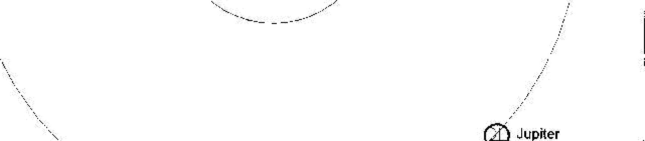

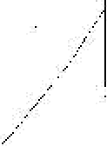
.'’’
* Mars
i
'

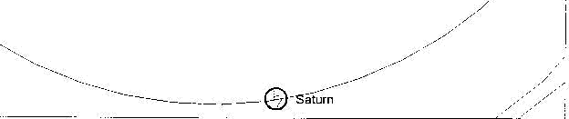

ligu 17. Tire plenctnry configuration of JulS' 21, 1899. Note that flu Wardi lv passed S'1ars. which now' sets beiore lupiter.
Fig. 13

6

TABLE I. SUMMARY OF SELECTED JOVIAN STORM PREDICTIONS

DATE (Local) | Storm Type | Predicted Cease (Rad-Jup 1.0)* | Predicted Cease (Rad-Jup 2.0)** | Mars Sets (Local Time)
June 22, 1899 | Non-Io-A | 10:22 PM / | 10:20 PM / | 10:22 PM
July 1, 1899 | Io-D | 10:31 PM | 10:00 PM / | 10:00 PM
 | Io-B | 9:34 PM | 9:40 PM | 10:00 PM
July 7, 1899 | Io-C | 9:45 PM / | 9:40 PM / | 9:43 PM
July 17, 1899 | Io-D | 10:10 PM | 9:00 PM | 9:18 PM
July 21, 1899 | Io-A | 8:55 PM / | 9:00 PM / | 9:05 PM
 | Non-Io-A | 9:12 PM / | 9:00 PM / | 9:05 PM
* Rad-Jup 1.0 = Radio-Jupiter for Windows, Version 1.0, (February, 1996), Radio-Sky Publishing.
**Rad-Jup 2.0 = Radio-Jupiter 2.0, (1994), Radio-Sky Publishing.
The / mark indicates a strong correlation between the cessation of a predicted storm and the setting of Mars.

of these signals that conveyed the notion of intelligent communication. Return to 1899 and ask yourself, "What is left?" (At VLF, certainly not Marconi in the English Channel!) Finally, we call attention to the fact that although these astronomical predictions provide support for Tesla's assertions, we think that the strongest argument in his favor is that there is a demonstrable ionospheric window at the very frequencies where his receivers functioned and kilometric radiation is now
known to be emitted sporadically by Jupiter and Saturn.

§ 9. What Would You Have Done?
Before you answer that question, consider the time frame in which Nikola Tesla (1856-1943) labored. He arrived at Colorado Springs in May of 1899. (He had been there
receivers were tuned). His receivers were detecting code-like bursts which appeared only at certain times that were uncorrelated with diurnal variations, and they occurred only while Mars (and Jupiter and Saturn) appeared in the visible sky. We think that we've documented that the kilometric signals from Jupiter could have terminated when Mars was just passing below the curtain of mountains viewed on the western horizon from Tesla's laboratory.
In 1902, Lord Kelvin (1824-1907), himself a believer in the Martian signals, proclaimed that he was in complete agreement with Tesla on this issue.^{40,41} Oliver Lodge (1851-1940) was then attempting to detect RF solar emissions but he was listening at the wrong frequencies and with detectors far too insensitive.⁴² Twenty years later, Guglielmo Marconi (1874-1937) claimed

previously, conducting experiments on Pike's Peak in 1896.)
that he, too, had heard the signals from Mars.⁴³
[Marconi and

During June and July the western panorama visible in the late evening hours from the laboratory's double doors was presided over in the southwest by Mars, Arcturus and blue-white Spica, while Jupiter and red giant Antares were almost directly on the meridian, and the bright first magnitude stars Deneb, Altair and Vega were raining their own celestial fire as they, and the Milky Way, rose in the East. In the warm evening air, clearly, the spectacular brilliant rusty hue of Mars would not only dominate the western skies, but also the thoughts and speculations of even the most casual observer. Any alert scientist watching the evening skies from Tesla's laboratory at Colorado Springs and hearing such astonishing signals on his apparatus, with no identifiable terrestrial source, would surely have been taken by the enchanting spell of the brilliant starry sky.
Tesla reports that he started receiving atmospheric static in mid-June with his receivers. (From his notes it is evident that his sensitive regenerative receiver designs continued to evolve from mid-June to late September.) Put yourself in Tesla's place. There were no wireless stations on our planet other than his own (certainly none operating in the 10 kHz range where his
Kelvin never drew the ridicule and resentment for their remarks that Tesla received.] Tesla's assessment was that Marconi had heard RFI: Marconi's receiver was merely responding to transmitter "undertones".^{44*}
Ever a focal point of mystery and speculation, even Jonathan Swift's fictional masterpiece puzzles us. In 1726 he not only tells us that Mars has two satellites, but also that their periods are 10 hours and 21.5 hours.⁴⁵ Remarkably, Mars' two moons, Phobos ("fear") and Deimos ("panic"), were not discovered until 1877, and with periods determined as 7.65 hours and 30.28 hours, respectively. It was also in 1877 that Schiaparelli first

*Unlike Marconi, whose 1919 receivers performed in the LF/MF region, undertone reception would not have been the case for Tesla's Colorado Springs 10 kHz observations: undertones (subharmonic beats) require the presence of strong local transmitter signals (which Tesla did not have to contend with in 1899) and nonlinear mixing. Furthermore, VLF undertones are not radiated by antennas whose lengths are short relative to the wavelength, so there would have been no 1899 VLF signals emanating from the English Channel capable of being received in Colorado Springs, as some have mistakenly asserted.

7

observed the controversial "canali".
In 1883, Simon Newcomb (1835-1909), then director of the American Nautical Almanac, wrote the following:⁴⁶
"The early telescopic observers noticed that the disk of Mars did not appear uniform in color and brightness, but had a variegated aspect. . . The most interesting result of these markings on Mars is the probability that its surface is diversified by land and water, covered by an atmosphere, and altogether very similar to the surface of the earth. Some portions of the surface are of a decided red color, and thus give rise to the well-known fiery aspect of the planet. Other parts are of a greenish hue, and are therefore supposed to be seas. The most striking features are two brilliant white regions, one lying around each pole of the planet. It has been supposed that this appearance is due to immense masses of snow and ice surrounding the poles. If this were so, it would indicate that the processes of evaporation, cloud formation, and condensation of vapor into rain and snow go on at the surface of Mars as at the surface of the earth."

It was Harvard Observatory's William Pickering who first reported seeing dark spots where the Martian "canals" intersected. Astronomer Percival Lowell (1855-1914), on whose 1905 calculations Pluto was discovered by Clyde Tombaugh in 1930, described his contemporaneous optical observations of Mars in the most vivid of terms in his 1895 book, Mars. Through the 18" and 24" refracting telescopes at Lowell Observatory in Flagstaff, Arizona [Fig. 14], Mars appeared to Lowell as "a shimmering orange ball" with white polar caps and a system of dark green lines configured "like a spider's web" across the planet [Fig 15]. Three years later, fantasy writer, H.G. Wells was inspired to pen the Martian invasion story, "War of the Worlds" (1898), and later, "Star Begotten".
Tesla, in his 1907 article for Harvard Illustrated Magazine, acknowledged the strong predilection toward Mars that Lowell's work had contributed to his own conclusions:⁴⁷
"Chief among the stimulating influences was the revelatory work of Percival Lowell, described in a volume with which the observatory bearing his name has honored me."

Is it unreasonable to assume, as Tesla did, that the reception of "one - two - three" from an apparently identifiable extraterrestrial radio source could originate from some center of intelligence? Tesla interpreted the systematic sequence of pulses as an attempt to communicate intelligence through the universal concept of numbers. Interestingly, modern professional astronomers involved with the SETI (Search for Extra-Terrestrial Intelligence) program have embraced the identical concept. Concerning the search for extra-terrestrial intelligence funded at the Ohio State Radio Observatory,
Professor Kraus writes,⁴⁸
"Our Big Ear was now listening for other-men on other planets circling other stars who might have built beacon stations to announce their presence... We are searching for some kind of narrow-band signal that would appear ... If, in addition, it turned off and on in some systematic way this would be suggestive of an intelligent origin ... Suppose we do detect a
beacon signal? How could it be possible to understand the other-men about whom we know absolutely nothing? Is there anything that we and the dwellers on another planet even have in common? Is there any common semantic frame of reference? ... The idea of numbers or counting would be common. We might suppose that the other-men could initiate their beacon transmission with a series of dots:
- • • • • • • • • • etc.
The very narrow-band beacon signal would have alerted us to their presence and their slow dots and dashes taught us a language with which to understand them."

So, after a century of scientific progress, Tesla's speculations concerning a "Lingua Cosmica" have come to possess some degree of formal credibility in academic circles.

§ 10. What Really Happened?
It is now clear that Tesla's receivers can easily be stimulated by kilometric singlet, doublet, and triplet events (which occur quite frequently). Because of the 400 Hz beat frequency inherent in this receiver's coupled oscillation transformer, the 400 Hz audio response at the earphones (which re-initiates every time the receiver is stimulated) sounds like "Beep-Beep-Beep". For those of us that have heard the phenomenon, it is perfectly logical to describe the sound exactly as Tesla did on Orthodox Christmas of 1900 (January 7, 1900): "one ... two ... three
...". [Would you like to hear a recorded response of a Tesla VLF receiver? Audio recordings were made at the Tesla receiver earphone during Jovian storms in the late Spring of 1996 (a solar minimum), and played at the 1996 ITS Symposium. A short audio clip, recorded from a Tesla receiver, has been inserted, here. Listen closely. A faint sequence of code-like pulses can be heard through the stati c. ("I could not interpret the signals, but they seemed to suggest a numerical code..." Tesla, 1935) You must agree that, whatever the mechanism, a numerical sequence clearly suggests itself to the listener. These are not inherent in the receiver, nor are they present at all times. (Incidentally, the Tesla receiver response during an electrical storm can be heard by clicking here.)] We conclude that the observations of Percival Lowell and his assertions concerning the possibility of life on Mars, the nearness of the red planet (Mars was in opposition on Jan. 20, 1899), the night-time signals when Venus and the sun were below the horizon, the coincidence of the cessation of the radio signals as Mars disappeared b elow the observational horizon at Tesla' laboratory, the apparent implication of intelligence in the signals, etc., all provided supporting evidence for Tesla to subsequently mistakenly ascribe the signals to the red planet rather than some other cosmic source. Dr. Kraus and the Ohio State Radio Observatory, in a remarkably similar example of mistaken identity, reported receiving distinct separated pulses
from Venus in 1956:⁴⁹
"While monitoring for radiation from Venus, I also heard signals that came in distinct separated pulses. They seemed to be strongest when Venus was in the beam and seemed to follow Venus across the sky. I wrote a brief note about them published in Nature and suggested that they might come from Venus. It

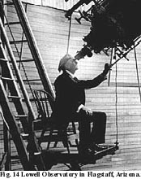

Fig. 15 "like a spider's web..."

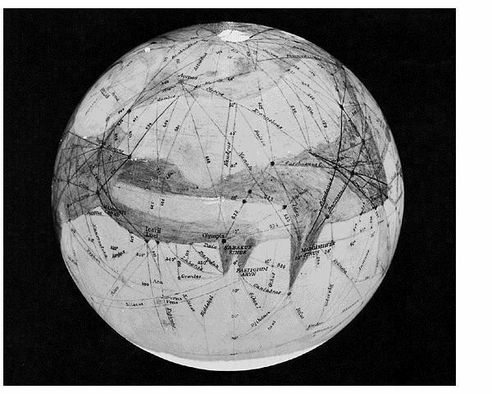

8

was a blunder, which taught me a lesson... It was something that has happened to other astronomers, physicists and chemists, including Nobel laureates, and continues to happen
. . . When you dare to publish a new scientific observation or calculation ... you don't want to be found in error but you can be so cautious that you never publish."

Enchanting Urania, inspirational Muse and nymph-goddess of Astronomy, seems to playfully practice innocent deception on her most impassioned suitors: sic itur ad astra. ("Such is the way to the stars.")

§ 11. Summary and Final Remarks.
Certainly, not everyone will agree with us. There may be other acceptable explanations. But, it is our opinion that it is entirely within reason to identify Tesla's signals as the detection of intense kilometric (VLF) emissions originating from Jupiter. Considerable work still needs to be done to convince the skeptical. However, the bottom line is that when you listen to the kilometric signals from Jupiter with one of Tesla's Colorado Springs receivers you occasionally hear "Beep... Beep-Beep... Beep-Beep-Beep"! Furthermore, extraterrestrial right circularly polarized kilometric signals penetrate the Earth's ionosphere during the time of sunspot minima. Tesla was at the right place, at the right time, doing the right thing, with the right equipment to be able to detect these unusual electrical signals of planetary origin. It was the scientific community that was unprepared.
In the early 1930s Karl G. Jansky (1905-1950) [Fig. 16], like Nikola Tesla before him, had been monitoring electrical disturbances due to thunderstorms. Using a vertically polarized rotatable modified Bruce array, he noted three distinct types of static at 20 MHz: that from local thunderstorms, that from distant thunderstorms, and "a steady hiss static, the origin of which is not known." Jansky was able to identify the latter as coming from the Milky Way⁵⁰ [Fig. 17] and for this he has been popularly recognized as the "father of radio astronomy".
Concerning cosmic radio signals, Tesla wrote in 1921,⁵¹ "Others may scoff at this suggestion or treat it as a practical joke, but I have been in deep earnest about it ever since I made the first observations at my wireless plant in Colorado from 1899 to 1900. . . . At the time I carried on those investigations there existed no other wireless plant on the globe other than mine, at least none that could produce a
[The discoveries were the rotating magnetic field and coupled tuned RF systems. The inventions for which he holds legal priority include the AC motor and generator, the AC polyphase power distribution system, and radio communications. Consider NASA's awesome 2002 photograph⁵⁴, "Earth at Night". [Fig.18] (What a breath-taking tribute to the genius and achievements of Nikola Tesla!) Can the reader identify even one pinpoint of light, anywhere in the photo, not operated through the electrical system given birth by Tesla? (And, the photograph only shows the optical spectrum - it reveals neither electromechanical applications nor radiowave communications.) Is there even one Noble Laureate since then that can be named who has contributed so much to relieve toil, dispel gloom and darkness, and harness the forces of nature for the benefit of humanity?] Tesla continues,
"... but my chief recreation was to study the universe, and the place of the earth in the starry system... [a method of communicating with other planets] ... I would willingly sacrifice all my other achievements to realize this dream."

This is the tragic story of a scientist that had to formulate theories and then devise his own hand-made sensitive instruments to delicately explore the enchanting wonders of the physical universe [Fig. 19], - authentic wonders that previously went undetected and existed only within the visions and dreams of his own creative mind, - electrical wonders and visions that few scientists would be able to perceive or comprehend until generations after their discovery was declared before a community of visionless skeptics. Not since the time of Leonardo da Vinci (1452-1519) has the world witnessed the energy, insight and achievements of such a gifted thinker and versatile genius. In an eloquent moment of reflection, Neils Bohr once said, "With deepest admiration, we think of how Tesla could accomplish such great achievements ..."⁵⁵
We hope that this little study will raise legitimate interest and elevate the controversy surrounding Tesla's "Martian signals" to quantifiable terms. Certainly, he was the first to detect, observe and study natural VLF radio waves from atmospheric storms. It is our conclusion that, under extremely favorable (but entirely feasible) circumstances, Tesla could have also heard the audio reaction of his regenerative detectors responding to the impulsive kilometric noise emanating from the planet Jupiter.

disturbance perceptible in a radius more than a few miles."

Tesla's pre-1900 radio astronomical observations haunted him the rest of his life, and he expressed a great desire to follow up on his remarkable discovery. In 1919 (fourteen years before Jansky's landmark paper), Tesla said,⁵²
"In later years, I have bitterly regretted that I yielded to the excitement of ideas and pressure of business instead of concentrating all my energies on that investigation."

In an unpublished 1935 interview, at age 79, Tesla said,⁵³ "Some of my discoveries and inventions have made electric history. They were practical devices, susceptible of commercial exploitation."

APPENDIX I. Radio Signals of Planetary Origin.
In this brief Appendix, we want to provide a concise introduction to the issues and concepts employed in the prediction of the non-thermal Jovian signals for 1899.

A Description of the Jovian System.
Jupiter is encircled by a system of light and dark bands of clouds parallel to its equator, which rotate differentially. Since no physical surface features can be used for reference purposes two coordinate standards have been adopted for Jupiter: System I has the rotational period of 09h 50m 30s corresponding to the Equatorial band of clouds, and System II moves a little slower

Fig. 16 Karl G. Jansky (early 1930's)

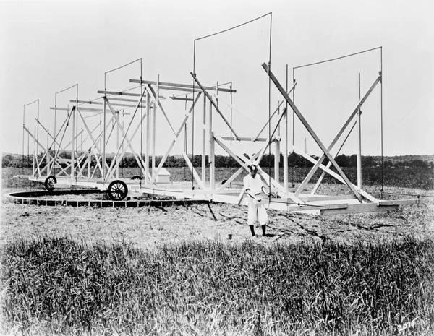

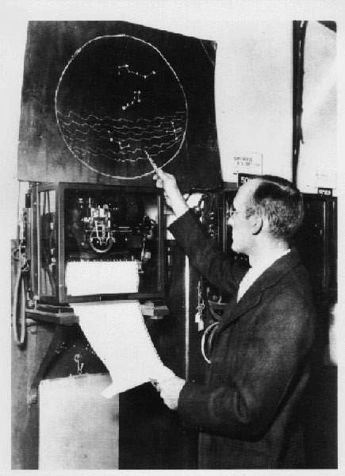
Fig. 17. Jansky identified the static as coming from the Milky Way.


Fig. 18 Tesła's Tribute • ”Eur th At Night". [Fer z 4nrger version,

4
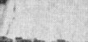




Fig. 19

9

with the rotational period of 09h 55m 40.6s corresponding to the rotational period of the mid-latitude (temperate zone) clouds.

  - CML III.
Jupiter's magnetic poles are tilted about 10E relative to its axis of rotation and, with the advent of radio observations, it was found that the planet's magnetic field, which appears to have a rotational period of 09h 55m 29.710s, could provide a coordinate reference system attached to the planet's surface.⁵⁶ The corresponding angular speed of a longitudinal line attached to the planet is 99.249 sec/deg. The International Astronomical Union subsequently designated this reference frame as System
III. The Sub-Earth longitude or Central Meridian Longitude (denoted as CML III) of the system rotating with the above period coincides with the System II longitude facing the Earth at 0^{h} Universal Time on January 1, 1965. Such a system of coordinates permits the specification of various features in Jupiter's magnetic field as they rotate with the planet. James Sky has noted that,⁵⁷

"It became apparent when plotting radio emission occurrences vs. CML III that the probability of detecting a radio event is greatly enhanced when any of three particular longitudes turns to face the Earth. These areas of enhanced probability have been named regions A, B, and C. . . region A, which peaks around 260E CML III, is the region of highest correlation. Regions B and C, at about 170E and 320E respectively, are somewhat less reliable, but certainly distinct and important predictors."

In addition to the Central Meridian Longitude of the planet, a correlation was also found with the angular position of one of Jupiter's moons.

  - SGC: The Io Phase.
From a catalogue of Jovian radio observations made between 1961 and 1963, E.K. Bigg deduced in 1964 that Jupiter's inner satellite, Io, appears to control the decametric emissions, which reach the Earth, to a remarkable degree.⁵⁸

[See Figure 20-I.1. The dependence of Jupiter's decametric radio signal strength on the angular position of the satellite Io.]

This figure, taken from Bigg, shows that there is a great probability of Jovian radiation whenever Io approaches two angular positions: 93E and 246E after Io's Superior Geocentric Conjunction (SGC). [The Superior Geocentric Conjunction is that position of Io when it is directly on the far side of Jupiter when Jupiter and Io lie in a straight line to the Earth. The Io phase, or SGC angle, is measured from that reference orientation as Io revolves around Jupiter. (See Figure 21-I.3.)] Io has a mean period of 2,548.5 minutes and moves angularly at
424.75 sec/deg.

Prediction of Decametric Radiation from Jupiter.
Realizing that both the CML III and Io's angular position relative to the SGC correlate with radio emissions from Jupiter,
Bigg plotted the intensity of the radiation on a graph with the SGC angle as ordinate and the CML III as abscissa.
[See Figure 20-I.2. This is a sketch of radio signal strength on a plot of the Io phase (Io's angular position with respect to the SGC) versus the rotational orientation of Jupiter (the angle between Jupiter's CML III and an Earth-Jupiter reference line).]

A procedure for the prediction of decametric radiation from Jupiter was then readily deduced. The Figure clearly reveals patterns where a high probability of signal reception exists. These configurations of activity may be summarized as shown in Table II:

TABLE II.
STORM | CML III | SGC | CHARACTER
Io-A | 200E-270E | 205E-260E | RH polarized L Bursts
Io-B | 105E-185E | 80E-110E | RH polarized S Bursts
Io-C | 285E-370E | 225E-260E | LH polarized L & S Bursts
Io-D | 100E-200E | 95E-130E
Non-Io-A | 200E-280E | 0E-360E
The CML III regions on the plot can be defined as shown in Table III.

TABLE III.
REGION | CML III
A | 200E - 290E
B | 100E - 200E
C | 290E - 320E
D | 20E - 100E

Figures I.1 and I.2 reveal that two phenomena are actually occurring. Clearly, the radio signal strength depends upon the departure of Io from the superior geocentric conjunction: Io strongly influences the emission of radio signals from Jupiter. But it is also apparent that the angular orientation of Jupiter's magnetic poles relative to the Earth also govern the radiation we receive. Jupiter's magnetic poles are tilted slightly with respect to its axis of rotation and so, as Jupiter's Central Meridian Longitude rotates, the changing aspect of Jupiter's magnetic equator as viewed from the Earth causes variations in the observed field strength and polarization. Moore observes th at,⁵⁹
"The total intensity goes through two maxima and two minima per revolution, the maxima occurring when the magnetic equator





b00

?0O

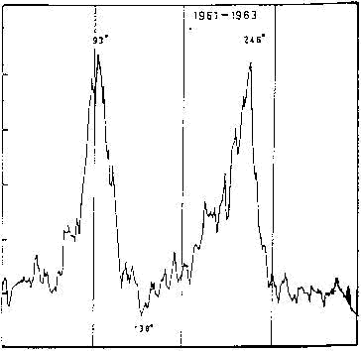
80’ 180’ ? 79’
le Pa rcure of 1z fro • superio r aiocc e •rtc caqJ uoct1o•

Fig. 20-I.2
Figure DI.1. The dependence or IupitcY <eric radio signai strcngth on the zigular position of the satellite Io. from E.R Biggs, 'Muence of Io,” kanire, Vòl. 203, 1964, p. 1008.)
Fig. 20-I.1

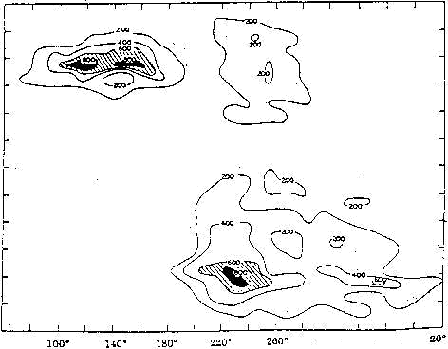
{0’
300‘
:M0’


’*

c o
"00º


Figure III.2. This is a sketch of radio si tai saength on a plot of the Io phase (Io's angular position
Jupitefs CML K and an RM-Jupitcr refcrcnce line). atum, Vol. 205, p. 100P.)

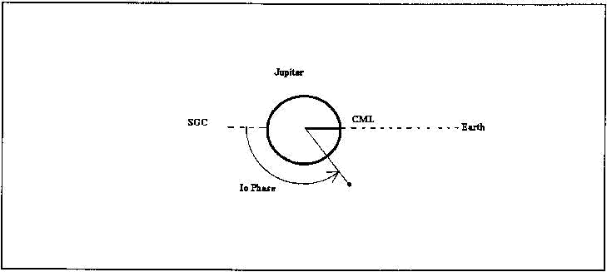

Figere III 3 This sketch illustratesthe SCiC (Superior Geocentric Conjunctions the Io phase, and also the CML (Central Meridian l_ongitude) of Jupiter on Jan. 1, 1965 ai tf' GMT.
Fig. 21 I.3
Fig. 21 I.4

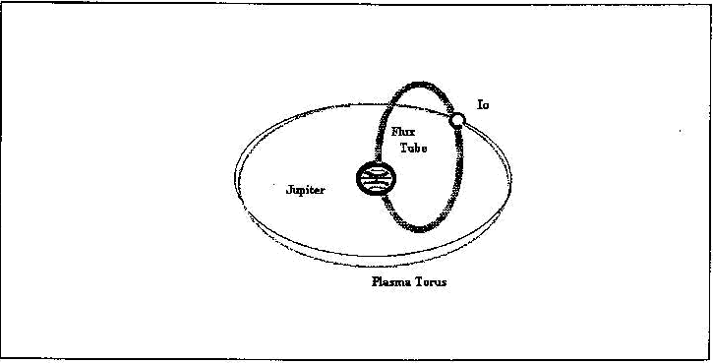

This sketch illustratm the toroidal shaped pÏasma dîsnibution around Jupiter and the orbit of Jupiter's moon, Io. The tonid is slightly inclined relative to lo's orbit bœause of the influence of JupitePs strong nugoetic field on the charged particles. The flux tube shown linking fupiter and lo carries a current of about 5 million amperes.

10

is viewed edge on, and the minima when the equatorial plane is viewed from extreme positive and negative latitudes."

[There is another phenomenon which comes into play for determining the variation of the Jupiter signals on Earth. The observed width of the Jovian radiation pattern is fairly narrow (on the order of 6E). Furthermore, Jupiter's orbit is slightly tilted with respect to the ecliptic plane (the plane of the Earth's orbit around the sun). To view it another way, from Jupiter's position, the plane of the Earth's orbit tilts slightly above and below Jupiter's orbital plane as the Earth revolves about the sun. The inclination is about 3.3E and this "Jovicentric Declination of the Earth" ( D_{e} ) moves the Earth into and slightly back out of the beam of radiation emanating from Jupiter. As a result, the probability of radio reception varies with D_{e} .]
While the above observations imply a procedure for predicting when the Earth receives radio signals from Jupiter, they do not yet explain the physics of why the Jovian system should radiate at all. We will turn to that topic next.

- Radiation Mechanisms: Plasma Torus &Io's Flux Tube. It is now known that both Jupiter and Saturn possess substantial magnetic fields: B - 10×10⁻⁴ Teslas (tipped about 10E with respect to the axis of rotation) for Jupiter and B -
2.5×10⁻⁵ Teslas (tipped less than 1E with respect to the axis of rotation) for Saturn. (By way of comparison, the Earth's magnetic field is on the order of 5×10⁻⁵ Teslas.) It is also known that these planets radiate nonthermal emissions at various wavelengths corresponding to frequencies extending from 3 kHz up to about 30 MHz.
While there exist a vast collection of hypotheses for the radiation from Jupiter and Saturn, it appears that the radio emissions are linked to electrical charges accelerated through the planets' magnetic field structure. Gyro radiation is produced when electrons spiral about magnetic fields under the influence of the Lorentz force at relatively low velocities. The frequency of the gyro radiation is given by

I.1

Radiation from Jupiter at 22 MHz by this mechanism would seem to imply emission from a magnetospheric region where B
- 7.86 gauss (1 Tesla = 1 Weber/m² = 10⁴ Gauss), while radiation at 10 kHz would seem to imply emission from a magnetospheric region where B - 3.57 milligauss. However, a simple application of conventional gyro radiation theory does not seem to explain the Jovian radiation spectrum. As pointed out above, it has long been recognized that the position of Io and its orbit plays some role in explaining Jovian radiation.
Io has a diameter of 3640 km and orbits Jupiter at a distance of 5.9 R_{J} (421.6 Mm; the equatorial radius of Jupiter is R_{J} = 71,398 km, and Jupiter's mass is M_{J} = 1.901× 10²⁷ kg.), well within Jupiter's magnetosphere, with a period of 1.769 days. It has an atmosphere and at least seven active volcanoes, with plumes extending up to 250 km above the surface of the Jovian
satellite.
Apparently, due to the sputtering action of material ejected from Io and high energy particles bombarding this moon, a toroidal ring of charged plasma particles has been created around Jupiter at the radius of Io's orbit. The "plasma torus" is slightly inclined to the orbit of Io due to the presence of Jupiter's strong magnetic field. (See Figure 21-I.4.) The kilometric radiation detected by Voyager 1 appeared to have been generated by plasma oscillations in the Io plasma torus.⁶⁰
It has been hypothesized that the Io-Jupiter system forms an enormous electrical generator.⁶¹ The Jovian magnetic field at Io is about 1900 nT and the motion of Io through Jupiter's magnetic field induces a v×B voltage across Io of about 400 kV.⁶² As a result, plasma electrons are driven along Jovian magnetic field lines forming a "flux tube" that connects Io and Jupiter's conducting ionosphere. The current flowing between Jupiter and Io along this flux tube is in excess of 5 million amperes, and this gravitationally driven natural electrical generator (which would excite the enthusiasm of any electrical engineer) has been estimated to operate at a power level in excess of 10¹² watts. There are many other issues associated with radio emissions from Jupiter and Saturn, and the reader is invited to turn to the literature of radio astronomy.
Technical issues related to the construction of Tesla's receivers, the parameters associated with the operation of his facility as a VLF radio telescope, atmospheric noise fields, and further detectable radio emission events are treated in greater detail in the engineering report mentioned at the beginning of this paper. Karl Jansky probably detected decametric radiation from Jupiter, although that can't be documented. Again, it is our conclusion that, under extremely favorable (but entirely feasible) circumstances, Tesla could have readily heard the audio reaction of his regenerative peak detectors responding to the impulsive kilometric noise emanating from the planet Jupiter [Fig. 22].

REFERENCES

- Letter to George Scherff, dated July 4, 1899.
- Nikola Tesla, "The Problem of Increasing Human Energy," The Century Illustrated Magazine, June, 1900, pp. 175-
211. (See p. 209.)
- Nikola Tesla, "Some Planet Affected His Machine," NY Sun, January 3, 1901.
- Nikola Tesla, letter to the Editor of the NY Sun, dated January 9, 1901. (Tesla Museum, Beograd, Yugoslavia, 3/4 #627.)
- Nikola Tesla, "Talking with Planets," Collier's Weekly, February 9, 1901, pp. 4-5. [Reprinted as Chapter XVI - Electrical Communication With The Planets - in the book

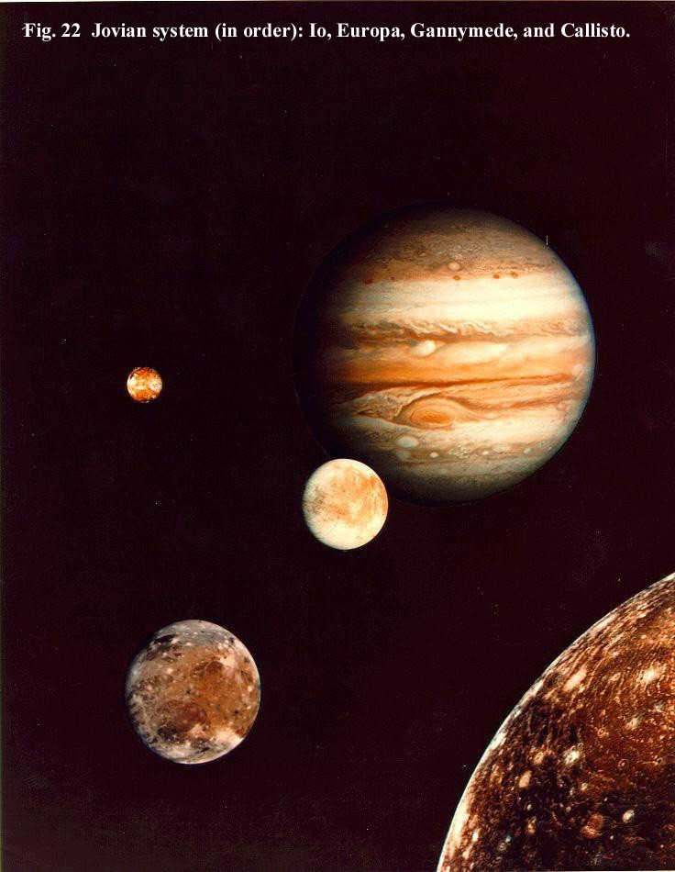

11

Polyphase Electric Currents and Alternate-Current Motors, by Silvanus P. Thompson, Volume 4 of The Library of Electrical Science, Collier and Son, New York, 1902, pp. 225-235.]
- Nikola Tesla, "Signalling to Mars - A Problem in Electrical Engineering," Harvard Illustrated, March, 1907,
pp. 119-121.
- Nikola Tesla, "How to Signal to Mars," New York Times, May 23, 1909, p. 10, col. 6, 7.
- Nikola Tesla, "Signals to Mars based on Hope of Life on Planet," New York Herald, Sunday, October 12, 1919, Magazine Section.
- Nikola Tesla, "Interplanetary Communication," Electrical World, September 24, 1921, p. 620.
- Nikola Tesla, "A Giant Eye to See Round the World," Albany Telegram, February 25, 1923.
- Nikola Tesla, "I Expect to Talk to Mars," an interview with George Sylvester Viereck, September 11, 1935. (Courtesy of Leland I. Anderson)
- "Lord Kelvin Believes Mars Now Signaling America," Philadelphia North American, May 18, 1902, Mag. Sect. V.
- Cheney, M, Tesla: Man Out of Time, Prentice-Hall, 1981, pg. 162.
- Wysock, W., J. Hardesty, K.L. Corum, and J.F. Corum, "Who was the Real Dr. Nikola Tesla?," AMTA (Antenna Measurement Techniques Association) Conference, Oct. 22-25, 2001, Denver, CO. The paper is available at http://www.ttr.com/what's_new.htm (Click on "Who was the Real Dr. Nikola Tesla?" to download the 137 kb file).
- Corum, K.L., J.F. Corum, and A.H. Aidinejad, "Atmospheric Fields, Tesla's Receivers and Regenerative Detectors," Proceedings of the 1994 International Tesla Symposium, International Tesla Society, Colorado Springs, CO, 1994.
- Nikola Tesla, "Talking with Planets," Collier's Weekly, February 9, 1901, pp. 4-5; reprinted in Polyphase Electric Currents, Chapter XIV of Volume 4 of The Library of Electrical Science, S.P. Thompson, Editor, Collier & Son, NY, 1902, pp. 225-235.
- Nikola Tesla, “Experiments with Alternate Currents of High Potential and High Frequency,” a lecture delivered before the Institution of Electrical Engineers in London, and then before the Royal Institution on Thursday, February 4, 1892. Published as Chapter XXVII in Inventions, Researches and Writings of Nikola Tesla, by
T.C. Martin, 1894, reprinted by Barnes and Noble Books, 1992, pp. 198-293.
- Watson, G.N., "The Transmission of Electric Waves round the Earth," Proceedings of the Royal Society, Vol. 95, 1919, pp. 546-563.
- Hodara, H., "The Use of Magnetic Fields in the Elimination of the Re-Entry Radio Blackout," Proceedings of the IRE, Vol. 49, 1961, pp. 1825-1830. (See p. 1826.)
- Appleton, E.V., "Wireless Studies of the Ionosphere," Journal of the IEE (London), Vol. 71, 1932, pp. 642-650.
- Hartree, D.R., "The Propagation of Electromagnetic Waves in a Refracting Medium in a Magnetic Field," Proceedings of the Cambridge Philosophical Society, Vol. 27, 1931, pp. 143-162.
- Fillipowsky, R.F. and E.I. Muehldorf, Space Communications Systems, Prentice-Hall, 1965, pp. 168-
169.
22. Leiphart, J.P., R.W. Zeek, L.S. Bearce, and E. Toth, "Penetration of the Ionosphere by Very-Low-Frequency Radio Signals: Interim Results of the LOFTI I Experiment," Proceedings of the IRE, Vol. 50, 1962, pp. 6-17. (See Figure 4, p. 8.)
- Ibid.
- Corum, K.L. and J.F. Corum, "Nikola Tesla, Lightning Observations and Stationary Waves," Proceedings of the 1994 International Tesla Symposium, International Tesla Society, Colorado Springs, Colorado, 1994.
- Corum, K.L., J.F. Corum, and A.H. Aidinejad, "Atmospheric Fields, Tesla's Receivers and Regenerative Detectors," Proceedings of the 1994 International Tesla Symposium, International Tesla Society, Colorado Springs, CO, 1994.
- Ort, C., "Discussion," Proceedings of the IRE, Vol. 5, 1917, pp. 163-166.
- Ort, C., Elektrotechnische Zeitschrift, 1909, pg. 655.
- Ort, C., Archive fur Elektrotechnik, Vol. 1,1912, pg. 192.
- Armstrong, E.H., (Superheterodyne Receiver), US Patent #1,342,885, June 8, 1920.
- Ort, C., "Discussion," Proceedings of the IRE, Vol. 5, 1917, pp. 163-166.
- Burke, B.F. and K.L. Franklin, "Observations of a Variable Radio Source Associated with the Planet Jupiter," Journal of Geophysical Research, Vol. 60, 1955,
pp. 213-217.
- Donato Creti, 1711, Musei e Gallerie Pontificie, Photographic Archives of the Vatican Museums and Galleries.
- Kraus, J.D., "Planetary and Solar Radio Emission at 11 Meters Wavelength," Proceedings of the IRE, Vol. 46, January, 1958, pp. 266-274.

12

- Ibid.
- Warwick, J.W., J.B. Pearce, A.C. Riddle, J.K. Alexander,
M.D. Desch, M.L. Kaiser, J.R. Thieman, T.D, Carr, S. Gulkis, A. Boischot, C.C. Harvey, and B.M. Pederson, "Voyager 1 Planetary Radio Astronomy Observations Near Jupiter," Science, Vol. 204, June 1, 1979, pp. 995-
998.
- Ibid.
- The American Ephemeris and Nautical Almanac, Washington Bureau of Equipment (now the US Government Printing Office). The 1899 volume was published in 1898, and 1900 was published in 1899.
- Corum, K.L. and J.F. Corum, "Nikola Tesla, Lightning Observations and Stationary Waves," Proceedings of the 1994 International Tesla Symposium, International Tesla Society, Colorado Springs, Colorado, 1994.
- "Lord Kelvin Believes Mars Now Signaling America," Philadelphia North American, May 18, 1902, Mag. Section V.
- Cheney, M., Tesla: Man Out of Time, Prentice-Hall, 1981, pg. 162.
- Lodge, Oliver, Signalling Across Space Without Wires, The Electrician Printing and Publishing Co., London, 1900.
- "Messages from Mars Scouted by Experts," New York Times, September 3, 1921, p. 4, Col. 4.
- Nikola Tesla, "Interplanetary Communication," Electrical World, September 24, 1921, p. 620.
- Swift, Jonathan, Gulliver's Travels, 1726, Part III, Chapt. 3.
- Newcomb, S. and E.S. Holden, Astronomy, Holt and Co., 1883, pp. 234-235.
- Nikola Tesla, "Signalling to Mars - A Problem in Electrical Engineering," Harvard Illustrated, March, 1907,
pp. 119-121.
- Kraus, J.D., Big Ear, Cygnus-Quasar Books, Powell, Ohio, 1976, pp. 204-205.
- Ibid, pp. 116-120.
- Jansky, K.G., "Electrical Disturbances Apparently of Extraterrestrial Origin," Proc. IRE, Vol. 21, 1933, pp. 1387-1398.
- Nikola Tesla, "Interplanetary Communication," Electrical World, September 24, 1921, pg. 620.
- Nikola Tesla, "Signals to Mars based on Hope of Life on Planet," New York Herald, Sunday, October 12, 1919, Magazine Section.
- Ref. 10, loc cit.
- For a larger version, go to the following web site: http://antwrp.gsfc.nasa.gov/apod/image/0208/earthlights 02_dmsp_big.jpg
- Bohr, N., Remarks presented at the Beograd Centenary Symposium of the Birth of Nikola Tesla, July 10, 1956, published in Tribute to Nikola Tesla, Nikola Tesla Museum, Beograd, Yugoslavia, 1961, p. LS-83.
- Gulkis, S. and T.D. Carr, "Radio Rotation Period of Jupiter," Science, Vol. 154, October 14, 1966, pp. 257-
259.
- Sky, J., "Radio-Jupiter 2.0 Observer's Guide," Radio-Sky Publishing (P.O. Box 3552, Louisville, KY, 40201-3552), 1994, pp. 3-4.
- Bigg, E.K., "Influence of the Satellite Io on Jupiter's Decametric Emission," Nature, Vol. 203, September 5, 1964, pp. 1008-1010.
- Moore, P. and G. Hunt, Atlas of the Solar System, Rand McNally, 1983, p. 259.
- Stone, E.C. and A.L. Lane, "Voyager 1 Encounter with the Jovian System," Science, Vol. 204, June 1, 1979, pp. 945-
948.
- Goldreich, P. and D. Lyndon-Bell, "Io - aJovian Unipolar Inductor," Astrophysical Journal, Vol. 156, 1969, p. 59 .
- Smoluchowski, R., "Jupiter 1975," American Scientist, Vol. 63, 1975, pp. 638-648.

