WEEK 7 –ReactJS-HOL

Submitted By: Nishant Kumar
Superset ID: 7985565
College: C. V. Raman Global University, Odisha
Registration No.: 2301020208
Email: nishantkumar6205003458@gmail.com

Question 9: ES6 Features with Map, Arrow Functions, and Destructuring in React Cricket App.

Code:
import React, { useState } from 'react'; import './App.css';

function App() {
const [flag, setFlag] = useState(true);
return (
<div className="App">
<h1>Cricket Players Dashboard</h1>
<button onClick={() => setFlag(!flag)}>
Toggle View ({flag ? "List View" : "Indian Players"})
</button>
{flag ? <ListofPlayers /> : <IndianPlayers />}
</div>
);
}
function ListofPlayers() { const players = [
{ id: 1, name: "Virat Kohli", score: 120 },
{ id: 2, name: "Rohit Sharma", score: 65 },
{ id: 3, name: "KL Rahul", score: 45 },
{ id: 4, name: "Rishabh Pant", score: 78 },
{ id: 5, name: "Hardik Pandya", score: 85 },
{ id: 6, name: "Jasprit Bumrah", score: 12 },
{ id: 7, name: "Ravindra Jadeja", score: 55 },
{ id: 8, name: "Mohammed Shami", score: 8 },
{ id: 9, name: "Shreyas Iyer", score: 92 },
{ id: 10, name: "Yuzvendra Chahal", score: 15 },
{ id: 11, name: "Bhuvneshwar Kumar", score: 25 }
];
const lowScorers = players.filter(player => player.score < 70); return (
<div>
<h2>All Players</h2>
<ul className="player-list">
{players.map(player => (
<li key={player.id}>
{player.name} - <span className="score">{player.score}</span>
</li>
))}
</ul>
<h2>Players with Score Below 70</h2>
<ul className="player-list">
{lowScorers.map(player => (
<li key={player.id}>
{player.name} - <span className="low-score">{player.score}</span>
</li>
))}
</ul>
</div>
);

}
function IndianPlayers() {
const players = ["Virat", "Rohit", "Dhoni", "Rahul", "Pant", "Bumrah", "Jadeja"];

const [first, second, ...others] = players;
const oddPlayers = players.filter((_, index) => index % 2 === 0); const evenPlayers = players.filter((_, index) => index % 2 !== 0);
const t20Players = ["Hardik", "Chahal", "Surya"]; const ranjiPlayers = ["Pujara", "Rahane", "Vihari"]; const allPlayers = [...t20Players, ...ranjiPlayers];

return (
<div>
<h2>Indian Players Analysis</h2>

<h3>Destructured Players</h3>
<p>First: {first}, Second: {second}, Others: {others.join(", ")}</p>

<h3>Odd vs Even Team</h3>
<div className="team-container">
<div>
<h4>Odd Team</h4>
<ul>
{oddPlayers.map((player, index) => (
<li key={index}>{player}</li>
))}
</ul>
</div>
<div>
<h4>Even Team</h4>
<ul>
{evenPlayers.map((player, index) => (
<li key={index}>{player}</li>
))}
</ul>
</div>
</div>

<h3>Merged Players (T20 + Ranji)</h3>
<ul>
{allPlayers.map((player, index) => (
<li key={index}>{player}</li>
))}
</ul>
</div>
);
}
export default App;

Output:

Question 10: JSX & Inline CSS in React

Code:
import React from 'react'; import './App.css';
function App() { const offices = [
{ id: 1, name: "Downtown Office", rent: 55000, address: "123 Main St", image: "https://via.placeholder.com/300x200?text=Office+1" },
{ id: 2, name: "Tech Park Suite", rent: 75000, address: "456 Tech Ave", image: "https://via.placeholder.com/300x200?text=Office+2" },
{ id: 3, name: "Executive Plaza", rent: 65000, address: "789 Business Blvd", image: "https://via.placeholder.com/300x200?text=Office+3" },
{ id: 4, name: "Innovation Hub", rent: 45000, address: "321 Creative Lane", image: "https://via.placeholder.com/300x200?text=Office+4" }
];
return (
<div className= "App" >
<h1>Office Space Rental </h1>
< div className = "office-list" >
{
offices.map(office => (
<div key= { office.id } className = "office-card" >
<img src={ office.image } alt = { office.name } />
<h2>{ office.name } </h2>
< p > Address: { office.address } </p>
< p style = {{ color: office.rent < 60000 ? 'red' : 'green', fontWeight: 'bold' }} > Rent: ₹{ office.rent.toLocaleString() }
</p>
</div>
))
}
</div>
</div>
);
}

export default App;

Output:

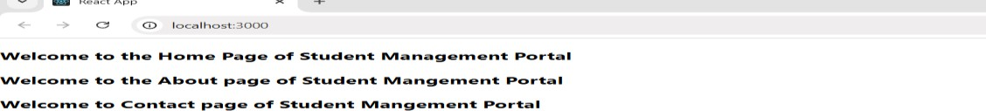

Question 11: Event Handling in React

Code:
import React, { useState } from 'react'; import './App.css';
function App() {
const [count, setCount] = useState(0); const [message, setMessage] = useState(''); const [rupees, setRupees] = useState(''); const [euros, setEuros] = useState('');
const increment = () => { setCount(count + 1); sayHello();
};
const sayHello = () => {
setMessage('Hello! Welcome to React Events!');
};
const sayWelcome = (msg) => { setMessage(msg);
};

const handleClick = (e) => { console.log(e); setMessage('I was clicked!');
};
const handleConversion = () => {
const rate = 0.011; // 1 INR = 0.011 EUR setEuros((rupees * rate).toFixed(2));
};
return (
<div className= "App" >
<h1>React Event Examples </h1>
< div className = "counter-section" >
<h2>Counter: { count } </h2>
< button onClick = { increment } > Increment(+1 and Say Hello) </button>
< button onClick = {() => setCount(count - 1)
}> Decrement </button>
</div>

< div className = "message-section" >
<h3>{ message } </h3>
< button onClick = {() => sayWelcome('Welcome to React!')}> Say Welcome
</button>
< button onClick = { handleClick } > Click Me(Synthetic Event)
</button>
</div>
< div className = "converter-section" >
<h2>Currency Converter </h2>
< div >
<label>

Indian Rupees:
<input
type="number" value = { rupees }
onChange = {(e) => setRupees(e.target.value)}
/>
</label>
< button onClick = { handleConversion } > Convert to Euros </button>
</div>
{ euros && <p>₹{ rupees } = €{ euros } </p> }
</div>
</div>
);
}

export default App;

Output:
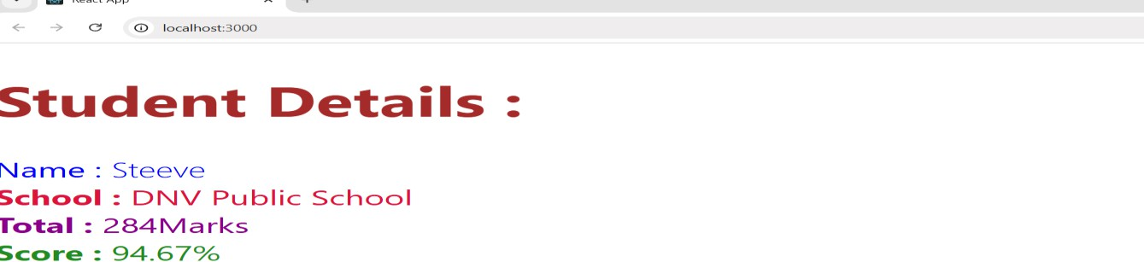

Question 12: Conditional Rendering with Login/Logout in React Ticket Booking App.

Code:
import React, { useState } from 'react'; import './App.css';
function App() {
const [isLoggedIn, setIsLoggedIn] = useState(false); const flights = [
{ id: 1, flightNo: 'AI101', from: 'Delhi', to: 'Mumbai', time: '10:00 AM' },
{ id: 2, flightNo: 'AI202', from: 'Mumbai', to: 'Chennai', time: '12:30 PM' },
{ id: 3, flightNo: 'AI303', from: 'Bangalore', to: 'Delhi', time: '03:15 PM' }
];

return (
<div className= "App" >
<h1>Flight Ticket Booking </h1>
< button
onClick = {() => setIsLoggedIn(!isLoggedIn)
}
className = { isLoggedIn? 'logout-btn': 'login-btn' }
>
{ isLoggedIn? 'Logout': 'Login' }
</button>
{
isLoggedIn ? (
<div className= "user-view" >
<h2>Welcome User! </h2>

< div className = "booking-form" >
<h3>Book Your Flight </h3>
<select>
{
flights.map(flight => (
<option key= { flight.id } value = { flight.flightNo } >
{ flight.flightNo }: { flight.from } to { flight.to }({ flight.time })
</option>
))
}
</select>
< input type = "date" placeholder = "Travel Date" />
<input type="number" placeholder = "Passengers" min = "1" />
<button className="book-btn" > Book Now </button>
</div>
</div>
) : (
<div className= "guest-view" >
<h2>Available Flights </h2>
< table >
<thead>
<tr>
<th>Flight No </th>
< th > From </th>
< th > To </th>
< th > Time </th>
</tr>
</thead>
<tbody>
{
flights.map(flight => (
<tr key= { flight.id } >
<td>{ flight.flightNo } </td>
< td > { flight.from } </td>
< td > { flight.to } </td>
< td > { flight.time } </td>
</tr>
))
}
</tbody>
</table>
< p > Please login to book tickets </p>
</div>
)
}
</div>
);
}
export default App;

Output:
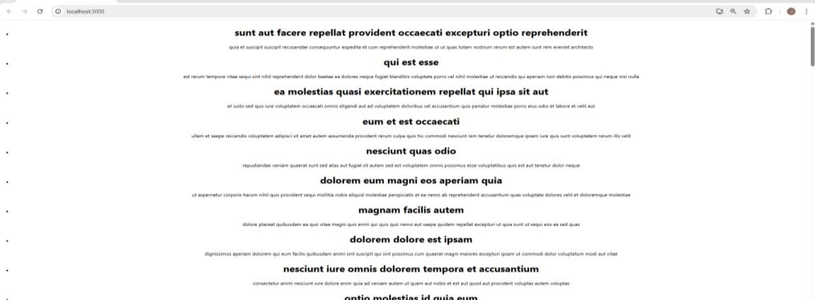

Question 13: Conditional Rendering in React

Code:
import React, { useState } from 'react'; import './App.css';

function App() {
const [activeTab, setActiveTab] = useState('books');
// Sample data const books = [
{ id: 1, title: 'React Basics', author: 'John Doe', pages: 200 },
{ id: 2, title: 'Advanced JavaScript', author: 'Jane Smith', pages: 350 }
];
const blogs = [
{ id: 1, title: 'Getting Started with React', author: 'Alex Johnson', date: '2023-05-15' },
{ id: 2, title: 'ES6 Features You Should Know', author: 'Sarah Williams', date: '2023-06-20' }
];

const courses = [
{ id: 1, title: 'React Fundamentals', duration: '4 weeks', level: 'Beginner' },
{ id: 2, title: 'Advanced React Patterns', duration: '6 weeks', level: 'Advanced' }
];
return (
<div className= "App" >
<h1>Blogger App </h1>
< div className = "tabs" >
<button
onClick={ () => setActiveTab('books') } className = { activeTab === 'books' ? 'active' : ''
}
>
Books
</button>
< button
onClick = {() => setActiveTab('blogs')} className = { activeTab === 'blogs' ? 'active' : ''}
>
Blogs
</button>
< button
onClick = {() => setActiveTab('courses')} className = { activeTab === 'courses' ? 'active' : ''}
>
Courses
</button>
</div>
< div className = "content" >
{ activeTab === 'books' && (
<div className="book-details" >
<h2>Book Details </h2>
<ul>
{
books.map(book => (
<li key= { book.id } >
<h3>{ book.title } </h3>
< p > Author: { book.author } </p>
< p > Pages: { book.pages } </p>
</li>
))
}
</ul>
</div>
)}
{
activeTab === 'blogs' && (
<div className="blog-details" >
<h2>Blog Details </h2>
<ul>
{
blogs.map(blog => (

<li key= { blog.id } >
<h3>{ blog.title } </h3>
< p > By { blog.author } on { blog.date } </p>
</li>
))
}
</ul>
</div>
)
}
{
activeTab === 'courses' && (
<div className="course-details" >
<h2>Course Details </h2>
< table >
<thead>
<tr>
<th>Title </th>
< th > Duration </th>
< th > Level </th>
</tr>
</thead>
<tbody>
{
courses.map(course => (
<tr key= { course.id } >
<td>{ course.title } </td>
< td > { course.duration } </td>
< td > { course.level } </td>
</tr>
))
}
</tbody>
</table>
</div>
)
}
</div>
</div>
);
}
export default App;
Output:
