COGNIZANT DIGITAL NURTURE 5.0 – DEEP SKILLING PHASE
WEEK 1 : Advanced SQL Mandatory Exercises

Submitted By
Name: Nishant Kumar
Superset ID: 7985565
Email: nishantkumar6205003458@gmail.com
University: C. V. Raman Global University, Odisha

Exercise 1: Ranking and Window Functions Goal:
Use ROW_NUMBER(), RANK(), DENSE_RANK(), OVER(), and PARTITION BY.
Scenario: Find the top 3 most expensive products in each category using different ranking functions. Steps: 1. Use ROW_NUMBER() to assign a unique rank within each category. 2. Use RANK() and DENSE_RANK() to compare how ties are handled. 3. Use PARTITION BY Category and ORDER BY Price DESC.

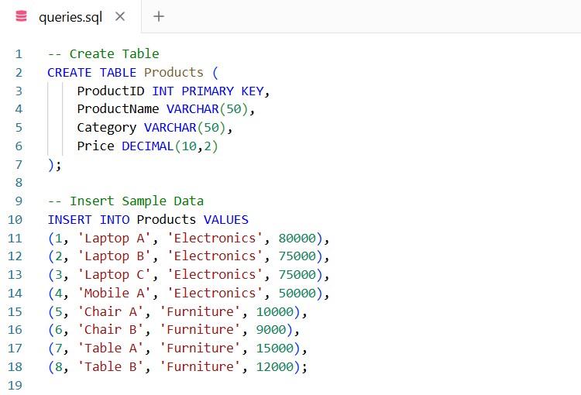
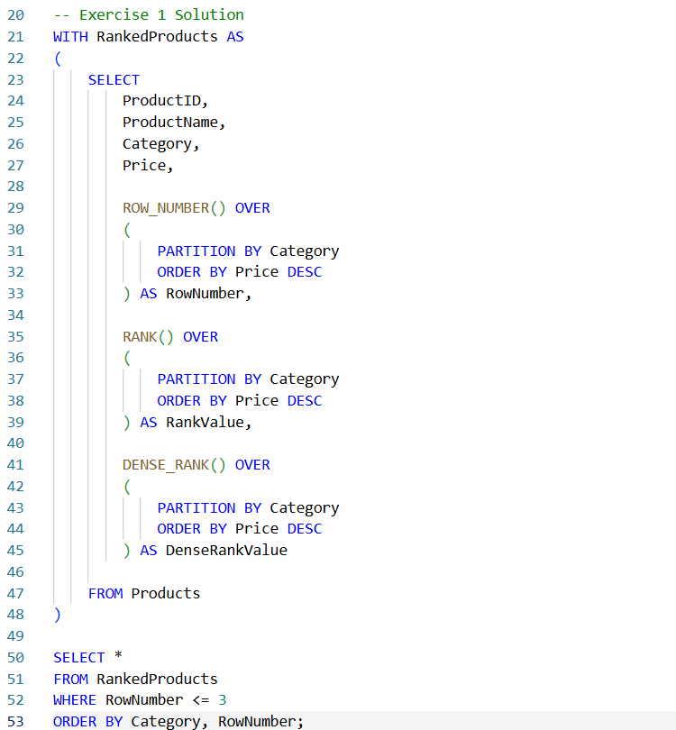

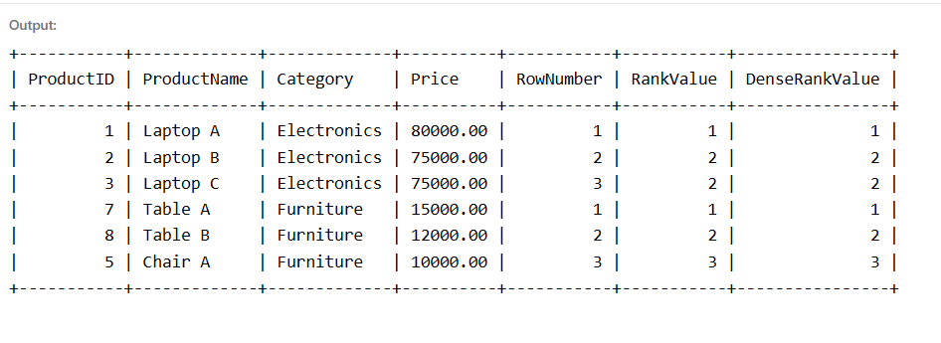
Exercise 2: Create a Stored Procedure Goal: Create a stored procedure to retrieve employee details by department.
Steps:
1. Define the stored procedure with a parameter for DepartmentID.
2. Write the SQL query to select employee details based on the DepartmentID.
3. Create a stored procedure named `sp_InsertEmployee` with the following code: CREATE PROCEDURE sp_InsertEmployee @FirstName VARCHAR(50), @LastName VARCHAR(50), @DepartmentID INT, @Salary DECIMAL(10,2), @JoinDate DATE
AS
BEGIN INSERT INTO Employees (FirstName, LastName, DepartmentID, Salary, JoinDate) VALUES (@FirstName, @LastName, @DepartmentID, @Salary, @JoinDate); END;
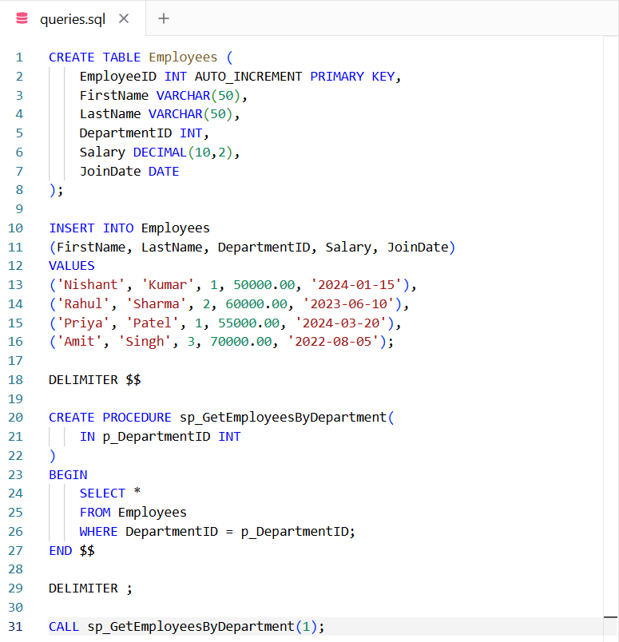
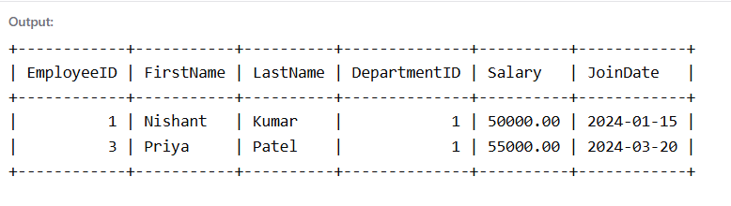

Exercise 5: Return Data from a Stored Procedure Goal:
Create a stored procedure that returns the total number of employees in a department.
Steps:
1. Define the stored procedure with a parameter for DepartmentID.
2. Write the SQL query to count the number of employees in the specified department.
3. Save the stored procedure by executing the Stored procedure content.
