DOC

Table of contents:
Contents
Chapter 1: 2
About the Project 2
Group Members 3
Chapter 2 3
Use Case Diagram 3
FA22 BSE 059 – Syed Shah Mansoor Trimzi 3
SP23 BSE 096 – Murtaza Tanveer 4
SP23 BSE 076 – Naseem Shahid 6
FA22 BSE 074 – Amanullah Khan 7
Chapter 3 9
Full Dressed Usecase 9
FA22 BSE 059 – Syed Shah Mansoor Trimzi 9
SP23 BSE 096 – Murtaza Tanveer 11
SP23 BSE 076 – Naseem Shahid 14
FA22 BSE 074 – Amanullah Khan 17
Chapter 4 22
SSD 22
FA22 BSE 059 – Syed Shah Mansoor Trimzi 22
SP23 BSE 096 – Murtaza Tanveer 23
SP23 BSE 076 – Naseem Shahid 25
FA22 BSE 074 – Amanullah Khan 27
Chapter 5 29
Class Diagram 29
FA22 BSE 059 – Syed Shah Mansoor Trimz 29
SP23 BSE 096 – Murtaza Tanveer 31
SP23 BSE 076 – Naseem Shahid 33
FA22 BSE 074 – Amanullah Khan 35

2
DOC

Chapter 1:

About the Project
Inventory Management System - Java + MySQL
This is a simple Inventory Management System designed for grocery stores, built as a Software Design and Architecture semester project by a team of four. It follows proper Object-Oriented Programming, UML modeling, and design principles to support real-world maintainability and scalability.
Key Modules
The system is divided into 7 functional modules, each mapped to a clear use case and independently implementable:
Login / Logout
Role-based authentication (Admin, Employee) Session management
Account Management
Admin can create, edit, or delete employee accounts Enforces role-based access
Add Item to Inventory
Add new grocery items with attributes like name, quantity, category, price Delete Item from Inventory
Delete outdated or discontinued items by Admin Search Item
Search inventory by name, category, or ID View Inventory
Display complete list of items with filtering options Generate Reports
Create summary reports based on stock, activity, and item trends
⚙Tech Stack Layer Technology
Language Java (JDK 17+) Database MySQL
UI Java Swing Database Access JDBC
Design Tools Draw.io / Lucidchart for UML Design Methodology
Object-Oriented Programming (O P)
We used OOP to ensure modularity, reusability, and clean separation of concerns:

2

DOC

Encapsulation: Each module has its own data and behavior Abstraction: Users interact with high-level operations Inheritance: Roles (e.g., Admin, Employee) can extend base User
Polymorphism: Future enhancements can allow custom UI actions per role Software Design Principles & Patterns
Single Responsibility Principle (SRP): Each class has a well-defined job GRASP Patterns:
Controller: Each module has its own controller class Creator: DAOs are responsible for creating model objects
Information Expert: Logic resides in the class that has the data MVC Architecture:
Model: User, Item, Inventory View: LoginUI, InventoryUI, etc.
Controller: LoginController, InventoryController UML Diagrams (Created)
For each use case (module), the following were developed:
General Use Case Diagram (with <<include>> and <<extend>> as needed) Fully Dressed Use Cases (structured table format)
System Sequence Diagrams (SSD) Communication Diagrams (based on GRASP)
Class Diagrams (showing structure and relationships) Roles & Access Control
Role Capabilities
Admin Full access: account mgmt, inventory CRUD, reports Employee Limited access: login, view/search inventory, add items

Group Members:
- FA22 BSE 059 – Syed Shah Mansoor Trimzi
- SP23 BSE 096 – Murtaza Tanveer
- SP23 BSE 076 – Naseem Shahid
- FA22 BSE 074 – Amanullah Khan

Chapter 2

Use Case Diagram:

FA22 BSE 059 – Syed Shah Mansoor Trimzi

2

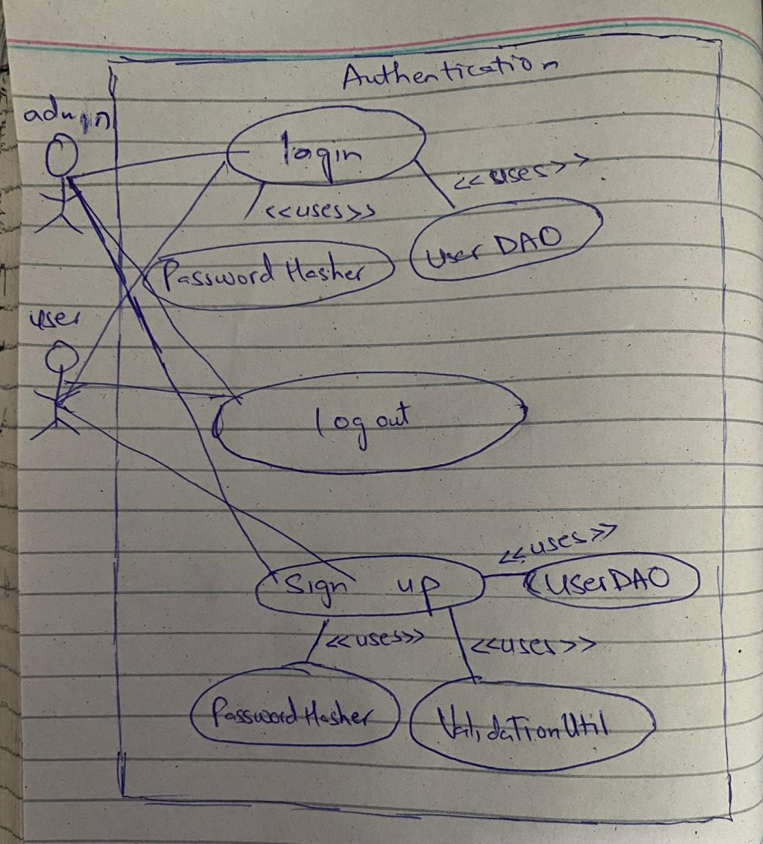
DOC

SP23 BSE 096 – Murtaza Tanveer

2

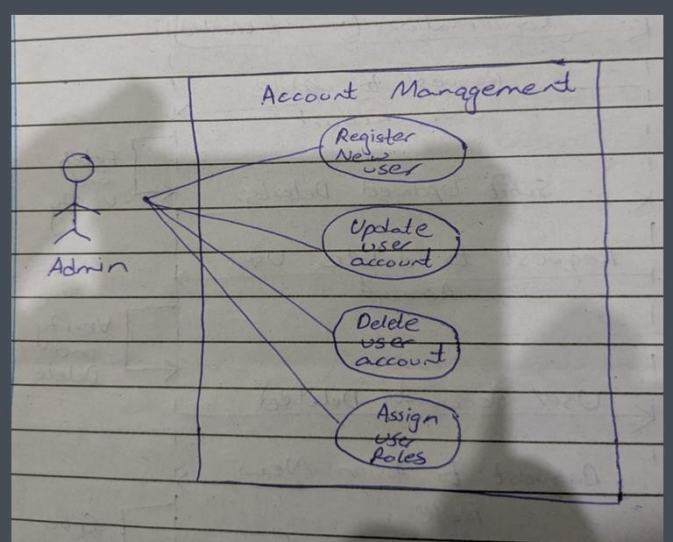
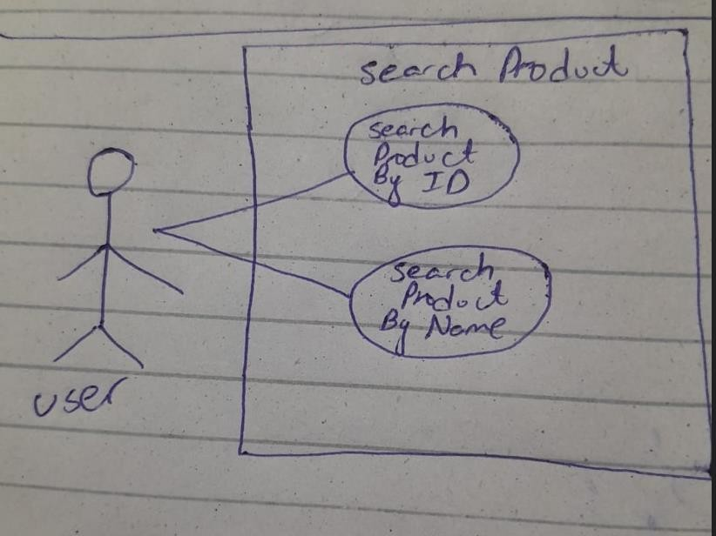
DOC

2

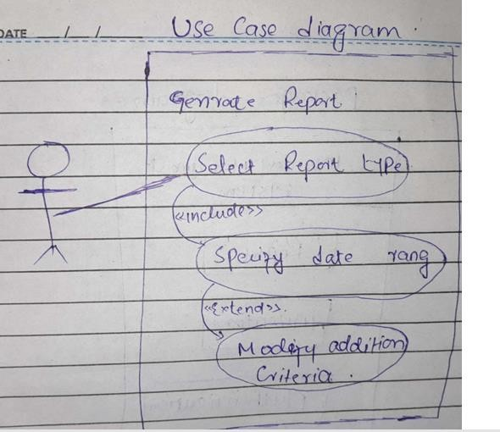
DOC

SP23 BSE 076 – Naseem Shahid

2

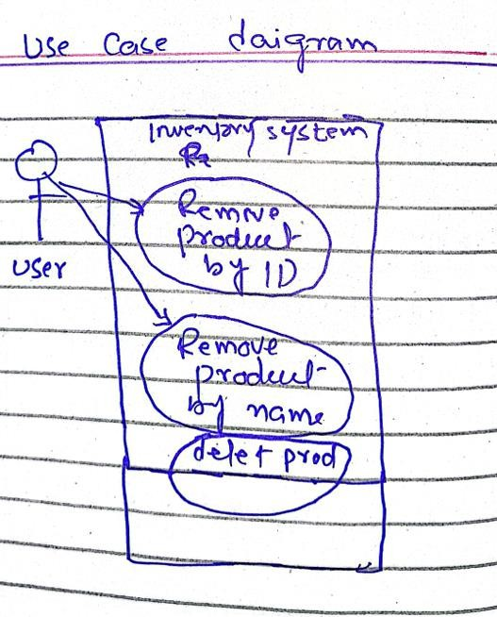
DOC

FA22 BSE 074 – Amanullah Khan

2

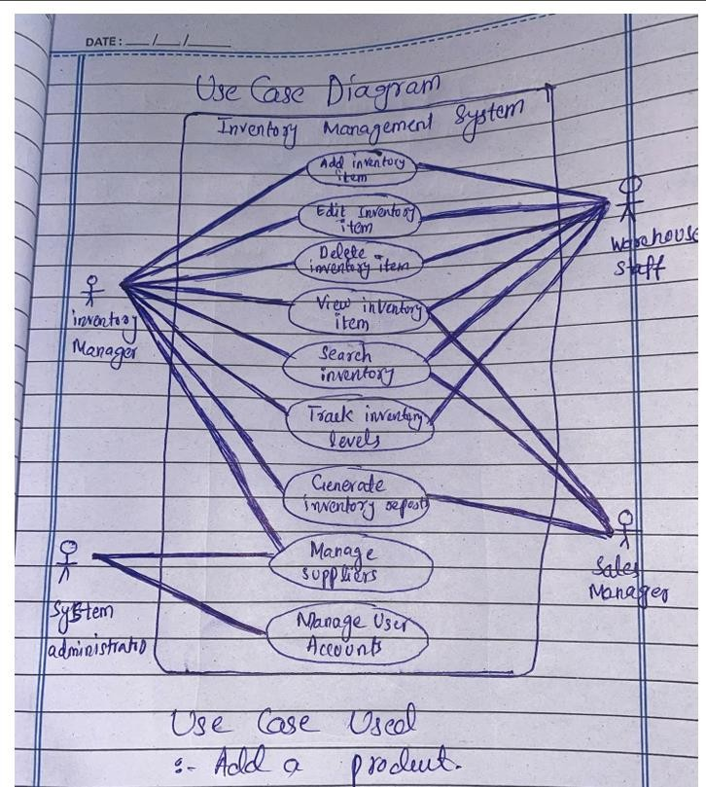
DOC

2
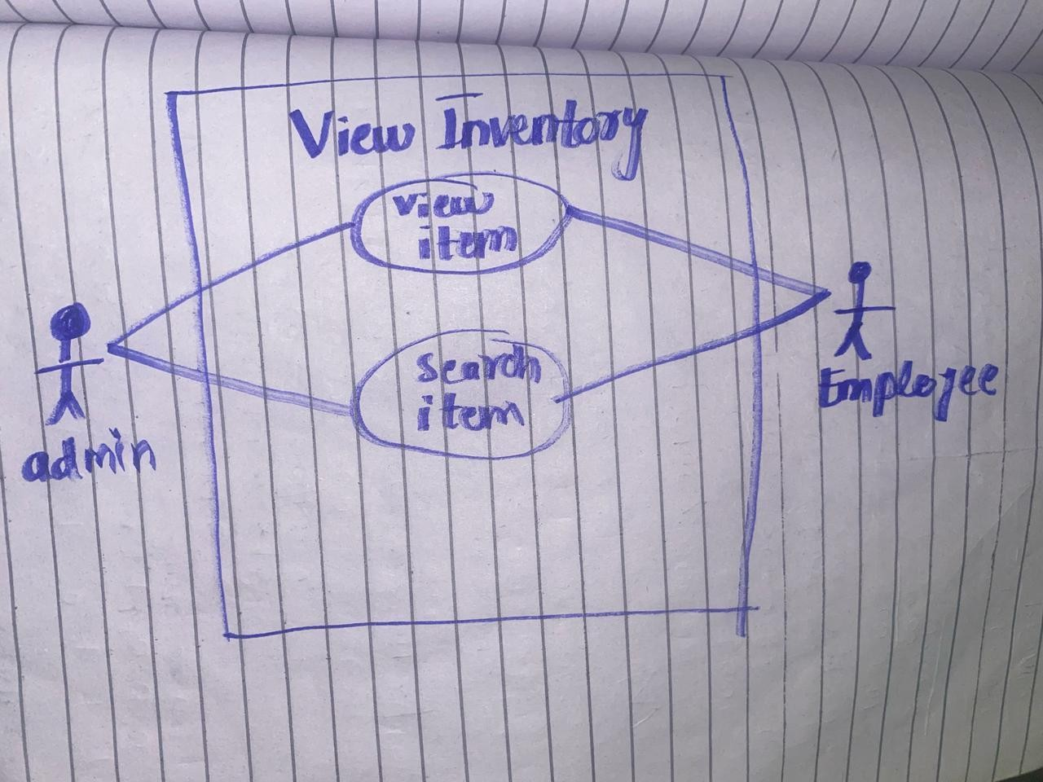
DOC

Chapter 3

Full Dressed Usecase:

FA22 BSE 059 – Syed Shah Mansoor Trimzi

Use Case Name: Authentication
Scope: Inventory Management System for Grocery Store
Level: User Goal
Primary Actor: Admin, Employee

Stakeholders and Interests:

2

DOC

- Admin/Employee: Need secure access to system functions.
- System: Must verify user identity and prevent unauthorized access.

Preconditions:
- System is running and connected to the database.
- For login: user account exists and is approved.
- For sign-up: username must be unique.

Postconditions:
- On login: user is authenticated, and session starts.
- On logout: session ends securely.
- On sign-up: account is created with pending status.

Main Success Scenario (Basic Flow):

Login:
- User accesses the login screen.
- Enters username and password.
- System fetches user from database using UserDAO.
- Confirms status is “approved”.
- Verifies password using PasswordHasher.
- Identifies user role and grants access.
- User uses the system.
- User logs out.
- System ends the session.

Sign Up:
- User opens sign-up form.
- Enters username, password, email, and role.
- System validates input and checks username availability.
- Hashes password and creates user with pending status.
- Saves user to database using UserDAO.

Extensions (Alternative Flows):

Login – Invalid Credentials:
  - If username or password is incorrect, system displays error and prompts retry.

Login – Account Not Approved:
  - If user exists but is not approved, access is denied.

Sign Up – Username Exists:

2

DOC

  - If username already exists, system shows an error and requests a new one.

Sign Up – Invalid Input:
  - If input is invalid or incomplete, system prompts correction.

System Error (Both Flows):
  - On connection failure or exceptions, system logs error and shows a failure message.

Special Requirements:
  - Passwords are stored using SHA-256 hashing (PasswordHasher).
  - Only approved users can log in.
  - UI should distinguish admin and employee roles after login.
  - All user-related DB operations go through UserDAO.
  - Data is temporarily stored in User model objects.

SP23 BSE 096 – Murtaza Tanveer

Primary Actor: Admin
Secondary Actors: System, Email Service

Preconditions:
Admin is logged in with sufficient privileges. System is operational.

Main Success Scenario:
- Admin selects an account management action (Register/Update/Delete/Assign Roles).

2

DOC

- System displays the relevant form based on the action: Register New User: Name, email, role fields.
Update User: Editable fields (e.g., name, email). Delete User: Confirmation dialog.
Assign Roles: Role dropdown list.

- Admin enters required details and submits the request.
- System validates inputs:
For registration: Checks email uniqueness. For updates: Verifies user exists.
For deletion: Confirms no active dependencies.
For role assignment: Ensures admin has permission.

- System processes the request: Creates/updates/deactivates the user account or updates roles. Sends notifications (e.g., welcome email for new users).

- System confirms success to the Admin.

Postconditions:
  - For registration: New user is added to the system.
  - For updates: User details are modified.
  - For deletion: User account is deactivated/removed.
  - For role assignment: User permissions are updated.

2

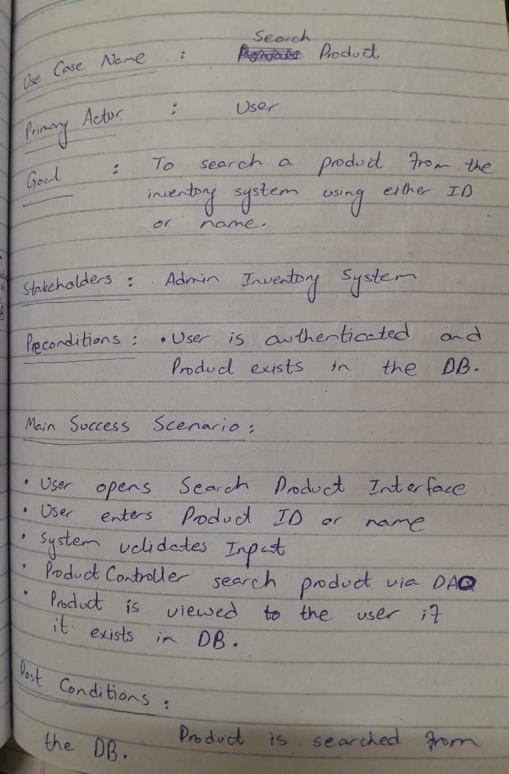
DOC

2

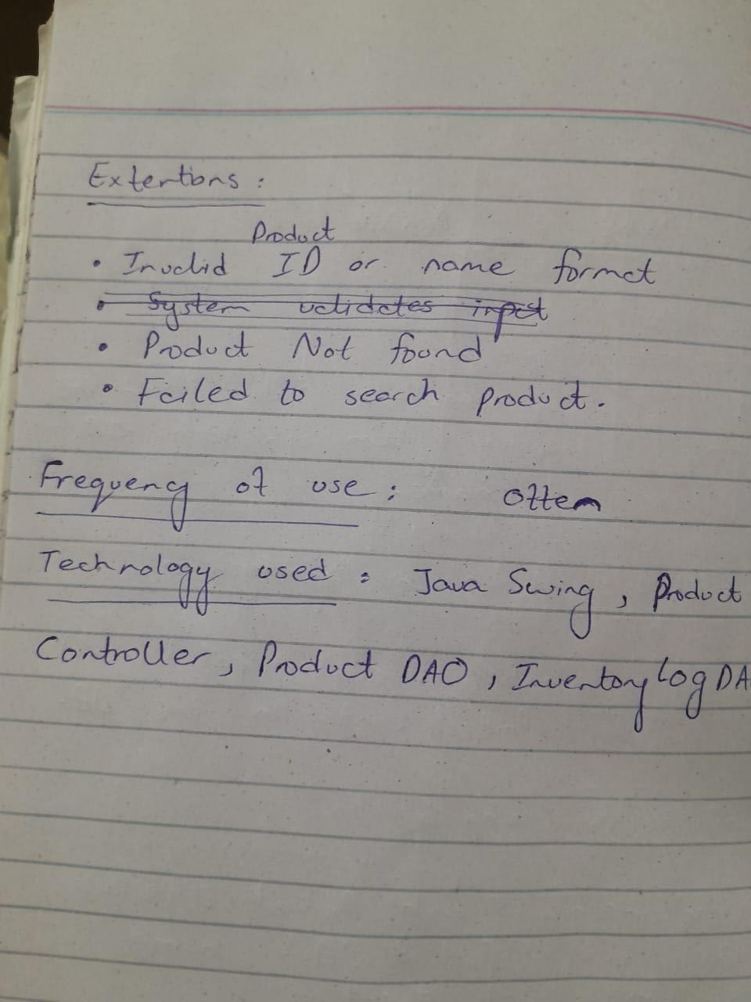
DOC

SP23 BSE 076 – Naseem Shahid

2

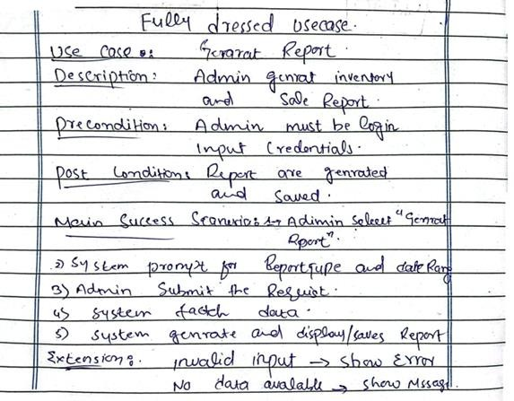
DOC

2

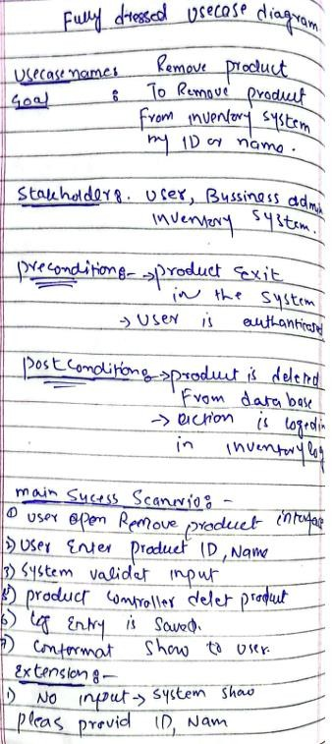
DOC

2

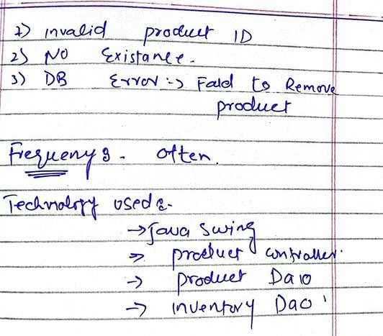
DOC

FA22 BSE 074 – Amanullah Khan Fully Dressed Use Case: Add Item to Inventory Use Case Name Add Item to Inventory Primary Actor Admin or Employee
Stakeholders and Interests Admin and Employee want to maintain accurate stock levels. The organization wants reliable inventory data for operations, sales, and reordering.
Preconditions - User must be logged in
- User must have appropriate role (Admin/Employee) Postconditions - New item is saved in the database
- Inventory is updated with the new item

2

DOC

Main Success Scenario (Basic Flow)
The user selects "Add Item" from the dashboard.

The system displays the item input form (name, quantity, price, category, etc.).

The user fills in all the required fields.

The user clicks the "Add" or "Save" button.

The system validates the input.

The system saves the new item to the inventory database.

The system confirms the addition and updates the inventory list.

The user sees a success message.

Extensions (Alternate Flows)
5a. Input is invalid (e.g., missing name or negative quantity)

The system highlights the invalid fields and shows error messages.

The user corrects the input.

Returns to Step 4.

2

DOC

6a. Database connection fails

The system displays an error message: "Failed to save item. Please try again later."

The system logs the error.

Use case ends with failure.

Special Requirements
Form must validate input before submission.

Quantity must be numeric and non-negative.

Item name should be unique (or warn about duplicates).

The system must log all item additions with timestamps and user IDs for audit.

⬛’ Frequency of Use

Frequently used by Admin and Employees during restocking or item updates.

Technology and Data Variations Inventory is stored in a MySQL database.

Item addition form is implemented in a Java Swing UI.

Backend interacts with the database using JDBC.

2

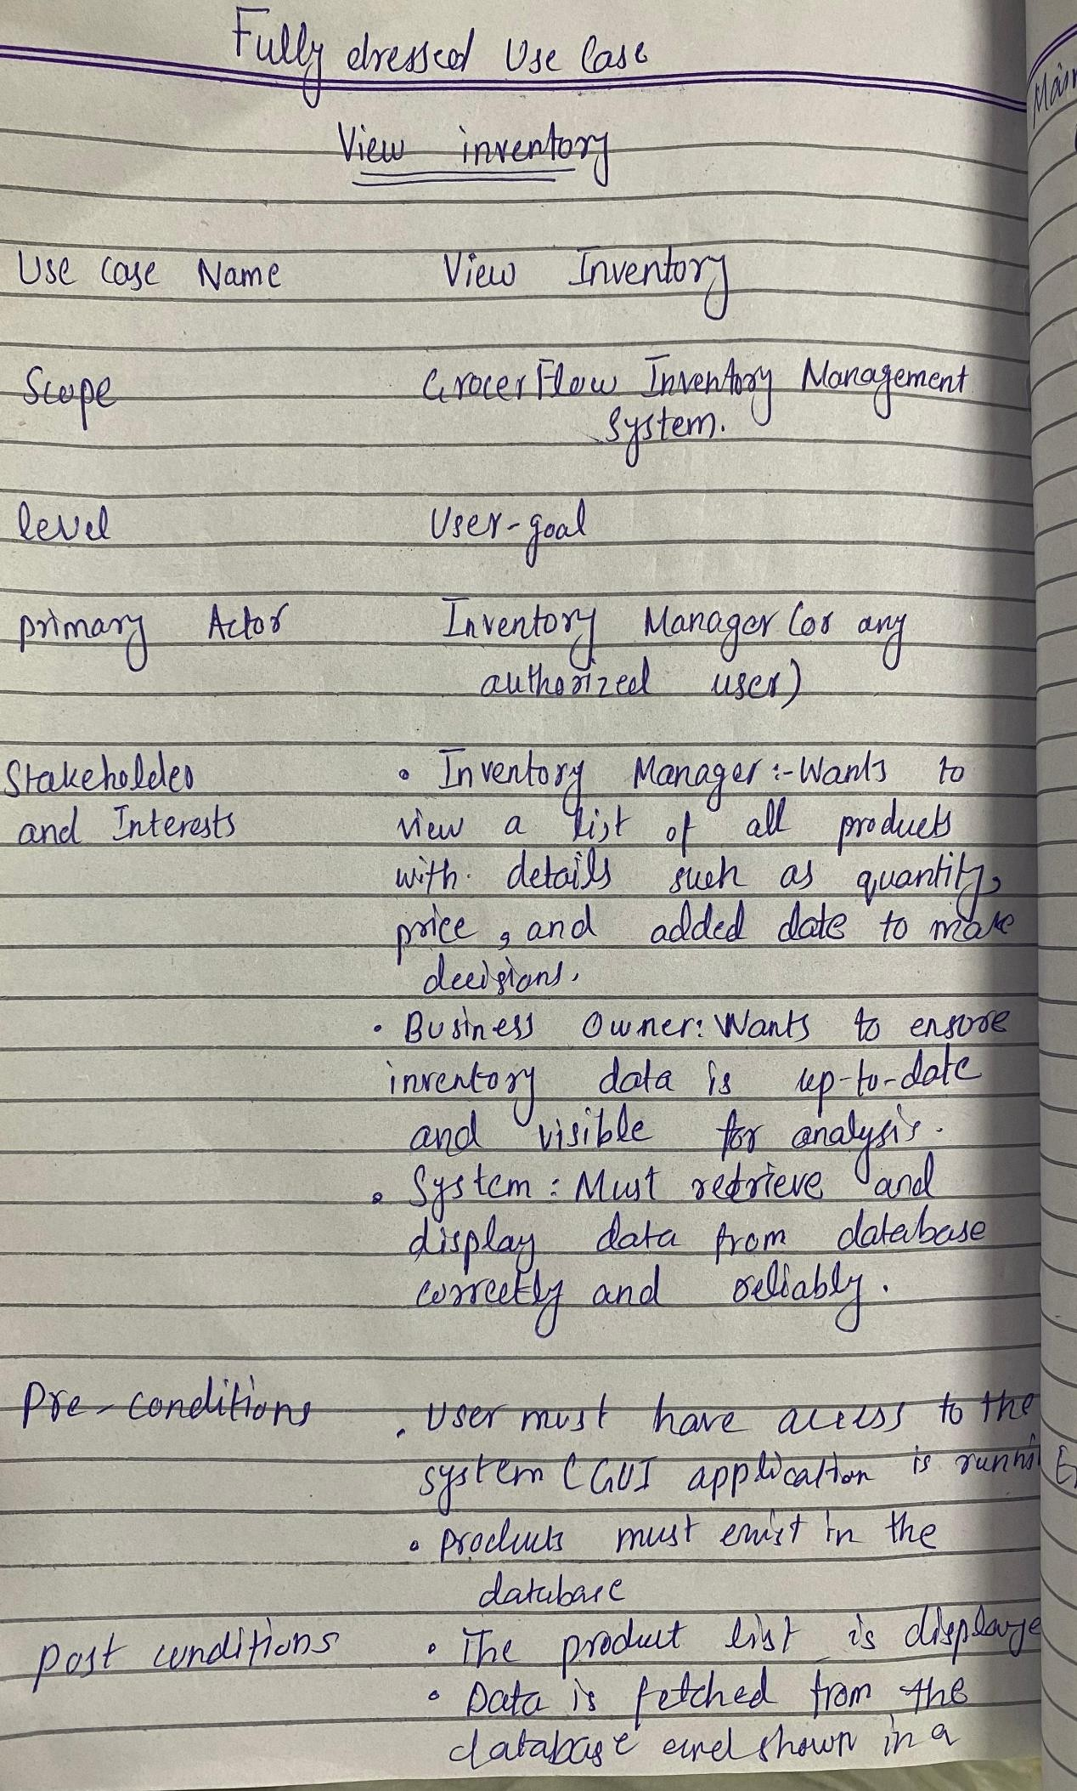
DOC

2

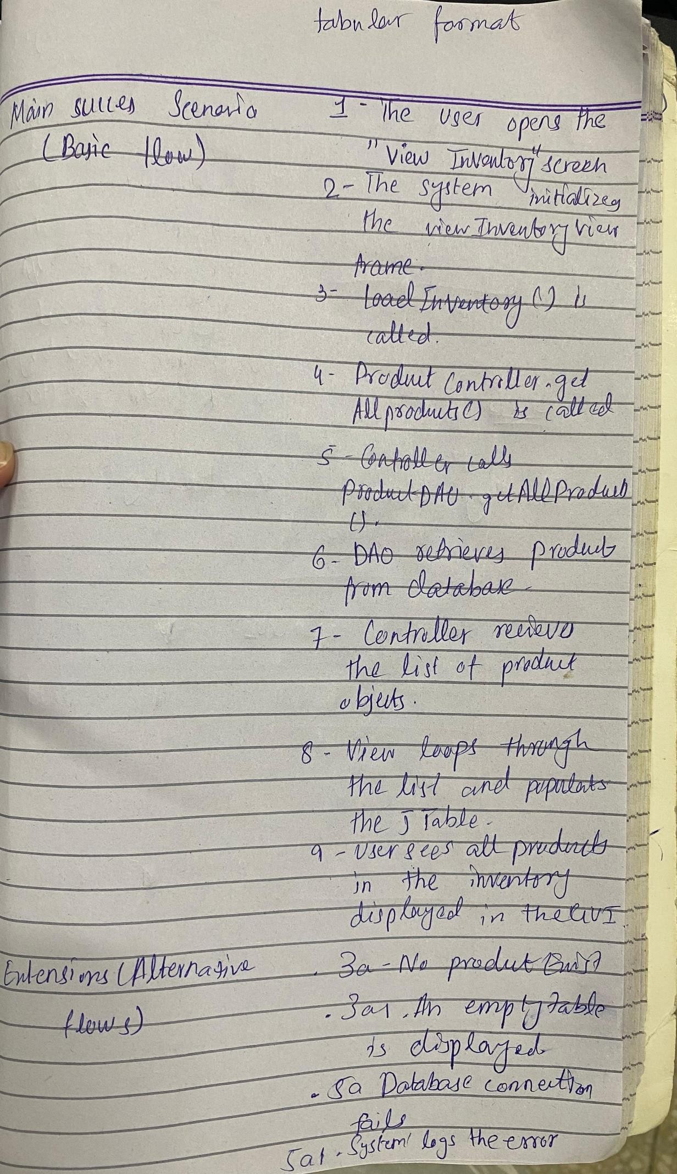
DOC

2
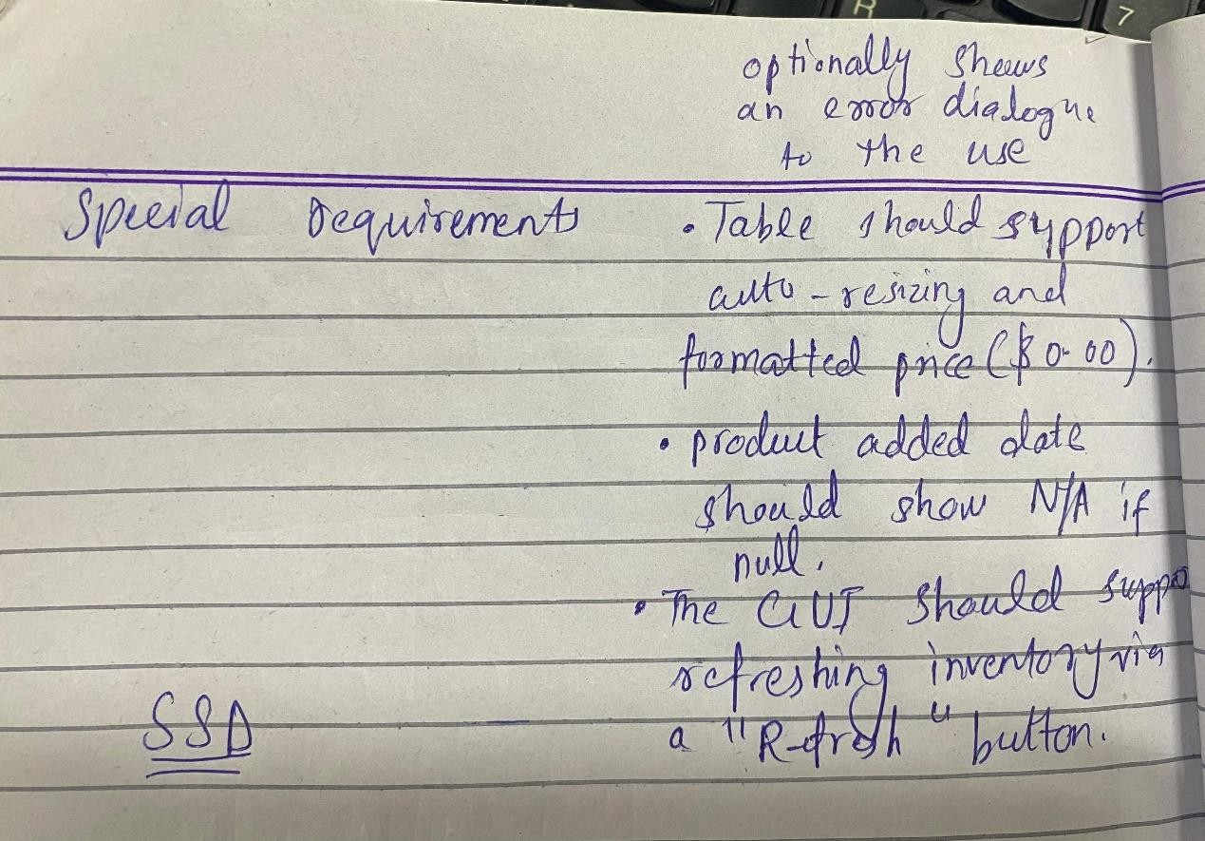
DOC

Chapter 4

SSD

FA22 BSE 059 – Syed Shah Mansoor Trimzi

2

DOC
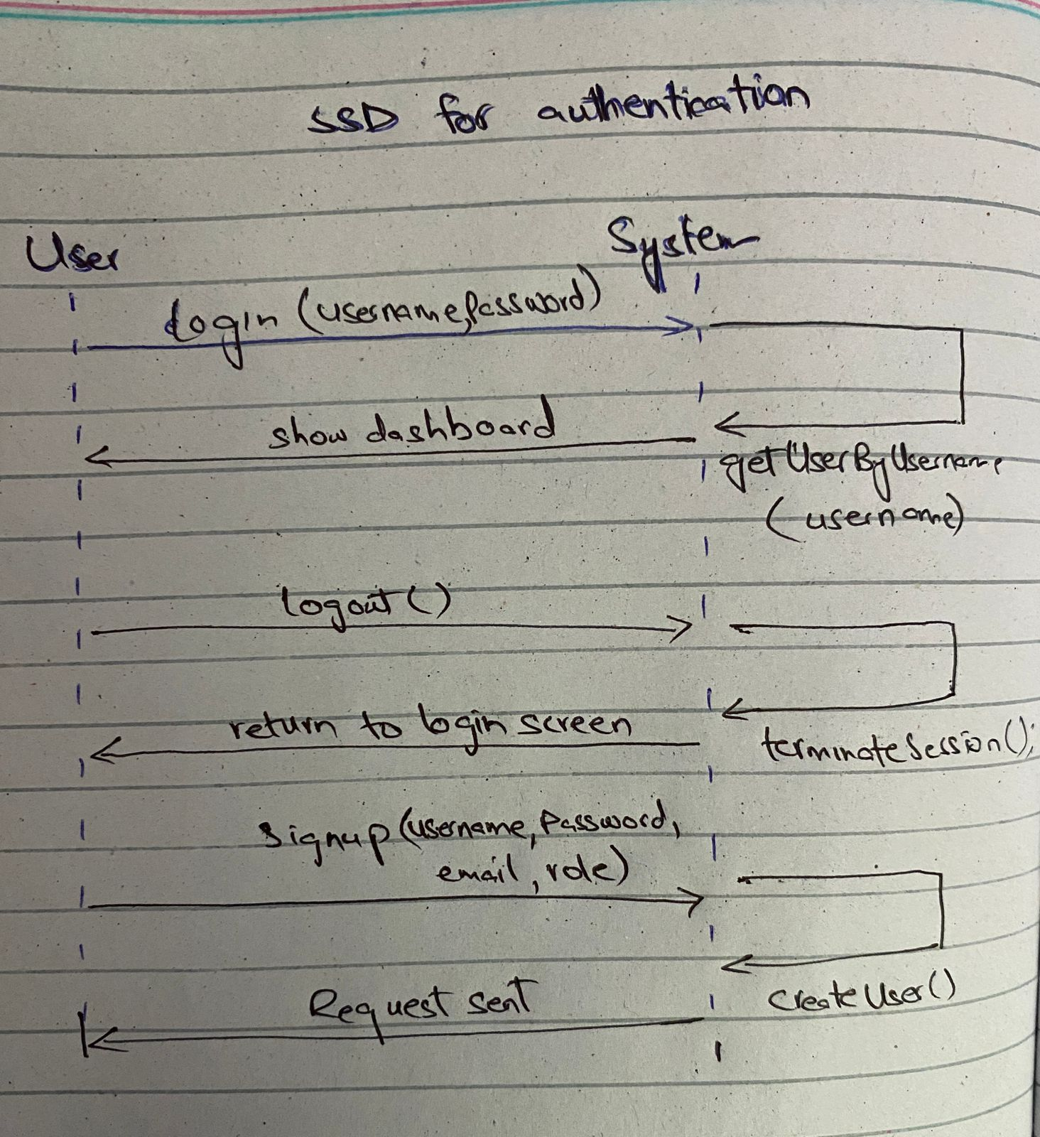

SP23 BSE 096 – Murtaza Tanveer

2

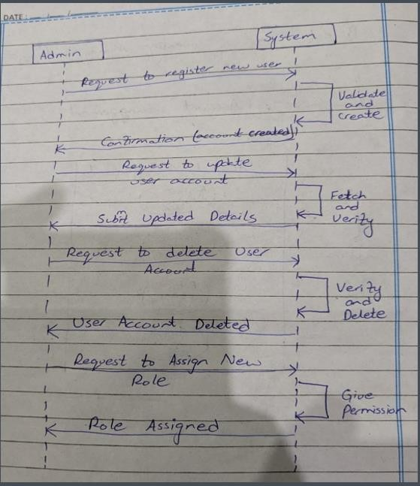
DOC

2

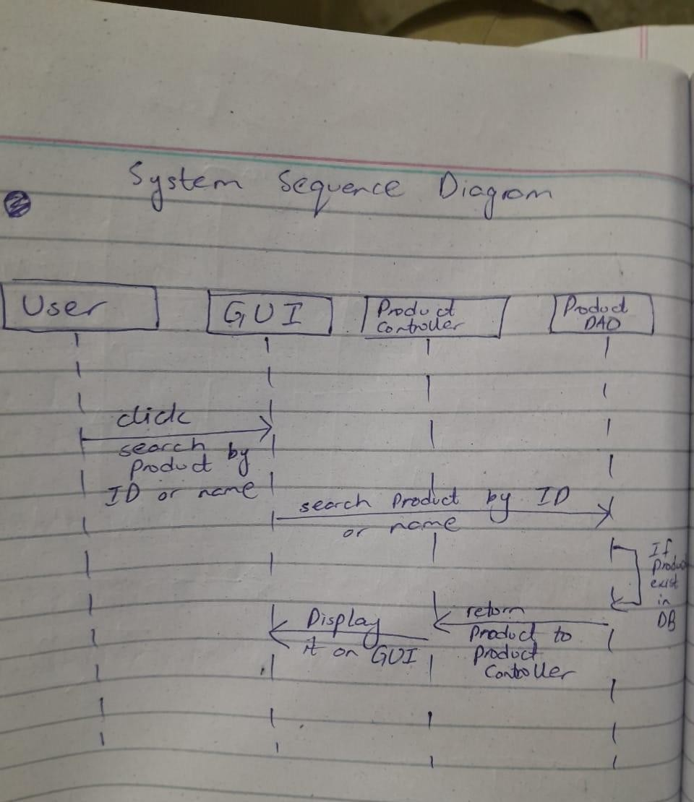
DOC

SP23 BSE 076 – Naseem Shahid

2

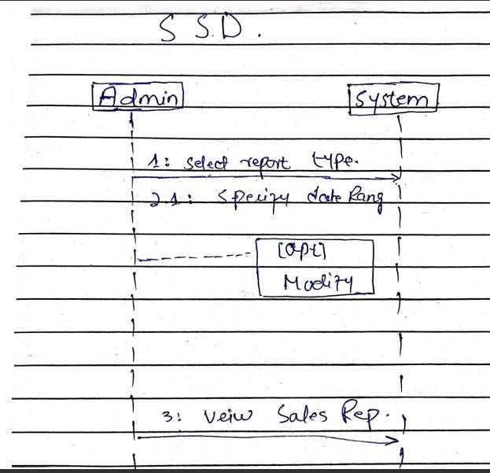
DOC

2

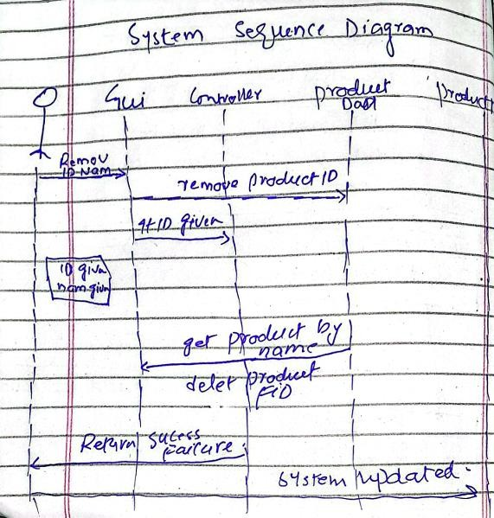
DOC

FA22 BSE 074 – Amanullah Khan

2

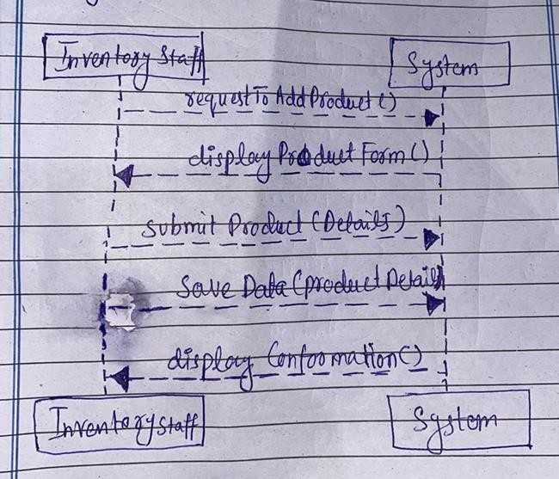
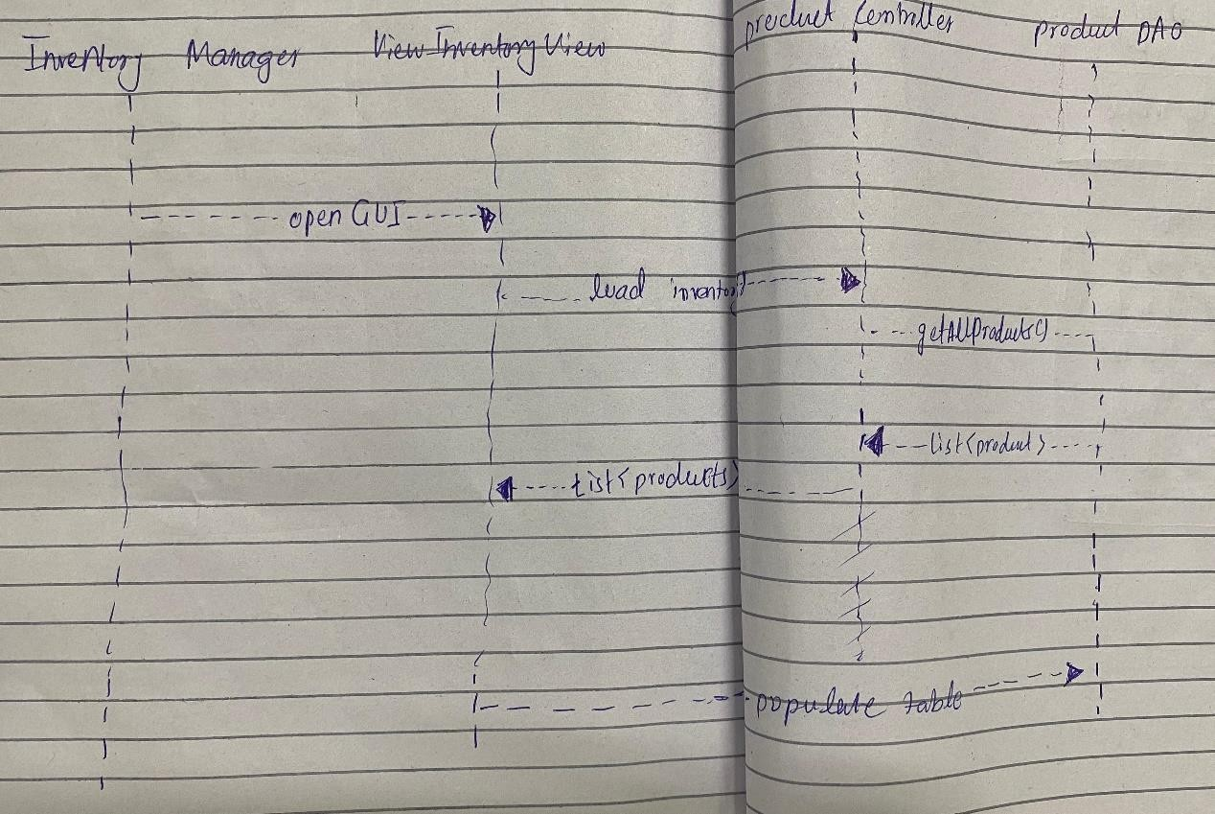
DOC

2
DOC

Chapter 5

Class Diagram:

FA22 BSE 059 – Syed Shah Mansoor Trimz

2

DOC
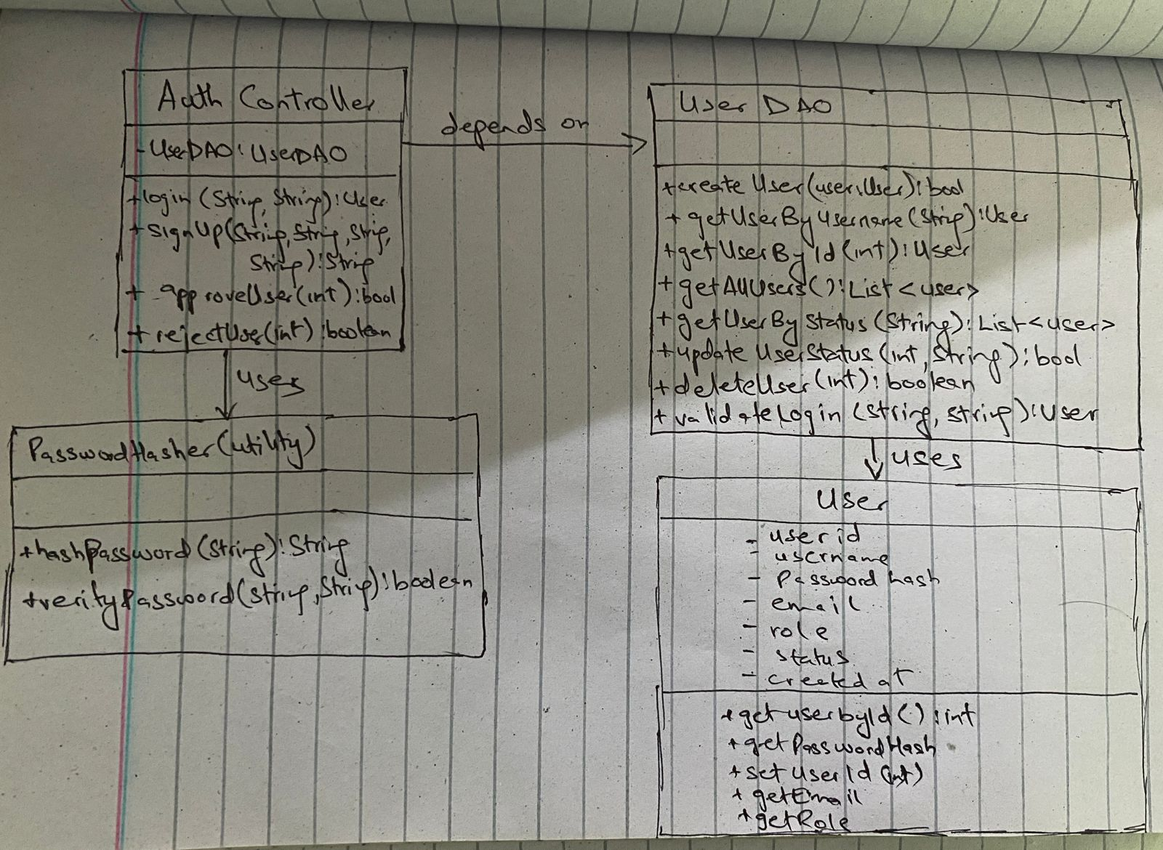

2

DOC

SP23 BSE 096 – Murtaza Tanveer

2

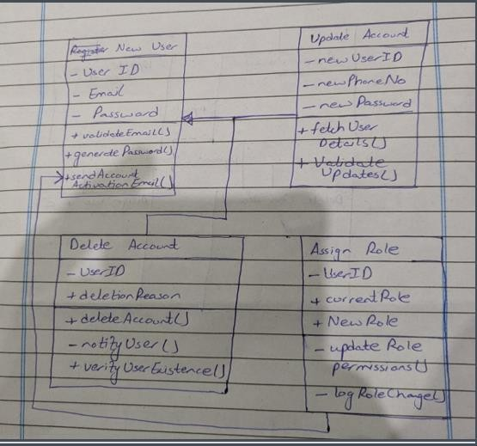
DOC

2

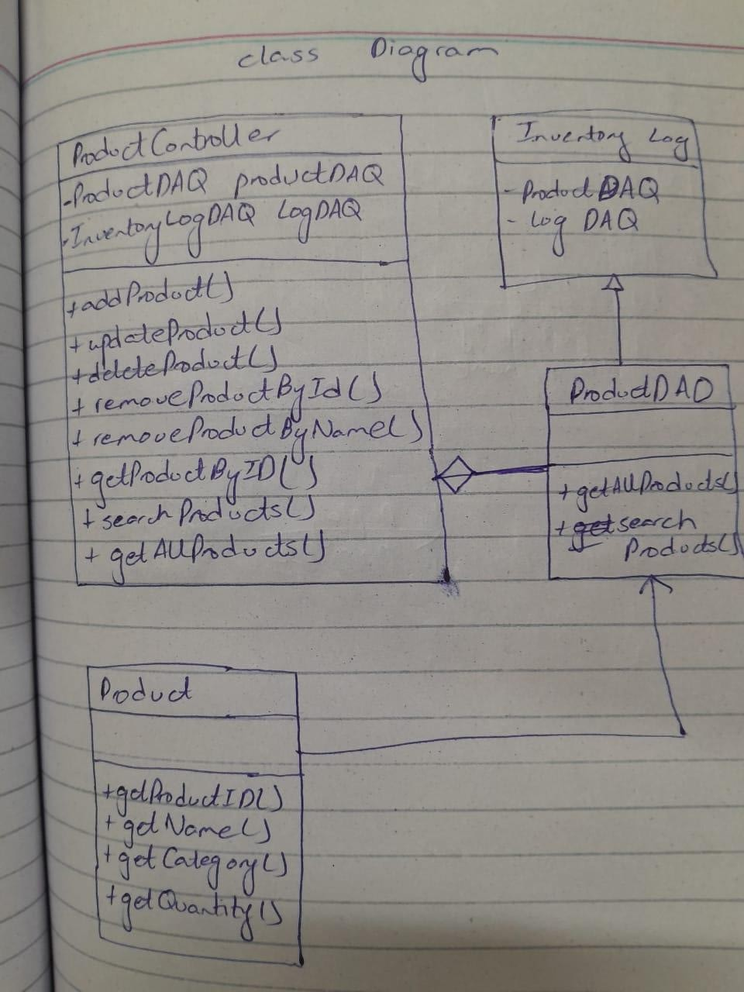
DOC

SP23 BSE 076 – Naseem Shahid

2

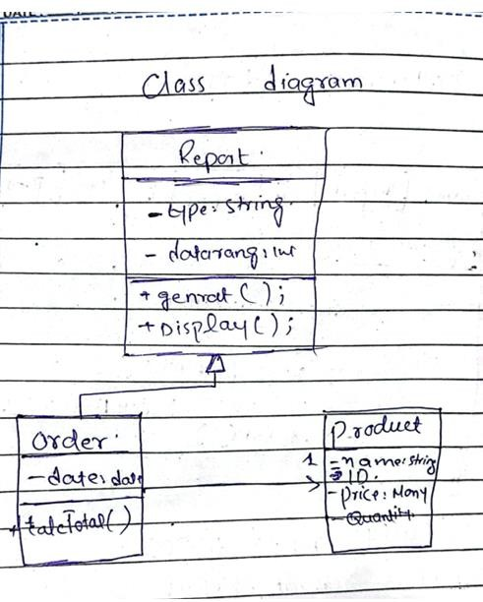
DOC

2

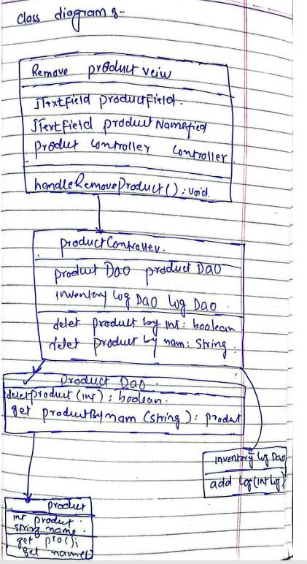
DOC

FA22 BSE 074 – Amanullah Khan

2

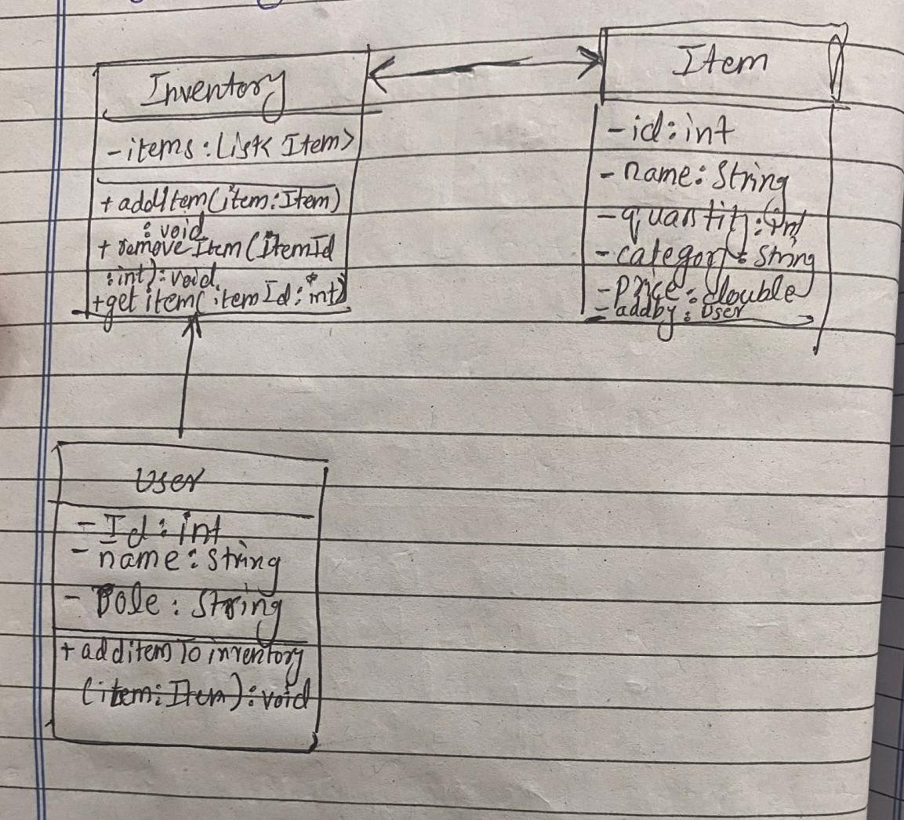
DOC

2

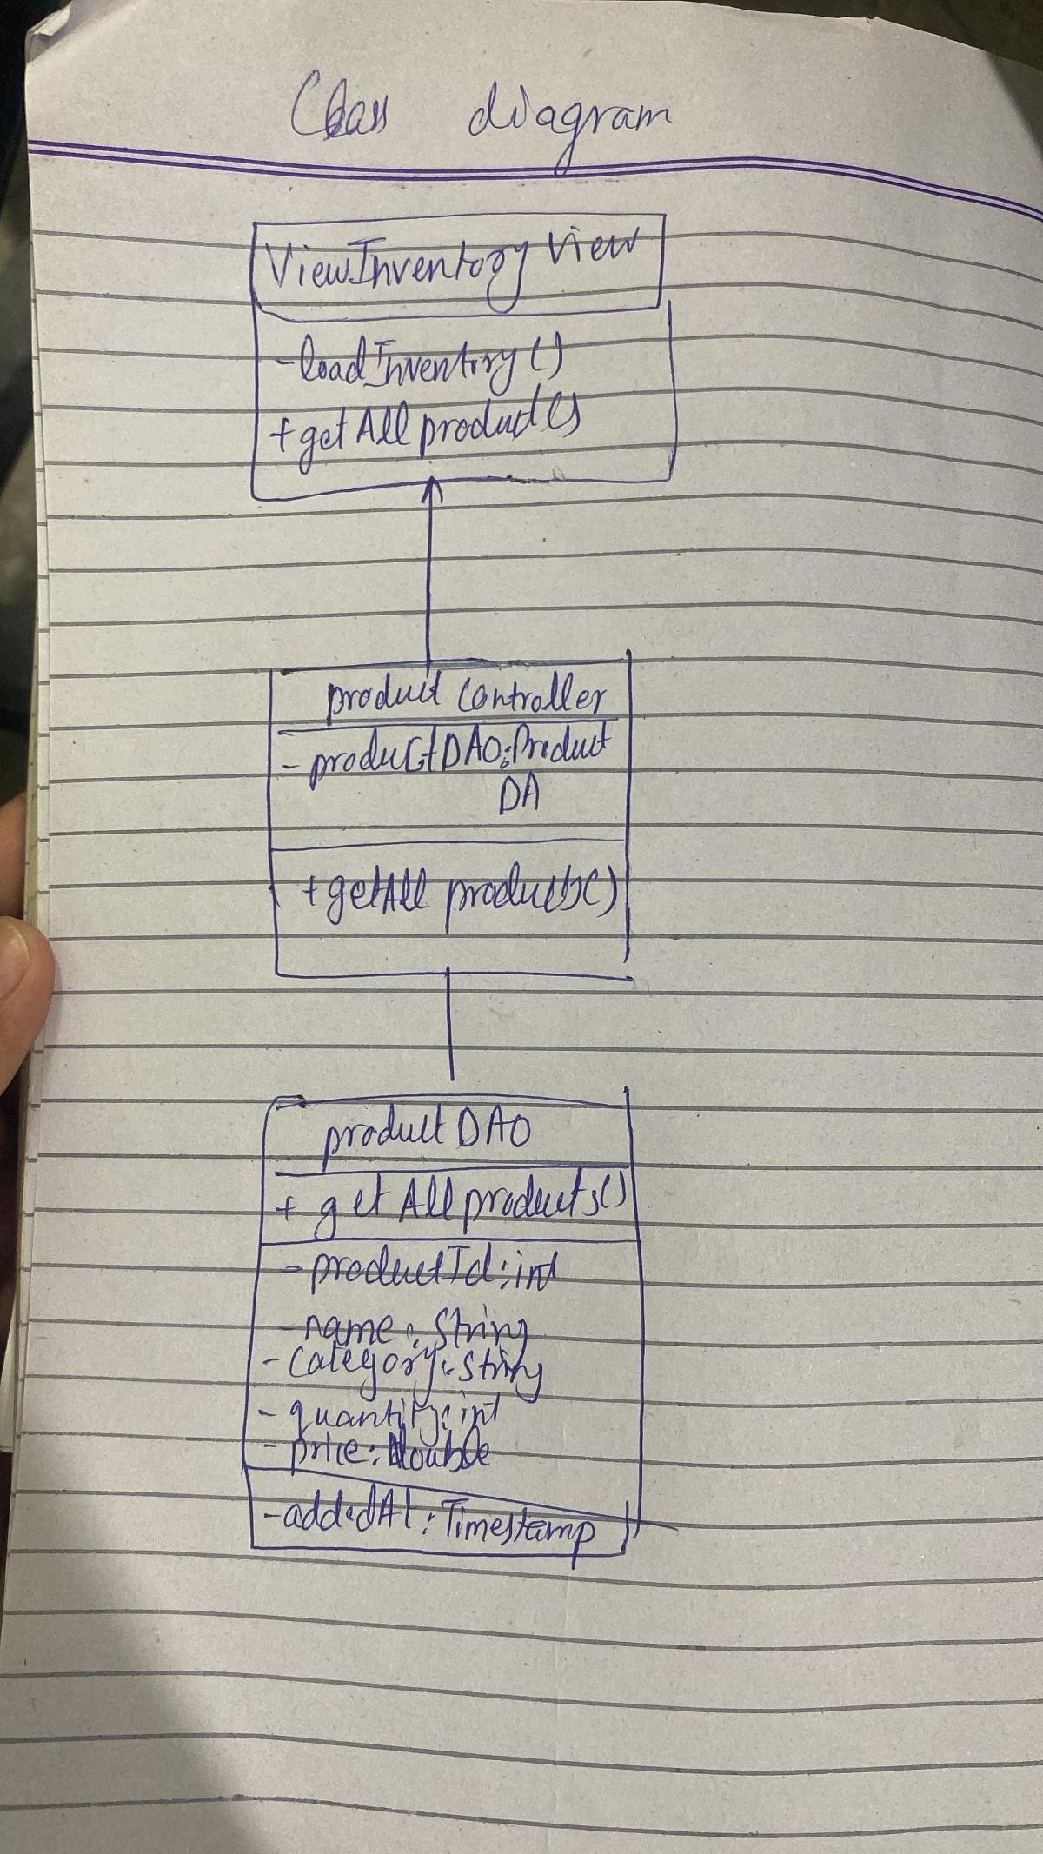
DOC

2

DOC

2

