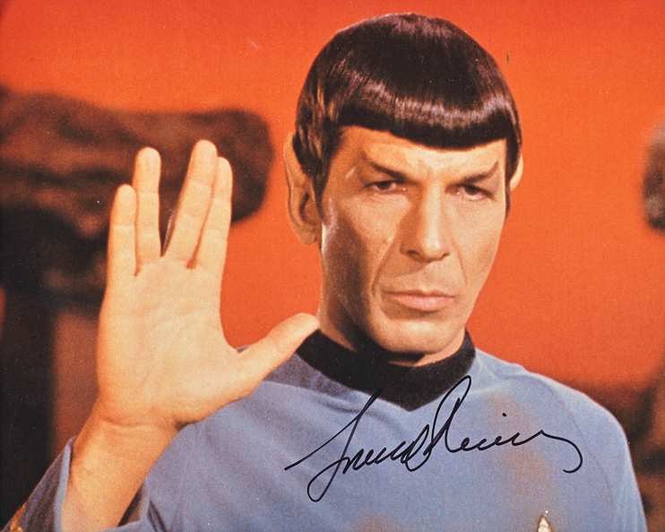

Image taken from https://www.vintagememorabilia.com/mcms_site/uploads/images/E375C045-1517-6111-28BFBC36092F97D4.png

Assignment 1

Rock Paper Scissors Lizard and Spock

Constantine Grigoriadis Student Number: Professor & Software Engineering Technologist

McMaster University

Table of Contents

Gaming Pseudo Logic 4

GameState Object 4

GameObject 4

UpdateGameWithWinner 4

Check Draw 5

Check Spock 5

Check Lizard 5

Check Scissors 5

Check Paper 5

Check Rock 6

Game Requirements As Given in the Assignment 6

Source Code 7

Output and Results 11

From 10 Million Games 11

Each Games Output 12

Data visualization 13

Assumptions 14

Conclusion 14

Code Location 14

# Gaming Pseudo Logic

## GameState Object

|  |
| --- |
| Choice 0 = StartupMode |
| Choice 1 = Rock |
| Choice 2 = Paper |
| Choice 3 = Scissors |
| Choice 4 = Lizard |
| Choice 5 =Spock |

Has a variable for its Value

Has a method Output Label

## GameObject

|  |
| --- |
| Choice 0 = NotSet |
| Choice 1 = Player1 |
| Choice 2 = Player2 |
| Choice 3 = Tie |

Has a winner in the range 0 ,1,2

Player1 = GameState

Player2 = GameState

Game has method that takes(GameState, GameState)

Given each win condition

### UpdateGameWithWinner

This method takes the two player states

First it checks the draw

Then based on player ones selection it will call a method

If 1 CheckRock

If 2 CheckPaper

If 3 CheckScissors

If 4 CheckLizard

If 5 CheckSpock

### Check Draw

Before the other conditions are check we can look for equality to shorten the other logic

if Gamestate 1 == Gamestate 2

The game is a draw in the following 5 conditions we set the Winner to Choice 3

Player 1 Selects Spock / Player 2 Selects Spock

Player 1 Selects Lizard / Player 2 Selects Lizard

Player 1 Selects Scissors / Player 2 Selects Scissors

Player 1 Selects Paper / Player 2 Selects Paper

Player 1 Selects Rock / Player 2 Selects Rock

### Check Spock

CheckSpock(Gamestate2) – This method will update the win condition

Spock beats scissors(1) and rock(3), but loses to paper(2) and lizard(4).

If Gamestate2 == Scissors(1) || Rock(3)

Winner = 1

Elif

Winner = 2

### Check Lizard

CheckLizard(Gamestate2) – This method checks win loss conditions for Lizard

Lizard beats Spock(5) and paper(2), but loses to rock(1) and scissors(3).

### Check Scissors

CheckScissors(Gamestate2) This method checks win loss conditions for Scissors

Scissors beats paper(2) and lizard(4), but loses to rock(1) and Spock(5)

### Check Paper

CheckPaper(Gamestate2) This method checks win loss conditions for Paper

Paper beats rock(1) and Spock(5), but loses to scissors(3) and lizard(4)

### Check Rock

CheckRock(Gamestate2) This method checks win loss conditions for Lizard

Rock beats scissors(3) and lizard(4), but loses to paper(2) and Spock(5).

## Game Requirements As Given in the Assignment

Spock beats scissors and rock, but loses to paper and lizard.

Lizard beats Spock and paper, but loses to rock and scissors.

Rock beats scissors and lizard, but loses to paper and Spock.

Paper beats rock and Spock, but loses to scissors and lizard.

Scissors beats paper and lizard, but loses to rock and Spock.

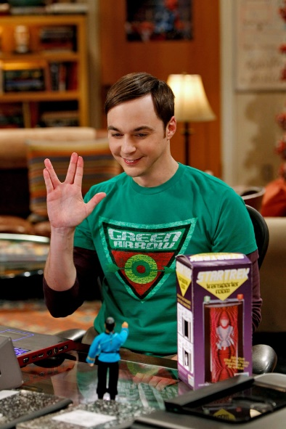Players

VS 

Sheldon Penny

Each Player gets a Random choice Between one of the 5 options from a random function

The Winner is tallied and totaled across 10 million games

# Source Code

The source code contained in this document are embedded word files feel free to double Click them to access the code.

There are 3 Source files Given

|  |  |
| --- | --- |
| File Name | Description |
| PlayerState.py | The player state file contains information regarding every specific player in the Game.  Contains a players choice, a Players Name  This Module/Class is used at higher levels |
| Spock.py | Spock.py  Contains all the information to play one game of Rock Paper Scissors Lizard Spock  This file keeps track of  Game Winner  2 PlayerState objects  With the players choices, Name etc  The Verb being used in winning sentence  This File randoms numbers from 1-5 and uses it as player choices for player 1 and Player 2  Then outputs the winner  There are also functions in place to export the data so that Analysis can be done on multiple games |
| Enterprise.py | Enterprise contains the all games played.  This file runs 1 million games of Rock Paper Scissors Lizard Spock  Then When completed provides the win percent of each Choice  Also it provides the win – lose and Tie percent for both players across the million games |

## 

Spock.Py





# Output and Results

## From 10 Million Games

## Each Games Output

I chose two Random game outcomes from the Ten million

## Data visualization

From Ten Million Games

Win Rate Across Choices

|  |  |  |  |  |  |
| --- | --- | --- | --- | --- | --- |
| Rock | Paper | Scissors | Lizard | Spock | Total |
| 15.9898% | 15.98655 | 16.02038% | 15.99977% | 16.0129099% | Of 10 000 000 |

# Assumptions

I made an assumption that a Tie game would be an acceptable outcome. In the tv show The Big Bang theory. Ties are replayed

# Conclusion



Penny Wins after 10 million Games of Rock Paper Scissors Lizard Spock

# Code Location

https://github.com/constantine2920/McMasterAssignment1

Images taken from google

Penny <https://i.pinimg.com/originals/35/11/8d/35118d5f6e3f9683c4e1d9811cbf8f0f.jpg>

Sheldon <https://static01.nyt.com/images/2017/09/10/arts/10YOUNGSHELDON2/10YOUNGSHELDON2-jumbo.jpg>

Spock <https://www.vintagememorabilia.com/mcms_site/uploads/images/E375C045-1517-6111-28BFBC36092F97D4.png>