**Slide One - Introduction**

## **What is Amazon Kinesis?**

Amazon Kinesis is a real-time, fully managed, and scalable platform for streaming data on **Amazon Web Services.** It has multiple functionalities, allowing one to perform various tasks – such as ingesting and processing real-time data, and developing custom streaming applications for specific requirements.

Amazon Kinesis can collect and process hundreds of gigabytes of data per second from hundreds of thousands of sources, allowing you to easily write applications that process information in real-time, from sources such as web site click-streams, marketing and financial information, manufacturing instrumentation and social media, and operational logs and metering data.

Amazon Kinesis is a tool in the **Real-time Data Processing** category of a tech stack.

Kinesis is massively scalable and durable real-time data streaming service. KDS can continuously capture gigabytes of data per second from hundreds of thousands of sources such as website clickstreams, database event streams, financial transactions, social media feeds, IT logs, and location-tracking events.

It provides key capabilities in the form of:

* **Kinesis Firehose** – to easily load streaming data into AWS;
* **Kinesis Analytics** – to easily process and analyze streaming data with standard SQL;
* **Kinesis Streams** – to build custom applications that process and analyze data.

Amazon Kinesis has attracted use from many well-known corporations. *Netflix*, for instance, monitors all communications between its applications using Kinesis, enabling it to detect and quickly solve any technical issues

The [Amazon Kinesis](https://aws.amazon.com/kinesis) suite of services is the central piece of the architecture that addresses the real-time, data ingestion needs integrating with managed services like [Amazon EMR](https://aws.amazon.com/emr/), [Amazon DynamoDB](https://aws.amazon.com/dynamodb/), [Amazon RDS Aurora](https://aws.amazon.com/rds/aurora/), [Amazon Redshift](https://aws.amazon.com/redshift/), [AWS IoT](https://aws.amazon.com/iot/) and other AWS services ([Amazon EC2](https://aws.amazon.com/ec2/), [Amazon SNS](https://aws.amazon.com/sns/), [Amazon SQS](https://aws.amazon.com/sqs/)) to offer optimal application experiences for analytics and machine learning. The Amazon Kinesis suite of services includes [Amazon Kinesis Data Streams](https://aws.amazon.com/kinesis/data-streams/) (Kinesis streams/KDS), [Amazon Kinesis Data Firehose](https://aws.amazon.com/kinesis/data-firehose/)(Firehose), [Amazon Kinesis Data Analytics](https://aws.amazon.com/kinesis/data-analytics/) (Kinesis data analytics) and [Amazon Kinesis video streams](https://aws.amazon.com/kinesis/video-streams/).

Now let’s review the technologies and patterns in the order of collection, processing, storage and analytics.

Presentation Notes:

Business today receive massive amount of data at a massive scale from various data sources that continuously generate streams of data. Enterprises are eyeing to extract precise insights on a real-time or near real-time from the unstructured data to deliver value and growth to their business.

Unstructured data can be from any available sources to the business, such as application logs, telemetry, social feeds, Internet Of Thing (IOT) etc. Business is enthusiastically looking forward to mine treasured information from the data that can help them more to learn about their customers, values so that they can delivery long term values to their customer.

Amazon Kinesis service is the central suite of the architecture to address the real-time , data ingestion needs.

**Slide Two - Streaming with Amazon Kinesis**













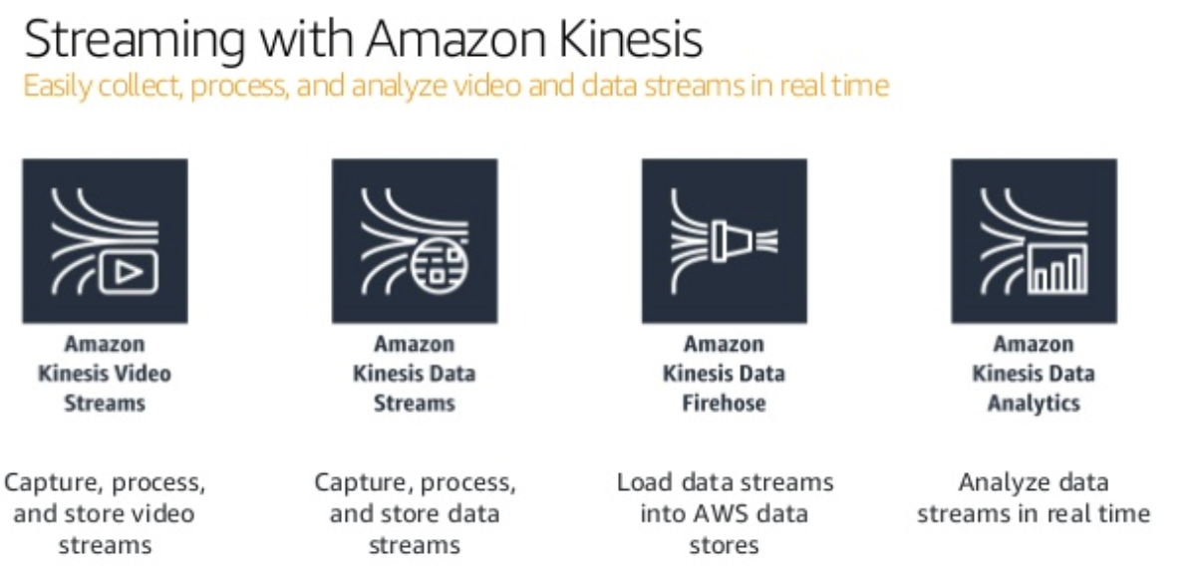

* **Kinesis Firehose** – to easily load streaming data into AWS;
* **Kinesis Analytics** – to easily process and analyze streaming data with standard SQL;
* **Kinesis Streams** – to build custom applications that process and analyze data.

Kinesis has multiple services under its name, like Data Streams, Firehose, Analytics, and Video Streams. We will only look at the Data Streams and Analytics service in this post.

**Slide Three - Amazon Kinesis Data Streams Overview**

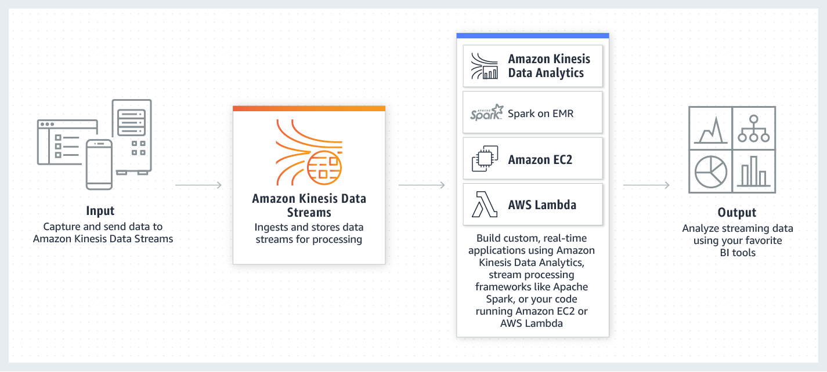

Demo notes:

Kinesis Data Streams (KDS) is a component of Kinesis. KDS is a service used to ingest and temporarily store data streams for processing by downstream consumers. Downstream consumers “get” data from streams (it is not pushed to applications by KDS).

and all other description is here: <https://aws.amazon.com/kinesis/data-streams/faqs/>

**Maybe Slide:**

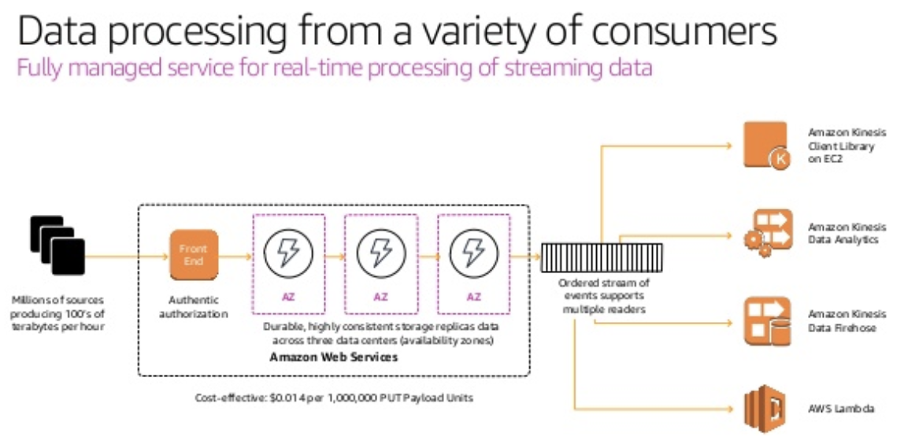

**Slide Four - Amazon Kinesis Firehose Overview**

**Slide Five - Amazon Kinesis Firehose Delivery Architecture**

**Slide Six- Amazon Kinesis Data Analytics Overview**

**Slide X - Use Cases**

Amazon Kinesis has attracted use from many well-known corporations. *Netflix*, for instance, monitors all communications between its applications using Kinesis, enabling it to detect and quickly solve any technical issues.