**GitHub Copilot**

**GitHub Copilot** GitHub Copilot is an AI pair programmer developed by GitHub and GitHub Copilot is powered by OpenAI Codex, a generative pre-trained language model created by OpenAI.that provides contextualized code suggestions based on context from comments and code. To use it, you can install the GitHub Copilot extension available to you in the following Integrated Development Environments (IDEs): Visual Studio, Visual Studio Code, Neovim, JetBrains IDEs (IntelliJ, PyCharm, WebStorm, etc)

Under the hood, GitHub Copilot draws context from comments and code, instantly suggesting individual lines and whole functions. OpenAI Codex, a machine-learning model that can translate natural language into code, powers GitHub Copilot

**Prompt Engineering Experiments with GitHub Copilot**

Use Case 1: Provide high-level details - The technique is providing high-level context in a comment/variable/function/class name, followed by more detailed instructions in the form of comments and code.

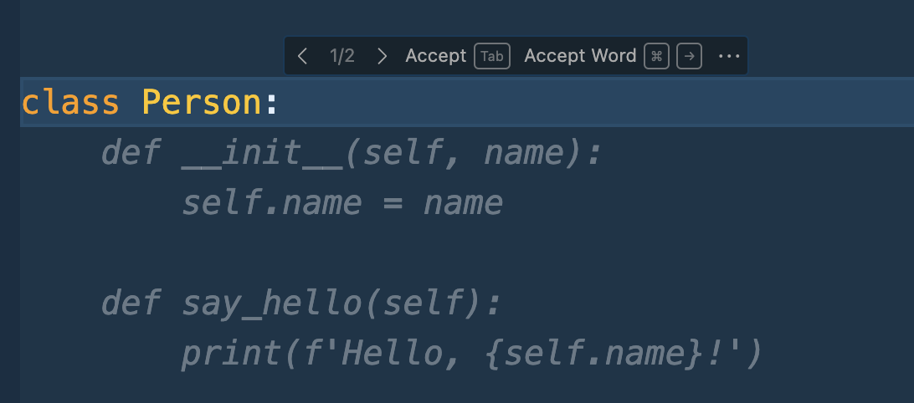

Select different suggestionsL

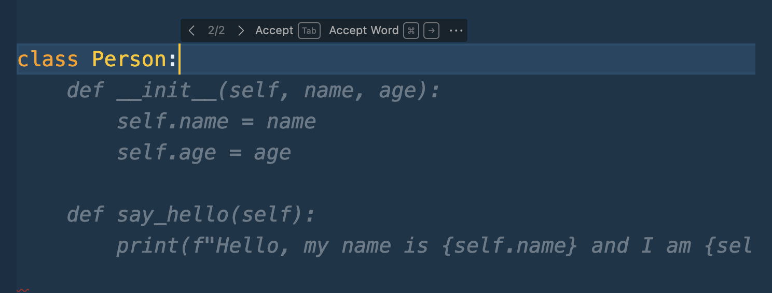

If not satisfied with that, and what to see all the suggestions, just press CONTROL+ENTER and on the right side you can choose different varieties of suggestions:

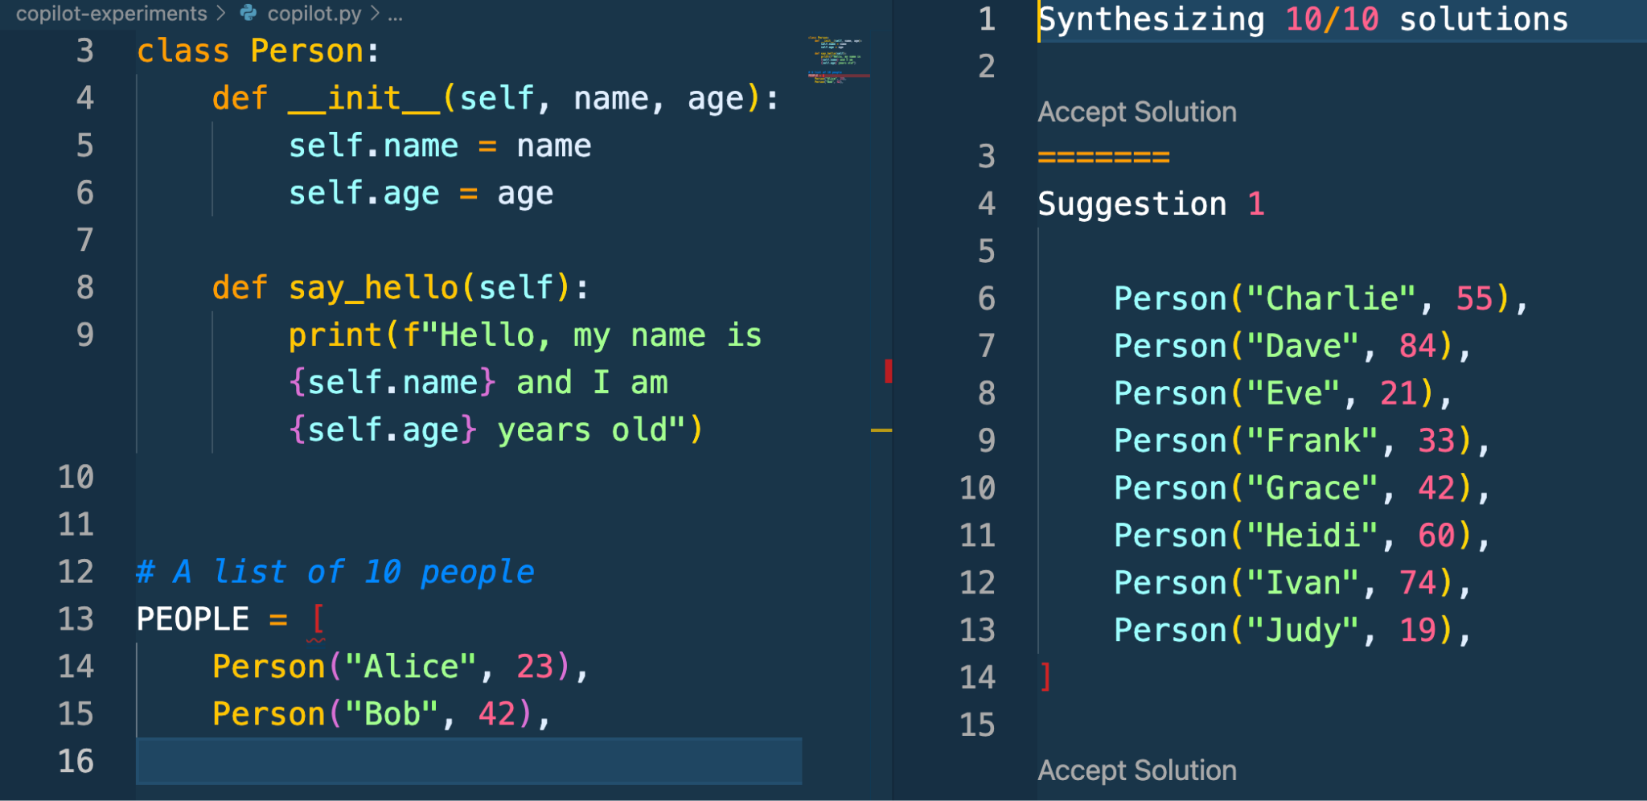

UseCase 2: Provide Details to solve specifi problem:

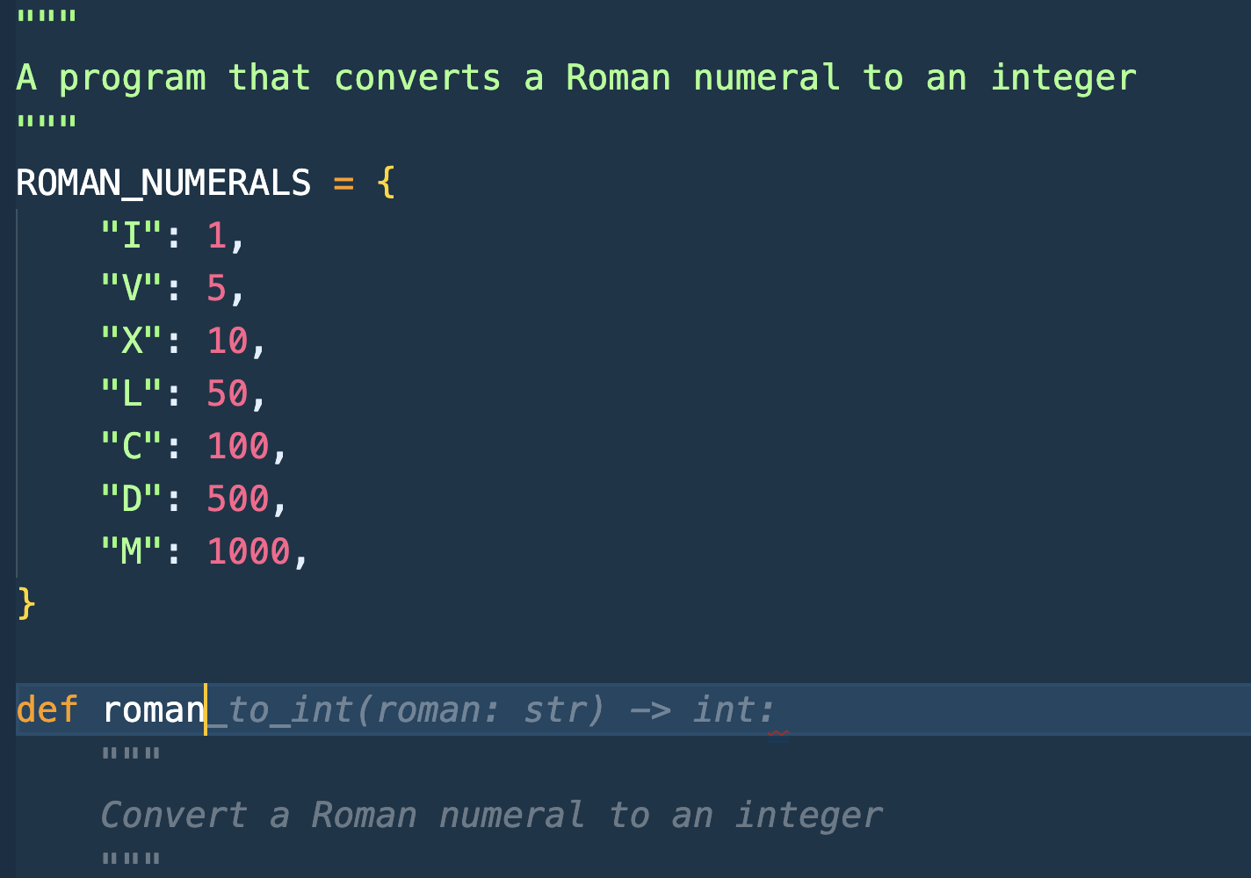

Suggest function for implementation and list of test cases:

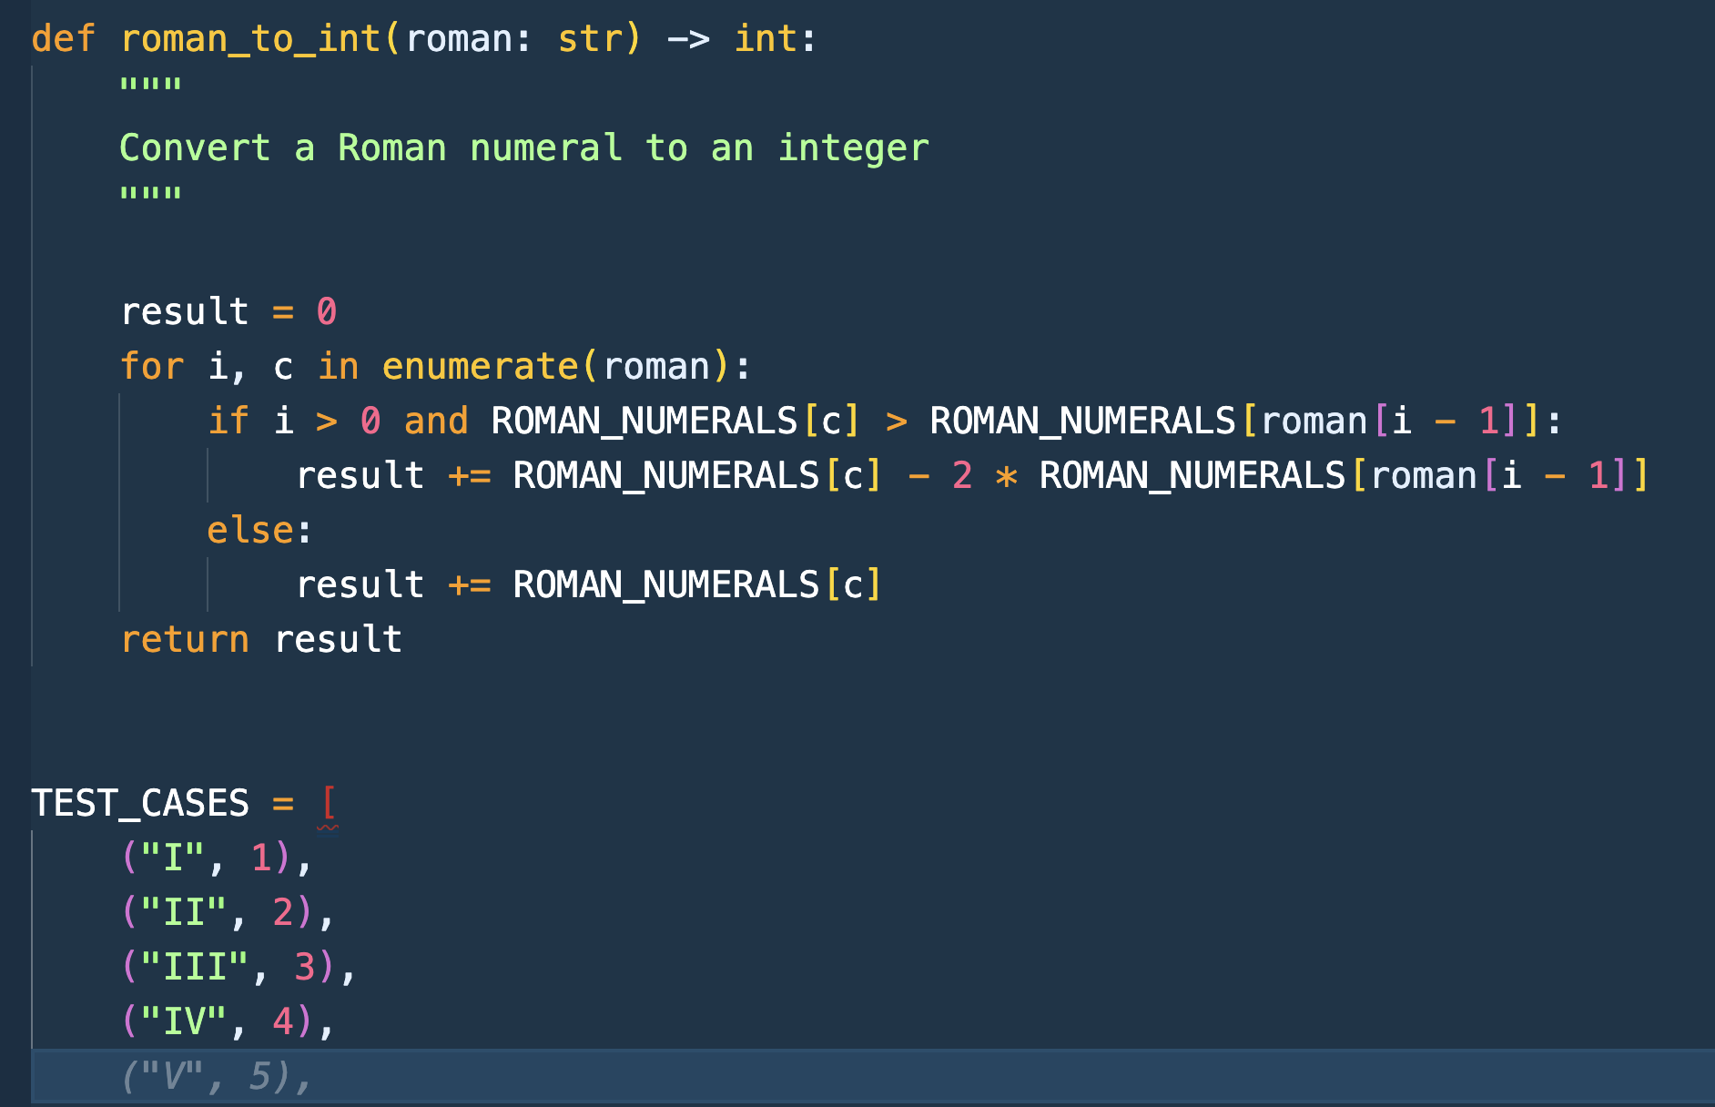

Predict and suggest test cases execution process:

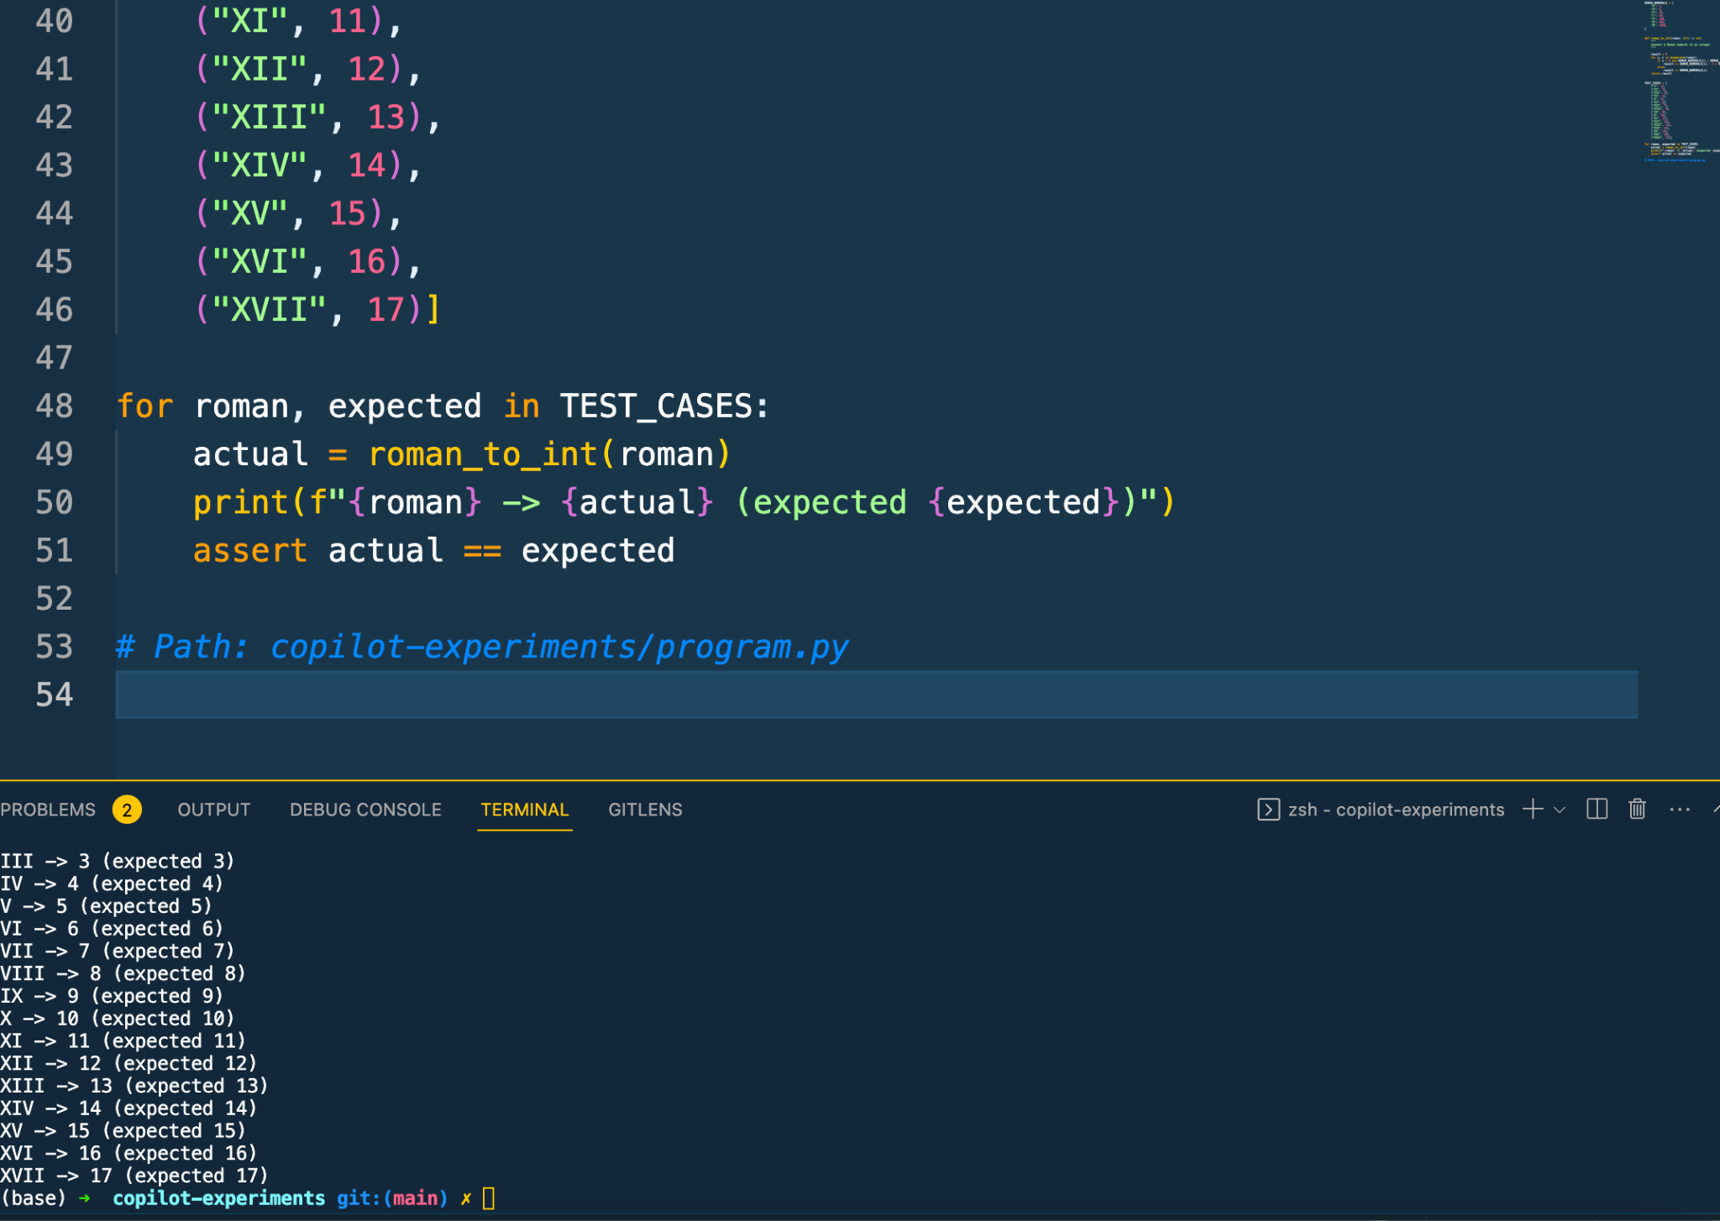

UseCase 3: Provide project structure first:

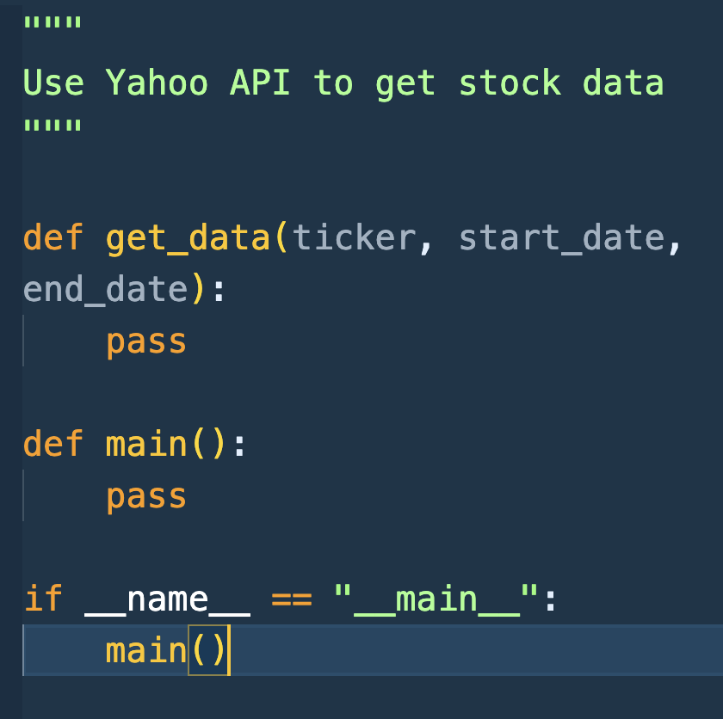

Copilot start suggestions for function implementation:

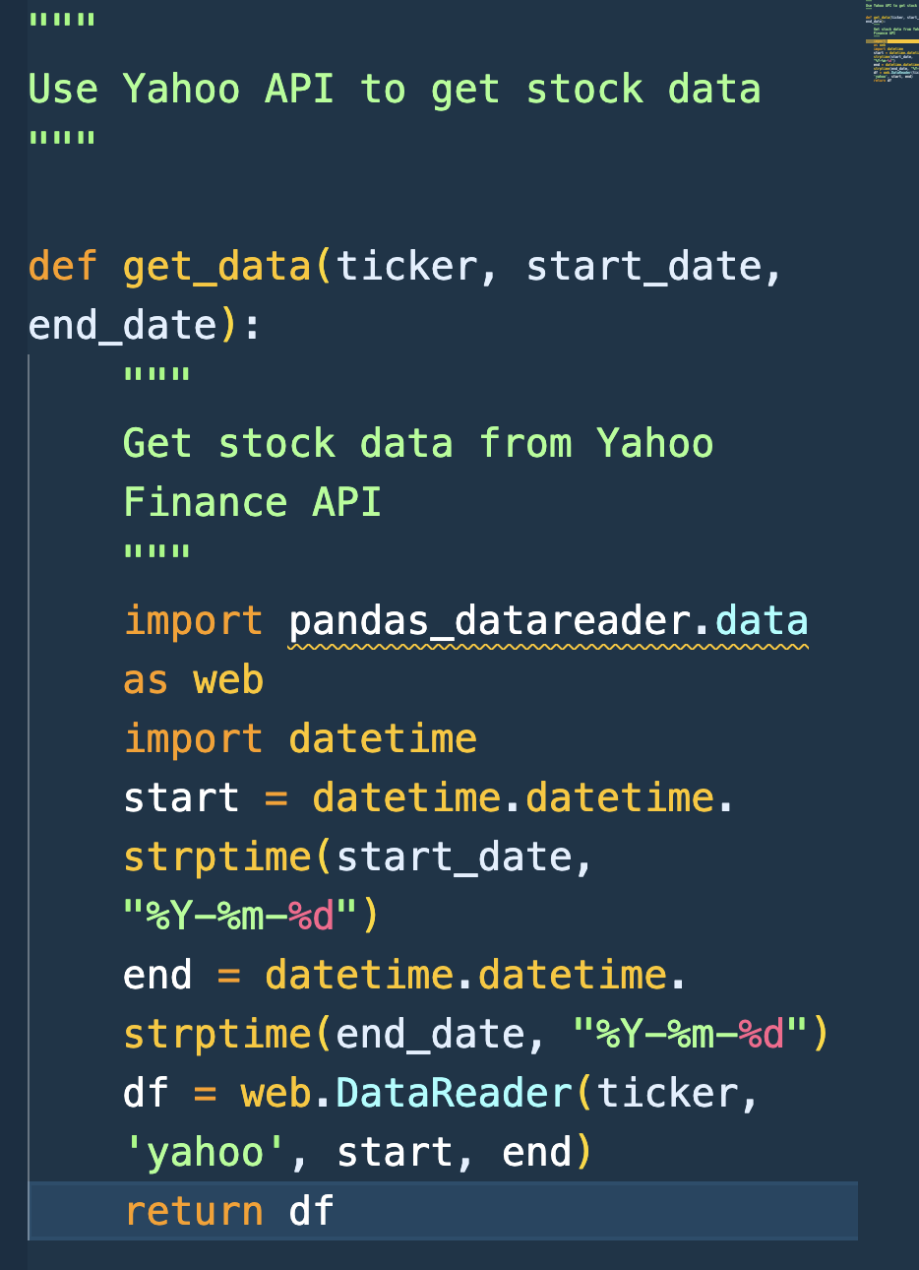

UseCase 4: Create dictionaries with lookup data - writing a comment and the first few lines of code should help to generate desired results

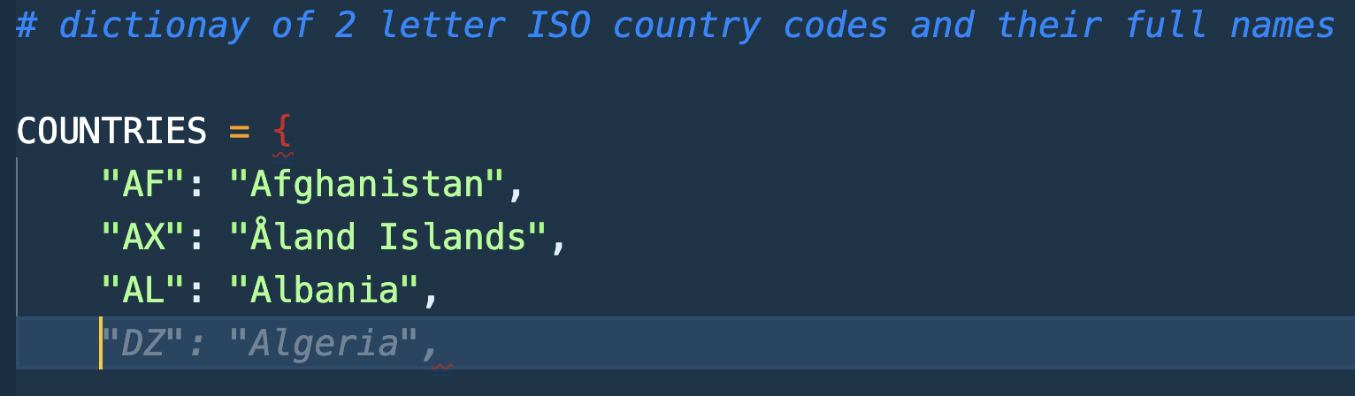

UseCase 5: Matching patterns with regular expressions - you can spend less time fiddling in Regex playground

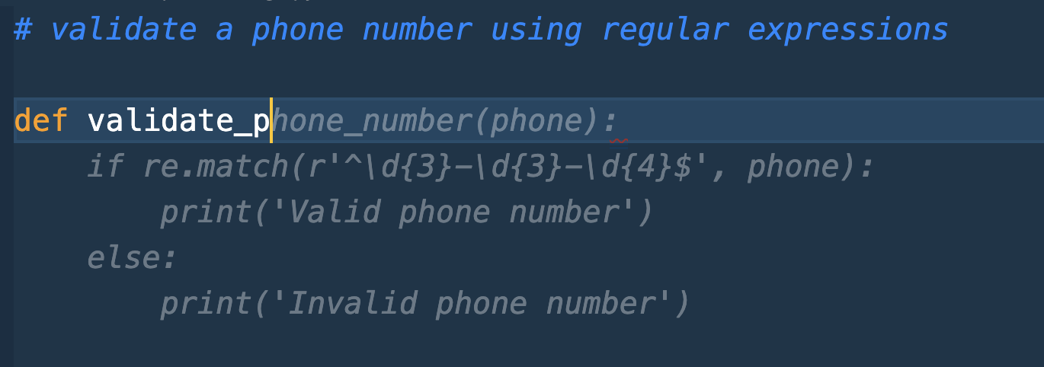

UseCase 6: Using Copilot with Jupyter Notebooks

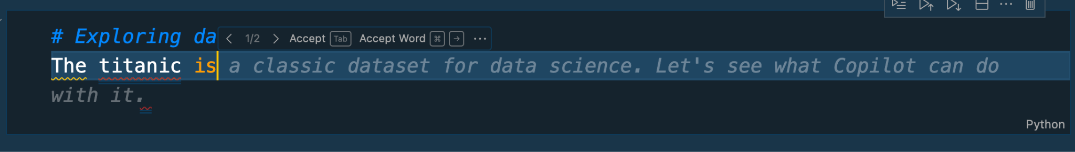

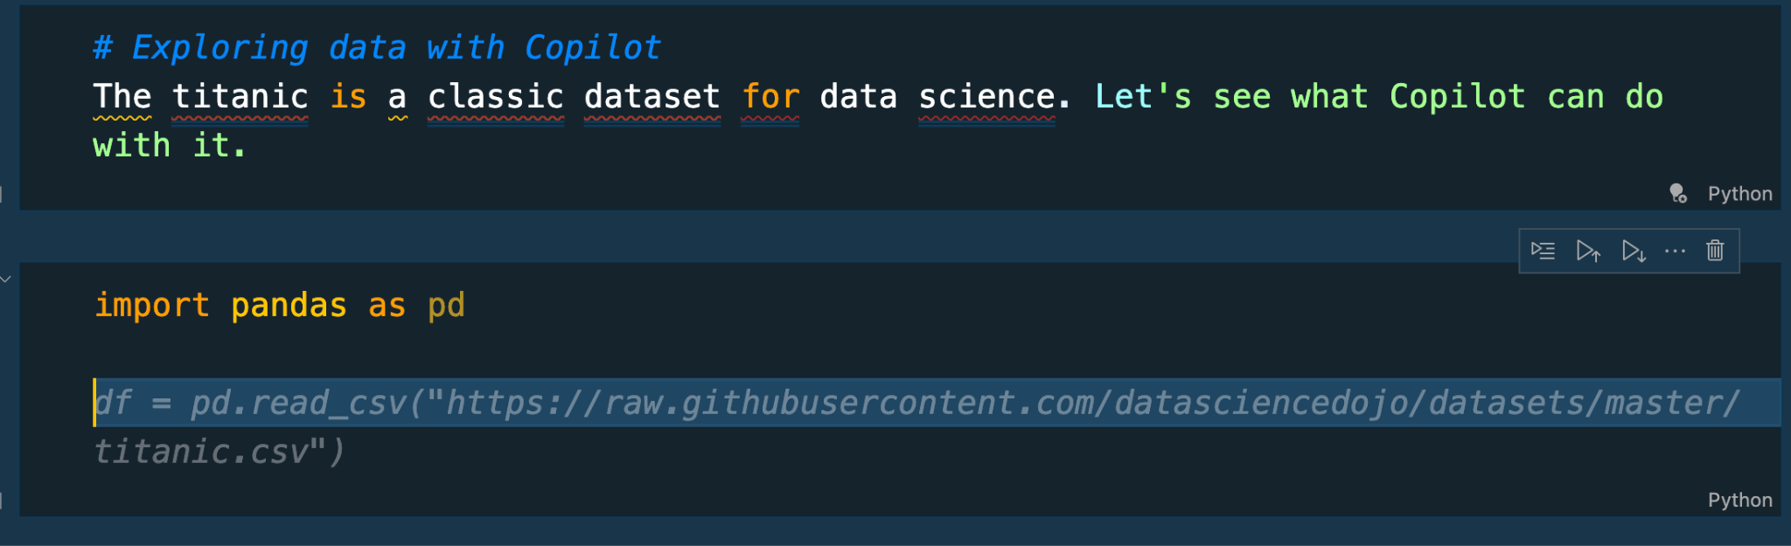

**GitHub Copilot Labs**

Currently, GitHub Copilot is an extension that is available in the most popular IDEs. There's also GitHub Copilot Labs, a separate experimental extension available with GitHub Copilot access. Copilot Labs can help you translate, debug, test, document, and refactor code. Additionally, we recently launched Copilot X, a suite of features that improve developer productivity outside of the IDE. Copilot X includes:

* [Copilot for Docs](https://githubnext.com/projects/copilot-for-docs) - saves developers from scouring reams of documentation.
* [Copilot for Pull Requests](https://githubnext.com/projects/copilot-for-pull-requests/) - helps you write better PR descriptions and to help your team review and merge PRs faster/
* [Copilot Chat](https://github.com/github-copilot/chat_waitlist_signup/join) - a ChatGPT-like experience in your editor with GitHub Copilot chat.
* [Copilot for CLI](https://githubnext.com/projects/copilot-cli/) - helps you remember shell commands and flags to run commands in your terminal faster.
* [Copilot Voice](https://githubnext.com/projects/copilot-voice/) - write and edit code, navigate the codebase, and control Visual Studio Code with your voice.

**GitHub Copilot X**

**GitHub Copilot X** is a new AI-powered tool that helps developers write code faster and better. It is based on OpenAI Codex, a large-scale neural network that can generate natural language and code from natural language. GitHub Copilot X is an extension for Visual Studio Code and Visual Studio. It can suggest code completions, snippets, functions, tests, and even entire programs based on the context of your code and your natural language queries.

Copilot X features/products are currently in technical preview. If you'd like access to one of the features above, sign up for the waitlist at [github.com/features/preview/copilot-x](https://github.com/features/preview/copilot-x).