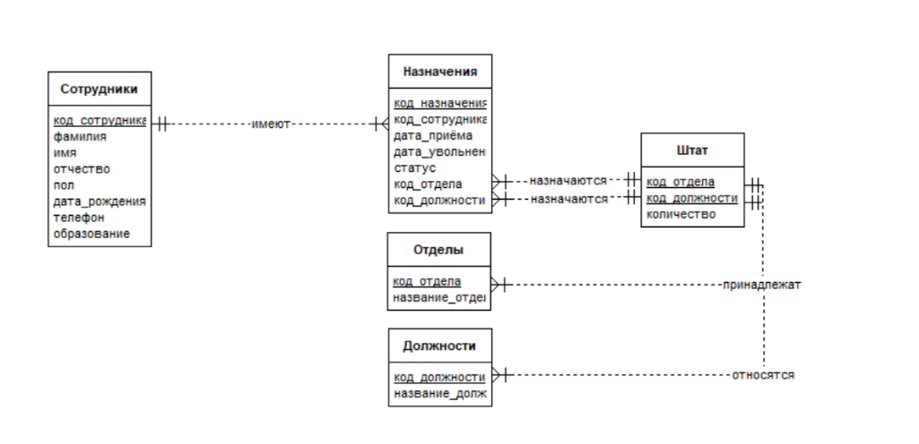

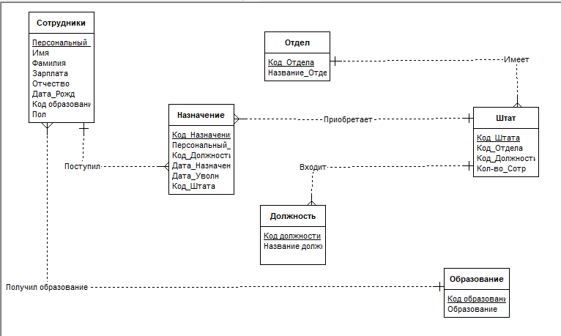

Создать и выполнить хранимую процедуру, позволяющую выбрать отделы с

заданным количества штатных сотрудников, которое ввести в качестве параметра:

USE [Staff_table]

GO

CREATE PROCEDUR DepNameWithParameterNumber

@Counter_ INT

AS

BEGIN

SELECT DISTINCT DepName

FROM Departments INNER JOIN

Positions

ON Positions.DEpNO = Departments.DepNO

GROUP BY Departments.DepName

HAVING SUM(Positions.Count_of_people) = @Counter_

END;

USE Staff_table

EXEC DepNameWithParameterNumber 8

Создать и выполнить хранимую процедуру, позволяющую выбрать отделы с

заданным количества штатных сотрудников, которое ввести в качестве параметра:

USE [Staff_table]

GO

CREATE PROCEDUR DepNameWithParameterNumber

@Counter_ INT

AS

BEGIN

SELECT DISTINCT DepName

FROM Departments INNER JOIN

Positions

ON Positions.DEpNO = Departments.DepNO

GROUP BY Departments.DepName

HAVING SUM(Positions.Count_of_people) = @Counter_

END;

USE Staff_table

EXEC DepNameWithParameterNumber 8

Скрипт на создание БД:

USE [master]

GO

GO

CREATE PROCEDURE

AS

BEGIN

/****** Object: Database [Staff_table] Script Date: 07.03.2023 11:43:21 ******/

CREATE DATABASE [Staff_table]

CONTAINMENT = NONE

ON PRIMARY

( NAME = N'Staff_table', FILENAME = N'C:\Program Files\Microsoft SQL

Server\MSSQL14.SQLEXPRESS\MSSQL\DATA\Staff_table.mdf' , SIZE = 8192KB ,

MAXSIZE = 102400KB , FILEGROWTH = 10240KB )

LOG ON

( NAME = N'Staff_table_log', FILENAME = N'C:\Program Files\Microsoft SQL

Server\MSSQL14.SQLEXPRESS\MSSQL\DATA\Staff_table_log.ldf' , SIZE = 8192KB ,

MAXSIZE = 102400KB , FILEGROWTH = 10240KB )

GO

ALTER DATABASE [Staff_table] SET COMPATIBILITY_LEVEL = 140

GO

IF (1 = FULLTEXTSERVICEPROPERTY('IsFullTextInstalled'))

begin

EXEC [Staff_table].[dbo].[sp_fulltext_database] @action = 'enable'

end

GO

ALTER DATABASE [Staff_table] SET ANSI_NULL_DEFAULT OFF

GO

ALTER DATABASE [Staff_table] SET ANSI_NULLS OFF

GO

ALTER DATABASE [Staff_table] SET ANSI_PADDING OFF

GO

ALTER DATABASE [Staff_table] SET ANSI_WARNINGS OFF

GO

ALTER DATABASE [Staff_table] SET ARITHABORT OFF

GO

ALTER DATABASE [Staff_table] SET AUTO_CLOSE OFF

GO

ALTER DATABASE [Staff_table] SET AUTO_SHRINK OFF

GO

ALTER DATABASE [Staff_table] SET AUTO_UPDATE_STATISTICS ON

GO

ALTER DATABASE [Staff_table] SET CURSOR_CLOSE_ON_COMMIT OFF

GO

ALTER DATABASE [Staff_table] SET CURSOR_DEFAULT GLOBAL

GO

ALTER DATABASE [Staff_table] SET CONCAT_NULL_YIELDS_NULL OFF

GO

ALTER DATABASE [Staff_table] SET NUMERIC_ROUNDABORT OFF

GO

ALTER DATABASE [Staff_table] SET QUOTED_IDENTIFIER OFF

GO

ALTER DATABASE [Staff_table] SET RECURSIVE_TRIGGERS OFF

GO

ALTER DATABASE [Staff_table] SET DISABLE_BROKER

GO

ALTER DATABASE [Staff_table] SET AUTO_UPDATE_STATISTICS_ASYNC OFF

GO

ALTER DATABASE [Staff_table] SET DATE_CORRELATION_OPTIMIZATION OFF

GO

ALTER DATABASE [Staff_table] SET TRUSTWORTHY OFF

GO

ALTER DATABASE [Staff_table] SET ALLOW_SNAPSHOT_ISOLATION OFF

GO

ALTER DATABASE [Staff_table] SET PARAMETERIZATION SIMPLE

GO

ALTER DATABASE [Staff_table] SET READ_COMMITTED_SNAPSHOT OFF

GO

ALTER DATABASE [Staff_table] SET HONOR_BROKER_PRIORITY OFF

GO

ALTER DATABASE [Staff_table] SET RECOVERY SIMPLE

GO

ALTER DATABASE [Staff_table] SET MULTI_USER

GO

ALTER DATABASE [Staff_table] SET PAGE_VERIFY CHECKSUM

GO

ALTER DATABASE [Staff_table] SET DB_CHAINING OFF

GO

ALTER DATABASE [Staff_table] SET FILESTREAM(

NON_TRANSACTED_ACCESS = OFF )

GO

ALTER DATABASE [Staff_table] SET TARGET_RECOVERY_TIME = 60 SECONDS

GO

ALTER DATABASE [Staff_table] SET DELAYED_DURABILITY = DISABLED

GO

ALTER DATABASE [Staff_table] SET QUERY_STORE = OFF

GO

USE [Staff_table]

GO

ALTER DATABASE SCOPED CONFIGURATION SET IDENTITY_CACHE = ON;

GO

ALTER DATABASE SCOPED CONFIGURATION SET

LEGACY_CARDINALITY_ESTIMATION = OFF;

GO

ALTER DATABASE SCOPED CONFIGURATION FOR SECONDARY SET

LEGACY_CARDINALITY_ESTIMATION = PRIMARY;

GO

ALTER DATABASE SCOPED CONFIGURATION SET MAXDOP = 0;

GO

ALTER DATABASE SCOPED CONFIGURATION FOR SECONDARY SET

MAXDOP = PRIMARY;

GO

ALTER DATABASE SCOPED CONFIGURATION SET PARAMETER_SNIFFING =

ON;

GO

ALTER DATABASE SCOPED CONFIGURATION FOR SECONDARY SET

PARAMETER_SNIFFING = PRIMARY;

GO

ALTER DATABASE SCOPED CONFIGURATION SET

QUERY_OPTIMIZER_HOTFIXES = OFF;

GO

ALTER DATABASE SCOPED CONFIGURATION FOR SECONDARY SET

QUERY_OPTIMIZER_HOTFIXES = PRIMARY;

GO

USE [Staff_table]

GO

/****** Object: Table [dbo].[Appointments] Script Date: 07.03.2023 11:43:22 ******/

SET ANSI_NULLS ON

GO

SET QUOTED_IDENTIFIER ON

GO

CREATE TABLE [dbo].[Appointments](

[NO] [int] NOT NULL,

[EmpNO] [int] NULL,

[HireDate] [datetime] NULL,

[FireDate] [datetime] NULL,

[DepNO] [int] NULL,

[SpecNO] [int] NULL,

[status] [nvarchar](255) NULL,

CONSTRAINT [PK_Appointments] PRIMARY KEY CLUSTERED

(

[NO] ASC

)WITH (PAD_INDEX = OFF, STATISTICS_NORECOMPUTE = OFF,

IGNORE_DUP_KEY = OFF, ALLOW_ROW_LOCKS = ON, ALLOW_PAGE_LOCKS

= ON) ON [PRIMARY]

) ON [PRIMARY]

GO

/****** Object: Table [dbo].[Departments] Script Date: 07.03.2023 11:43:22 ******/

SET ANSI_NULLS ON

GO

SET QUOTED_IDENTIFIER ON

GO

CREATE TABLE [dbo].[Departments](

[DepNO] [int] NOT NULL,

[DepName] [nvarchar](255) NULL,

CONSTRAINT [PK_Departments_1] PRIMARY KEY CLUSTERED

(

[DepNO] ASC

)WITH (PAD_INDEX = OFF, STATISTICS_NORECOMPUTE = OFF,

IGNORE_DUP_KEY = OFF, ALLOW_ROW_LOCKS = ON, ALLOW_PAGE_LOCKS

= ON) ON [PRIMARY]

) ON [PRIMARY]

GO

/****** Object: Table [dbo].[Positions] Script Date: 07.03.2023 11:43:22 ******/

SET ANSI_NULLS ON

GO

SET QUOTED_IDENTIFIER ON

GO

CREATE TABLE [dbo].[Positions](

[DepNO] [int] NOT NULL,

[SpecNO] [int] NOT NULL,

[Count_of_people] [int] NULL,

CONSTRAINT [PK_Positions] PRIMARY KEY CLUSTERED

(

[DepNO] ASC,

[SpecNO] ASC

)WITH (PAD_INDEX = OFF, STATISTICS_NORECOMPUTE = OFF,

IGNORE_DUP_KEY = OFF, ALLOW_ROW_LOCKS = ON, ALLOW_PAGE_LOCKS

= ON) ON [PRIMARY]

) ON [PRIMARY]

GO

/****** Object: Table [dbo].[Specialities] Script Date: 07.03.2023 11:43:22 ******/

SET ANSI_NULLS ON

GO

SET QUOTED_IDENTIFIER ON

GO

CREATE TABLE [dbo].[Specialities](

[SpecNO] [int] NOT NULL,

[SpecName] [nvarchar](255) NULL,

CONSTRAINT [PK_Specialities_1] PRIMARY KEY CLUSTERED

(

[SpecNO] ASC

)WITH (PAD_INDEX = OFF, STATISTICS_NORECOMPUTE = OFF,

IGNORE_DUP_KEY = OFF, ALLOW_ROW_LOCKS = ON, ALLOW_PAGE_LOCKS

= ON) ON [PRIMARY]

) ON [PRIMARY]

GO

/****** Object: Table [dbo].[Workers] Script Date: 07.03.2023 11:43:22 ******/

SET ANSI_NULLS ON

GO

SET QUOTED_IDENTIFIER ON

GO

CREATE TABLE [dbo].[Workers](

[EmpNO] [int] NOT NULL,

[Surname] [nvarchar](255) NULL,

[First_name] [nvarchar](255) NULL,

[Last_name] [nvarchar](255) NULL,

[gender] [nvarchar](255) NULL,

[Dateofbirth] [datetime] NULL,

[phoneNO] [int] NULL,

[degree] [nvarchar](255) NULL,

CONSTRAINT [PK_Workers] PRIMARY KEY CLUSTERED

(

[EmpNO] ASC

)WITH (PAD_INDEX = OFF, STATISTICS_NORECOMPUTE = OFF,

IGNORE_DUP_KEY = OFF, ALLOW_ROW_LOCKS = ON, ALLOW_PAGE_LOCKS

= ON) ON [PRIMARY]

) ON [PRIMARY]

GO

ALTER TABLE [dbo].[Appointments] WITH CHECK ADD CONSTRAINT

[FK_Appointments_Positions1] FOREIGN KEY([DepNO], [SpecNO])

REFERENCES [dbo].[Positions] ([DepNO], [SpecNO])

GO

ALTER TABLE [dbo].[Appointments] CHECK CONSTRAINT

[FK_Appointments_Positions1]

GO

ALTER TABLE [dbo].[Appointments] WITH CHECK ADD CONSTRAINT

[FK_Appointments_Workers] FOREIGN KEY([EmpNO])

REFERENCES [dbo].[Workers] ([EmpNO])

GO

ALTER TABLE [dbo].[Appointments] CHECK CONSTRAINT

[FK_Appointments_Workers]

GO

ALTER TABLE [dbo].[Positions] WITH CHECK ADD CONSTRAINT

[FK_Positions_Departments1] FOREIGN KEY([DepNO])

REFERENCES [dbo].[Departments] ([DepNO])

GO

ALTER TABLE [dbo].[Positions] CHECK CONSTRAINT [FK_Positions_Departments1]

GO

ALTER TABLE [dbo].[Positions] WITH CHECK ADD CONSTRAINT

[FK_Positions_Specialities1] FOREIGN KEY([SpecNO])

REFERENCES [dbo].[Specialities] ([SpecNO])

GO

ALTER TABLE [dbo].[Positions] CHECK CONSTRAINT [FK_Positions_Specialities1]

GO

/****** Object: StoredProcedure [dbo].[DepNameWithParameterNumber] Script Date:

07.03.2023 11:43:22 ******/

SET ANSI_NULLS ON

GO

SET QUOTED_IDENTIFIER ON

GO

CREATE PROCEDURE [dbo].[DepNameWithParameterNumber]

@Counter_ INT

AS

BEGIN

SELECT DISTINCT DepName

FROM Departments INNER JOIN

Positions

ON Positions.DEpNO = Departments.DepNO

GROUP BY Departments.DepName

HAVING SUM(Positions.Count_of_people) = @Counter_

END;

GO

/****** Object: StoredProcedure [dbo].[EmpFIOWithParameters] Script Date:

07.03.2023 11:43:22 ******/

SET ANSI_NULLS ON

GO

SET QUOTED_IDENTIFIER ON

GO

CREATE PROCEDURE [dbo].[EmpFIOWithParameters]

@Dname nvarchar(255),

@Sname nvarchar(255)

AS

BEGIN

SELECT Workers.FIO, Departments.DepName, Specialities.SpecName

FROM Workers

INNER JOIN

Appointments ON Appointments.EmpNO = Workers.EmpNO

INNER JOIN

Departments ON Departments.DepNO = Appointments.DepNO

INNER JOIN

Specialities ON Specialities.SpecNO = Appointments.SpecNO

WHERE DepName = @Dname AND SpecName = @Sname

END;

GO

USE [master]

GO

ALTER DATABASE [Staff_table] SET READ_WRITE

GO

END;