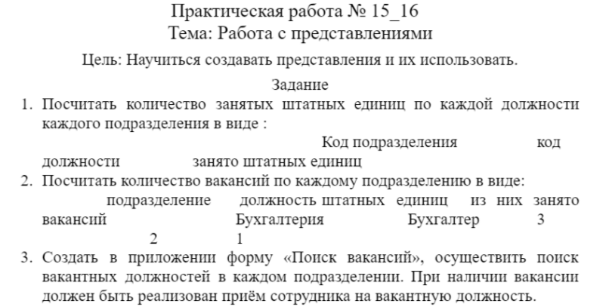

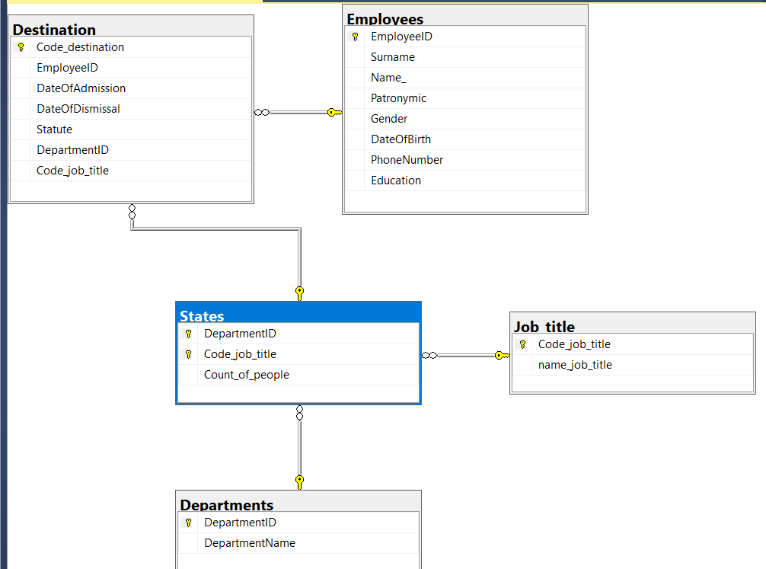

Скрипт на создание бд

USE master;

IF EXISTS (SELECT * FROM SYS.DATABASES WHERE NAME = 'PR15_16')

DROP DATABASE PR15_16

GO

CREATE DATABASE PR15_16

ON

( NAME = PR15_16_data,

FILENAME = 'C:\VS Projects\Commit\Kursach\Create_base_script\All\PR15-16.mdf',

SIZE = 8,

MAXSIZE = 100,

FILEGROWTH = 10 )

LOG ON

( NAME = PR15_16_log,

FILENAME = 'C:\VS Projects\Commit\Kursach\Create_base_script\All\PR15-16.ldf',

SIZE = 5MB,

MAXSIZE = 25MB,

FILEGROWTH = 5MB );

GO

USE PR15_16;

IF EXISTS (SELECT * FROM SYSOBJECTS WHERE NAME = 'Departments')

DROP TABLE Departments

IF EXISTS (SELECT * FROM SYSOBJECTS WHERE NAME = 'Employees')

DROP TABLE Employees

IF EXISTS (SELECT * FROM SYSOBJECTS WHERE NAME = 'Job_title')

DROP TABLE Job_title

IF EXISTS (SELECT * FROM SYSOBJECTS WHERE NAME = 'States')

DROP TABLE States

IF EXISTS (SELECT * FROM SYSOBJECTS WHERE NAME = 'Positions')

DROP TABLE Positions

IF EXISTS (SELECT * FROM SYSOBJECTS WHERE NAME = 'Destination')

DROP TABLE Destination

CREATE TABLE Employees (

EmployeeID int IDENTITY PRIMARY KEY,

Surname varchar(50),

Name_ varchar(50),

Patronymic varchar(50),

Gender char(1),

DateOfBirth date,

PhoneNumber varchar(15),

Education varchar(50)

);

INSERT INTO Employees (Surname, Name_, Patronymic, Gender,

DateOfBirth, PhoneNumber, Education)

VALUES ('Фуфаев','Ярослав', 'Станиславович','м',

'1990-03-01', '3955889', 'высшее'),

('Бабичев','Евгений', 'Иванов','м',

'1960-06-12', '2356789', 'высшее'),

('Нагаев','Дмитрий', 'Иванов','м',

'1985-09-20', '4231112', 'высшее'),

('Семенова','Ольга', 'Евгеньевна','ж',

'1960-06-12', '2357890', 'высшее'),

('Акимов','Аким', 'Акимович','м',

'1960-02-17', '2354678', 'высшее');

CREATE TABLE Departments (

DepartmentID int PRIMARY KEY,

DepartmentName varchar(100)

);

INSERT INTO Departments (DepartmentID, DepartmentName)

VALUES (1,'Административно-управленческий персонал'),

(2,'Бухгалтерия'),

(3,'Отдел кадров'),

(4,'Учебная часть'),

(5,'Штат преподавателей');

CREATE TABLE Job_title (

Code_job_title int PRIMARY KEY,

name_job_title varchar(100)

);

INSERT INTO Job_title (Code_job_title, name_job_title)

VALUES (1,'директор'),

(2,'зам дир по уч работе'),

(3,'зам дир по вос раб '),

(4,'Ст бух'),

(5,'Бух');

CREATE TABLE States (

DepartmentID int,

Code_job_title int,

Count_of_people int,

primary key (DepartmentID, Code_job_title),

FOREIGN KEY (DepartmentID) REFERENCES Departments (DepartmentID)

ON DELETE CASCADE ON UPDATE CASCADE,

FOREIGN KEY (Code_job_title) REFERENCES Job_title (Code_job_title)

ON DELETE CASCADE ON UPDATE CASCADE

);

INSERT INTO States (DepartmentID, Code_job_title, Count_of_people)

VALUES (1, 1, 1),

(2, 2, 1),

(3, 3, 1),

(4, 4, 1),

(5, 5, 1);

CREATE TABLE Destination (

Code_destination int IDENTITY PRIMARY KEY,

EmployeeID int,

DateOfAdmission date,

DateOfDismissal date,

Statute varchar(50),

DepartmentID int,

Code_job_title int,

FOREIGN KEY (DepartmentID, Code_job_title) REFERENCES States (DepartmentID, Code_job_title)

ON DELETE CASCADE ON UPDATE CASCADE,

FOREIGN KEY (EmployeeID) REFERENCES Employees(EmployeeID)

ON DELETE CASCADE ON UPDATE CASCADE

);

INSERT INTO Destination(EmployeeID, DateOfAdmission, DateOfDismissal,

Statute, DepartmentID, Code_job_title)

VALUES (1, '2002-05-30', NULL, 'работает',1, 1),

(2, '2007-11-26', NULL, 'работает',2, 2),

(3, '2003-02-17', NULL, 'работает',3, 3),

(4, '2003-02-18', '2019-02-19', 'уволен',4, 4),

(5, '2003-02-18', NULL, 'работает',5, 5);

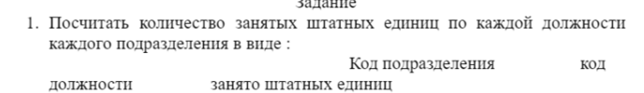

--CREATE VIEW v_staff_count AS

SELECT Destination.DepartmentID, Destination.Code_job_title, COUNT(DISTINCT Destination.EmployeeID)

AS staff_count

FROM Destination

JOIN Employees ON Destination.EmployeeID = Employees.EmployeeID

GROUP BY Destination.DepartmentID,Destination.Code_job_title ,Destination.Code_destination;

--код департамента, код работы, сколько сотрудников

--работники и назначения

1. Посчитать количество вакансий по каждому подразделению в виде: подразделение должность штатных единиц  из них занято    вакансий Бухгалтерия Бухгалтер 3 2 1

SELECT States.DepartmentID, States.Code_job_title, States.Count_of_people

FROM States

INNER JOIN Departments

ON States.DepartmentID = Departments.DepartmentID

INNER JOIN Job_title

ON States.Code_job_title = Job_title.Code_job_title

Order By States.Count_of_people

--штат vs департмент и job