

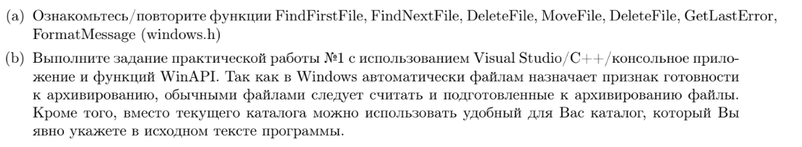

<http://zetblog.ru/winapi-rabota-s-faylami-osnovnye-funktsii.html>

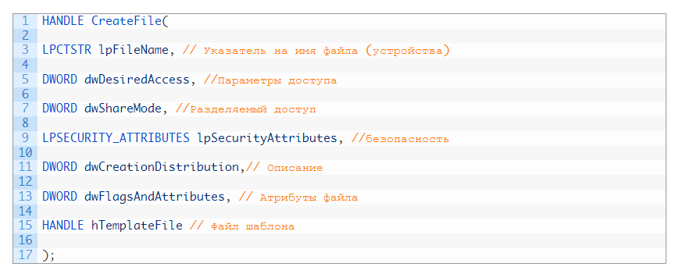

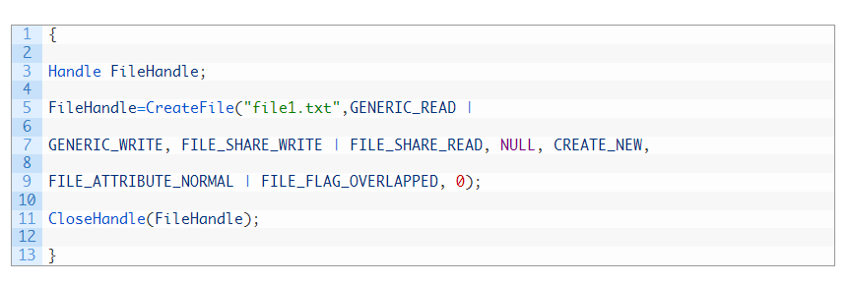

#include <Windows.h>

#include <malloc.h>

#include <string.h>

#include <tchar.h>

#include <cstdlib>

#include <iostream>

#include <string>

#include <string.h>

#include <stdio.h>

using namespace std;

#if defined(_UNICODE)

#define _T(x) L##x

#else

#define _T(x) x

#endif

#define _CRT_SECURE_NO_WARNINGS

#define BUFFER_SIZE 256

#define DIRECTORY_NAME _T("C:\\Users\\Constantine\\Desktop\\Education\\Practice1\\2\\Test_2\\")

int wmain(int argc, wchar_t* argv[]) {

setlocale(LC_ALL, "Russian");

WIN32_FIND_DATAW wfd;

HANDLE directory_handle = FindFirstFile(DIRECTORY_NAME _T("*"), &wfd);

if (directory_handle == INVALID_HANDLE_VALUE) {

return 0;

FindClose(directory_handle);

exit(0);

}

int empty_files_counter = 1;

do {

if (wfd.dwFileAttributes != FILE_ATTRIBUTE_DIRECTORY)

{

if ((wcscmp(wfd.cFileName, L".") != 0) && (wcscmp(wfd.cFileName, L"..") != 0))

{

TCHAR file_name[BUFFER_SIZE] = _T("");

_tcscpy_s(file_name, DIRECTORY_NAME); //копирует в file_name

//слияние строк (конкатенация)

_tcscat_s(file_name, &wfd.cFileName[0]); //путь\\файл

HANDLE file = CreateFile(file_name, GENERIC_READ, 0, NULL, OPEN_EXISTING, FILE_ATTRIBUTE_NORMAL, NULL);

int size = GetFileSize(file, NULL);

CloseHandle(file);

if (size == 0)

{

if ((wfd.cFileName[0] != (TCHAR)".") && (wfd.cFileName[0] != (TCHAR)".."))

{

TCHAR zero_postfix[BUFFER_SIZE] = _T("zero");

TCHAR empty_file_number[BUFFER_SIZE] = _T("");

_itot_s(empty_files_counter, empty_file_number, 10); //в символы в 10-ой сс

TCHAR new_file_name[BUFFER_SIZE] = _T("");

_tcscat_s(new_file_name, DIRECTORY_NAME); //путь

_tcscat_s(new_file_name, zero_postfix); //путь + постфикс

_tcscat_s(new_file_name, empty_file_number); //значение

_tcscat_s(new_file_name, _T(".txt")); //расширение

if (MoveFile(file_name, new_file_name)); //типа переименовывает

else

{

cout << "ошибка" << endl;

}

empty_files_counter++;

}

}

}

}

} while (FindNextFile(directory_handle, &wfd) != NULL);

FindClose(directory_handle);

return 0;

}

