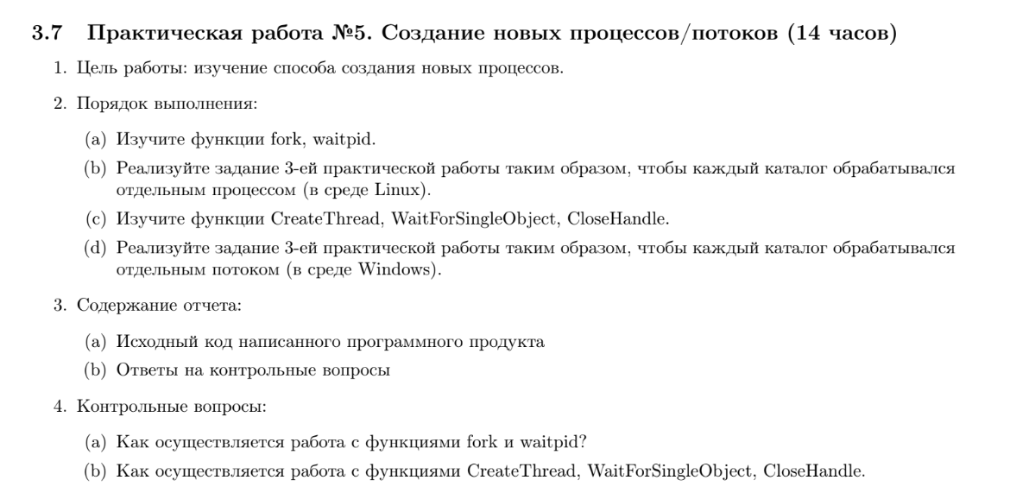



1. Посчитать число каталогов
2. Обработка

#include <Windows.h>

#include <malloc.h>

#include <string.h>

#include <tchar.h>

#include <cstdlib>

#include <iostream>

#include <string>

#include <string.h>

#include <stdio.h>

#include <vector>

#include <array>

using namespace std;

#if defined(_UNICODE)

#define _T(x) L##x

#else

#define _T(x) x

#endif

#define _CRT_SECURE_NO_WARNINGS

#define BUFFER_SIZE 260

#define DIRECTORY_NAME _T("C:\\Users\\Constantine\\Desktop\\Education\\Practice1\\2\\Test_2\\")

#define REC_COUNT 0

#define REC_DIRS 1

int empty_files_counter = 1; //итератор zero<индекс>

bool is_pseudodirectory(WIN32_FIND_DATA* wfd) {

return wcscmp(wfd->cFileName, _T(".")) == 0 || wcscmp(wfd->cFileName, _T("..")) == 0;

}

bool is_directory(WIN32_FIND_DATA* wfd) {

return (wfd->dwFileAttributes & FILE_ATTRIBUTE_DIRECTORY) && !(wfd->dwFileAttributes & FILE_ATTRIBUTE_REPARSE_POINT);

}

void get_new_path(LPTSTR path, WIN32_FIND_DATA* wfd, LPTSTR new_path) {

wcscpy_s(new_path, BUFFER_SIZE, path);

wcscat_s(new_path, BUFFER_SIZE, wfd->cFileName);

wcscat_s(new_path, BUFFER_SIZE, L"\\");

}

void get_old_name(LPTSTR path, WIN32_FIND_DATA* wfd, LPTSTR old_file_name)

{

wcscpy_s(old_file_name, BUFFER_SIZE, path);

wcscat_s(old_file_name, BUFFER_SIZE, L"\\");

wcscat_s(old_file_name, BUFFER_SIZE, wfd->cFileName);

}

void get_new_name(LPTSTR path, WIN32_FIND_DATA* wfd, LPTSTR new_file_name)

{

TCHAR empty_file_number[BUFFER_SIZE];

//новое имя

wcscat_s(new_file_name, BUFFER_SIZE, path);

wcscat_s(new_file_name, BUFFER_SIZE, _T("zero"));

_itot_s(empty_files_counter, empty_file_number, 10); //в символы в 10-ой сс

wcscat_s(new_file_name, BUFFER_SIZE, (LPTSTR)empty_file_number); //значение

wcscat_s(new_file_name, BUFFER_SIZE, _T(".txt")); //расширение

}

HANDLE get_directory_iterator(LPTSTR path_, WIN32_FIND_DATA* wfd) {

TCHAR loc_path[BUFFER_SIZE];

wcscpy_s(loc_path, BUFFER_SIZE, path_);

wcscat_s(loc_path, BUFFER_SIZE, L"*");

HANDLE hdl = FindFirstFile(loc_path, wfd);

if (hdl == INVALID_HANDLE_VALUE)

{

FindClose(hdl);

exit(0);

}

return hdl;

}

int get_file_size(WIN32_FIND_DATA* wfd, LPTSTR path) {

TCHAR loc_path[BUFFER_SIZE] = _T("");

get_old_name(path, wfd, loc_path);

HANDLE file = CreateFile(loc_path, GENERIC_READ, 0, NULL, OPEN_EXISTING, FILE_ATTRIBUTE_NORMAL, NULL);

int size = GetFileSize(file, NULL);

CloseHandle(file);

return size;

}

HANDLE mut = CreateMutex(NULL, FALSE, NULL);

bool rename_file(WIN32_FIND_DATA* wfd, LPTSTR path)

{

//переименовывание файла

//старое имя

TCHAR old_file_name[BUFFER_SIZE] = _T("");

get_old_name(path, wfd, old_file_name);

//новое имя

TCHAR new_file_name[BUFFER_SIZE] = _T("");

get_new_name(path, wfd, new_file_name);

return MoveFile(old_file_name, new_file_name); //типа переименовывает

}

//перебор файлов

void search_file(LPTSTR path) {

WIN32_FIND_DATA wfd = { 0 };

HANDLE hdl = get_directory_iterator(path, &wfd);

//поиск всех файлов в каталоге

do {

if (is_directory(&wfd))

{

continue;

} // файл

if (is_pseudodirectory(&wfd))

{

continue;

} // не псевдодиректория

if (!(get_file_size(&wfd, path) == 0)) {

continue;

} // нулевой размер

if (!(rename_file(&wfd, path)))

{

cout << "ошибка" << endl;

continue;

}

rename_file(&wfd, path);

WaitForSingleObject(mut, INFINITE);

std::wcout << path << L"//" << wfd.cFileName << endl;

empty_files_counter++;

ReleaseMutex(mut);

} while (FindNextFile(hdl, &wfd) != NULL);

FindClose(hdl); //поиск окончен

}

//перебор каталогов

void rec_dir(LPTSTR path) //DIRECTORY_NAME

{

wcout << path << endl;

search_file(path); //изначально перебираю файлы в папке -> потом рассматриваю каталоги

WIN32_FIND_DATA wfd = { 0 };

HANDLE hdl = get_directory_iterator(path, &wfd);

std::vector<HANDLE> threads; //потоки

std::vector<DWORD> thrId; //идентификаторы потоков

std::vector<LPTSTR> paths;

do

{

//обработка каталогов -> потоки

//WaitForSingleObject(mut, INFINITE);

//Начало критической секции

if (!(is_directory(&wfd))) //если директория

{

continue;

} //директория

if (is_pseudodirectory(&wfd)) //не точки

{

continue;

} //не псевдодиректория

paths.push_back(new TCHAR[BUFFER_SIZE]()); //мусор в вектор

get_new_path(path, &wfd, paths.back());

//thrId.emplace_back();

threads.push_back(CreateThread(NULL, 0, (LPTHREAD_START_ROUTINE)rec_dir,

(LPVOID)paths.back(), 0, NULL));

if (threads.back() == NULL)

{

cout << "ошибка создания потока" << endl;

}

//WaitForSingleObject(threads.back(), INFINITE);

// конец критической секции

//ReleaseMutex(mut);

} while (FindNextFile(hdl, &wfd));

FindClose(hdl); // поиск окончен

if (threads.size() != 0)

{

WaitForMultipleObjects(threads.size(), threads.data(), TRUE, INFINITE);

}

for (int a = 0; a < threads.size(); a++)

{

CloseHandle(threads[a]);

}

}

int wmain(int argc, wchar_t* argv[])

{

setlocale(LC_ALL, "Russian");

rec_dir((LPTSTR)DIRECTORY_NAME);

return 0;

}