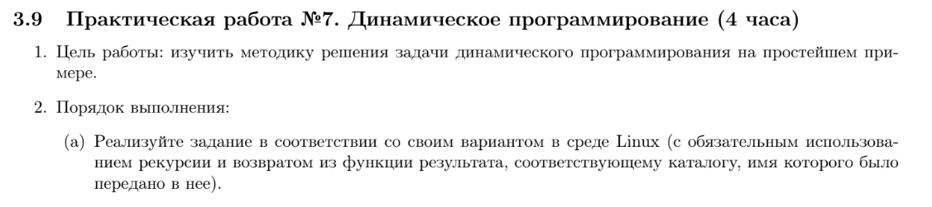



#include <dirent.h>

#include <stdio.h>

#include <sys/types.h>

#include <sys/stat.h>

#include <unistd.h>

#include <stdlib.h>

#include <string.h>

#include <string>

#include <memory>

#include <vector>

#include <stdlib.h>

#include <malloc.h>

#include <sys/stat.h>

#include <sys/wait.h>

#include <limits.h>

#include <errno.h>

#include <pthread.h>

#include <sys/mman.h>

#define PATH "/home/consta/practice1/1/Test1/"

#define BUFFER_SIZE 256

#include <stdio.h>

#include <stdlib.h>

#include <sys/mman.h>

#include <stdlib.h>

#include <string.h>

#include <sys/types.h>

#include <sys/ipc.h>

#include <sys/shm.h>

void* create_shared_memory(size_t size)

{

// Our memory buffer will be readable and writable:

int protection = PROT_READ | PROT_WRITE;

// The buffer will be shared (meaning other processes can access it), but

// anonymous (meaning third-party processes cannot obtain an address for it),

// so only this process and its children will be able to use it:

int visibility = MAP_SHARED | MAP_ANONYMOUS;

// The remaining parameters to `mmap()` are not important for this use case,

// but the manpage for `mmap` explains their purpose.

return mmap(NULL, size, protection, visibility, -1, 0);

}

bool is_pseudodirectory(struct dirent* ent)

{

return strcmp(ent->d_name, (".")) == 0 || strcmp(ent->d_name, ("..")) == 0;

}

void get_old_name(char* path, struct dirent* ent, char* old_file_name)

{

sprintf(old_file_name, "%s%s", path, ent->d_name);

}

void get_new_path(char* path, struct dirent* ent, char* new_path)

{

sprintf(new_path, "%s%s%s", path, ent->d_name, "/");

}

bool is_directory(char* path_, struct stat* st)

{

stat(path_, st);

return S_ISDIR(st->st_mode);

}

void UpdateMin(int* size1, int size2, char* path1, char* path2)

{

if (*size1 <= size2)

return;

*size1 = size2;

strcpy(path1, path2);

}

int* min_count_file = (int*)create_shared_memory(4);

char* dir_name = (char*)create_shared_memory(BUFFER_SIZE);

// nya

void search_file(char* path)

{

DIR* dir = opendir(path);

int loc_count_file = 0;

while (struct dirent* ent = readdir(dir))

{

struct stat sb;

char file_name[BUFFER_SIZE] = "";

get_old_name(path, ent, file_name);

if (stat(file_name, &sb) == -1)

{

continue;

}

if (is_pseudodirectory(ent))

{

continue;

}

if (!(sb.st_mode & S_IFREG))

{

continue;

}

loc_count_file++;

}

closedir(dir);

// printf("%d\n", loc_count_file);

UpdateMin(min_count_file, loc_count_file, dir_name, path);

}

char* rec_dir(char* path) // DIRECTORY_NAME

{

// printf("%s", "odin");

search_file(path);

DIR* dir = opendir(path);

std::vector<std::unique_ptr<char[]>> paths;

std::vector<int> procs;

while (struct dirent* ent = readdir(dir))

{

struct stat sb;

// printf("%s", "dva");

char dir_path[BUFFER_SIZE] = "";

get_old_name(path, ent, dir_path);

if (!(is_directory(dir_path, &sb)))

{

continue;

}

// printf("%s", "tri");

if (is_pseudodirectory(ent))

{

continue;

}

// printf("%s", "chert");

paths.emplace_back(new char[BUFFER_SIZE]());

get_new_path(path, ent, paths.back().get());

int pid = fork();

switch (pid)

{

case -1:

printf("Process error\n");

exit(1);

case 0:

rec_dir(paths.back().get());

exit(0);

default:

procs.push_back(pid);

break;

}

}

for (int i = 0; i < procs.size(); i += 1)

{

int status;

waitpid(procs[i], &status, 0);

}

closedir(dir);

return dir_name;

}

int main(int argc, char* argv[])

{

*min_count_file = INT_MAX;

printf("%s\n", rec_dir(PATH));

return 0;

}