

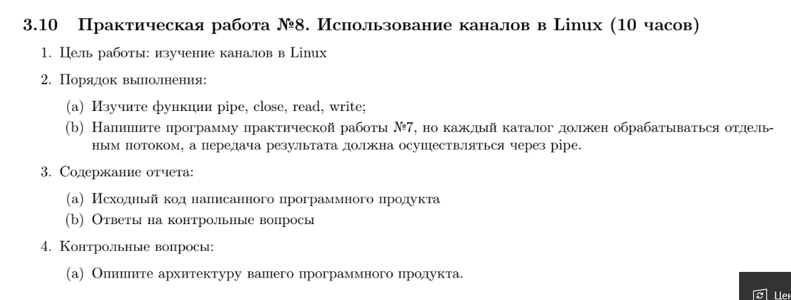

#include <dirent.h>

#include <stdio.h>

#include <sys/types.h>

#include <sys/stat.h>

#include <unistd.h>

#include <stdlib.h>

#include <string.h>

#include <string>

#include <memory>

#include <vector>

#include <stdlib.h>

#include <malloc.h>

#include <sys/stat.h>

#include <sys/wait.h>

#include <limits.h>

#include <errno.h>

#include <pthread.h>

#include <sys/mman.h>

#define PATH "/home/consta/practice1/1/Test1/"

#define BUFFER_SIZE 256

#include <stdio.h>

#include <stdlib.h>

#include <sys/mman.h>

#include <stdlib.h>

#include <string.h>

#include <sys/types.h>

#include <sys/ipc.h>

#include <sys/shm.h>

#include <pthread.h>

#include <stdio.h>

#include <unistd.h>

#include <sys/types.h>

bool is_pseudodirectory(struct dirent *ent)

{

return strcmp(ent->d_name, (".")) == 0 || strcmp(ent->d_name, ("..")) == 0;

}

void get_old_name(char *path, struct dirent *ent, char *old_file_name)

{

sprintf(old_file_name, "%s%s", path, ent->d_name);

}

void get_new_path(char *path, struct dirent *ent, char *new_path)

{

sprintf(new_path, "%s%s%s", path, ent->d_name, "/");

}

bool is_directory(char *path_, struct stat *st)

{

stat(path_, st);

return S_ISDIR(st->st_mode);

}

struct DirInfo

{

int file_count;

char path[BUFFER_SIZE];

};

void UpdateMin(DirInfo *old_min, DirInfo *new_info)

{

if (old_min->file_count <= new_info->file_count)

return;

old_min->file_count = new_info->file_count;

strcpy(old_min->path, new_info->path);

}

int fd[2];

void count_files(char *path)

{

DIR *dir = opendir(path);

DirInfo dir_info;

strcpy(dir_info.path, path);

dir_info.file_count = 0;

while (struct dirent *ent = readdir(dir))

{

struct stat sb;

char file_name[BUFFER_SIZE] = "";

get_old_name(path, ent, file_name);

if (stat(file_name, &sb) == -1)

{

continue;

}

if (is_pseudodirectory(ent))

{

continue;

}

if (!(sb.st_mode & S_IFREG))

{

continue;

}

if (!(sb.st_mode & S_IRUSR))

{

continue;

}

// if ((sb.st_mode & S_IRWXU))

// {

// continue;

// }

printf("файл на чтение");

dir_info.file_count += 1;

}

closedir(dir);

write(fd[1], &dir_info, sizeof(DirInfo));

}

void *rec_dir_helper(void *path);

void rec_dir(char *path)

{

count_files(path);

DIR *dir = opendir(path);

std::vector<std::unique_ptr<char[]>> paths;

std::vector<pthread_t> threads;

while (struct dirent *ent = readdir(dir))

{

struct stat sb;

char dir_path[BUFFER_SIZE] = "";

get_old_name(path, ent, dir_path);

if (!(is_directory(dir_path, &sb)))

{

continue;

}

if (is_pseudodirectory(ent))

{

continue;

}

paths.emplace_back(new char[BUFFER_SIZE]());

get_new_path(path, ent, paths.back().get());

threads.emplace_back();

pthread_create(&threads.back(), NULL, rec_dir_helper, (void *)paths.back().get());

}

for (int i = 0; i < threads.size(); i += 1)

{

pthread_join(threads[i], NULL);

}

closedir(dir);

}

void *rec_dir_helper(void *path)

{

rec_dir((char *)path);

return NULL;

}

void *main_rec_dir(void *path)

{

rec_dir((char *)path);

close(fd[1]);

return NULL;

}

int main(int argc, char *argv[])

{

pipe(fd);

DirInfo answer;

answer.file_count = INT_MAX;

strcpy(answer.path, "default dir");

pthread_t rec_dir_thread;

pthread_create(&rec_dir_thread, NULL, main_rec_dir, (void *)PATH);

DirInfo buffer;

while (read(fd[0], &buffer, sizeof(DirInfo)))

{

UpdateMin(&answer, &buffer);

}

printf("%s\n", answer.path);

}