MPHY0030: Programming Foundations for Medical Image Analysis

LSA Resit Coursework Assignment 2018/19:

Visualisation of 3D Medical Images

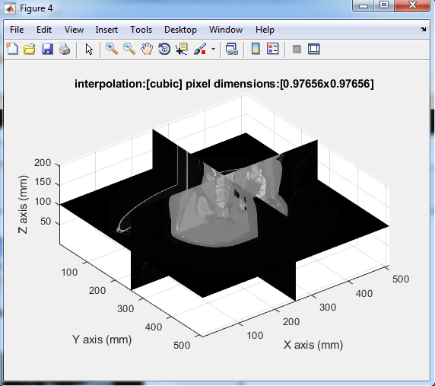

Date: 2/9/2019

Author: 18156558

**Report**

1. ***LoadDICOMVolume*** function loads DICOM images and rearrange it according to its order (slice number), function asks user to select the folder using UI command as shown in figure. i) When user presses the cancel button before on the dialog box without selecting the folder containing DICOM images an error dialog box is generated with the message “Please specify the folder containing the 3D DICOM image” (as shown in fig 2). i) When user selects a wrong folder which doesn’t contains the DICOM images then also an error dialog box is generated with a message “Please select a folder which contains DICOM images” (as shown in fig 3).

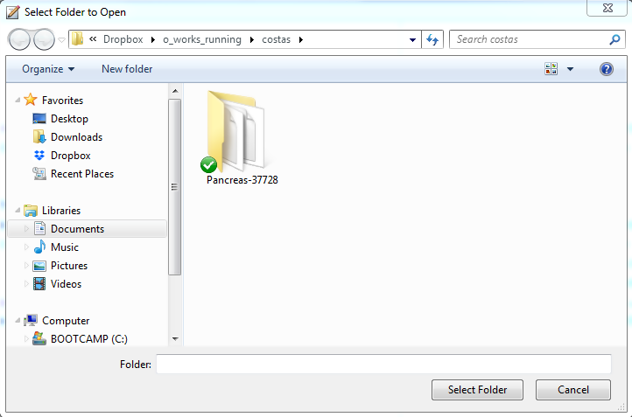

***Figure 1***

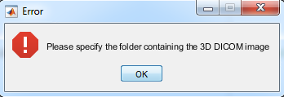 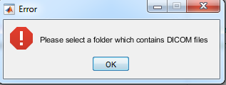

***Figure 2 Figure 3***

**2.** ***ComputeOrthogonalSlice*** uses the concept of interpolation to calculate the not defined pixel or position between the slices, moreover DICOM images has series of slices which can be used to predict any point in 3D using 3D interpolation. Three algorithms were used to predict interpolation ('linear', 'cubic' and 'spline').

Function also has the option to give pixel dimensions along with interpolation method, by using different pixel dimensions we can see the effect of slice clarity and visualization. A function ***test_script_2.m*** was built which calls ***ComputeOrthogonalSlice*** to run in different conditions.

This function shows three slices in different planes x-y, y-z and x-z, we used all the slices at the center of a voxel. Following figures shows the effect of different interpolation method along with pixel dimensions asked.

The dimension of the voxel used is 0.97656 x 0.97656 x 1. The following set of images consist of three images. Each set represents each type of interpolation used which are linear, cubic and spline respectively. First image has both the pixel dimensions equal to the smallest dimension of the voxel i.e. (0.975656 x 0.97656). second image has the both the pixel dimensions equal to the largest dimension of the voxel i.e. (1 x 1). Third image has both the pixel dimension equal to the 4 times the largest of the voxel i.e. (4 x 4).

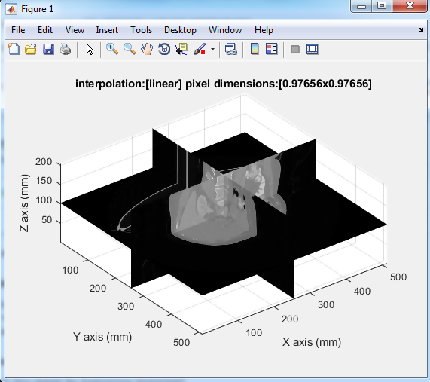 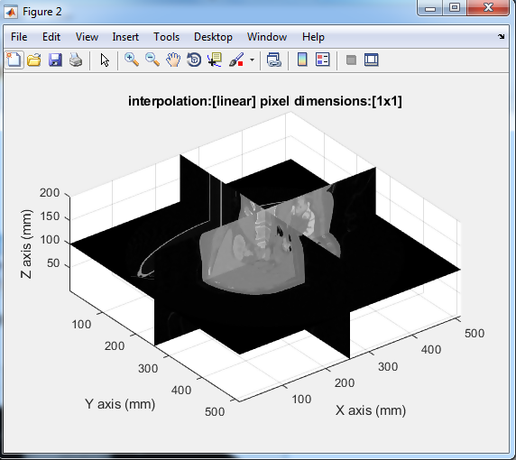

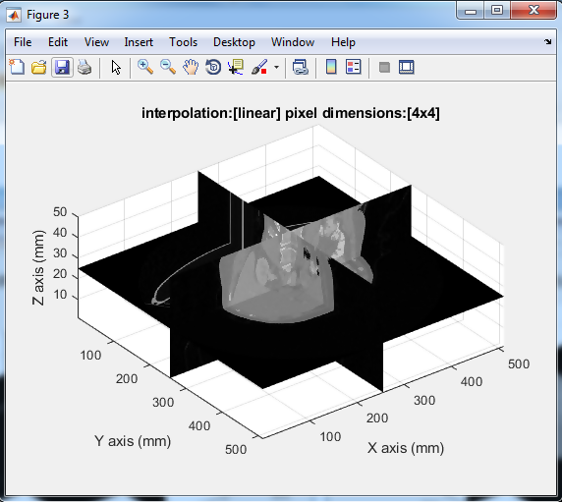

Set

 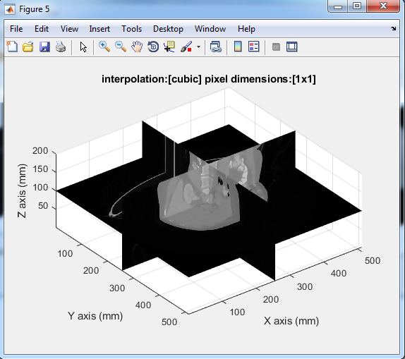

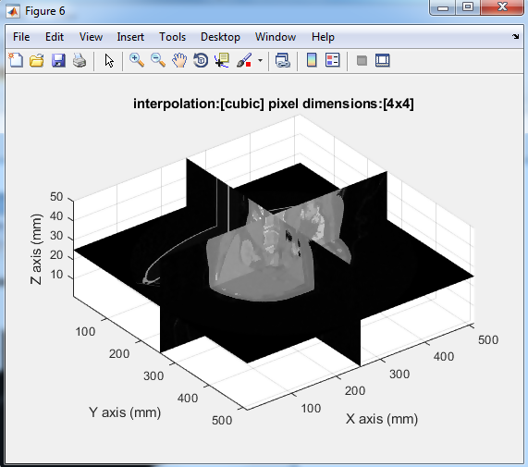

Set

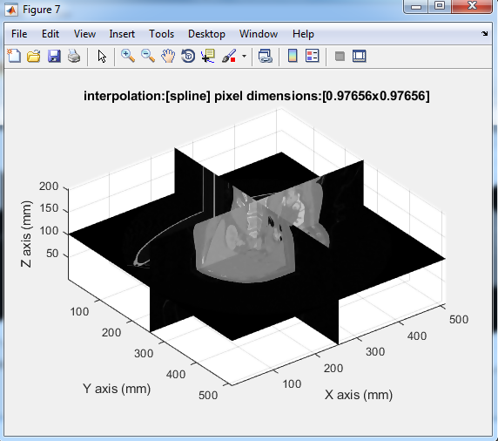 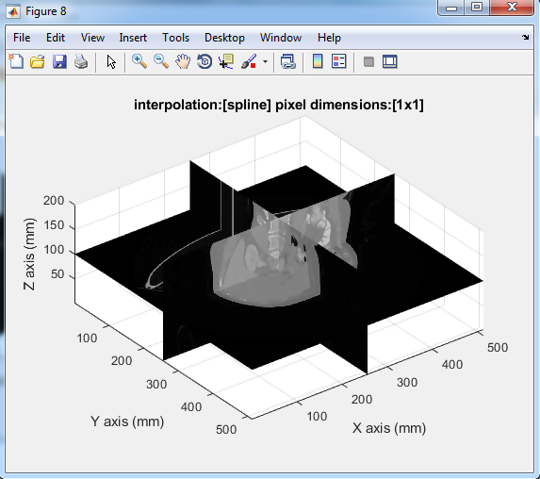

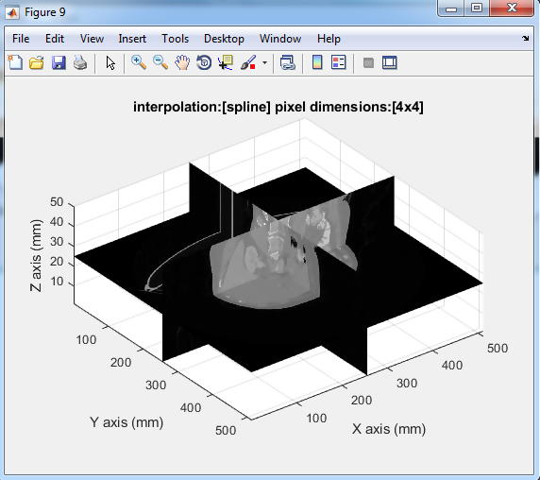

Set

1. **GUI** using MATLAB is made. MATLAB has many toolboxes which helps a lot in making a GUI. Another advantage of using MATLAB for GUI development is that making backend and UI with same environment i.e. MATLAB it reduces the delay time and makes it more prominent.

***4. SliceViewer*** is the function to see any slice by using slider window for any of the plane; it uses the toolbox of GUI commands. It has the option to select x, y and z resolution in mm. figure 4 shows different views x-y, y-z and x-z in the GUI whose slice also shown in left side of the GUI. Following are the screenshots of the GUI. As shown the desired options to change the resolutions as per the requirements and there are sensible limits applied in the resolution change. As you can see there is a reset button which reverses the change to the original resolution.

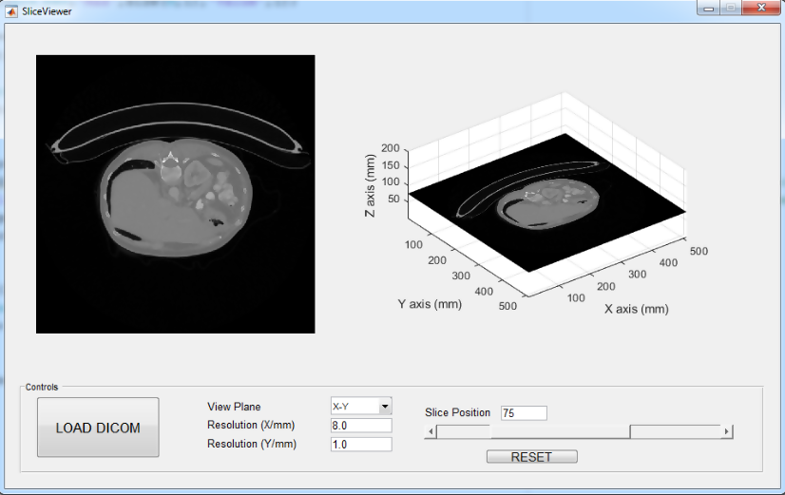

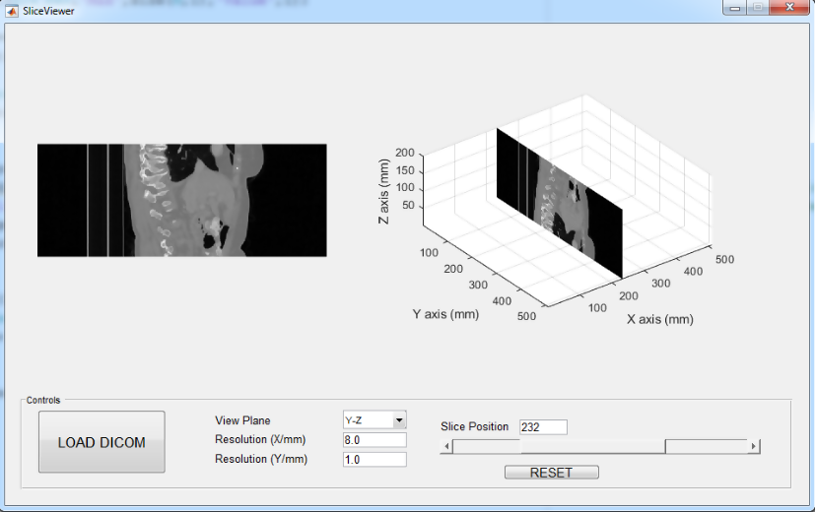

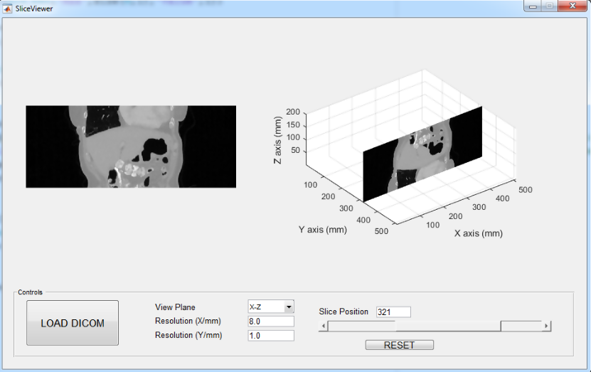

**Figure 4**

***5. BlurSlices*** is the function which uses Gaussian blur to make the interpolation artefacts smooth, this is done using gamma-x, gamma-y, and gamma-z kernels, figure 5 has two images left one is the raw slice and the right images is result image after applying Gaussian filter.

*Test_script_5 calls function BlurSlices and plot different planes with respected gamma axis.*

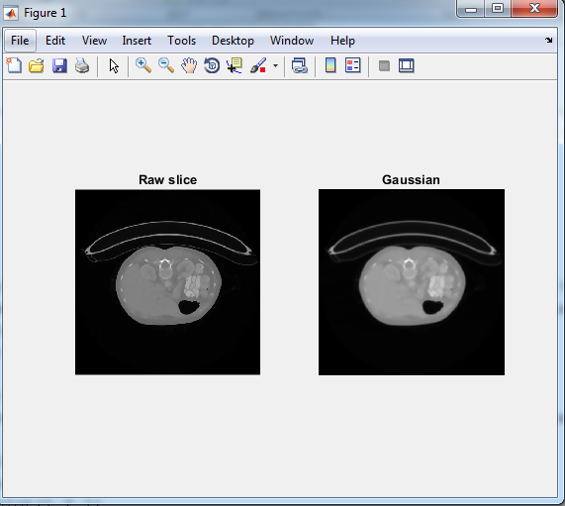

**Figure 5**