This is the reset button, it restarts the game, resets your score and number one and two

This is the pause button, press it to stop game play

This shows your degree of responsiveness and is measured out of 100%

This is your current score and your best score

This is the progress bar and shows how much time is remaining

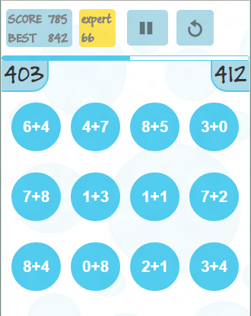

This is number one

This is the correct answer since 412 – 403 = 9 and 7 + 2 = 9

This is number two. The goal of the game is to click a circle that corresponds to the difference between number one and two