Simple wall

MATLAB / Octave files: n00ReadWeatherFiles.m n01SimpleWall.m

Objectives:

* Physical analysis
* Discrete mathematical model: DAE and state-space
* Implement the model
* Discuss the stability and precision

# Physical analysis and mathematical model

Let’s consider the heat transfer through a wall which separates the outside air, at temperature from the inside air. Heat is added to the inside air by a fan-coil.

Table 1 Thermophysical properties (Bergman, et al., 2011)

|  |  |  |  |
| --- | --- | --- | --- |
| Description | Conductivity, | Density, | Specific heat, |
| Concrete  (stone mix) | 1.400 | 2300.0 | 880 |
| Insulation (polystyrene, moulded beads) | 0.040 | 16.0 | 1210 |
| Air |  | 1.2 | 1 |

Let’s consider a simple concrete wall with indoor insulation (Figure 1).

;

Concrete: ; ;

Insulation: ; ;

A fan-coil in the indoor space.

*w1*

*w2*

*w*

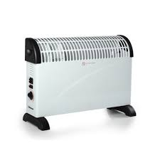

Figure 1 Simple wall: concrete and insulation

If the length and the height are much larger than the width (i.e. about 1à times larger), the heat transfer can be considered only in one direction (1D model).

The heat transfer phenomena:

* convection from wall to outdoor air,
* conduction through the wall,
* convection from wall to indoor air,

The temperature of the indoor air is considered homogenous.

No other heat transfers are considered.

# Discrete mathematical model

The desired simulation time is 1 h.

## Choice of discretization

For explicit Euler method, Von Neumann stability analysis for heat equation (Anon., 2016):

|  |  |
| --- | --- |
|  | (1) |

or

|  |  |
| --- | --- |
|  | (2) |

with . This is applicable for heat equation. In general, the stability condition for explicit Euler method requires that all eigenvalues of the transfer matrix satisfy the condition (Ebery, 2008):

|  |  |
| --- | --- |
|  | (3) |

or, if the eigenvalues are all real (as is the case for thermal networks):

|  |  |
| --- | --- |
|  | (4) |

Since the eigenvalues are related to the time constants:

|  |  |
| --- | --- |
|  | (5) |

it results that the condition for stability is

|  |  |
| --- | --- |
|  | (6) |

which is related to Shannon-Nyquist sampling theorem which requires that the sampling time is smaller than half of the shortest time constant. Note that if the discretization time step is larger than twice a time constant, that time constant can be neglected.

## Thermal network

Discretization: concrete in 4 slices and insulation in 2 slices

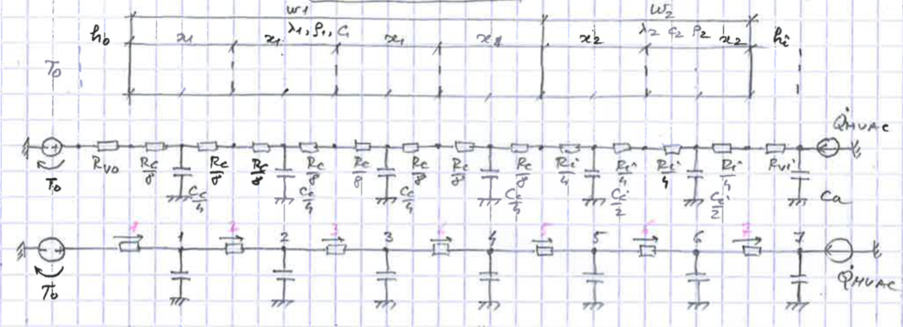

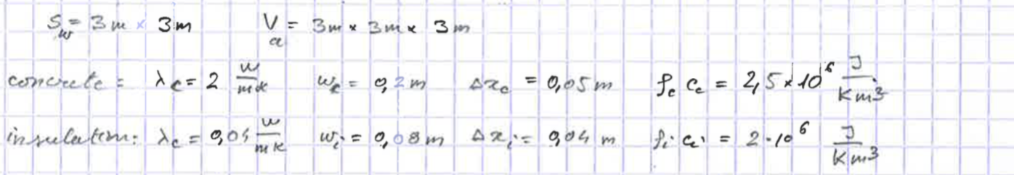

## Differential-algebraic equations

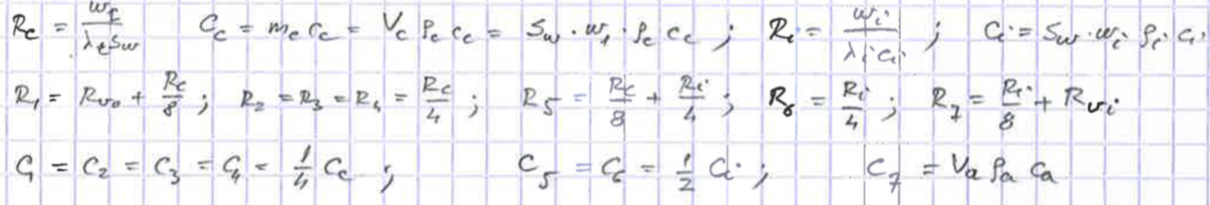

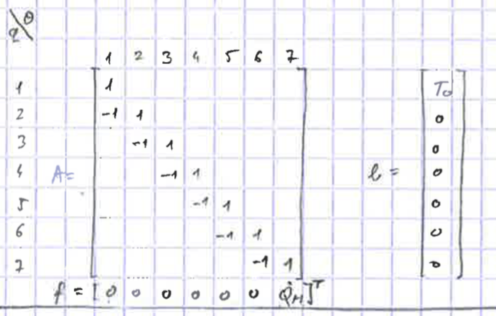

The differential-algebraic equations (DAE) model is

|  |  |
| --- | --- |
|  | (7) |

If is not singular, then the systems of equations may be put in the state-space representation

|  |  |
| --- | --- |
|  | (8) |

where

is the transfer matrix;

in the input matrix.

## State-space representation

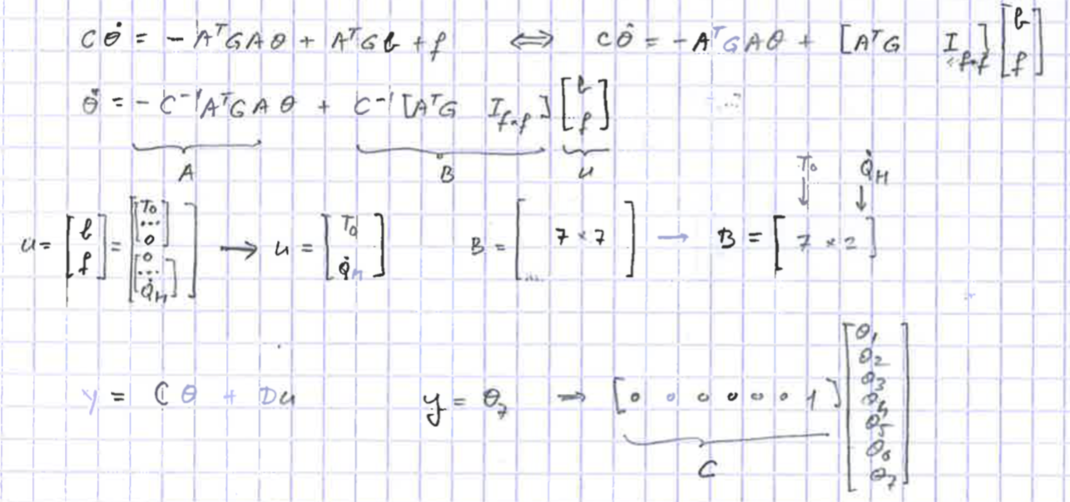

Note that the size of **B** is initially 7 x 14:

* 7 lines for the number of temperatures in nodes;
* 14 columns for the inputs: 7 temperature sources on the seven branches and 7 heat-flow sources in the seven nodes.

Since only 2 inputs are really in the model, (input 1) and (input 14), only they will be kept.

page4image8586880

# Implementation

See t02SimpleWall.m

## Thermal network and state-space

Arc-node incidence matrix written as difference matrix (related to discretization)



Change of context from thermal network to state-space (matrices A and C change their meaning)

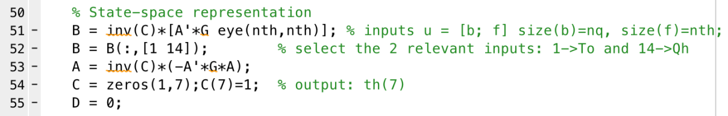

## Integration by using Euler forward and backward methods

The formulas for Euler forward (explicit)

and for Euler backward (implicit)

The integration requires an initial value of the temperatures, .

The implementation is:

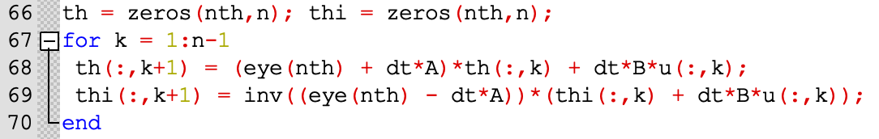

See D. Rowell (2002) for more information.

# Numerical experiments and discussions

## Display

Change the display of the time-axis: line 72

plot(Time/3600,th(7,1:n)), xlabel('Time [h]')

change to

plot(Time,th(7,1:n)), xlabel('Time [s]')

for display in seconds and to

plot(Time/3600/24,th(7,1:n)), xlabel('Time [day]')

for display in days.

## Stability

The condition of stability is



This condition is respected if the number of steps per hour is ; if , the system is numerically unstable. Compare with the results of implicit and explicit method.

Change the value of dt = 1827

page8image8602640

Compare the results given by forward and backward Euler methods.

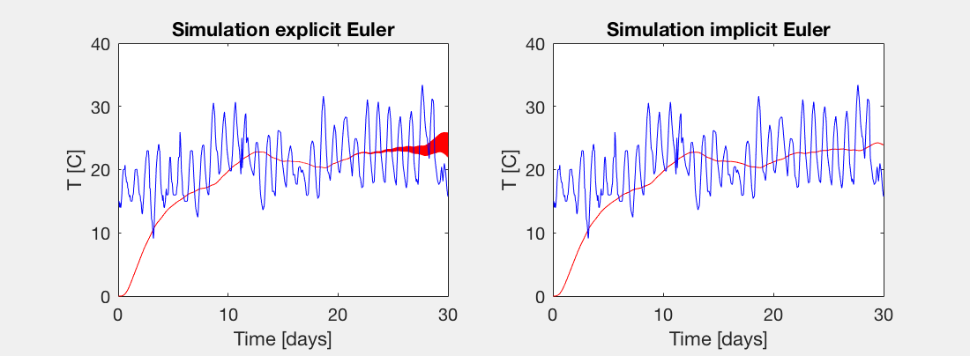

Figure 2 Comparison between forward (explicit) and backward (explicit) Euler methods for numerical integration.

## Step responses

Make the system stable by choosing in line 55 of higher.

**Step response for**

Find the heat flow rate in steady-state:



**Step response for**

Find that the final temperature is .

Deduce the total thermal resistance and verify that it is equal to .



**Simulation for outdoor temperature**

Discuss the evolution of indoor temperature for the two numerical integration methods (Euler explicit and implicit).

Compare the mean outdoor temperature with the mean indoor temperature.

# References

Anon., 2016. *Von Neumann stability analysis.* [Online]   
Available at: https://en.wikipedia.org/wiki/Von_Neumann_stability_analysis

Bergman, T., Lavine, A., Incropera, F. & Dewitt, D., 2011. *Fundamentals of Heat and Mass Transfer.* 7 ed. s.l.:John Wileu & Sons.

Ebery, D., 2008. *Stability Analysis fos Systems of Differential Equations.* [Online]   
Available at: https://www.geometrictools.com/Documentation/StabilityAnalysis.pdf