Cube with two different walls: feed-back indoor temperature control

MATLAB / Octave files:

t03Cube2wFB.m;

fTC2SS.m

fSolRadTiltSurf.m

fReadWeather.m

Objectives:

* Physical analysis of a cube with 5 concrete walls and a glass wall
* Model a controller for indoor temperature
* Discuss the influence of the controller and of the position of the insulation

# Physical analysis and mathematical model

Let’s consider a cubic building with an insulated concrete wall and a window () having the characteristics:

$S_{w}=3 m ×3 m$; $V_{a}=3 m ×3 m ×3 m$

Concrete: $κ_{c}=2.00W/{mK}$; $w_{c}=0.20 m$; $ρ_{c}c_{c}=2.5∙{10}^{6}J/{{K m}^{2}}$

Insulation: $κ_{i}=0.04 W/{mK}$; $w_{i}=0.08 m$; $ρ_{i}c_{i}=2.0∙{10}^{6}J/{{K m}^{2}}$

Glass: $κ_{i}=1.2 W/{mK}$; $w_{g}=0.08 m$; $ρ_{g}c_{g}=2.0∙{10}^{6}J/{{K m}^{2}}$

A fan-coil controls the temperature in the indoor space.

If the length and the height are much larger than the width (i.e. about 10 times larger), the heat transfer can be considered only in one direction (1D model).

The heat transfer phenomena are:

* convection from wall to outdoor air, $h=10 W/m^{2}K$,
* conduction through the wall,
* convection from wall to indoor air, $h=4 W/m^{2}K$.

The temperature of the indoor air is considered homogenous. No other heat transfers are considered.



Figure 1 A cubic house with 5 walls and 1 window: a) the cube; b) the conceptual model; c) the thermal model

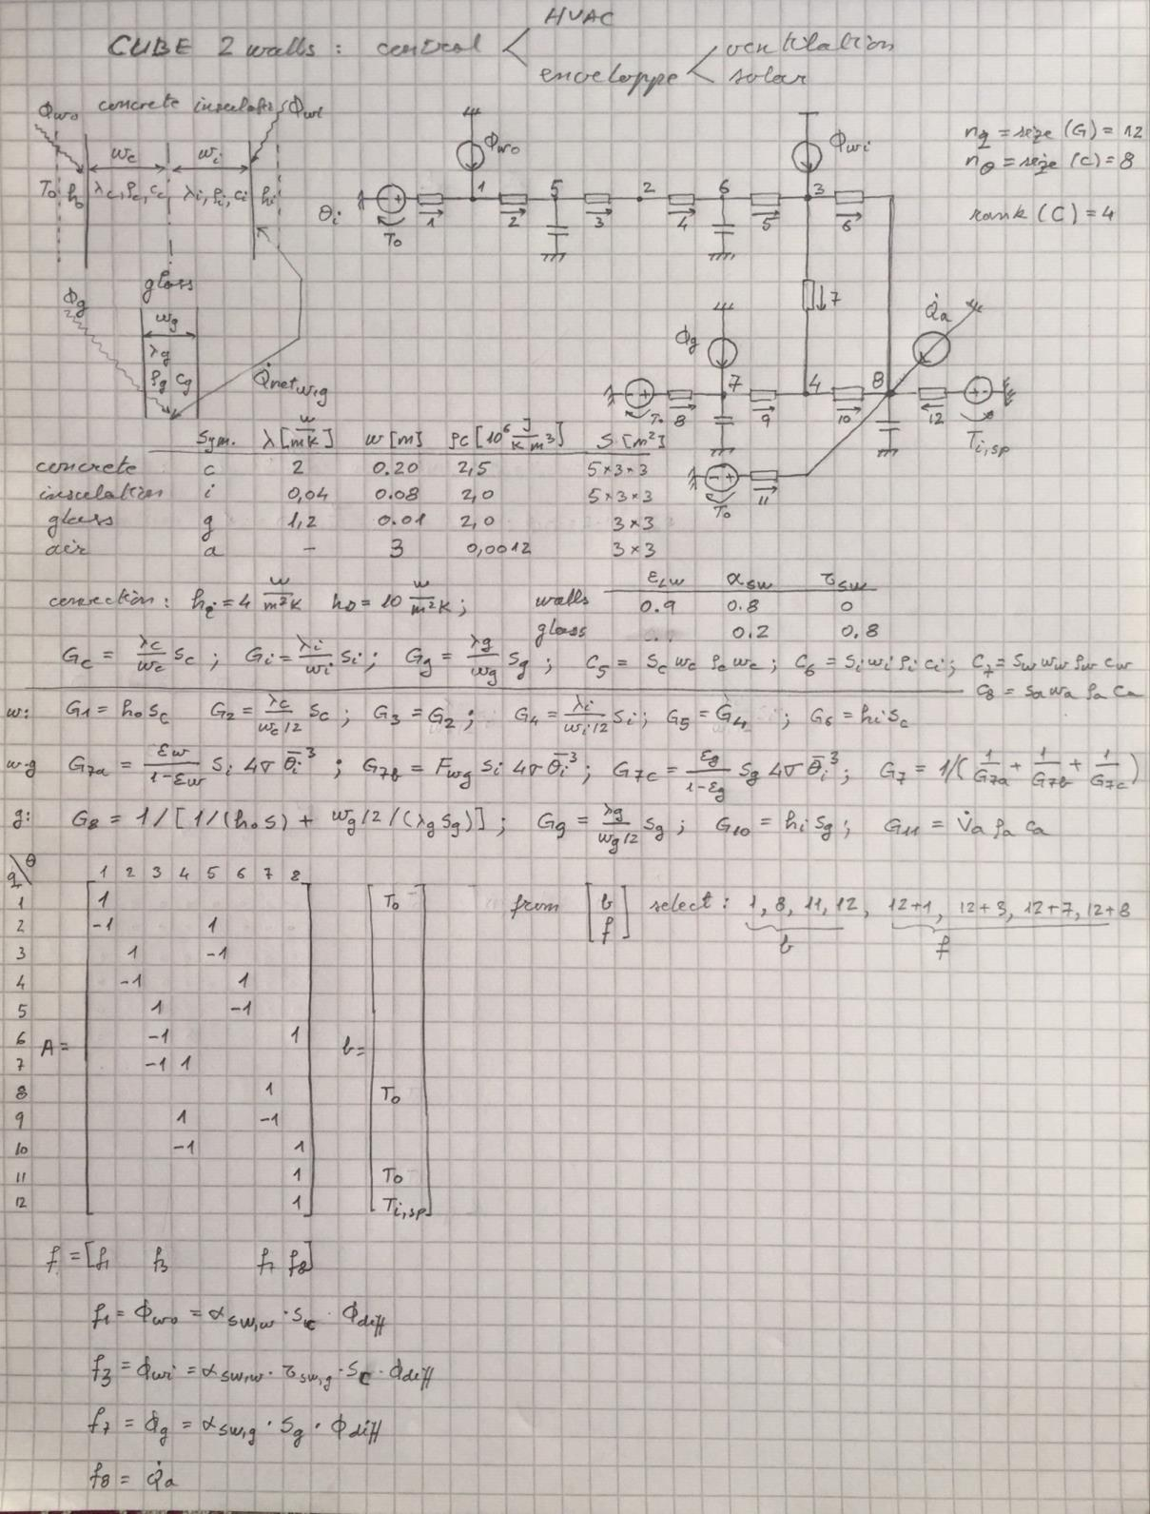

Figure 2 The cube: thermal model, physical values, arc-node incidence matrix.

# Transform thermal circuit to state-space representation

MATLAB/Octave function:

fTC2SS.m

Example of call:

[As,Bs,Cs,Ds] = fTC2SS(A,G,C,b,f,y);

The state-space model is:

$\left\{\begin{matrix}\dot{x}=A_{s}x+B_{s}u \\ y=C_{s}x+D_{s}u\end{matrix}\right.$

where:

- the state vector: temperatures in nodes with capacities;

- output vector: temperatures in the nodes of interest;

- input vector: temperature sources and flow-rate sources;

- state matrix;

- input matrix;

- output matrix;

- feedthrough matrix.

The thermal circuit model is:

$C\dot{θ}=-A^{T}GAθ+A^{T}Gb+f$

where:

- vector of temperaturesin the nodes of the thermal circuit;

- vector of temperature sources on the branches with elements 1 if there is a source and 0 if there is no source;

- vector of flow-rate sources in the nodes with elements 1 if there is a source and 0 if there is no source;

- vector of output temperatures with elements 1 if the node is an output and 0 if it isn’t;

- arc-node incidence matrix, with elements 1 for an arc which enters the node, -1 for an arc which exits a node, and zero otherwise;

- capacity matrix;

- conductance matrix.

# Numerical experiments and discussion

## Heat capacity of the indoor air

The heat capacity of the indoor air may be taken or not into consideration. Comment line 67 in order to consider the heat capacity of the indoor air and uncomment line 67 in order to not take it into account.



Compare the minimum simulation time step for the two situations (with and without heat capacity of the indoor air).

By considering the air heat capacity, make simulations by changing the time step in line 78 from 5 s to 7 s.



Discuss the results.

Without considering the indoor air capacity,



make simulations by increasing the time step

page5image11720800

Comment the results.

## Controller amplification

On line 6

page5image11730576

change the controller proportional constant Kp: 1e4, 1e3, 1e2, 1e1, 1e0, 1e-1. Discuss the significance of these values and their connection with the time step $Δt$.