If, else, else if, elif, for, while, for in, for of, for in, while

# Bucles FOR

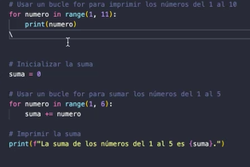

Concatenado

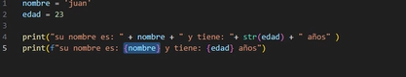

Bucle para imprimir cada fruta

