Abboskhon Sobirov, id 20202037.  
  
  
Assignment 1, task 1.  
  
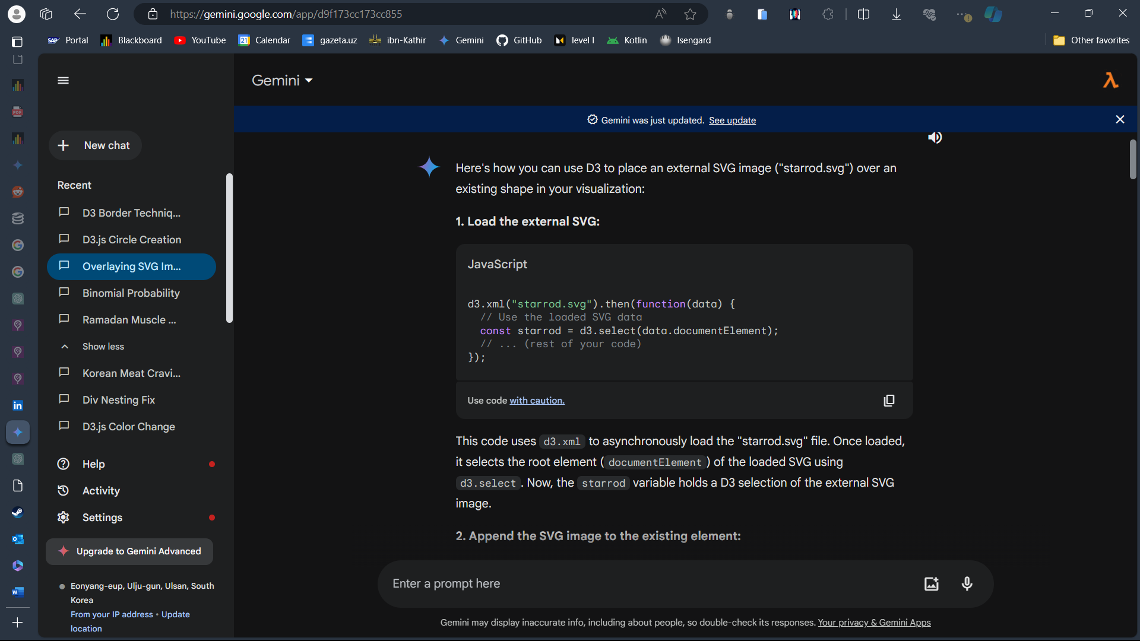  
  
Throughout task 1, I used mostly what I know. I first created a HTML file in an image I saw it and outlined it in CSS. However, I then decided to draw everything in D3 and adressed Gemini so that it helps me use Starrod better, because I knew how to draw in D3.   
  
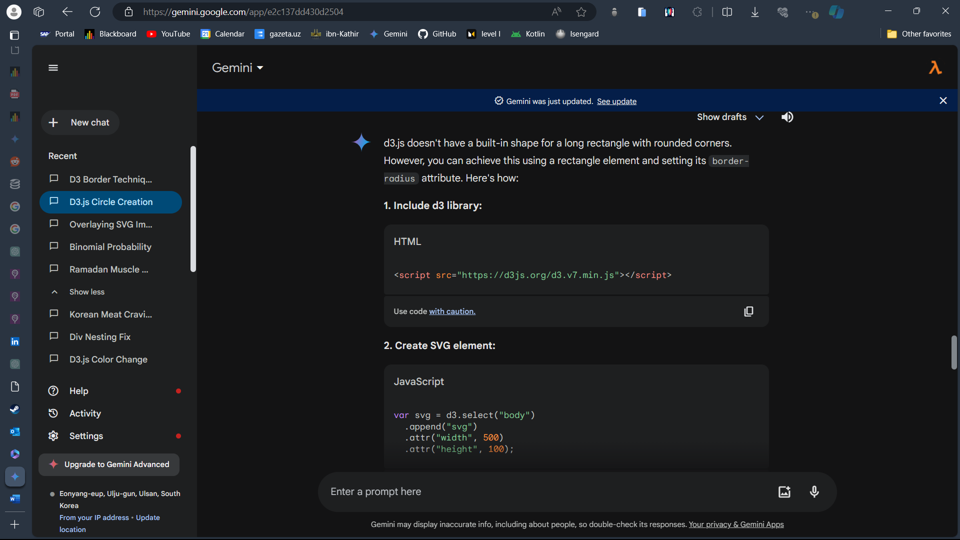  
  
In the above screenshot, I ask Gemini to show me the basics of circle creation, which I then used with const to create some kind of semblance to my body of work.  
  
  
Assignment 1, task 2.  
  
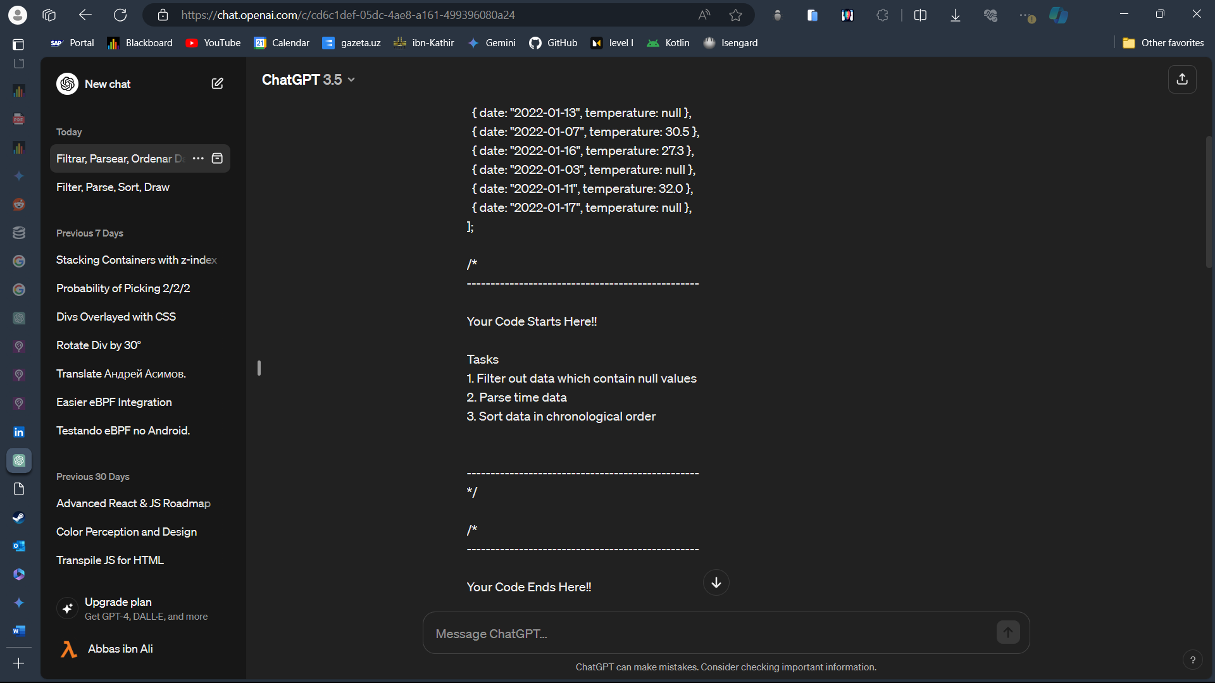  
  
Assignment 1, task 2 was a simple drag and drop, as seen in the ChatGPT query. I copy-pasted the details and got a desired answer, without the need to delve deeper into the code. I also analyzed the dataset first.  
  
